Lab 4 Biomechanics of Frog Skeletal Muscle

I. Purpose

This exercise is designed to demonstrate some mechanical and physiological properties of skeletal muscle using the gastrocnemius muscle of a frog.

II. Performance Objectives

At the end of this exercise the student should be able to:

1. Define minimal (threshold), subminimal, maximal, and supramaximal stimulus.
2. Explain what is meant by a “graded” response.
3. Draw a diagram of the setup used in this lab exercise.
4. Calculate the work that is done in a given muscle.
5. Describe the function of a force displacement transducer.
6. Describe what happens to muscle contraction when the load is increased.
7. Define twitch, treppe, tetanus and incomplete tetanus.
8. Explain the difference between a single and double pith of the frog.

III. Introduction

The gastrocnemius muscle contains many muscle fibers. Each fiber has its own threshold and responds all-or-none when stimulated. It is known that all of the fibers in a muscle do not have the same threshold and that a stimulus applied to a muscle does not necessarily excite all the fiber in it. The threshold is that intensity (voltage) of stimulus which brings response. As the intensity (voltage) of the stimulus is increased above the threshold, more and more fibers are stimulated and the response becomes greater and greater. Eventually, however, a stimulus intensity (voltage) is reached beyond which the response is constant. This stimulus, called the maximal stimulus marks the point where all of the fibers in the muscle are stimulated and responding all-or-none. Stimuli above this maximal stimulus are called supramaximal stimuli. Stimuli below the threshold that do not initiate a mechanical response are called subthreshold stimuli.

The frog muscle is used in this laboratory exercise in place of mammalian muscle because of its tolerance to temperature change and handling. The results are similar to what would be seen in more carefully controlled mammalian experiments.

III. Preparation of the Frog

After the frog has been doubly pithed you are ready to remove a muscle for testing. One of the largest and easiest muscles to obtain is the gastrocnemius of the lower leg. Before beginning the procedure rinse the frog briefly in the sink.

Place the frog on an clean dissecting pan. Be sure that neither the pan nor the dissecting instruments have been contaminated with preservatives such as formaldehyde. The instructor will provide you with pans and tools reserved specifically for the dissection of fresh materials.

It is not necessary to tie down the frog when using the femur clamp preparation. As the muscle is dissected assign one of your lab partners the task of frequently flooding the surgical area with frog ringers using a small beaker and dropper. The muscle must not dry out while dissecting or it will be useless.

With forceps, lift the skin from one thigh and cut the skin completely around the leg using scissors. Pull the cut end back and peel the skin off the leg. Be careful not to touch the outer surface of the skin to the muscle tissues or to touch your contaminated hands to the muscle as poisons on the skin may damage some of the muscle cells. With a blunt probe or the blunt end of the forceps separate the body of the gastrocnemius from the underlying bone. The distal end of the muscle is attached to the Achilles tendon – a silvery white to yellow strand of fibrous tissue. Loosen a portion of the Achilles tendon from the bone then insert a piece of thread about 10 inches long around the tendon and tie it securely. Cut the tendon distal to this knot. The proximal end of the gastrocnemius is attached to the femur. Do not remove it from the bone. Carefully remove all other muscles from the upper leg but leave the gastrocnemius attached. Then cut the lower leg bone at or slightly distal to the “knee” joint with strong scissors or bone cutters (DO NOT USE A SCALPEL). Cut the proximal end of the femur leaving at least one half inch of bone attached to the muscle. You should now have a preparation resembling that in the figure. With the proximal end of the gastrocnemius attached to the femur and the distal end attached to a portion of thread. This is the “muscle – bone preparation” you will use for your muscle physiology experiments. Continue to periodically wet the tissue preparation with saline now and throughout the duration of the experiment.

IV. iWorx Frog Skeletal Muscle Physiology Setup. If the system is already set up, skip to step 8.

1. Make sure computer and iWorx interface (black box) are unplugged)
2. Attach the cable of the Displacement Transducer to the bottom channel 3 input plug
3. Insert the “stimulator cable” plug into channel 4 of the iWorx box
(which is attached to the stimulator section of the iWorx interface)
4. Plug the computer power cord into the power outlet.

5. Plug the iWorx power cord into the outlet
6. Turn on the iWorx interface
7. Turn on the computer
8. After the computer has booted up, click on the iWorx icon
9. Use cursor to select “settings” → choose “load group” in the drop down menu that appears
10. Use cursor to select “AK204” in the box that appears and choose “load” in the same box
11. Use cursor to select “settings” again → choose “Muscle #2”

Your equipment is now ready for the experiment

V. Standardize the movement of the transducer
1. When the transducer is pulled by the contracting muscle, the amplitude of the contraction will be given as “volts” in the window to the upper right of channel 3 (muscle) (ignore any – signs).

2. To convert this reading to actual millimeters of muscle contraction
a. Click start

b. Pull the transducer rod as high as it will go and the release it
c. Click stop

d. Now use a mm ruler to measure the actual distance that the rod moved (this is usually about 30 mm)

f. Click “autoscale” on the channel 3 if needed

g. Click the 2-cursor icon and measure the height of the deflection on channel 3 by placing the first blue line on the peak of the deflection and the second blue line on the baseline after the deflection has returned to its original position.

h. Read and record the Volts reading above and to the right of channel 3 (ignore negative signs). This “voltage” reading is equivalent to the actual mm of movement measured by the ruler

j. Divide the mm of movement by the “voltage” to get a conversion factor

3. Whenever you measure amplitude of a contraction in “voltage” you can now convert it to millimeters of contraction by multiplying this value by your conversion factor determined above.

VI. Set up the frog muscle preparation as follows:

1. Compress the femur in the femur clamp

2. Adjust the clamps so that the thread is vertical and the displacement transducer rod rests just on the upper stop with no slack in the thread; try to make the thread vertical

3. Position the stimulator electrodes so that they lie against the muscle about midway between the knee and the tendon; the two electrodes should not touch one another, but both must be in contact with the muscle

4. Place two nickels (10g) in the weight pan

5. Occasionally add frog ringers to keep the muscle preparation moist.

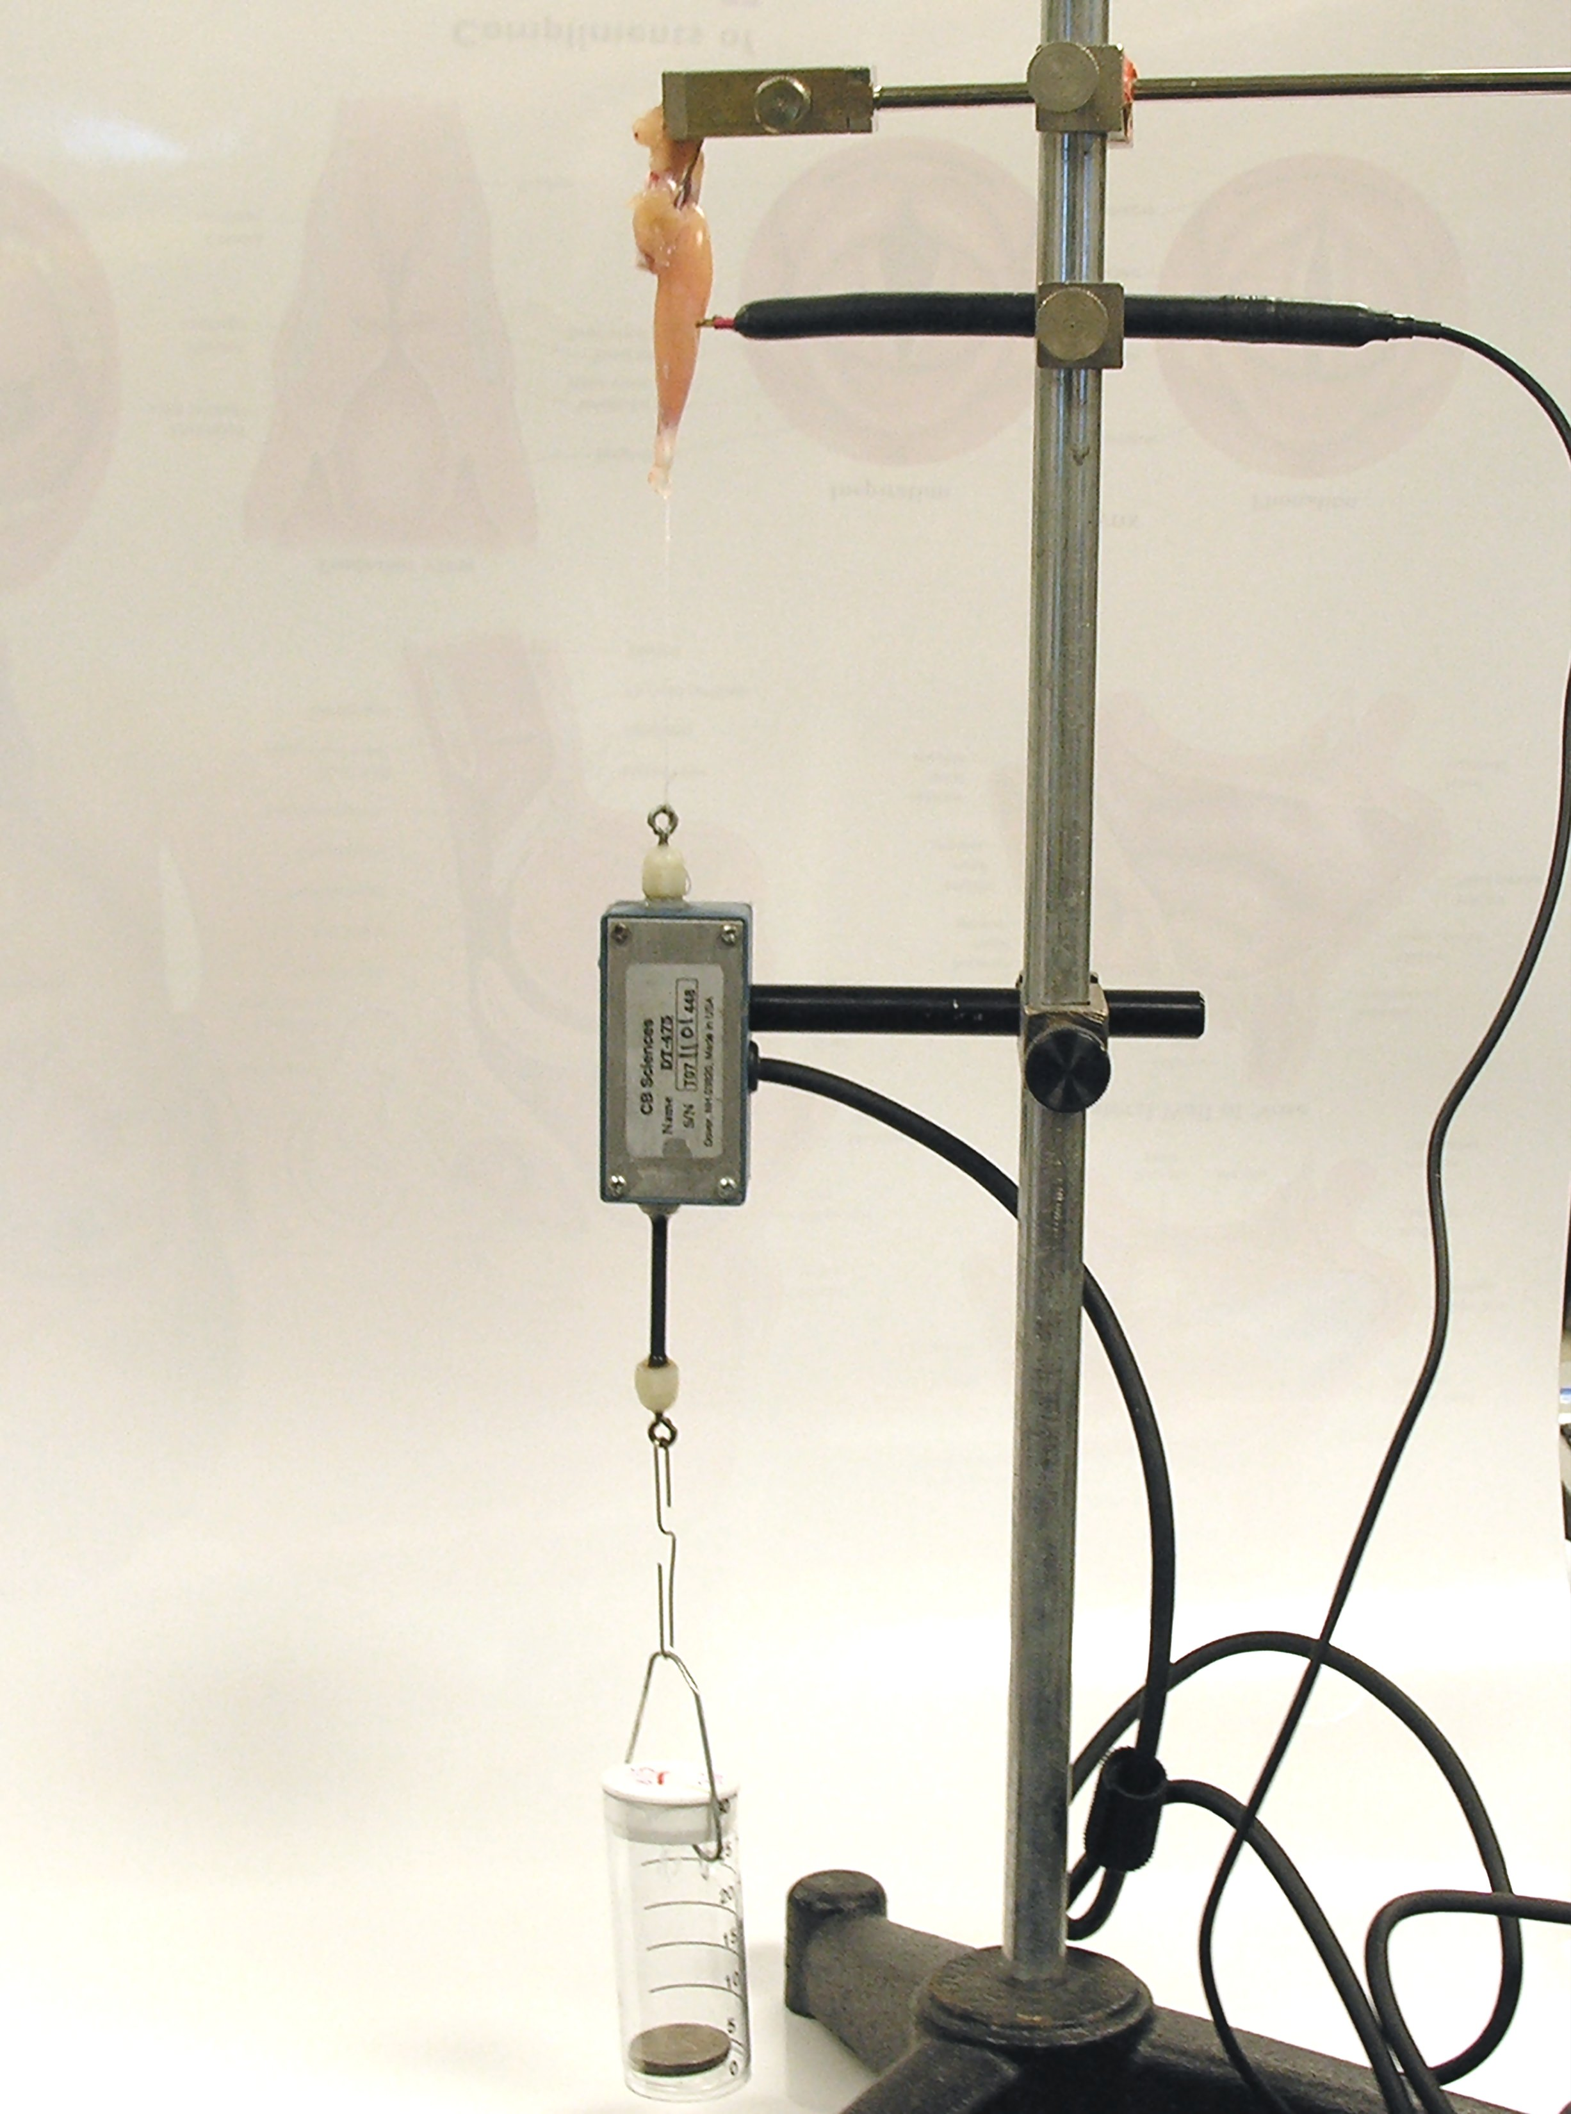

VII. Exercises in Frog Muscle Physiology

A. Determining the threshold stimulus

1. Set up the stimulator (select <preferences> in Edit menu) as follows:

Pulse Width = 10 ms
Delay = 50 ms
Amplitude = 0 Volts
Frequency = 0.5 Hz
# of Pulses = 1

2. Type “0 v” in the ‘marks box’, click ‘Start’ to begin recording and press ‘enter’. The stimulus and a record of the muscles response (if any) will be displayed in channel #4 (shock) and channel #3 (muscle, respectively.

3. Quickly click ‘stop’.

4. Click the <2 cursor> icon so that two blue vertical lines appear over the recording window.

5. Adjust the display time if needed and move the mouse to place the cursor on the left line, click the mouse and drag it to the peak of the first response wave (if there is one). Drag the second cursor, to the baseline after the response.

6. The value in the channel three title area, above and to the right of the channel three window is the value for the amplitude of contraction in volts at the stimulus voltage used. Record this value in the table on your data sheet.

7. Convert this amplitude ‘voltage’ to millimeters of contraction by multiplying it by the conversion factor determined in part V and record this in the table in your data sheet as well.

8. Open the stimulator dialog box and change the stimulus amplitude to 0.25v.

9. Repeat steps 2 through 7, this time typing .25 v in the ‘marks’ box before starting.

10. Repeat the above procedure increasing the voltage in 0.25 volt increments until you are
stimulating the muscle with 5 volts.

11. Once you have completed your table you should be able to complete the observations below:

12. The threshold stimulus is the minimum stimulus needed to get any kind of a response from the frog muscle.

13. Record the threshold stimulus on your data sheet

B. Observing Graded Muscle Response to Increased Stimulus Intensity

1. Using the data from the previous section, make a graph placing stimulus voltage on the x-axis and the amplitude of contraction in millimeters on the y-axis. Paste the graph below.

2. Note the range of stimulus voltages in which you produced a graded response by the muscle. What is occurring in the muscle organ at this point?

___________________________________________________________________
___________________________________________________________________

____________________________________________________________________

____________________________________________________________________

3. The amount of contraction should peak and remain relatively constant at some stimulus voltage; this is your maximal contraction and maximal stimulus voltage
When the curve levels off you have reached maximal stimulus voltage. Estimate the maximal stimulus voltage from your graph and record it on your data sheet. Why can’t the muscle contract any more since you are still increasing the stimulus after this point?

___________________________________________________________________
___________________________________________________________________

____________________________________________________________________

____________________________________________________________________

C. Timing the Muscle Twitch

1. Set the stimulus voltage at the value you determined was the maximal stimulus (usually 3-4 volts)

2. Scroll to one of the contractions at or near maximal contraction.

3. Type “twitch” in the marks area; click ‘start’ and quickly press ‘enter’ to mark the record and produce a single twitch

4. Click stop.

5. If necessary, right click after recording to invert trace.

6. If necessary adjust the display time as needed by clicking the <half display time> icon one or more times to facilitate your analysis

7. Scroll to the beginning of the section of data you want to investigate; click AutoScale if necessary.

8. Click the 2 cursor icon so that two blue vertical lines appear over the recording window and measure:

a. The amplitude of the twitch and convert it to mm as before.

b. The duration of the latent period: Place one cursor line at the stimulus mark (in window 4) and the other on window 3 just before a contraction begins and read T2-T1 in upper left corner of screen. This is the duration of the latent period in seconds.

c. Use the double cursors to measure the duration of the period of contraction in the same way

d. Use the double cursors to also measure the duration of the period of relaxation. Convert these values to milliseconds and record them on your data sheet.

10. Print a copy of this tracing for your group.

D. Observing Graded Muscle Response to Increased Stimulus Frequency

1. Open the stimulator dialog box and change the number of pulses to 250, make sure the stimulus is still set to the maximal stimulus voltage as determined earlier

2. Type 0.5 Hz in the marks box; click ‘Start’ and press ‘Enter’ on the keyboard to mark your record.

3. Click ‘stop’

4. Increase the frequency to 1, 5, 10 and then 20 Hz and repeat steps 2 and 3. Notice that the first few contractions increase in intensity even though the stimulus is the same. Notice also that at a certain frequency the muscle does not have sufficient time to fully relax so that the response does not return to baseline, this is summation.

5. Record the frequency at which summation first appears on your data sheet

6. Print a group copy of the tracing on your screen at this frequency

7. As you continue to increase the frequency of stimulation, notice that at some frequency there is no relaxation at all between each stimulus, this is tetanus.

E. Determining the Effect of Load on Skeletal Muscle

Within limits, increases in the load (i.e., passive tension) placed on a muscle before it contracts results in corresponding increases in the strength of the contractions (i.e., active tension). There is however, a maximum tension that a muscle can exert, and beyond that limit, increases in load (passive tension) result in weaker and weaker contractions (active tension).

1. Set the stimulus voltage to produce maximal stimulus as determined previously (usually between 3 to 5 volts)

2. Reset stimulator settings to those used in part C on the previous page

3. With 2 nickels in the hanger type “10 g” on the keyboard

4. Click ‘Start’ and press ‘Enter’ to mark the record and produce a single twitch.

5. Click Stop.

6. Add two more nickels (10 g) to the hanger for a total of 20 g

7. Repeat the run as above (#3 & 4)

8. Continue increasing the weight in the hanger in 10 g (two nickel) increments until there is no discernable contraction of the muscle

Data Analysis: Effect of load on muscle

9. Adjust the display time and autoscale as needed

10. Scroll to the beginning of this section of data or use the ‘Marks’ icon to find each of the above runs
11. Click the 2cursor icon so that two blue vertical lines appear over the recording window and for each twitch at each weight, measure the amplitude of the twitch both as a voltage measurement and after converting it to millimeters using your conversion factor and record on your data sheet
13. Calculate the “work done” for each weight that produced a measurable contraction of the muscle as:

work done (g-mm) = weight of load (g) X amplitude of contraction (mm)

13. Record this value in the table on your data sheet

14. Make a combined graph. For one data set plot the load on the x-axis and the amplitude of contraction in mm on the y axis. For the second data set plot load on the x-axis and work done on the y axis. Paste the graphs below.

G: Muscle Fatigue

Muscle fibers cannot continually lift. After a short time, the muscle will lose its ability to shorten and will ultimately fail. Due to the accumulation of waste products and the depletion of stored energy materials, a muscle is said to have lost its contractility and become fatigued.

After completion of the above exercises, ask the instructor to help with the demonstration of fatigue.

Inducing Treppe, or the Staircase Phenomenon (optional)

An interesting phenomenon can sometimes be seen during the early stages of a series of twitches. Upon application of a single stimulus of adequate intensity, the muscle contracts. With successive stimuli, it contracts a little more strongly by small increments, making this part of the myographic record appear like a staircase. For this reason, the effect has been called the "Staircase Phenomenon" or "Treppe". It is believed that the slight increase in temperature of the muscle fibers during contraction increases their contractility and that this may be the explanation for the increased strength of contractions.

1 Dissect and setup the gastrocnemius from the other leg.

2. Using a maximal stimulus as determined previously, stimulate the muscle with 5 stimuli set at a frequency of 1.

3. Print a copy of the events that take place and determine if treppe occurred.

VIII. Completing your report. Your lab report should have:

1. All data sheets completed

2. A graph of graded response and maximal stimulus

3. A graph of load versus work done

4. A printout of a muscle twitch with all phases of a twitch contraction labeled.

5. A printout showing summation.

6. A printout showing tetanus.

Cleanup and Disposal

1. Wrap frog and muscle preparation in paper towels or plastic bag provided and discard in trash can.
2. Clean all dissecting equipment with soap and water, blot dry with paper towels and return to tray
3. Disconnect the femur clamp from your station, rinse with DI water, and replace on the ring stand at your station
4. Wet a paper towel with DI water and wipe down the transducer, stimulator probes and clamps, blot dry with a paper towel
5. Turn off the iWorx station.
6. Remember to spray your work area with disinfectant before leaving the lab room.

Data Sheet

Exercises in

Frog Skeletal Muscle Physiology

Conversion factor to convert “voltage” to mm of displacement: ___________

Record the values in the table below:

stimulus
voltage
contraction (volts)
contraction
(mm)

stimulus
voltage
contraction (volts)
contraction
(mm)

Determining the Threshold Stimulus

At what stimulus voltage did a measurable contraction first occur?_____________

Do all motor units have the same stimulus threshold? Explain

___________________________________________________________________________
___________________________________________________________________________

___________________________________________________________________________

Observing Graded Muscle Response to Increased Stimulus Intensity

Make a graph of degree of contraction vs. stimulus voltage and paste below.

How much did the muscle contract at maximal contraction? ____________

What was the stimulus voltage at maximal contraction? ____________

What was happening to the muscle cells within the muscle as the stimulus voltage was increased up to maximal stimulus in terms of recruitment of motor units?

What happened to the cells within the muscle once maximal contraction was reached? Explain why the strength of the contraction does not increase once the maximal stimulus is reached.

Timing the Muscle Twitch

Stimulus voltage used: ___________ Amplitude of contraction (mm):___________

Durations of:
Latent Period (ms): _____________

Period of Contraction (ms): _____________

Period of Relaxation (ms): _____________

Label the tracing of a twitch with each phase and the duration of each phase and paste below.

How do these values compare with the time intervals given in lecture or text? Explain.

Inducing Treppe, or the Staircase Phenomenon

Optional. If this was attempted by your group, include the data and printout here.

Observing Graded Muscle Response to Increased Stimulus Frequency

1. What was the frequency that produced summation: ___________?

2. What was the frequency that produced tetanus: ___________?

Inducing Muscle Fatigue

Instructor will provide the instructions for this section.

Explain what is happening in the muscle cells during fatigue even if you did not get to induce muscle fatigue in your group.

Determining the Effect of Load on Skeletal Muscle

Load  (g) | Amplitude of  Contraction  (volts) | Amplitude of Contraction  (mm) | Work Done  (gmm)
10 g
20 g
30 g
40 g
50 g
60 g
70 g
80 g

Did the amplitude of the contraction increase or decrease with increasing load? Explain.

Did the work done increase or decrease with increasing load? Explain.

Explain your results in terms of energy required, and the interplay between isotonic and isometric contractions.

