Lab 14,15 Biomechanics of Frog Skeletal Muscle

I. Purpose

This exercise is designed to demonstrate some mechanical and physiological properties of skeletal muscle using the gastrocnemius muscle of a frog.

II. Performance Objectives

At the end of this exercise the student should be able to:

1. Define minimal (threshold), subminimal, maximal, and supramaximal stimulus.
2. Explain what is meant by a “graded” response.
3. Draw a diagram of the setup used in this lab exercise.
4. Calculate the work that is done by gastrocnemius muscle of the frog.
5. Describe the function of a force displacement transducer.
6. Describe what happens to muscle contraction when the load is increased.
7. Define twitch, treppe, tetanus and incomplete tetanus.
8. Explain the difference between a single and double pith of the frog.
9. Post all data to Google Drive.

III. Introduction

The gastrocnemius muscle contains many muscle fibers. Each fiber has its own threshold and responds all-or-none when stimulated. It is known that all the fibers in a muscle do not have the same threshold and that a stimulus applied to a muscle does not necessarily excite all the fiber in it. The threshold is that intensity (voltage) of stimulus which brings response. As the intensity (voltage) of the stimulus is increased above the threshold, more and more fibers are stimulated and the response becomes greater and greater. Eventually, however, stimulus intensity (voltage) is reached beyond which the response is constant. This stimulus, called the maximal stimulus marks the point where all of the fibers in the muscle are stimulated and responding all-or-none. Stimuli above this maximal stimulus are called supramaximal stimuli. Stimuli below the threshold that do not initiate a mechanical response are called subthreshold stimuli.

The frog muscle is used in this laboratory exercise in place of mammalian muscle because of its tolerance to temperature change and handling. The results are similar to what would be seen in more carefully controlled mammalian experiments.

III. Preparation of the Frog

After the frog has been doubly pithed you are ready to remove a muscle for testing. One of the largest and easiest muscles to obtain is the gastrocnemius of the lower leg.

Place the frog on a clean dissecting pan. Be sure that neither the pan nor the dissecting instruments have been contaminated with preservatives such as formaldehyde. You will be provided with pans and tools reserved specifically for the dissection of fresh materials.

It is not necessary to tie down the frog when using the femur clamp preparation. As the muscle is dissected assign one of your lab partners the task of frequently flooding the surgical area with frog ringers using a small beaker and disposable pipet. The muscle must not dry out while dissecting or it will be useless.

With forceps, lift the skin from one thigh and cut the skin completely around the leg using scissors. Pull the cut end back and peel the skin off the leg. Minimize the touching of the muscle tissue with contaminated dissecting equipment. Keep the area moist with frog Ringers. With a blunt probe or the blunt end of the forceps separate the body of the gastrocnemius from the underlying bone. The distal end of the muscle is attached to the Achilles tendon, a white to yellow strand of fibrous tissue. Loosen a portion of the Achilles tendon from the bone then insert a piece of thread about 10 inches long around the tendon and tie it securely. Cut the tendon distal to this knot. The proximal end of the gastrocnemius is attached to the femur. Do not remove it from the bone. Carefully remove all other muscles from the upper leg but leave the gastrocnemius attached. Then cut the lower leg bone (tibia) at or slightly distal to the “knee” joint with strong scissors or bone cutters. Cut the proximal end of the femur leaving at least one half inch of bone attached to the muscle. You should now have a preparation resembling that in the figure. With the proximal end of the gastrocnemius attached to the femur and the distal end attached to a portion of thread. This is the “muscle – bone preparation” you will use for your muscle physiology experiments. Connect the femur to the femur clamp as shown in VI. Steps IV, V and VI can be done concurrently.

IV. iWorx Frog Skeletal Muscle Physiology Setup. If the system is already set up, skip to V. Standardize the movement of the transducer

1. Make sure computer and iWorx interface (black box) are unplugged)
2. Attach the cable of the Displacement Transducer to the bottom channel 3 input plug
3. Insert the “stimulator cable” plug into channel 3 of the iWorx box
(which is attached to the stimulator section of the iWorx interface)
4. Plug the computer power cord into the power outlet.
5. Plug the iWorx power cord into the outlet
6. Turn on the iWorx interface
7. Turn on the computer
8. After the computer has booted up, click on the Labscribe icon
9. On the Main window, pull down the Settings menu and
select the Skeletal Muscle-Summation-Tetanus-LS2 settings file.
10. After a short time, LabScribe will appear on the computer screen as configured by the Skeletal Muscle-Summation-Tetanus-LS2 settings.

Your equipment is now ready for the experiment

V. Standardize the movement of the transducer (Start here if Labscribe is ready)

1. When the transducer rod is pulled by the contracting muscle, the amplitude of the contraction will be given as “volts” in the upper right of the window as V₂ – V₁. Record the absolute value and ignore negative sign.

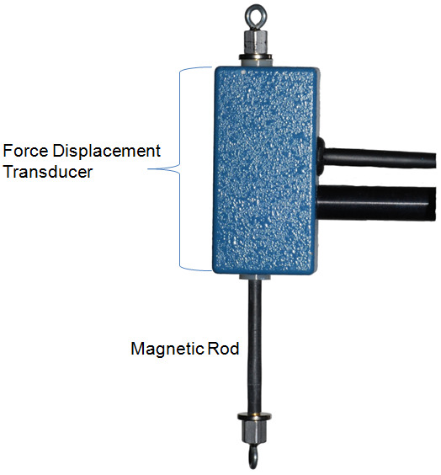 | 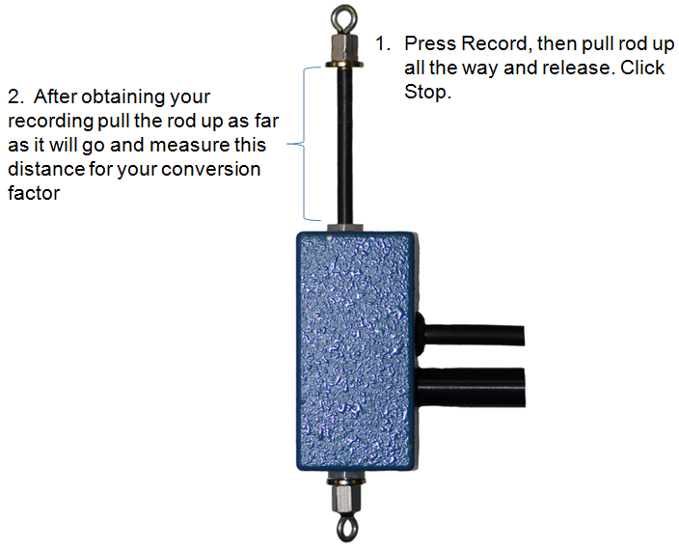

2. To convert this reading to actual millimeters of muscle contraction

a. Click record.

b. Pull the transducer rod as high as it will go and the release it.

c. Click stop.

d. Measure the actual distance that the rod moved (this is usually about
30-34 mm). See above pictures.

f. Click “autoscale” and “double” or “single mountain” icons as needed.

g. Click the 2-cursor icon and measure the height of the deflection on channel 3 by placing the first red line on the peak of the deflection and the second red line on the baseline (valley) after the deflection has returned to its original position.

h. Read and record the Volts reading above and to the right of the channel (ignore negative signs). This “voltage” reading is equivalent to the actual mm of movement measured by the ruler

j. Divide the mm of movement by the “voltage” to get a conversion factor. This will allow you to determine the distance the muscle has contracted, which is necessary to calculate the work done by the muscle.

k. Whenever you measure amplitude of a contraction in “voltage” you can now convert it to millimeters of contraction by multiplying this value by your conversion factor determined above.

VI. Set up the frog muscle preparation as follows:

1. Compress the femur in the femur clamp

2. Adjust the clamps so that the thread is vertical and the displacement transducer rod rests just on the upper stop with no slack in the thread; make sure the thread vertical

3. Position the stimulator electrodes so that they lie against the muscle about midway between the knee and the tendon; the two electrodes should not touch one another, but both must be in contact with the muscle

4. Place two nickels (10g) in the weight pan

5. Occasionally add frog ringers to keep the muscle preparation moist.

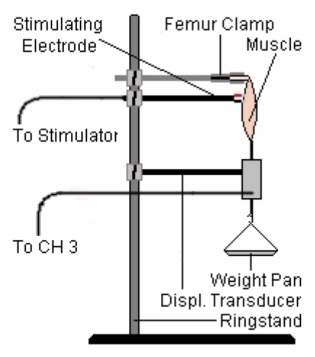
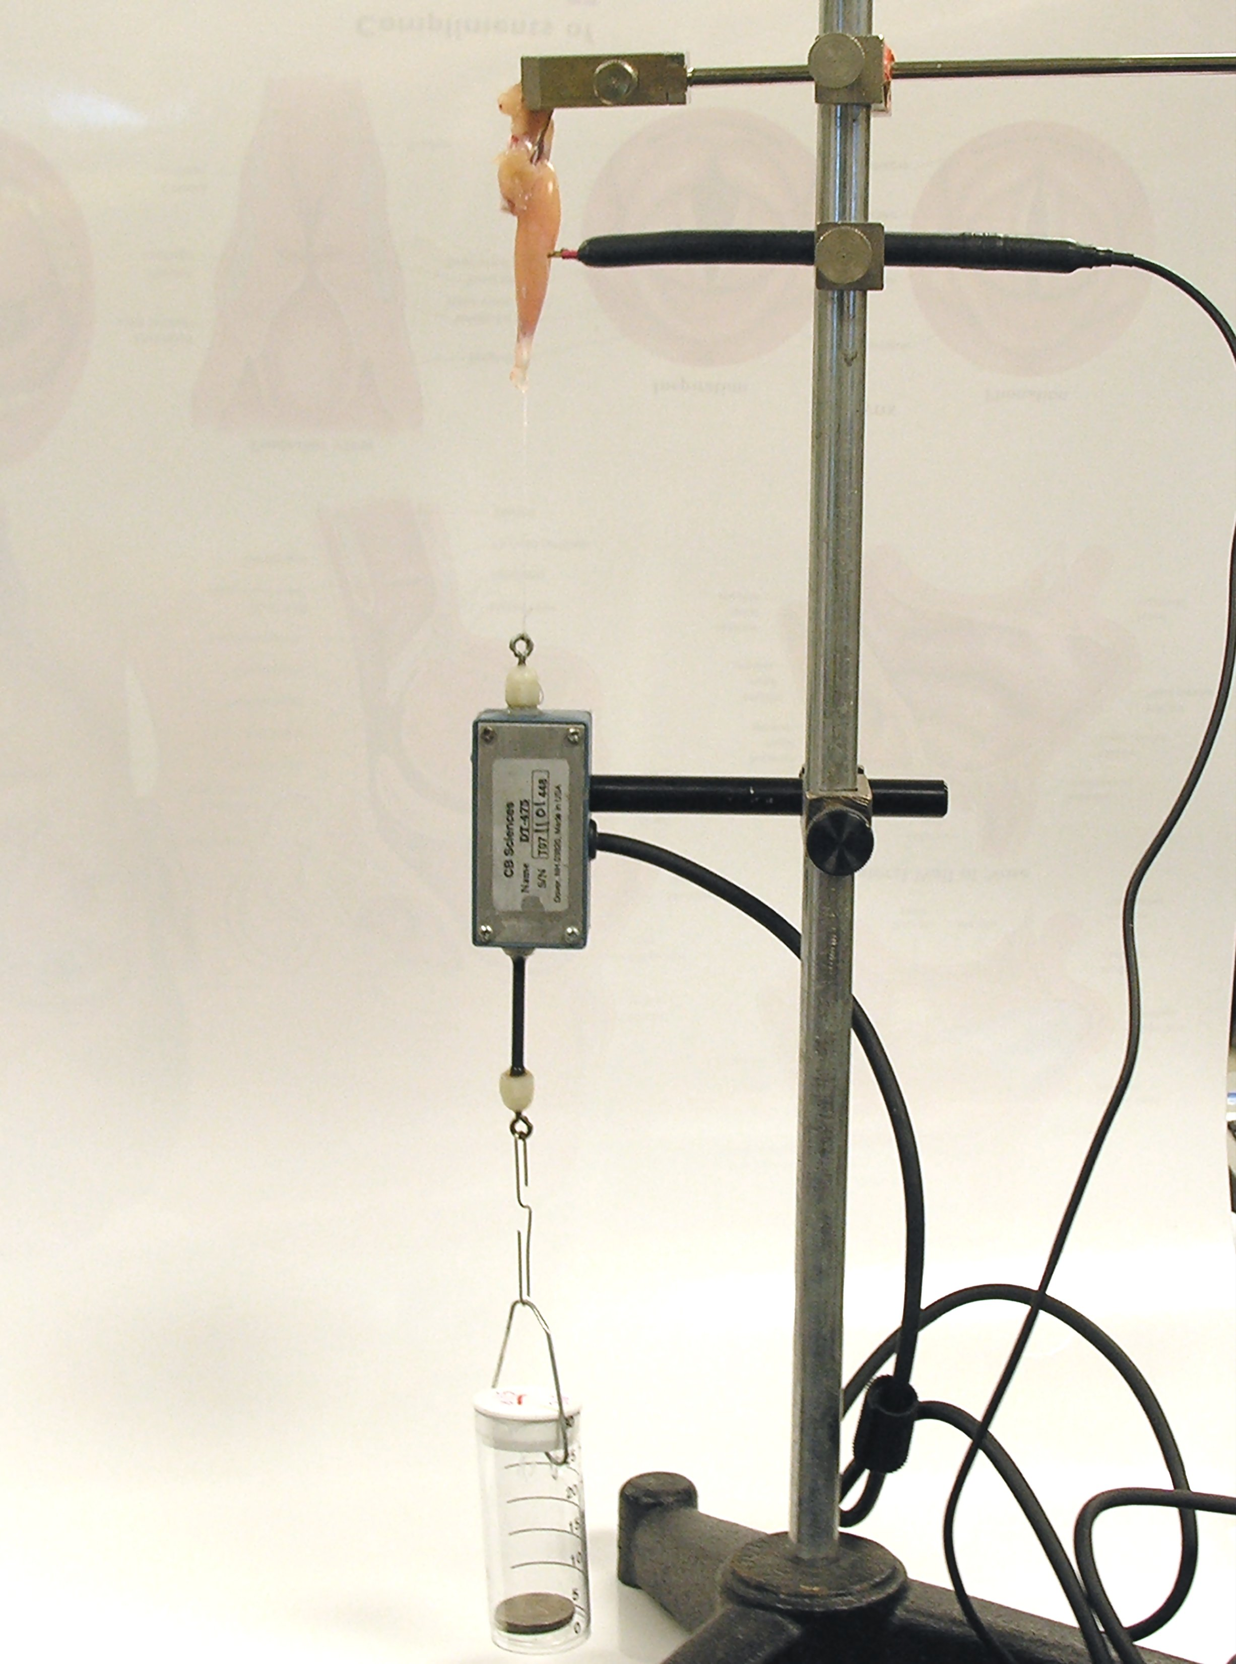

VII. Exercises in Frog Muscle Physiology

A. Determining the threshold stimulus.

1. Set up the stimulator (select <preferences> in Edit menu) or use the stimulator panel and set the following:

Pulse Width = 10 ms
Delay = 50 ms
Amplitude = 0 Volts
Frequency = 0.5 Hz
# of Pulses = 1

The stimulator control panel is shown below. Don't forget to click "apply" after each change.

If you don’t see the stimulator control panel, click the stimulator icon shown circled in green and the stimulator control panel will be shown.

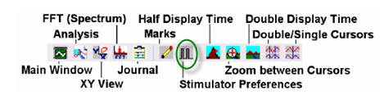

2. Type “0 v” in the ‘marks box’, click ‘Record’ to begin recording and press ‘enter’. The stimulus and a record of the muscles response (if any) will be displayed in channel #3 and channel #4, respectively.

3. Quickly click ‘stop’.

4. Click the <2 cursor> icon so that two red vertical lines appear over the recording window.

5. Adjust the display time if needed and move the mouse to place the cursor on the left line, click the mouse and drag it to the peak of the first response wave (if there is one). Drag the second cursor, to the baseline after the response.

6. The value in the channel three title area, above and to the right of the channel three window is the value for the amplitude of contraction in volts at the stimulus voltage used. Record this value in the table on your data sheet.

7. Convert this amplitude ‘voltage’ to millimeters of contraction by multiplying it by the conversion factor determined in part V and record this value in the table in your data sheet.

8. Open the stimulator dialog box and change the stimulus amplitude to 0.25v. Don’t forget to click apply after each change in the stimulator dialog box.

9. Repeat steps 2 through 7, this time typing .25 v in the ‘marks’ box before starting.

10. Repeat the above procedure increasing the voltage in 0.25 volt increments until you are
stimulating the muscle with 5 volts.

11. Once you have completed your table you should be able to complete the observations below:

12. The threshold stimulus is the minimum stimulus needed to get any kind of a response from the frog muscle.

13. Record the threshold stimulus in the data section

14. Use your data to make the required graphs as indicated in the data section.

C. Timing the Muscle Twitch

1. Set the stimulus voltage at the value you determined was the maximal stimulus (usually 3-4 volts)

2. Type “twitch” in the marks area; click ‘Record’ and quickly press ‘enter’ to mark the record and produce a single twitch

3. Click stop.

4. If necessary, right click after recording to invert trace.

5. If necessary adjust the display time as needed by clicking the half display time (single mountain) icon or double display time (double mountain) one or more times to spread the wave form out to facilitate your analysis.

6. Scroll to the beginning of the section of data you want to investigate; click AutoScale if necessary.

7. Click the 2-cursor icon so that two red vertical lines appear over the recording window and measure: tin the diagram below L equals latent period, C equals contraction phase, R equals relaxation phase and A is the amplitude of contraction.

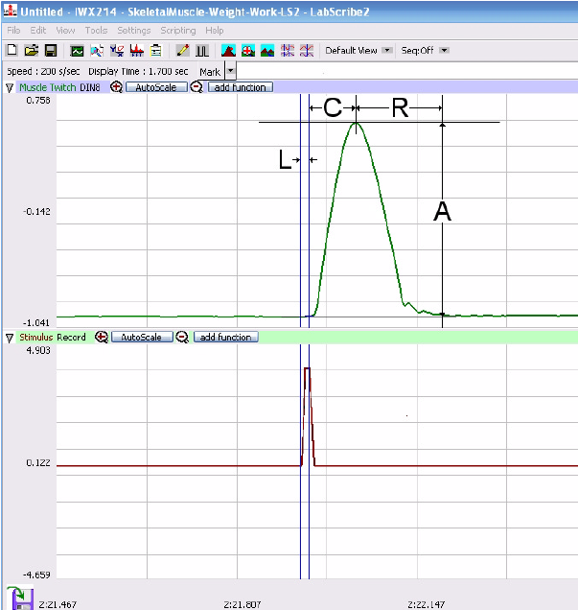

8. The amplitude of the twitch and convert it to mm as before.

9. The duration of the latent period: Place one cursor line at the stimulus mark (in window 4) and the other on window 3 just before a contraction starts and read T2-T1 in upper right corner of screen. This is the duration of the latent period in seconds.

10. Use the double cursors to measure the duration of the period of contraction in the same way

11. Use the double cursors to also measure the duration of the period of relaxation. Convert these values to milliseconds and record them on your data sheet.

12. Print a copy of this tracing for your group. Paste the graph in the data section of this lab exercise.

D. Determining the Effect of Load on Skeletal Muscle

Within limits, increases in the load (i.e., passive tension) placed on a muscle before it contracts results in corresponding increases in the strength of the contractions (i.e., active tension). There is however, a maximum tension that a muscle can exert, and beyond that limit, increases in load (passive tension) result in weaker and weaker contractions (active tension).

1. Set the stimulus voltage to produce maximal stimulus as determined previously (usually between 3 to 5 volts)

2. Reset stimulator settings to those used in part C on the previous page

3. With 2 nickels in the weight basket type “10 g” on the keyboard

4. Click ‘Record’ and press ‘Enter’ to mark the record and produce a single twitch.

5. Click Stop.

6. Add two more nickels (10 g) to the weight basket for a total of 20 g

7. Repeat the run as above (#3 & 4)

8. Continue increasing the weight in the weight basket in 10 g (two nickel) increments until there is no discernable contraction of the muscle

Data Analysis: Effect of load on muscle

9. Adjust the display time and autoscale as needed

10. Scroll to the beginning of this section of data or use the ‘Marks’ icon to find each of the above runs

11. Click the 2cursor icon so that two red vertical lines appear over the recording window and for each twitch at each weight, measure the amplitude of the twitch both as a voltage measurement and after converting it to millimeters using your conversion factor and record on your data sheet

13. Calculate the “work done” for each weight that produced a measurable contraction of the muscle as:

work done (g-mm) = weight of load (g) X amplitude of contraction (mm)

13. Record this value in the table on your data sheet

E. Observing Graded Muscle Response to Increased Stimulus Frequency

1. Open the stimulator dialog box and change the number of pulses to 250, make sure the stimulus is still set to the maximal stimulus voltage as determined earlier, use two (2)
nickels in the weight basket.

2. Type 0.5 Hz in the marks box; click ‘Record’ and press ‘Enter’ on the keyboard to mark your record.

3. Click ‘stop’

4. Increase the frequency to 1, 5, 10 and then 20 Hz and repeat steps 2 and 3. Notice that the first few contractions increase in intensity even though the stimulus is the same. Notice also that at a certain frequency the muscle does not have sufficient time to fully relax so that the response does not return to baseline, this is summation.

5. Record the frequency at which summation first appears on your data sheet

6. Print a group copy of the tracing on your screen at this frequency

7. As you continue to increase the frequency of stimulation, notice that at some frequency there is no relaxation at all between each stimulus, this is tetanus.

G: Muscle Fatigue

Muscle fibers cannot continually lift. After a short time, the muscle will lose its ability to shorten and will ultimately fail. Due to the accumulation of waste products and the depletion of stored energy materials, a muscle is said to have lost its contractility and become fatigued.

1. Set the stimulator voltage to the maximal stimulus voltage as determined previously.

2. Set the number of pulses to “0”. This will provide an infinite number of pulses.

3. Click record and observe the waveform produced. To see the effect of continuous stimulation the double mountain icon may have to be clicked several times to put much more data on the screen.

4. After several minutes or when the amplitude drops significantly, stop the recording.

5. Compress the data by using the double or single mountain icons.

6. Paste the recording where indicated in the data.

Inducing Treppe, or the Staircase Phenomenon (optional if time permits)

An interesting phenomenon can sometimes be seen during the early stages of a series of twitches. Upon application of a single stimulus of adequate intensity, the muscle contracts. With successive stimuli, it contracts a little more strongly by small increments, making this part of the myographic record appear like a staircase. For this reason, the effect has been called the "Staircase Phenomenon" or "Treppe". It is believed that the slight increase in temperature of the muscle fibers during contraction increases their contractility and that this may be the explanation for the increased strength of contractions.

1 Dissect and setup the gastrocnemius from the other leg.

2. Using a maximal stimulus as determined previously, stimulate the muscle with 5 stimuli set at a frequency of 1.

3. If you had time to do “Treppe” paste your recording where indicated in the data section.

VIII. Completing your report. Your lab report should have:

1. All data sheets completed

2. A graph of graded response and maximal stimulus

3. A graph of load versus work done

4. A printout of a muscle twitch with all phases of a twitch contraction labeled.

6. A printout showing tetanus and fatigue

Cleanup and Disposal

1. Wrap frog and muscle preparation in paper towels or plastic bag provided and discard in trash can.
2. Clean all dissecting equipment with soap and water, blot dry with paper towels and return to tray
3. Disconnect the femur clamp from your station, rinse with DI water, and replace on the ring stand at your station
4. Wet a paper towel with DI water and wipe down the transducer, stimulator probes and clamps, blot dry with a paper towel
5. Turn off the iWorx station.
6. Remember to spray your work area with disinfectant before leaving the lab room.

Data Sheet

Exercises in

Frog Skeletal Muscle Physiology

Conversion factor to convert “voltage” to mm of displacement: ___________

Record the values in the table below:

stimulus
voltage
contraction (volts)
contraction
(mm)

stimulus
voltage
contraction (volts)
contraction
(mm)

Determining the Threshold Stimulus

At what stimulus voltage did a measurable contraction first occur? _____________

Do all motor units have the same stimulus threshold? Explain

___________________________________________________________________________
___________________________________________________________________________

___________________________________________________________________________

Observing Graded Muscle Response to Increased Stimulus Intensity

1. Using the data from the previous section, make a graph placing stimulus voltage on the x-axis and the amplitude of contraction in millimeters on the y-axis. Paste the graph below.

Observing Graded Muscle Response to Increased Stimulus Intensity

2. Note the range of stimulus voltages in which you produced a graded response by the muscle. What is occurring in the muscle at this point?

___________________________________________________________________
___________________________________________________________________

____________________________________________________________________

____________________________________________________________________

3. The amount of contraction should peak and remain relatively constant at some stimulus voltage; this is your maximal contraction and maximal stimulus voltage
When the curve levels off you have reached maximal stimulus voltage. Estimate the maximal stimulus voltage from your graph and record it on your data sheet. Why can’t the muscle contract any more since you are still increasing the stimulus after this point?

___________________________________________________________________
___________________________________________________________________

____________________________________________________________________

____________________________________________________________________

What was the stimulus voltage at maximal contraction? ____________

What was happening to the muscle cells within the muscle as the stimulus voltage was increased up to maximal stimulus in terms of recruitment of motor units?

____________________________________________________________________

____________________________________________________________________

Timing the Muscle Twitch

Stimulus voltage used: ___________ Amplitude of contraction (mm):___________

Durations of:
Latent Period (ms): _____________

Period of Contraction (ms): _____________

Period of Relaxation (ms): _____________

Label the tracing of a twitch with each phase and the duration of each phase and paste where indicated.

Muscle Twitch

How do these values compare with the time intervals given in lecture or text? Explain.

____________________________________________________________________

____________________________________________________________________

Inducing Treppe, or the Staircase Phenomenon

Optional. If this was attempted by your group, include the data and printout where indicated.

Inducing Treppe

Observing Graded Muscle Response to Increased Stimulus Frequency

1. What was the frequency that produced summation: ___________?

2. What was the frequency that produced tetanus: ___________?

Inducing Muscle Fatigue

1. Did muscle fatigue occur? How was this determined?

____________________________________________________________________

____________________________________________________________________

2. Explain what is happening in the muscle cells during fatigue.

____________________________________________________________________

____________________________________________________________________

Inducing Muscle Fatigue and Tetanus

Determining the Effect of Load on Skeletal Muscle

Load  (g) | Amplitude of  Contraction  (volts) | Amplitude of Contraction  (mm) | Work Done  (g/mm)
10 g
20 g
30 g
40 g
50 g
60 g
70 g
80 g

Did the amplitude of the contraction increase or decrease with increasing load? Explain.

____________________________________________________________________

____________________________________________________________________

____________________________________________________________________

____________________________________________________________________

Did the work done increase or decrease with increasing load? Explain.

____________________________________________________________________

____________________________________________________________________

Explain your results in terms of energy required, and the interplay between isotonic and isometric contractions.

____________________________________________________________________

____________________________________________________________________

____________________________________________________________________

____________________________________________________________________

Make a combined graph. For one data set plot the load on the x-axis and the amplitude of contraction in mm on the y axis. For the second data set plot load on the x-axis and work done on the y axis. Paste the graph where indicated.

Combined Graph

Don’t forget to post your data to Google Drive!

