2-D Magnetic Field Demonstrator

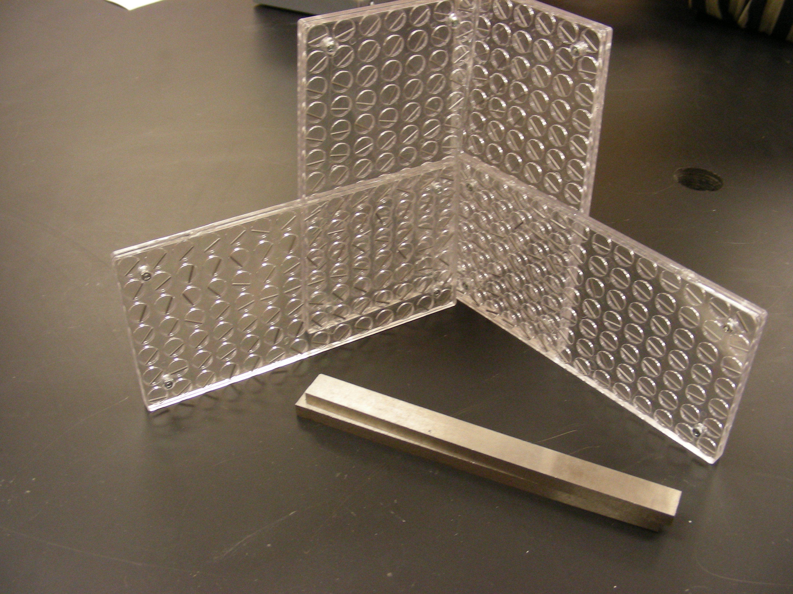
Introduction
To view magnetic direction field.

Theory
Place a magnet above or below this demonstrator. Magnetic field lines are clearly revealed as the iron bars align with the field. Lay the plates together to form a large plate, or stand them on edge to map out a 3-D field.

