Analog Sound level meter
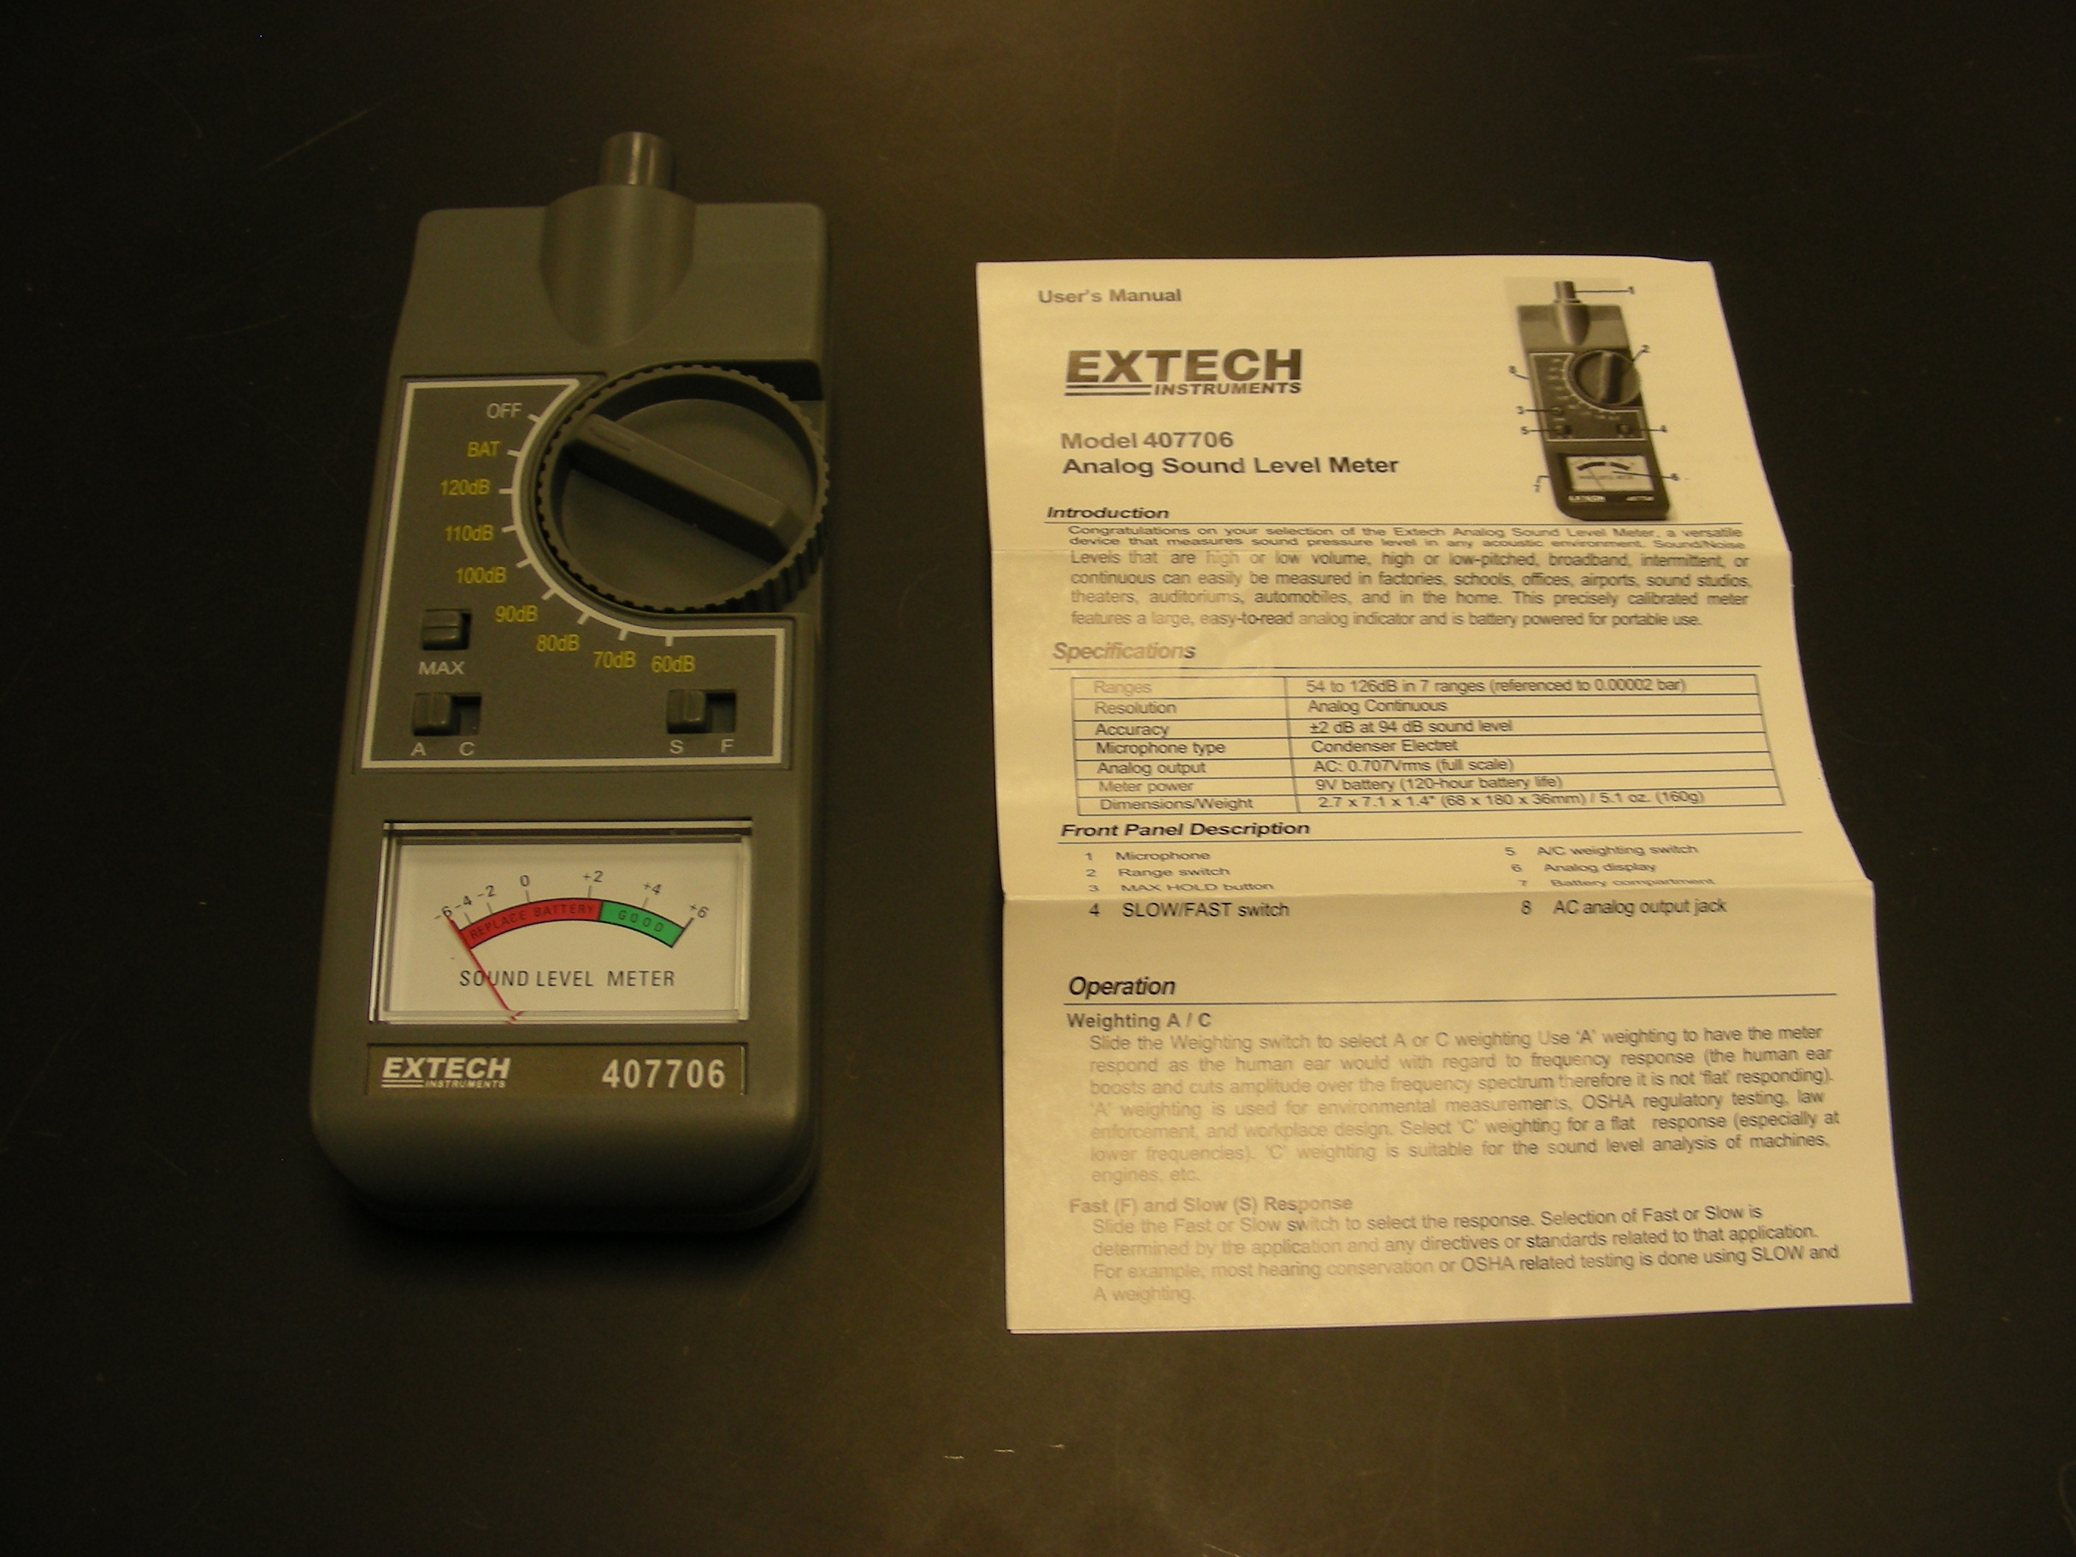
Introduction
It is a device that measures sound pressure level in any acoustic environment.

Theory
Identify noise ordinance violations, traffic noise measurements, community noise measurements, theater acoustic studies, stereo balancing.

