Ballistic Pendulum
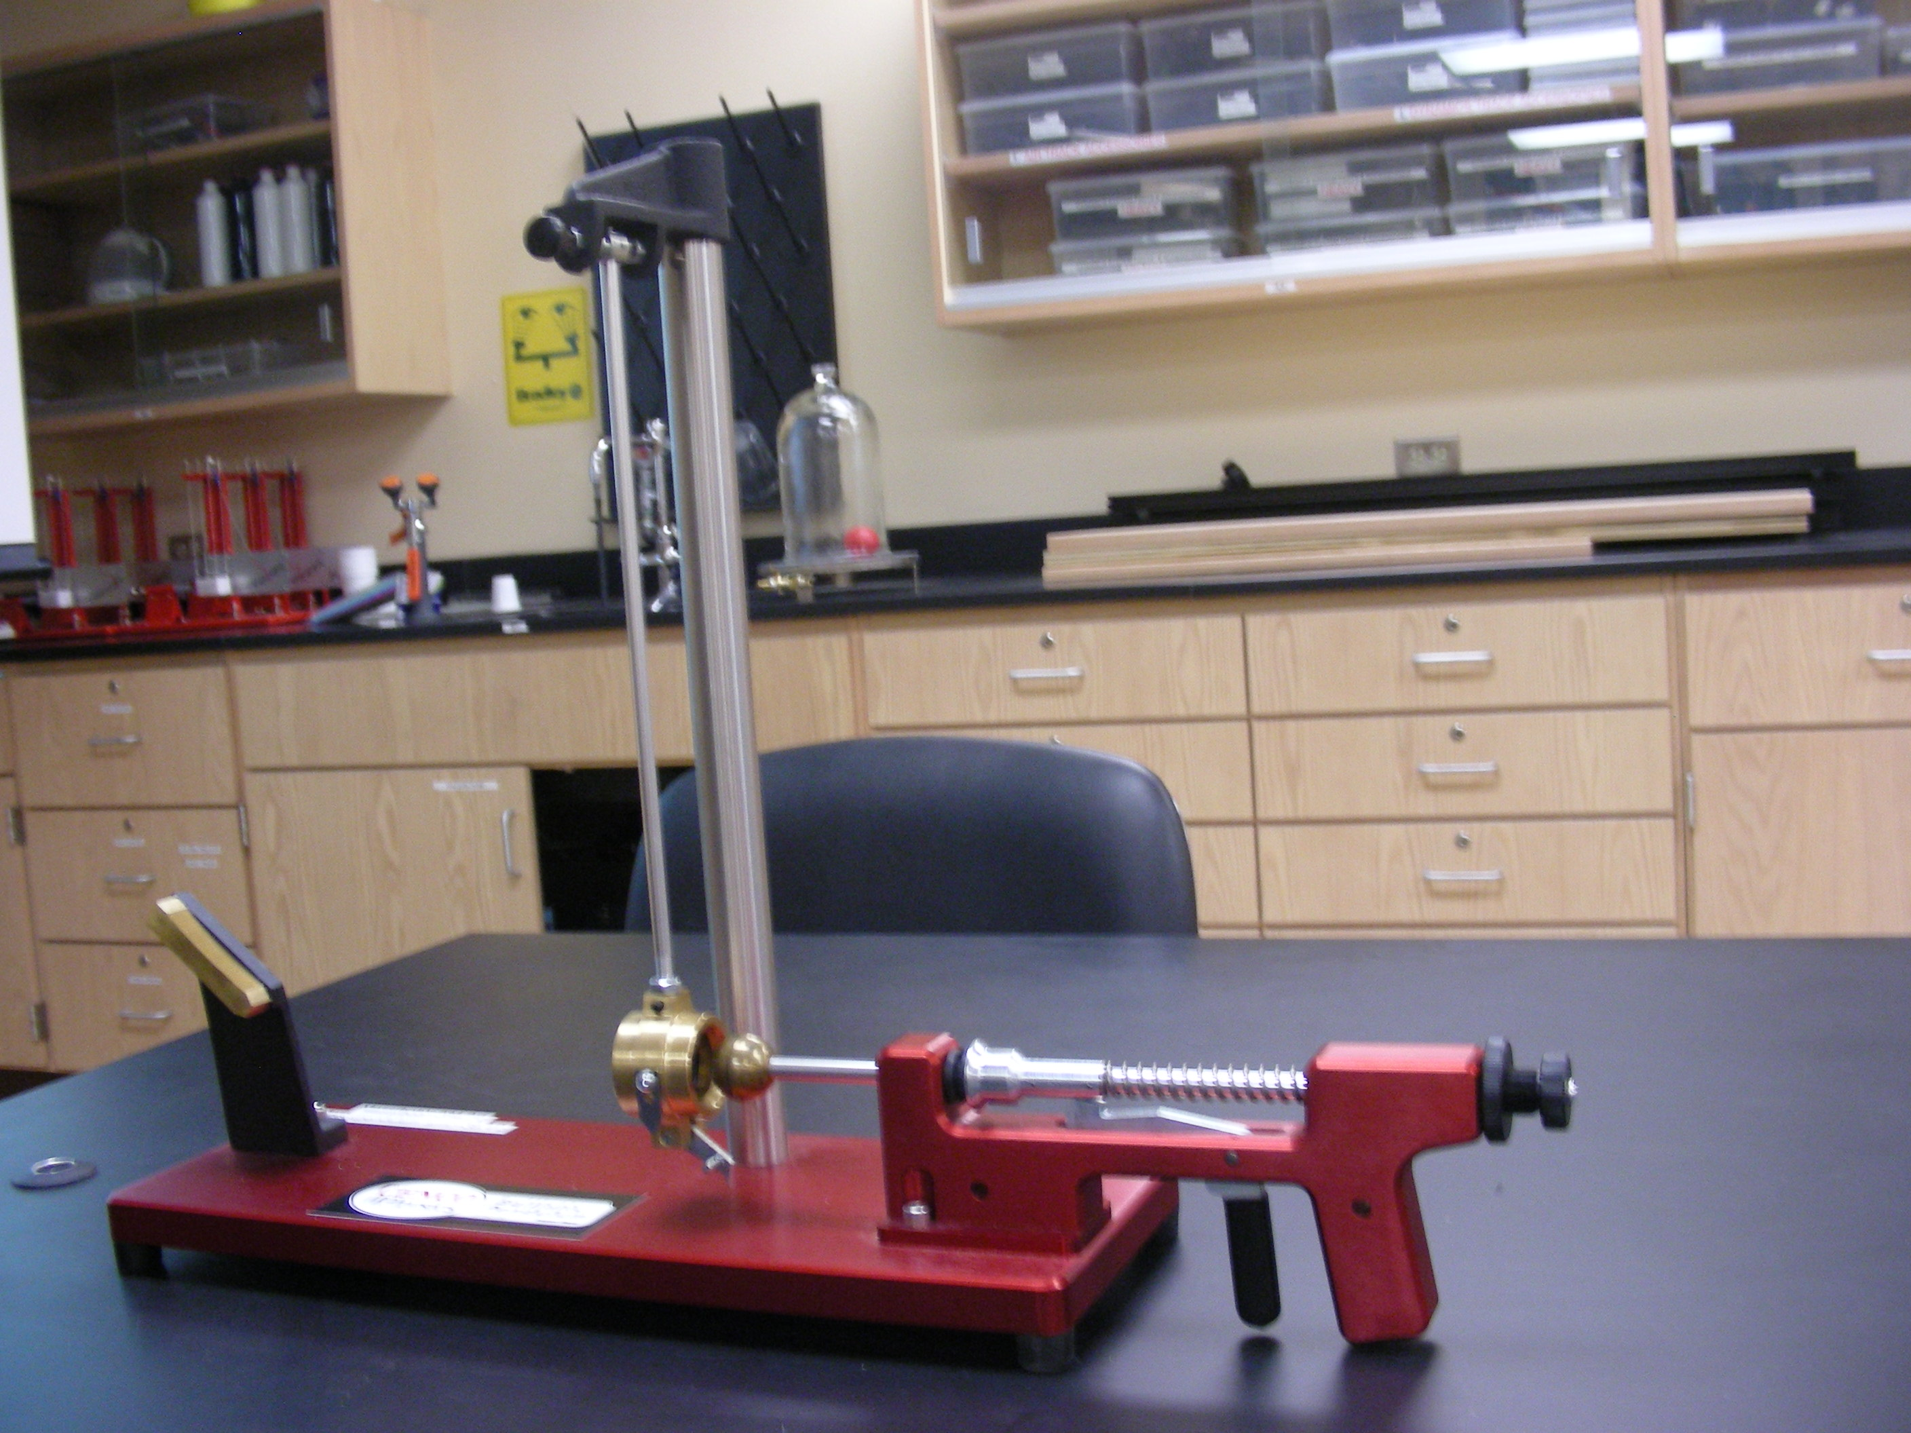

Introduction
Shows the conservation of momentum for inelastic collision as well as projectile motion.

Theory
A ball, "bullet", is projected from a spring "gun" and fired into a pendulum "bob". This collision is inelastic and the ball stays inside the "bob" of the pendulum. After the collision the remaining Kinetic Energy of the composite ball-bob is converted into potential energy of the pendulum as the ball-bob swing upward to a height, h. A ratchet mechanism prevents the ball-bob from swinging back down so that the maximum height of the pendulum can be measured. From the conservation of energy equation the velocity of the Ball-bob after the collision before it swung upward can be obtained, and that velocity can be used with the conservation of momentum to determine the initial velocity of the ball.

