Bell Jar
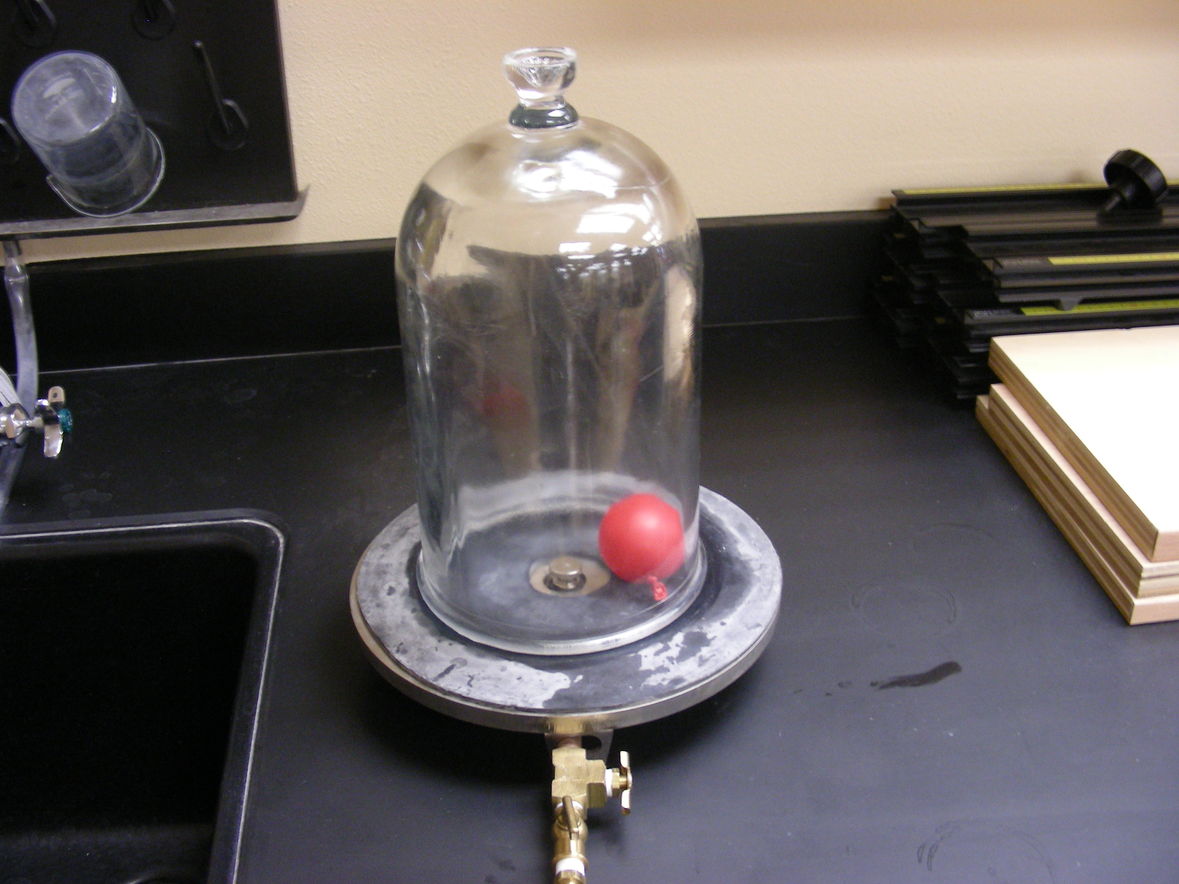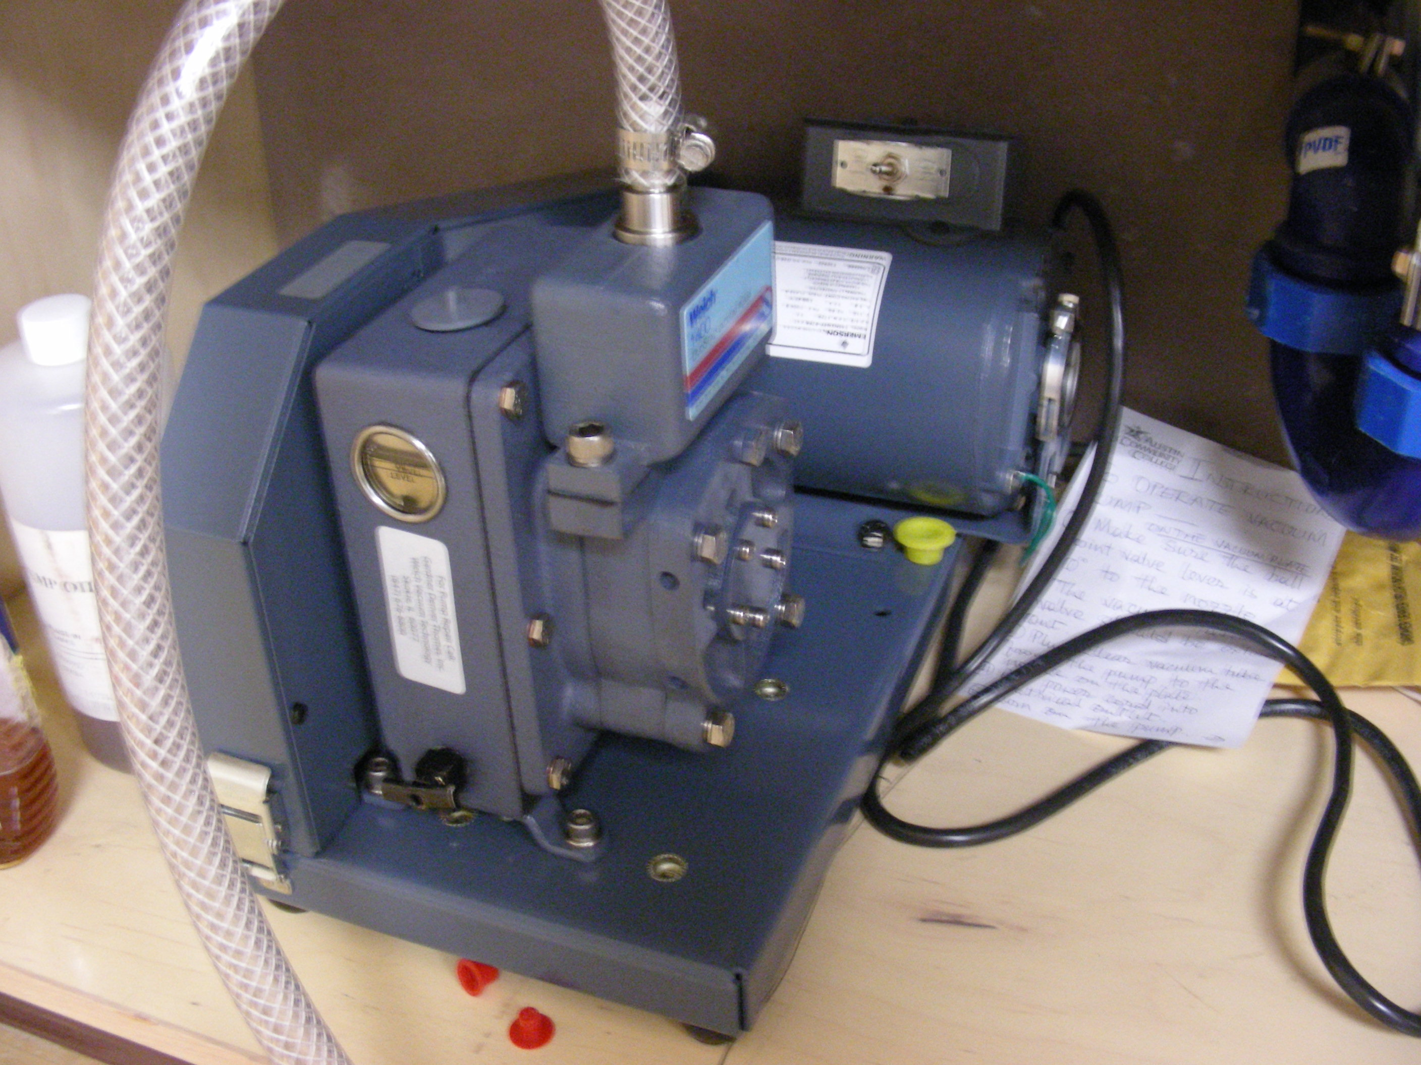
Introduction
Science of air pressure.
Theory
Vacuum the air out and watch the balloon expand. Another interesting demo is to observe water boiling at room temperature.

