Demonstration Mirrors
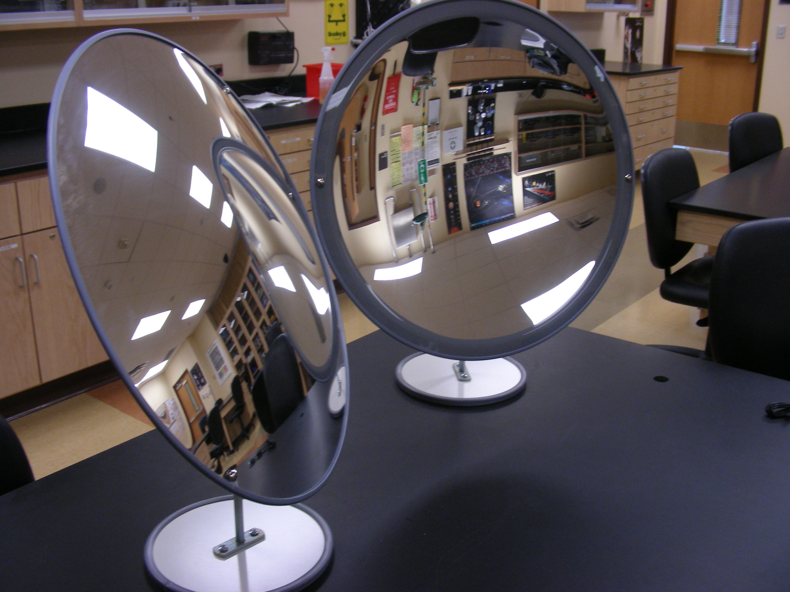
Introduction
To demonstrate the optics of convex and concave mirrors.
Theory
A convex mirror is a curved mirror in which the reflective surface bulges toward the light source. Convex mirrors reflect light outwards; therefore they are not used to focus light. Such mirrors always form a virtual image.
A concave mirror has a reflecting surface that bulges inward (away from the incident light). Concave mirrors reflect light inward to one focal point; therefore they are used to focus light. Unlike convex mirrors, concave mirrors show different image types depending on the distance between the object and the mirror.

