Digital Strobe
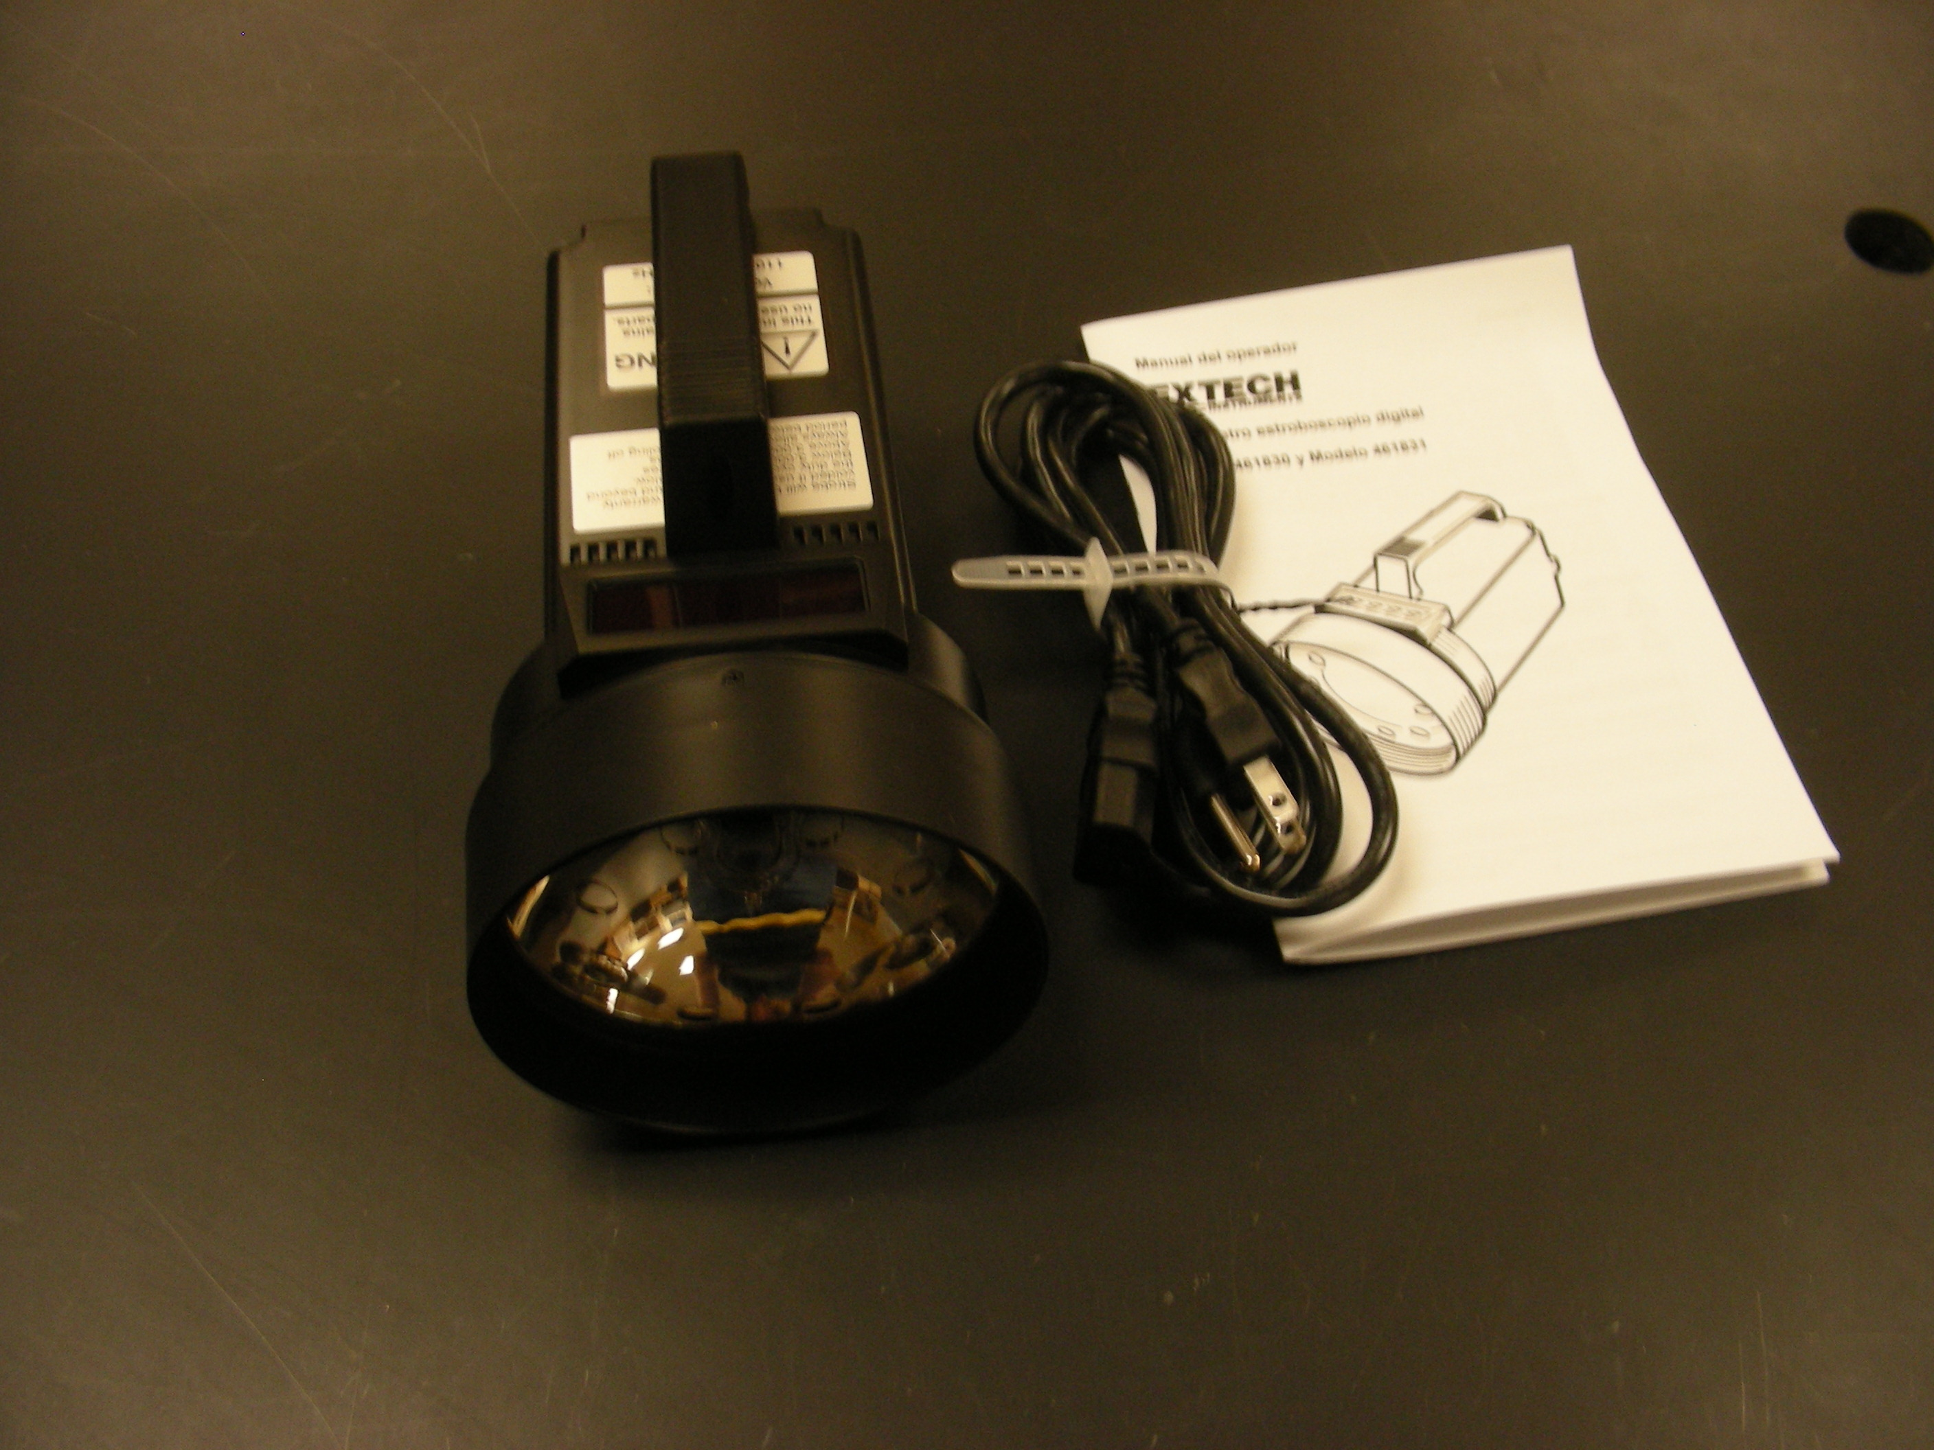
Introduction
Analyze motion and speed-simply aim and synchronize its flash rate with a rotating object.

Theory
Two or more stopped marks indicate a ‘harmonic’ measurement and the instrument will display double, triple, or quadruple the actual speed. A useful method of avoiding harmonic measurements is to adjust the FINE/COARSE knobs until two images appear and then lower the flash rate until a single, stationary image appears. This will be the actual speed.

