Electroscope with Accessories

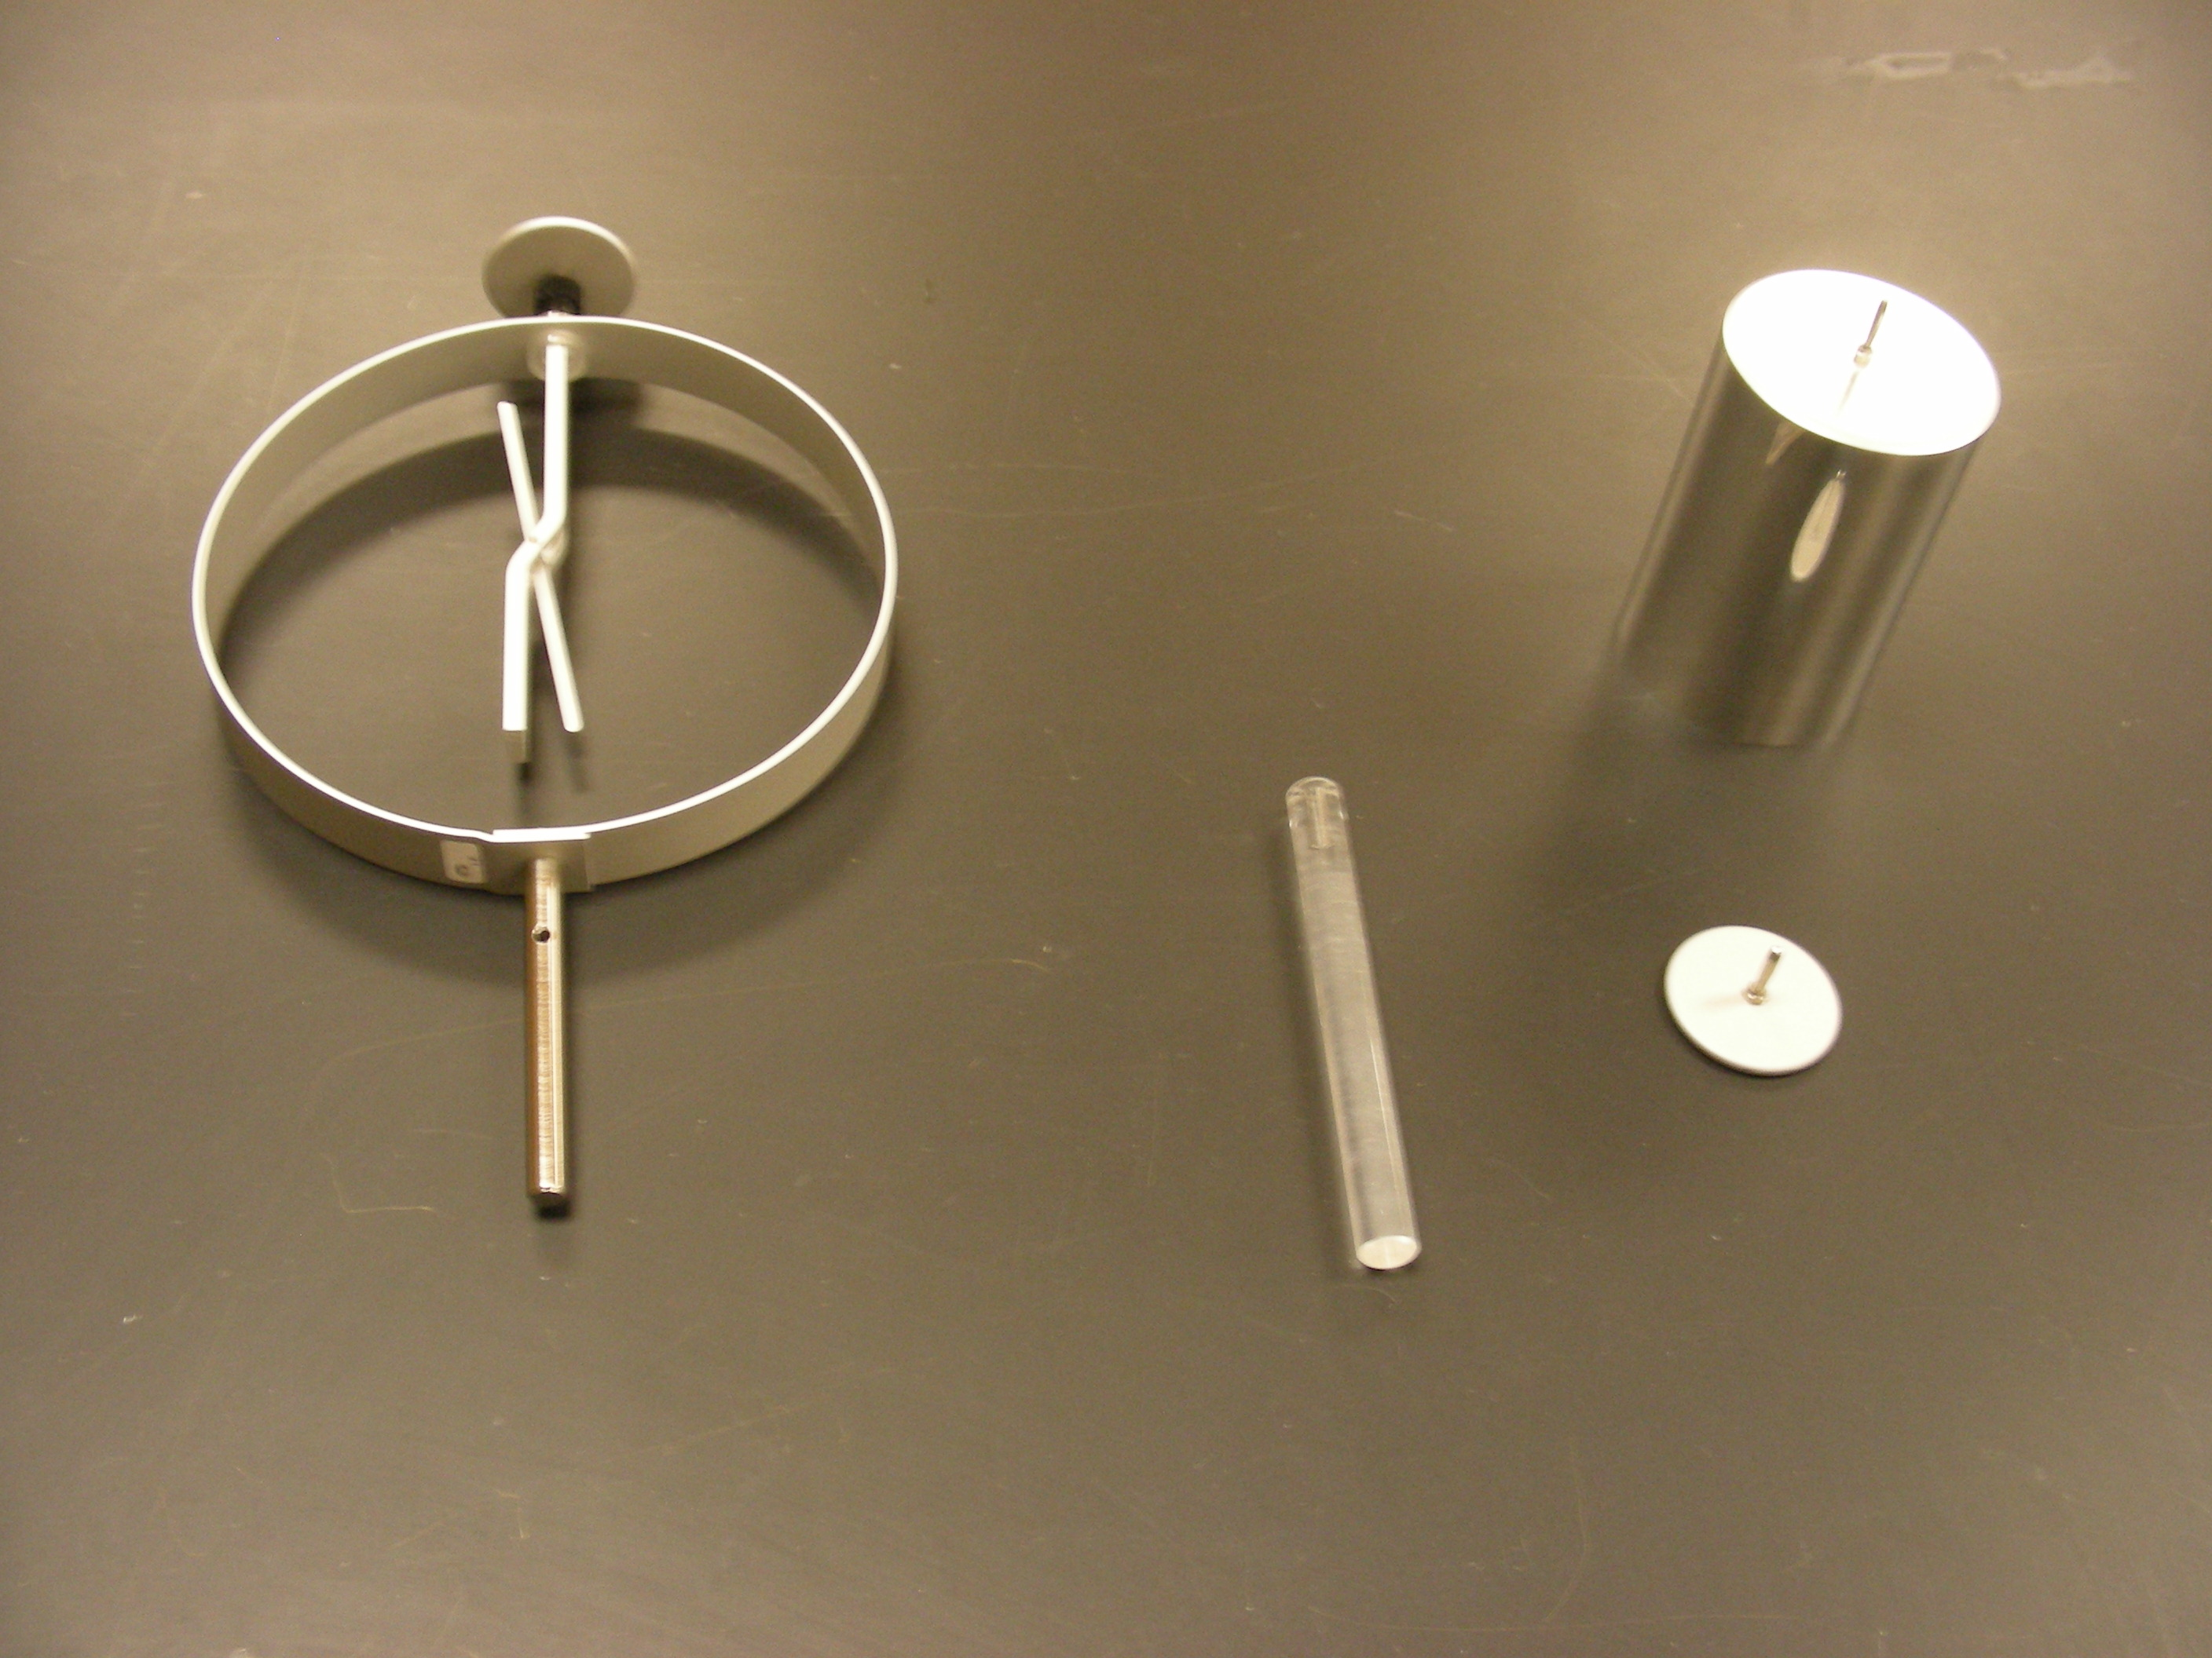

Introduction

Determine or measure the presence of electrostatic charges. The device's operation is simply based on the Coulomb Force Law.

Theory

Assume a positive-charged probe is touched to the metal disc, and then the positive charges will be induced on the surface of the metal rod and the deflection arm. Then Coulomb forces result in a repulsive force between the like positive charges. This then results in a clockwise directed torque on the deflection arm at the top and the bottom. The deflection arm is then rotated to a certain distance until the Coulomb force is in equilibrium with the gravitational force (F=mg) acting on the arm. What actually happens is that the arm goes through a simple harmonic motion, which is quickly damped out due to frictional forces, until such equilibrium is reached. Of course, the amount of deflection will be proportional in some manner to the amount of charge induced on the electroscope.

