Electrostatic System (basic)

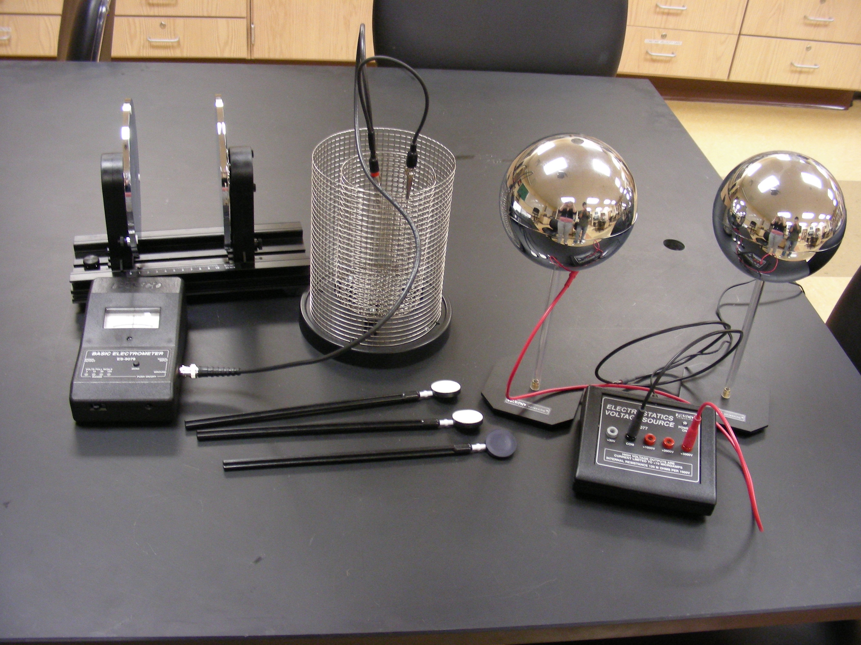

Introduction

The purpose of this demonstration is to investigate the way charge is distributed over a surface by measuring variations of charge density.

Theory

A charged surface will be sampled with a proof plane. The proof plane will then be inserted in the Faraday Ice Pail to measure the charge. By sampling different sections of the surface, the relative charge density can be observed.

