Grating Project Star
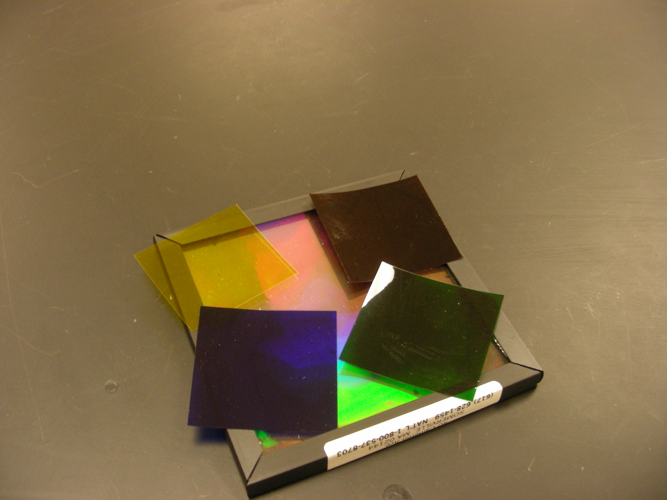
Introduction
It is used to study light and color and to produce a projected spectrum.

Theory
Use an overhead projector and a piece of holographic diffraction grating to examine the spectrum.

