High Road - Low Road
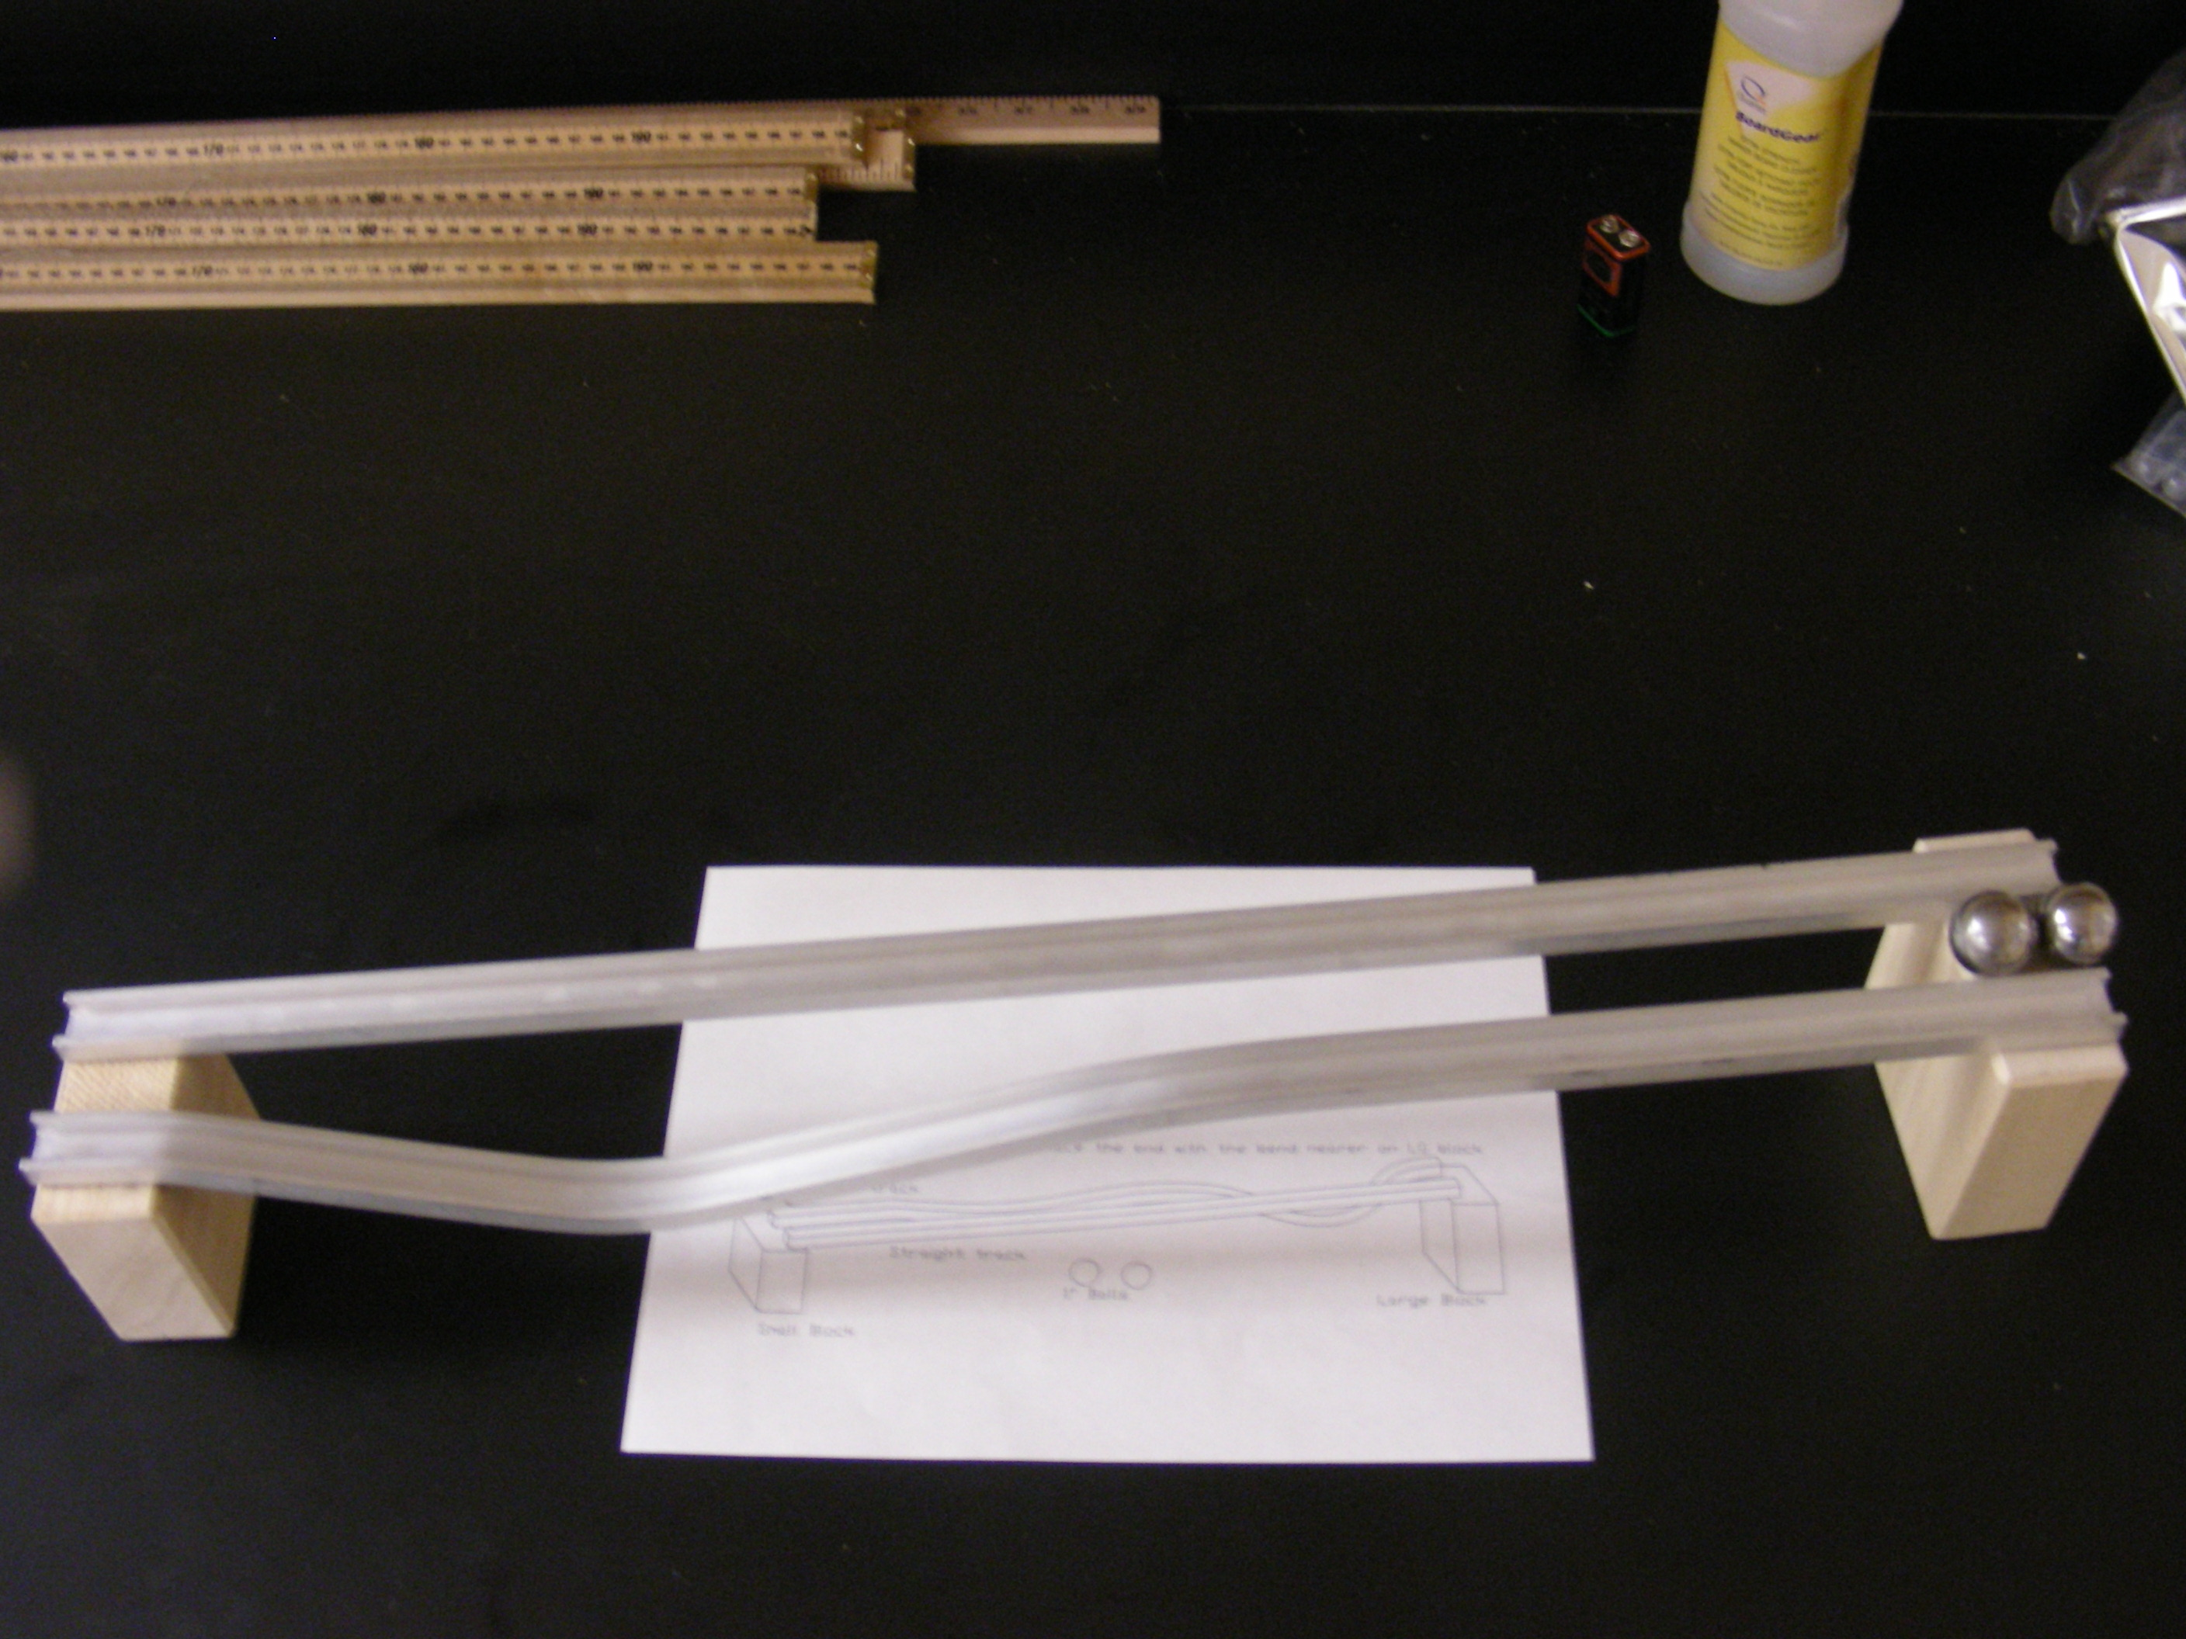
Introduction
This demonstrates that even though the low path is longer, it’s the way the object's potential energy is converted to mechanical energy that "wins the race".

Theory
Both balls begin and end at the same height. One ball travels on a low hilly path and the other on a straight incline. The ball traveling the low path converts more of its potential energy to kinetic energy. This gives it enough extra velocity to make it to the end faster even though it must travel farther.

