Magnetic Field Projectual

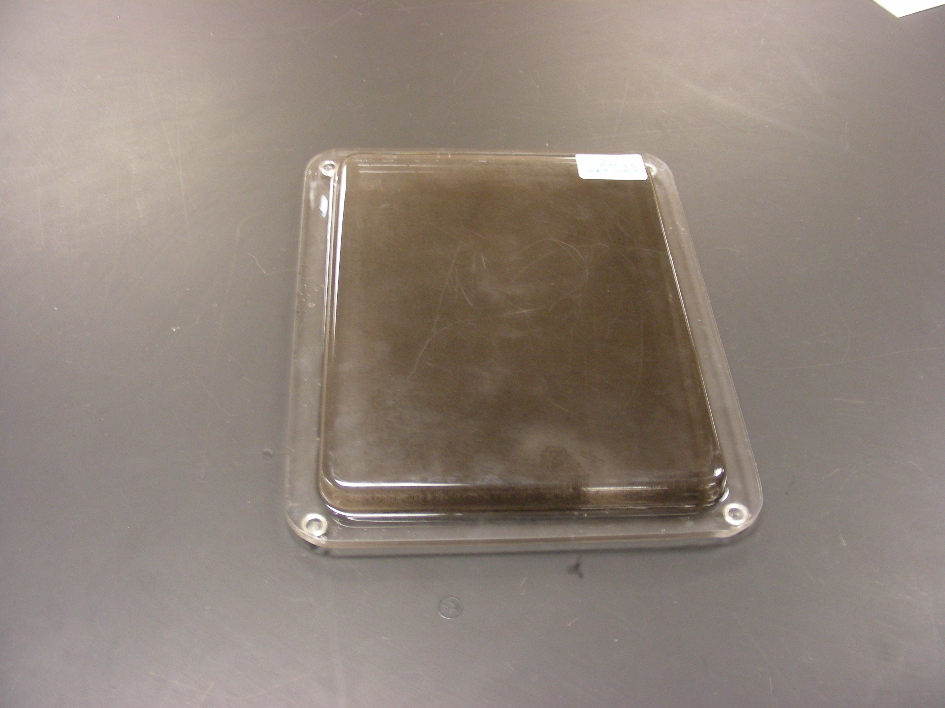

Introduction
It is used to visualize magnetic fields.

Theory
Simply place a magnet (bar magnet, horseshoe magnet, etc.) on the device, and the iron filings will move to form a pattern that shows the magnetic field of that magnet.

