The Magnetizer

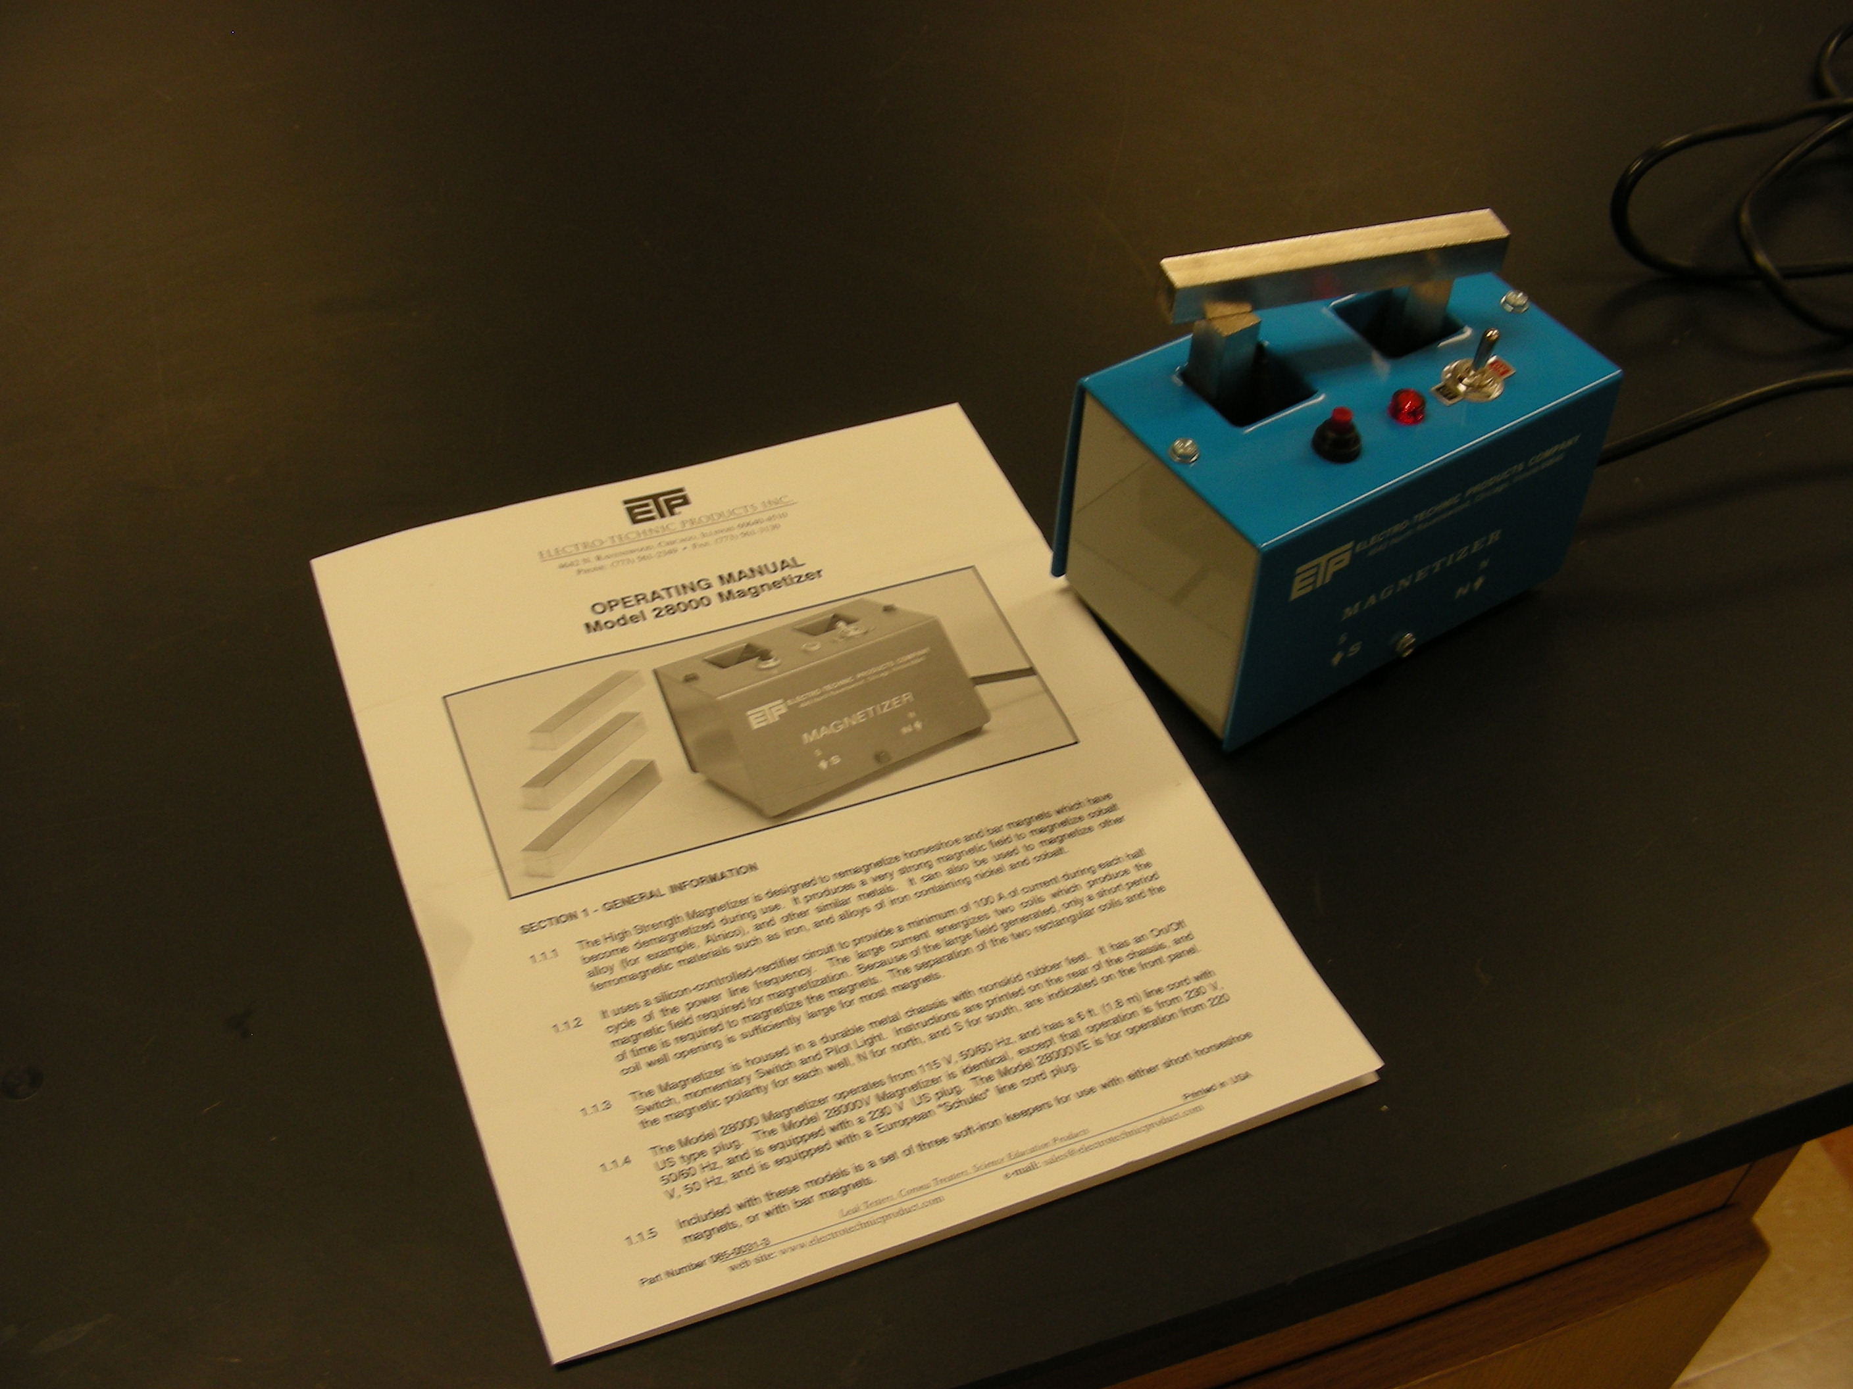

Introduction
Remagnetizes cobalt alloy and iron horseshoe and bar magnets.

Theory
Creates a magnetic field in metals at the flip of a switch. Select north or south pole, insert a metal in the 1" x 1" hole, and the metal becomes magnetized.

