Three Hole Can

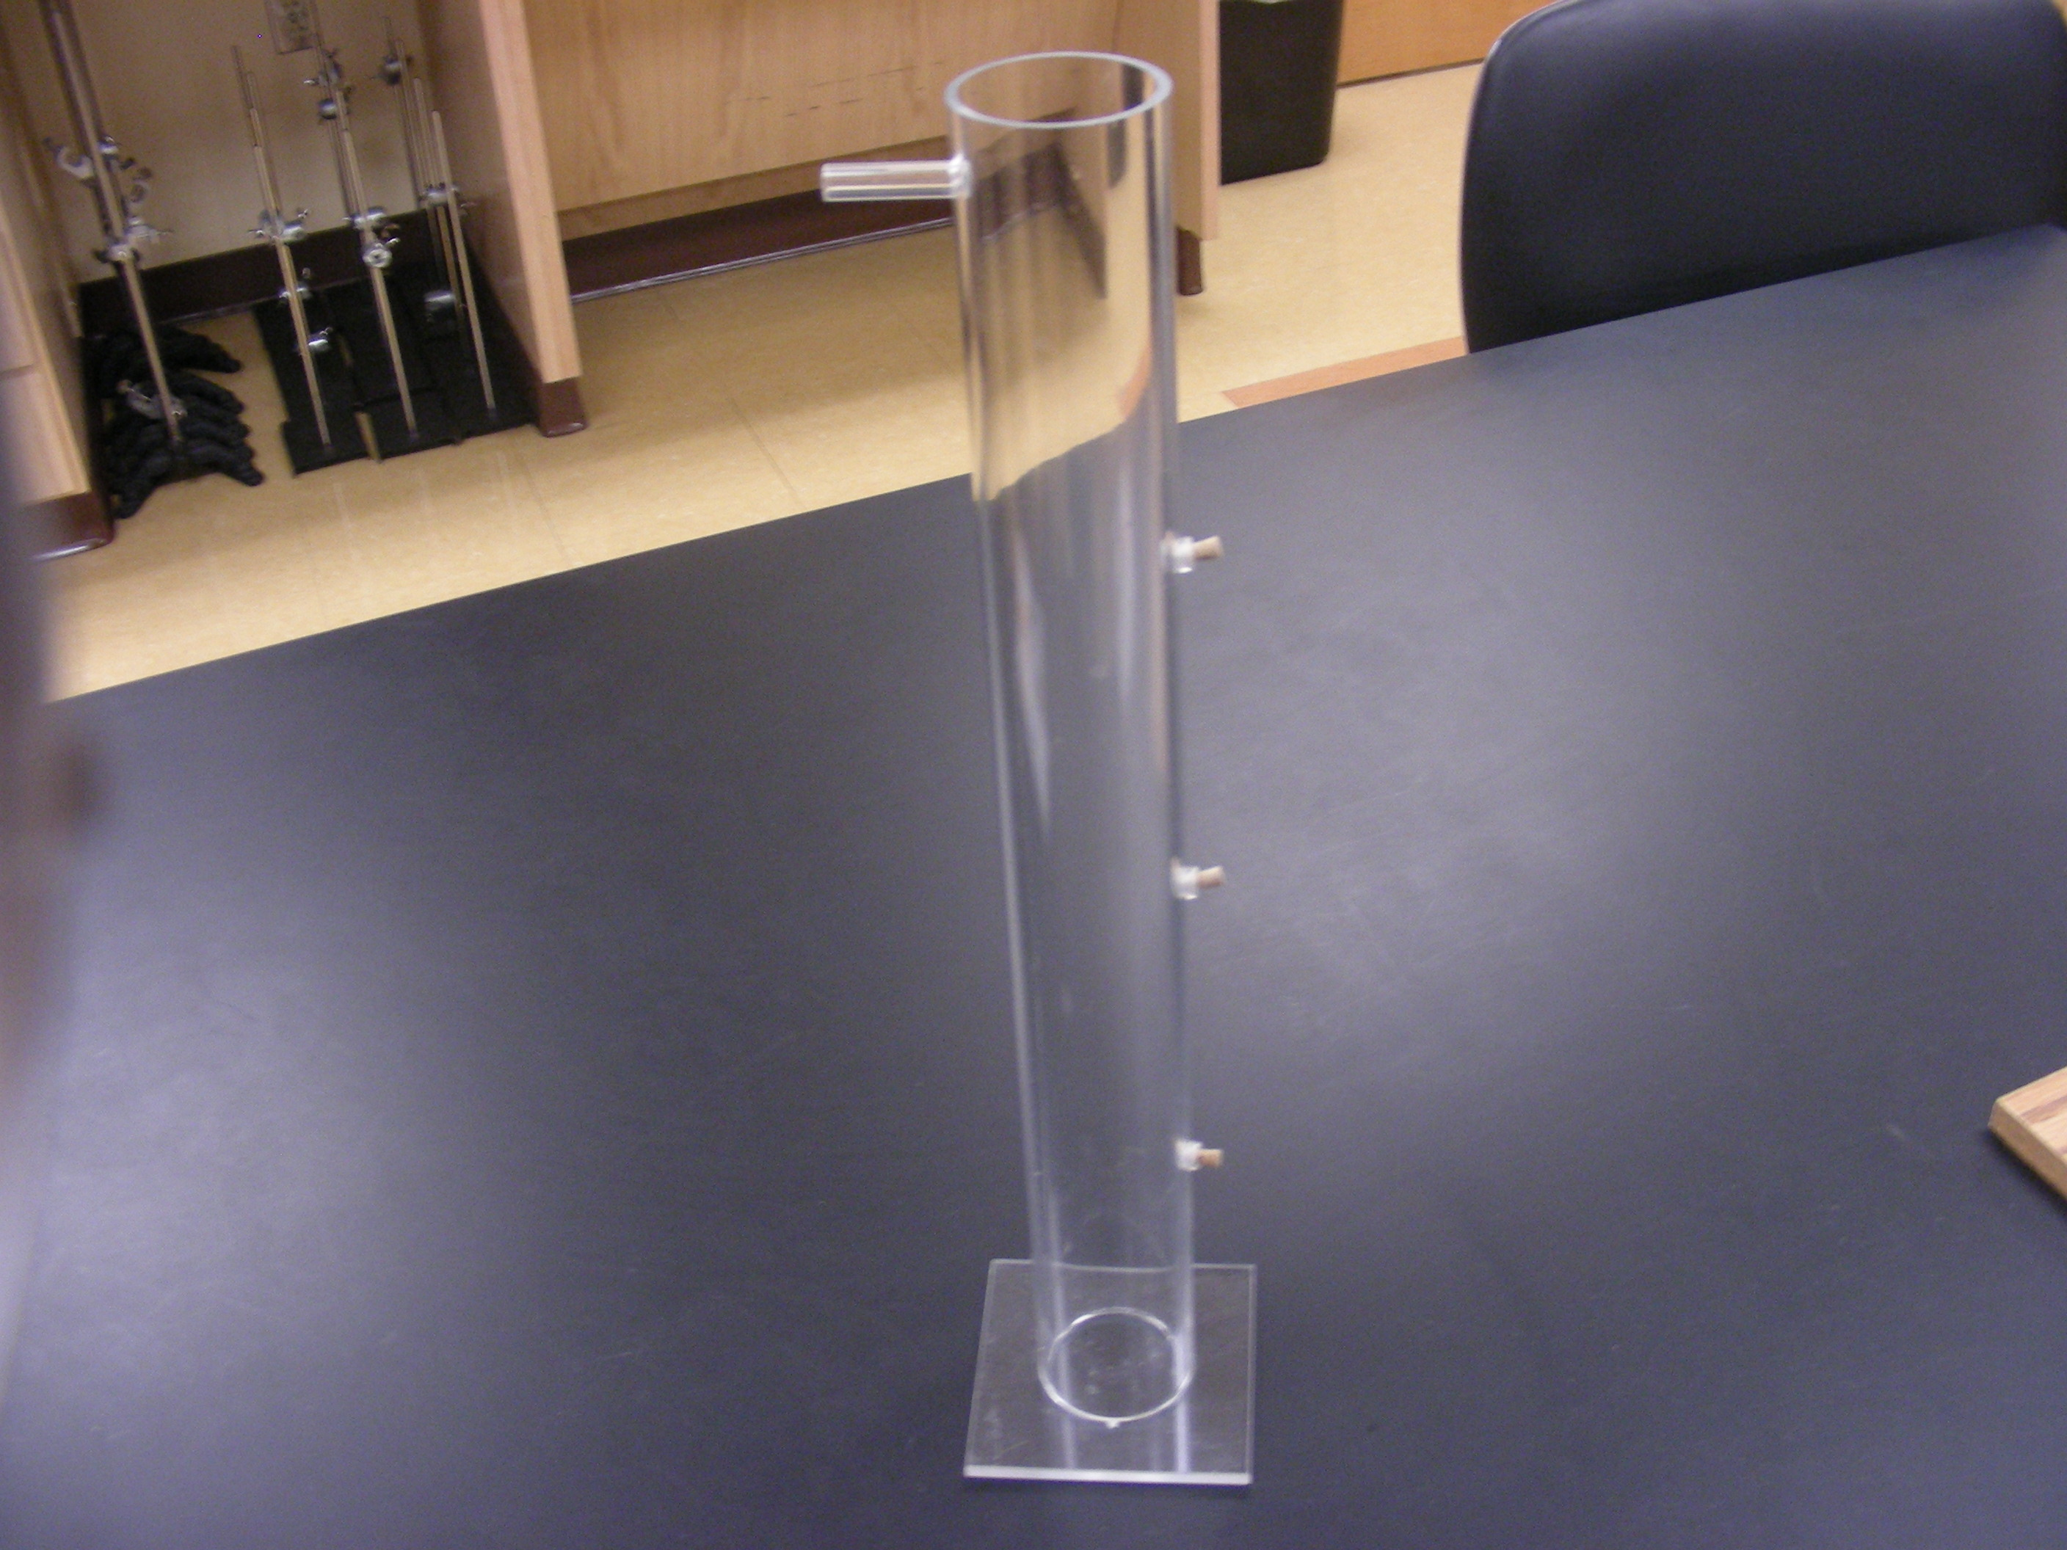

Introduction

Demonstrates the relationship between pressure and the depth of water.

Theory
Fill can to just below top. Maintain water at this height & observe difference in streams of water from the three holes.

