Name______________________ Date_____________

PHYS 1401 General Physics I
Measurement Lab

Equipment

Meter Stick
Ruler
Vernier Caliper
String
5 Cylindrical Objects
Graphical Analysis Software

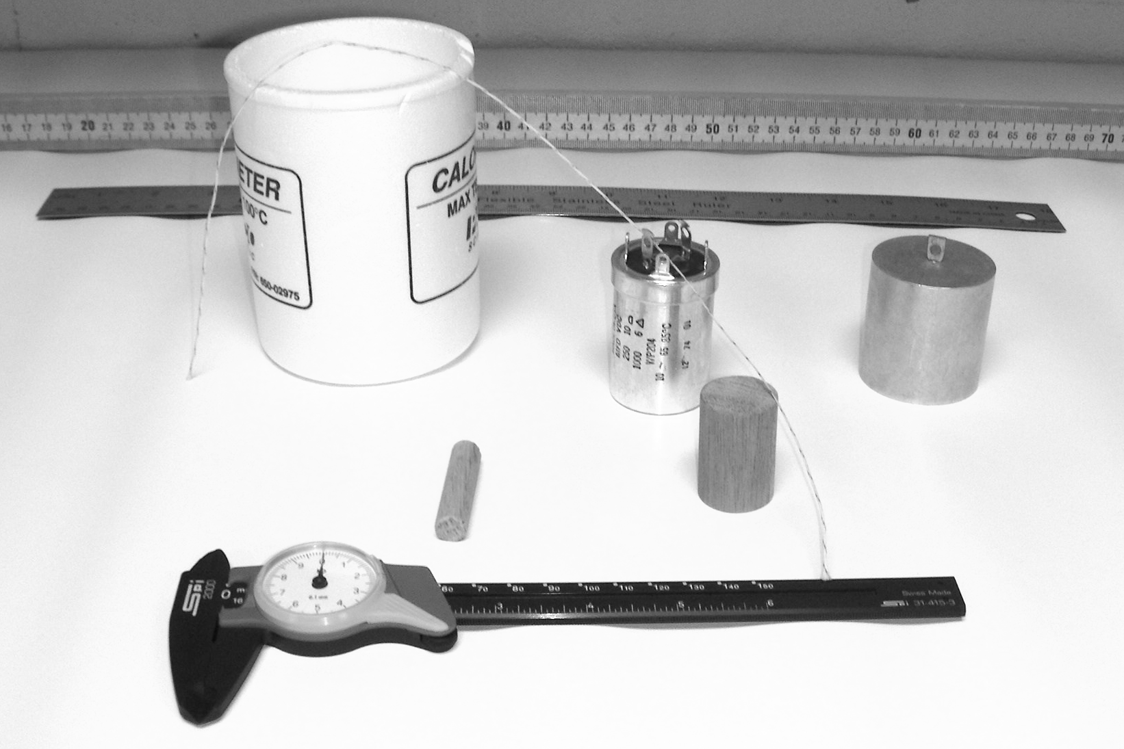

Overview
The objectives of this laboratory exercise are twofold. The first is to learn how to handle data that has been collected by making repeated measurements in order to reduce measurement error. Specifically, you are to learn the processes by which the uncertainty in the set of repeated measurements is statistically determined and investigating how the uncertainty in a calculated quantity might be obtained. The second objective is to learn how to use the Graphical Analysis program to produce a graph of your data set and to obtain both a linear regression and the uncertainty in the regression statistics.

Introduction
All measurements have associated with them an inherent uncertainty. This uncertainty can be determined according to the measuring device that was used to take the measurement in the first place or if repeated measurements have been taken then statistics may be used to determine the uncertainty in the measurement process. In this lab you will learn how to use statistics to determine the uncertainty for a repeated measurement. There will be some basic rules associated with the reporting of the uncertainty.

Rules for Uncertainties:
- The uncertainty should only have one significant digit. For example, when the standard deviation of the measurements is calculated you might obtain a value such as 0.03567 cm, this should be reported as the uncertainty in your

measurement as 0.04 cm. Since, the first significant digit is the three, but the next digit is a five so then you would round the three up to a four.
- Always round your reported result, which will be the average of the repeated measurements, to the same place as the place in which the one significant digit in the uncertainty occurs. For example, if your average were 23.672 cm then you would report your measurement as 23.67 cm, which is rounded to the hundredths place. Otherwise, it appears that your result is more (or less) accurate than indicated by the uncertainty.
- Both your measurement and your uncertainty must have units and they really should be reported with the same units. For example, your final result would be reported to be 23.67 cm ± 0.04 cm or (23.67 ± 0.04) cm. Also if your result is supposed to be reported in scientific notation, then they should both have the same power of ten based upon the result and not the uncertainty. You will move the decimal place the same way in the uncertainty as you did in the result and usually the power of ten is then factored out of the result as a common factor follows: (2.367 ± 0.004) * 10¹ cm.

Exercise #1: Measure the Length and Width of the Front Desk.

Each student will come up and measure both the length and the width of the font desk with a meter stick as accurately as possible. You should then record your value for your measurement here:

Length:_______________________ Width:___________________________

After everybody has made their measurements we will place them on the front board to generate a large sample of repeated measurements of the length and width of the front desk. You should record all of the data that was taken from the entire class on a separate piece of paper. You should then count the number of data entries that were obtained and record it here:
Number of data points N:________

We are going to perform a statistical analysis of the data set that we have just taken. The value that best represents the true length and width of the front desk is the mean or average of the data sets. The formula for the average is given by:

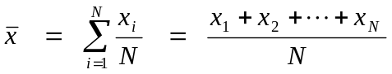

Where is the generic symbol for the average quantity and x_{i} is the generic symbol for the individual measurements. The subscript i is an index that stands for the various measurements in any order for 1 to N, the total number of measurements. We will then calculate the difference of the measurements from the average by subtracting the (x_{i} –). However this value is not very useful since the average of this quantity is nearly zero every time. So, if we square this value and then take an “average” we will get a useful number called the variance σ², but we will have to then take the square root to undo the fact that we have squared the values to begin with, this is then called the standard deviation σ. There is one technical detail that should be pointed out at this time, instead of a standard average we will be dividing by N-1 instead of N, this has to do with the fact that we are working with a sample of a population and not the entire population. The formula for the variance is as follows:

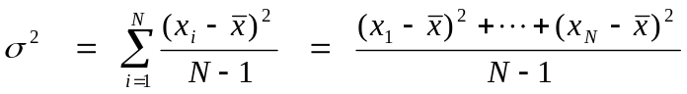

The uncertainty in the data set will be taken to be the standard deviation of the data set, which is given by:
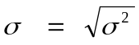

The calculations for the length and width of the table are easiest to do in a tabular form.

After you have calculated the mean values and standard deviations of the length and width of the front table, attach your sheet that shows the data set with your calculations and report your results here, both the values and uncertainties:

Length:__________________________________

Width:___________________________________

Now discuss with the members of your lab group how you would determine the area of the table. What process did you decide to use for the value of the area?

What process did you decide to use for the uncertainty in the area?

What was your final result for the area of the table, both value and uncertainty?

Area:______________________________________

List several sources of error for this portion of the lab (See the note about human error at the end of the lab!)

Exercise #2: Measurement of the Five Cylinders.

You are going to use an electronic caliper (or a Vernier caliper) and a piece of string and a ruler to measure the diameter and circumference of a set of five cylindrical objects.

Cylinder | Diameter | Circumference
1
2
3
4
5

You will enter the data that you take in the Graphical Analysis Program and produce a graph of the circumference versus the diameter of the objects. The governing equation should be C = πD you will need to learn to correctly label the axis and place units on the graph. You should also give the graph an appropriate title. I will then come around and show you how to produce a linear regression (or fit), which will draw the best fit line on the graph through your data points, and how to get the slope and intercept of the best fit line and their uncertainty. You will then turn in your completed data set and graph. You will also need to calculate a percent error in your slope value, since the slope of the line should be π. The formula for the percent error is as follows:

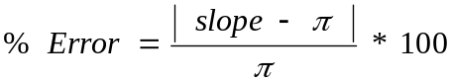

What is the value of your slope with uncertainty:______________________________
You should get this from the analysis that was done by the computer on the graph; try your best if possible to apply the rules for uncertainties in this case as well.

Is π in this range of uncertainty?_____________

What is your percent error?_____________

Note: You should only use the value of the slope from the graph and you should not try to include in any way the uncertainty in the slope when you do this calculation.

Finally you should list several reasons for possible sources of error in this portion of the lab. You should note that the pat answer of human error is not an acceptable answer, as this implies that you did the lab incorrectly and that means that you should simply rerun the lab. What are your possible sources of error for this portion of the lab?

