Name______________________ Date_____________

PHYS 1401 General Physics I

Uniform Circular Motion

Equipment

Circular motion apparatus
Triple Beam Balance
Stop watch (pink timer)
Mass set
Meter Stick

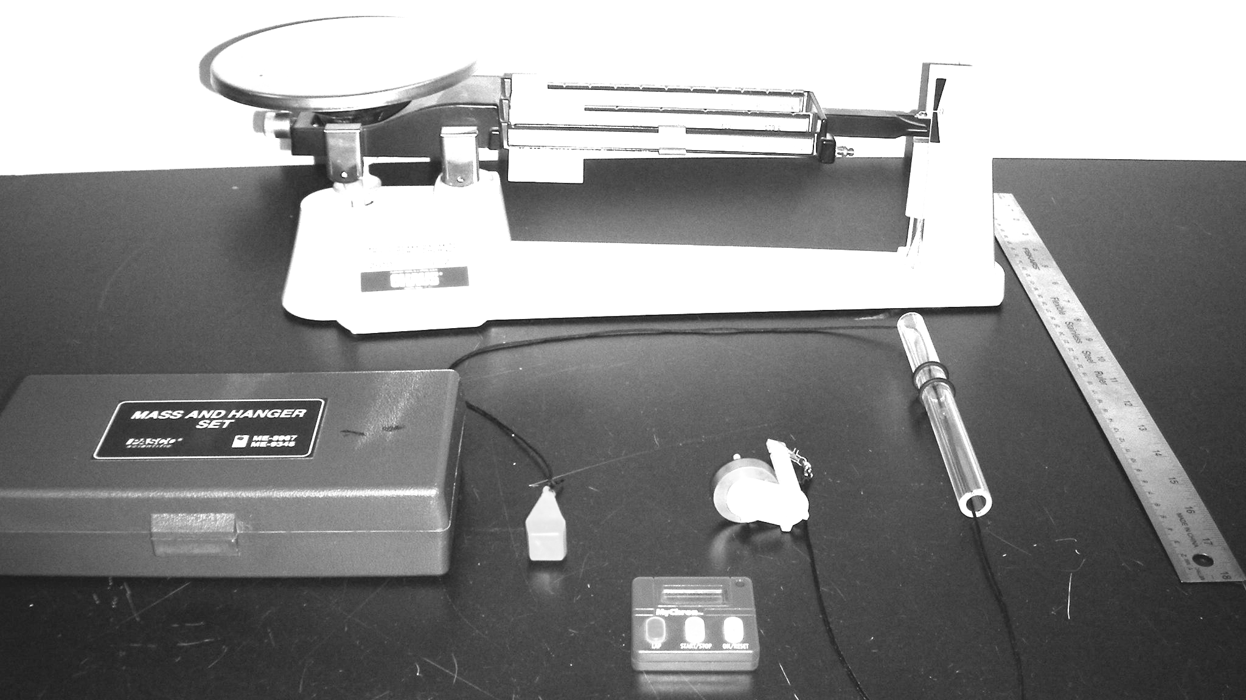

Theory
An object of mass m in uniform circular motion at constant speed v undergoes centripetal (center-seeking) acceleration because the direction of the velocity of the mass is changing at every instant along the path of the motion. The acceleration is provided by the net centripetal force acting on the mass according to Newton’s 2nd law,
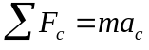
with the magnitude of the acceleration given by
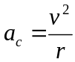
where r is the radius of the circular motion of the object. Thus, the expression for centripetal force is
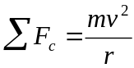
The velocity for circular motion is calculated by dividing the circumference of the circle by the period:
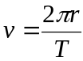
and the period is calculated as follows:
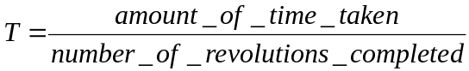

Procedure
You should measure the mass of the casting weight and enter its value in S.I. units in the correct location in the table. You should then add a 50 gram mass to the mass hanger and place the entire mass hanger on the triple beam balance to obtain its mass. Record the mass of the hanging mass in S.I. units in the correct location in the table. Carefully while holding the plexiglass tube vertically, hold the string with the mass hanger as it comes out of the bottom of the tube and begin to swing the casting weight in a circular motion above your head from the top of the tube. As you pick up speed, let go of the lower (mass hanger) string. Adjust your speed until the red bead on the string is consistently in the center of the region between the o-rings on the glass tube. Additionally, you want the circular motion of the casting weight to be as level as possible and do not touch the string or have it come in contact with you in any way. Once you have the motion of the casting weight fairly regular, go ahead and time ten revolutions of the casting weight and record this time in the correct location in the table. To do this you should begin your counting of the revolutions with 0, 1, 2, … 10, so that you end up timing ten complete revolutions and not just nine. This is the most sensitive measurement that you will make in the entire lab so repeat it three times in order to ensure that you have a consistent experimental process down and take the median time of the grouping. Recall that the median time is the middle time when they are placed in ascending or descending order. Now carefully stop the casting weight and position the string so that the red bead is centered between the two o-rings as it was during the experiment and while applying enough force to remove the slack from the line measure the radius of the circular motion of the casting weight from the center of the plexiglass tube to the line on the fattest part of the casting weight in S.I. units and record this in the table. This completes the experimental procedure for the lab. You must now complete the lab calculations and write up on the worksheet.

Names: 1. 3.
2. 4.

Uniform Circular Motion Worksheet & Data Tables

Experimental Data
Mass of the casting weight
Mass of the hanging mass
Time for 10 revolutions
Median time for 10 revolutions
Radius of the circular motion

Calculated results for the casting weight (see the THEORY section for the formulas):

Calculated Results
Period (T) of revolution for the weight
Velocity (v) of the weight
Centripetal acceleration (a_{c}) of the weight
Net centripetal force (F_{c}) on the weight | (a)

What supplies this force, or what kind of force is responsible for the centripetal acceleration? (Note: you may have to do the diagram first to answer this question)

Provide a free-body diagram of the situation (Indicate both the diagram for the hanging mass and the revolving casting weight):

Calculated results for the hanging mass (see the free-body diagram for clues):

Calculate the tension in the string: ______________________________ (b)

Compare our theoretical result for the centripetal force (a), ala the free-body diagram, with the measured dynamical value for the force (b). Since these are technically both measured we shall calculate the percent difference as follows:

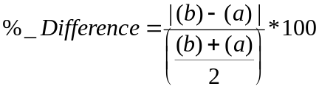

which is to say that it is the absolute value of the difference of the two values divided by the average of the values times 100. This is solely because both values in the comparison are measured.

Percent difference in net centripetal forces: _________________________

List several possible sources of error in the lab:

