Name______________________ Date_____________

PHYS 1402 General Physics II
Coulomb’s Law

Equipment

Coulomb Balance
Kilovolt Power Supply
Charging Probe
Graphical Analysis Software

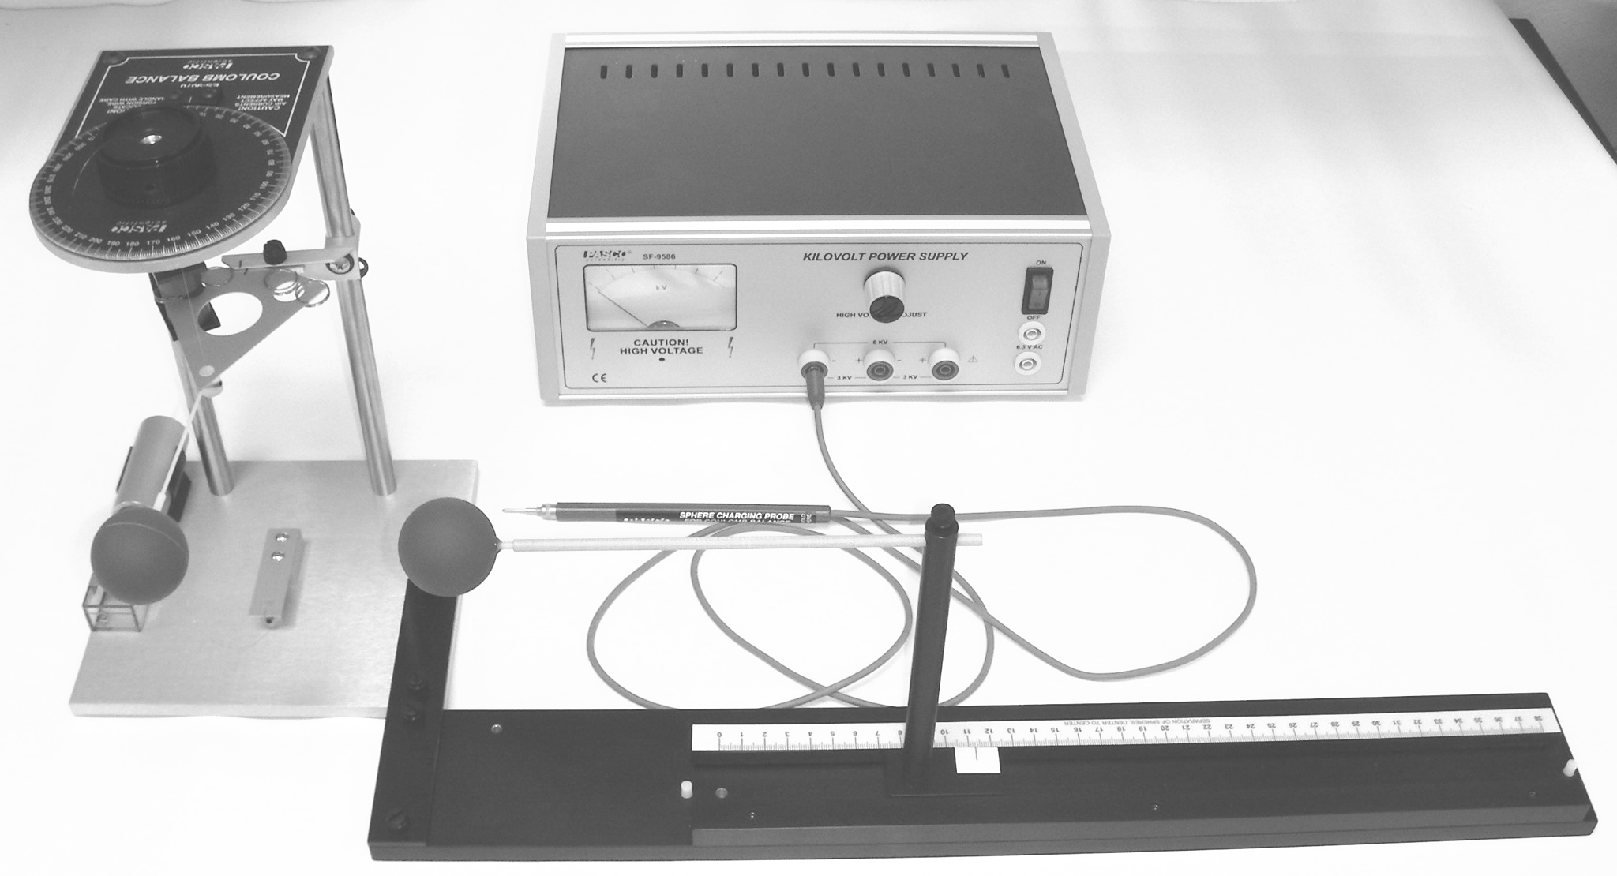

Objective
The objective of this lab is to investigate the dependence of the electrostatic force on the distance between two charged spheres.

Introduction
In this experiment we will investigate the dependence of the electrostatic force on the distance between two charged spherical conductors. The magnitude of the force between two point charges with charges 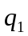 and 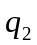, respectively, separated by a distance r is given by Coulomb’s Law as
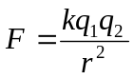.
The Coulomb constant, k, has a value of k = 8.988×10⁹ Nm²/C². In this lab, we will place the same charge on two spherical conductors and vary the distance between them. We will measure a quantity proportional to the force, the angle through which a torsional pendulum turns, as the distance is varied. Our final product will be a graph of the angle versus the distance, and we will investigate if there is an inverse square relationship between the two as expected.
The apparatus for this experiment will be a torsional pendulum. The two spheres will have equal charges of like sign. Thus, there will be a repulsive force between them. This will cause the pendulum to rotate about its axis to a new equilibrium position. The angle through which the pendulum rotates can be measured by measuring the angle required to return the torsional pendulum to its original position.
This relationship can be shown by the equation
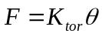,
where K_{tor} = 1.45 × 10⁻⁶ N/°θ. This value for each Coulomb Balance Apparatus is dependent on the tension of the wire but has been found experimentally to be only slightly different from one apparatus to another. It is also time consuming and tedious to produce. Thus, for a given deflection corrected to equilibrium, you can calculate the force that created it. We know that the value of k is Coulomb’s Constant and we are going to charge the pith balls in the same manner for each distance. This will give us a constant value for kq₁q₂ on each test. With this information you will be able to see that:
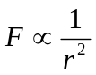 and 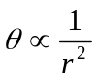.

Procedure
- Setup
The Coulomb balance apparatus should already be set-up. Gently touch both of the spheres to remove any charge. If not already done, move the angle indicator to 0˚. Zero the torsional pendulum by rotating the plastic piece holding the wire on the bottom of the apparatus until the line on the counter balance pan aligns with the index mark. Move the sliding sphere to its maximum separation from the sphere attached to the torsional pendulum.
Note: Check the slide calibration. This should be done before any data is taken. Move the slide to 3.8 cm. The balls should just touch at this point. (This is the center-to-center distance.) If this calibration is off have you instructor or the laboratory technician reset it for you. It has been set previously but can be disturbed. This is why the device numbers should match.

- Setup the high voltage power supply
Make sure that the high voltage (HV) power supply switch is in the off position, and that the adjustment knob is turned fully counter clockwise. The charging probe should be plugged into the plug labeled 6 kV on the front of the power supply. Make sure that the HV power supply is plugged in;)
Steps 3, 4, and 5 describe the data acquisition. Steps 3 and 4 need to be done carefully but rapidly one after the other to obtain good results.

- With the spheres at their maximum separation, hold the charging probe so that the tip is not touching anything or anyone, turn on the power supply and adjust the HV until the meter reads 6 kV. Touch the tip of the charging probe to each of the spheres successively for several seconds. Remove the tip, turn down the voltage and turn off the power supply.

- Measure the Torsion Angle
Move the sliding sphere so that it is at a position of 20 cm. Measure the torsion angle by turning the knob so that the pan returns to the equilibrium position. Record your results in a table with columns for the distance and the torsion angle.

- Discharge the spheres, and return them to maximum separation. Repeat steps 3 and 4 for separations of 14, 10, 9, 8, 7, 6, and 5 cm respectively.

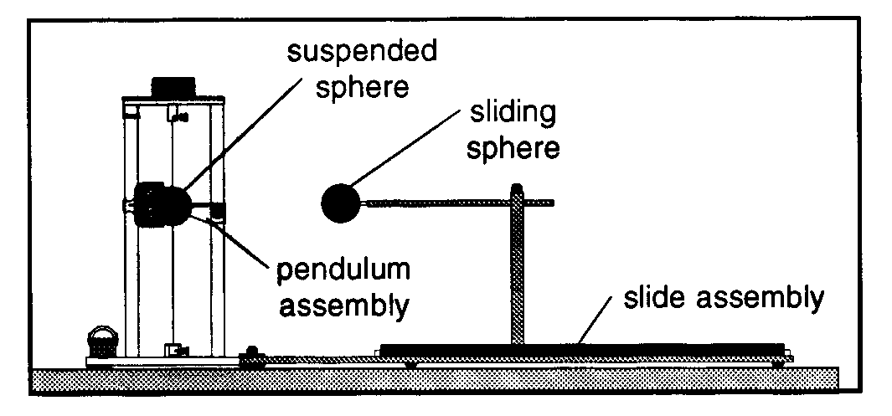
Figure 1 Schematic View
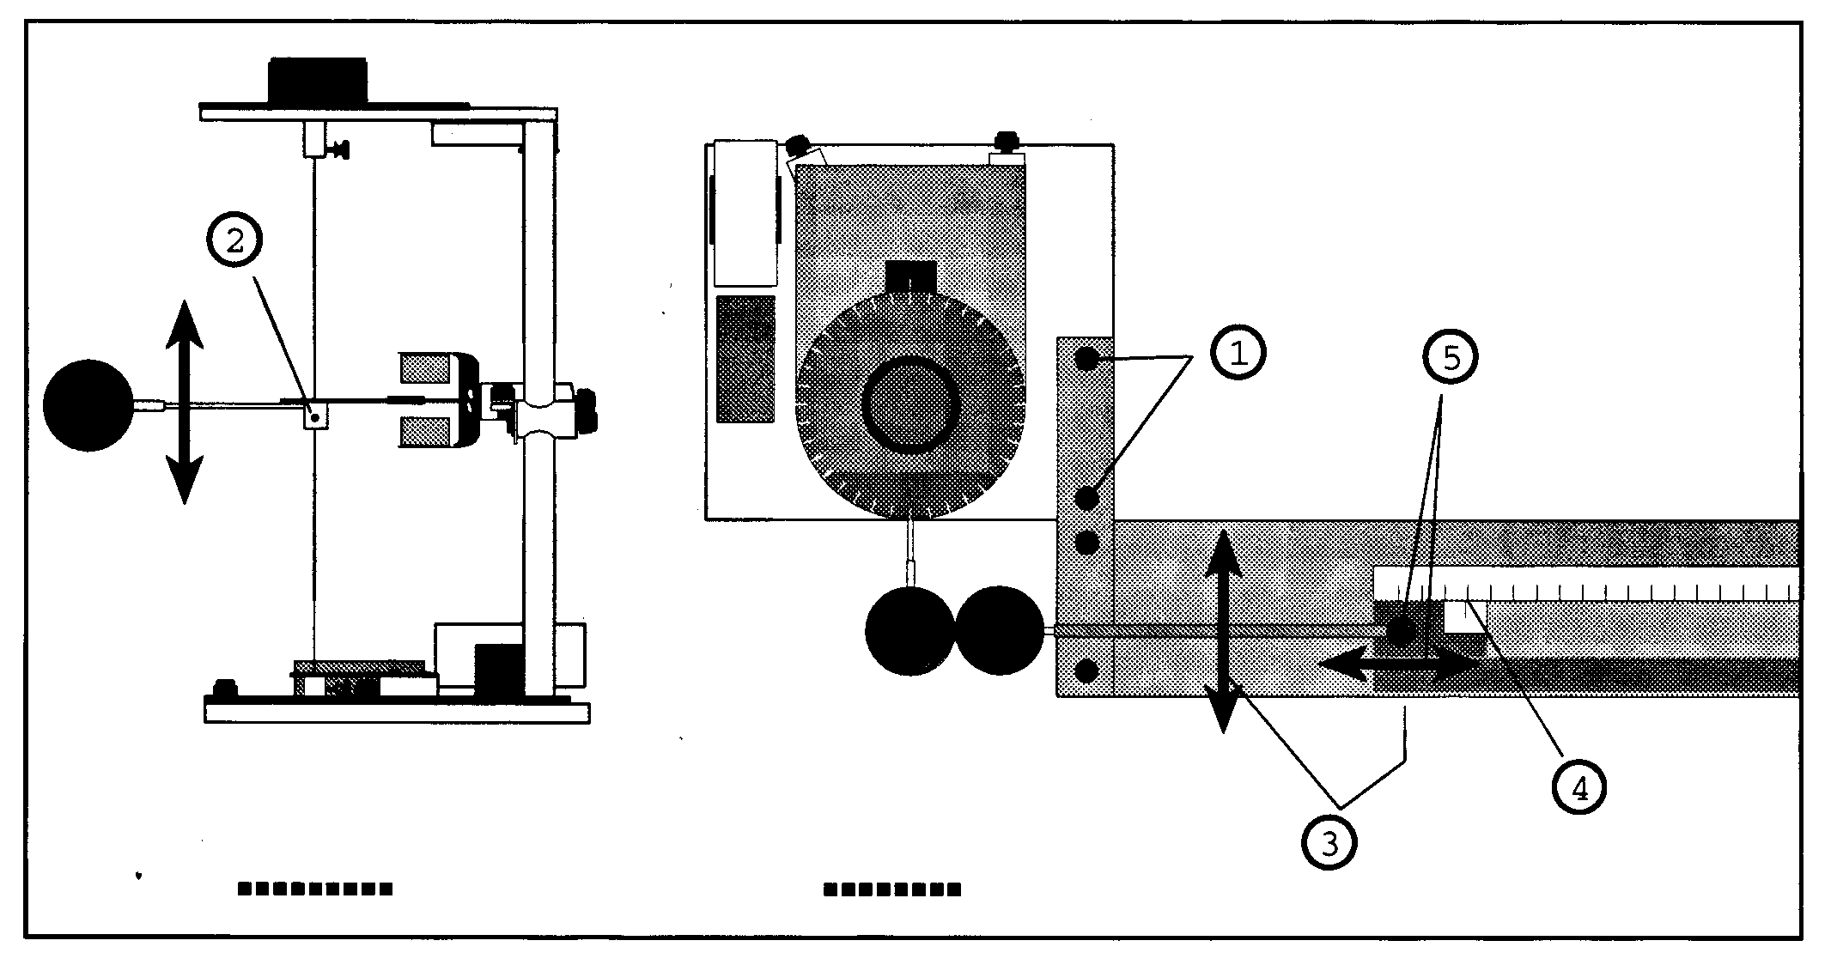
Figure 2 Sphere Alignments
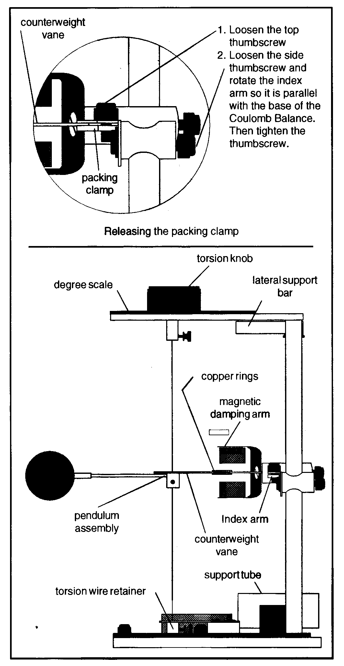
Figure 3 Setting Up the Coulomb Balance

Data

Distance (cm) | Torsion Angle (in Degrees)

20

14

10

9

8

7

6

5

Data Analysis
You can construct your graphs either by hand or with the computer.
- Construct a graph of the torsion angle versus the distance. According to Coulomb’s Law, what would you expect to be the functional dependence of θ vs. r? Does your graph seem to have this general shape?

- From your answers to the previous question, determine an appropriate way to plot your data so that you obtain a straight line. Construct your graph and find the equation of the best-fit line through your data including the uncertainty (standard deviation) of the slope. Did you obtain a good linear relationship? Does your data seem to fit better at one end of the line or the other? What assumptions have you made that might account for this?

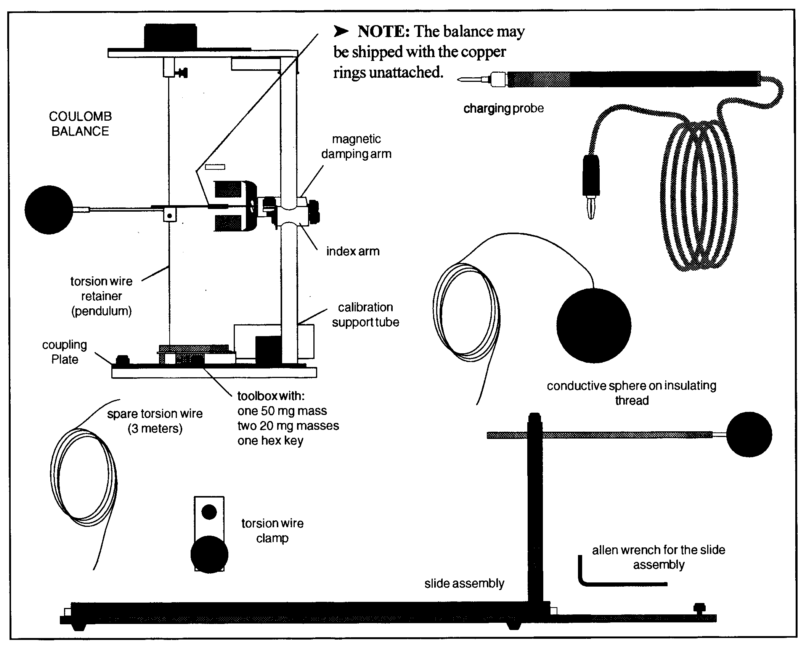
Figure 4 Parts and Accessories of the Pasco Coulomb Balance

Report Format
- Introduction. You should try to answer the following questions: What are you going to do? How are you going to do it? This section will essentially be the standard Purpose and Procedure sections that you may have encountered in other lab courses. You should succinctly tell me in 2-3 paragraphs the answer to these two questions. Note: you are not required to reproduce in detail the lab procedure, but you should give the gist of what occurred in the lab. You need to especially note if there were any differences in your actual procedure from the stated procedure in the lab. You should explain why you made these changes.
- Data & Analysis. Present your data in a neat and organized manner. Use units where necessary. Clearly outline any calculations you made showing your numbers and units. Make neat and clean graphs following the correct graphing procedures. Label fully and show on the graph any calculations that you made from the information on the graph.
- Results & Conclusions. In a paragraph or two clearly answer any questions that were given with the lab. You should report all of the major calculated values obtained through out the lab. If you were supposed to have done a percent difference then you should also state that along with the calculated value. Make sure that you address all of the issues that were originally raised in the purpose of the lab.
- Error Analysis. Indicate several possible sources of uncertainty (or error) that may have occurred during this lab. I am primarily interested in the main sources of uncertainty that arise from possible problems in the equipment, process and/or procedure performed in the lab. Note that human error is not an acceptable answer for this section. This will indicate that you performed the experiment incorrectly and you will be docked points for this answer. I am also not interested in errors that arise from mistakes in data collection, from erroneous calculations or from numeric round-off errors. I will assume that you appropriately followed instructions and correctly used your calculator, and if not then I will deduct an appropriate amount of points off of your lab report.

