Name______________________ Date_____________

PHYS 1402 General Physics II
RC Circuits: Capacitor Charge & Discharge

Equipment

Battery Eliminator (6V)
Decade Resistor Box
Banana Leads
Alligator Clips
500-2000μF Capacitors
Multimeter
Stop Watch (Pink Timer)
Computer with Graphical Analysis

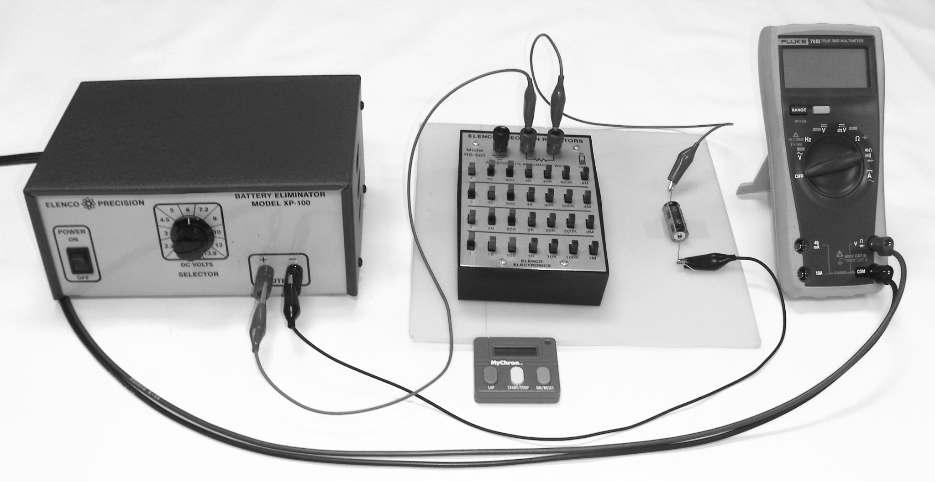

Objective
The objective of this experiment is to study the charging and discharging of a capacitor by measuring the potential difference (voltage) across the capacitor as a function of time. From these measurements the student will be able to graphically visualize the charging and discharging of a capacitor. The student will also calculate the time constant and compare it to their curve fitted value.

Theory
A capacitor consists of two conducting objects (plates) separated by a non conducting medium (dielectric). The capacitance of a capacitor is defined as the ratio of the charge on one of the conductors to the potential difference between them.
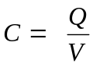

When a capacitor is connected to a power supply (battery), it begins to charge up. During this process, both the charge, Q and the potential difference, V, are increasing and the electric current is decreasing. This will continue until both Q and V reach their maximum values and the electric current goes to zero- indicating that the charging process has stopped. The characteristic time that indicates how fast or slow a capacitor charges or discharges is called the time constant. It is the time it takes the potential difference (or the charge) to increase from zero to 0.632 (or 63.2%) of its maximum value. The time constant depends on the values of capacitance and the resistance in the circuit as given by:
τ = RC
A capacitor needs 5 time constants to charge up to 0.993 (or 99.3%) of maximum value. When this happens we will assume the capacitor is fully charged.

Procedure

- Discharge your capacitor by grounding the leads.
- Measure C with your meter and record its value_________μF→ ____________F
- Discharge your capacitor again.
- Calculate the resistance needed to achieve a value of 5 time constants in 5 minutes. R_{calculated}= ___________Ω
- Set the decade resistor box to the calculated value of R, then measure it’s actual value with your ohmmeter. Now add/substract resistance on the decade box until R_{measured} is as close to R_{calculated} as possible. Record R_{measured} = ____________Ω

- Wire the circuit as shown below: NOTE: Polarity of the capacitor is important!!!

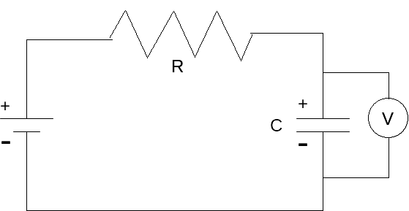

Figure 1 RC Circuit Diagram

- Set your power supply voltage to 6 volts. Record the voltage every 10 seconds in your table. When turning on the multimeter, be sure to hold down the yellow button so as to disable the Auto Shut-off feature. Turn the power supply on and start the timer. You will record while charging for 5 minutes. Upon reaching the 5 minute mark you will IMMEDIATELY switch to the discharge circuit by disconnecting the positive power supply lead and connecting it directly on top of the ground lead. Turn off the power supply. Keep recording V every 10 seconds for another 5 minutes.

Data and Analysis

- Using the Graphical Analysis software, plot V versus t for both the charging and discharging cycles on the same graph.

- Curve Fitting Click and drag the cursor across the charging phase of your graph to highlight these data points. Click the Analyze menu and select Curve Fit. In the dialog box that appears, click the “Define Function…” button. Now, fill in the “f(x)=” field with the equation describing the potential across a charging capacitor. Click “Try Fit” and then press “OK.”

Charging capacitor

Discharging capacitor

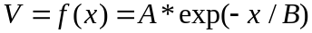

Your fit results will appear in a small box next to your curve with B representing your measured time constant, τ.

- Fit a curve to the discharging phase of your graph using the appropriate formula.

- Compare the experimental graph values for τ with your calculated time constant by calculating a percent difference for each of the charging and discharging phases.

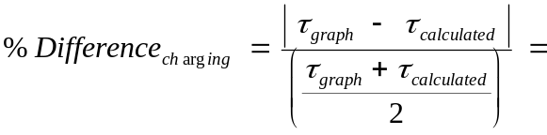

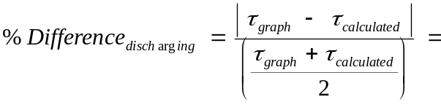

 |  | Data Table
time (s) | Voltage (V) |  | time (s) | Voltage (V)
0 |  |  | 310
10 |  |  | 320
20 |  |  | 330
30 |  |  | 340
40 |  |  | 350
50 |  |  | 360
60 |  |  | 370
70 |  |  | 380
80 |  |  | 390
90 |  |  | 400
100 |  |  | 410
110 |  |  | 420
120 |  |  | 430
130 |  |  | 440
140 |  |  | 450
150 |  |  | 460
160 |  |  | 470
170 |  |  | 480
180 |  |  | 490
190 |  |  | 500
200 |  |  | 510
210 |  |  | 520
220 |  |  | 530
230 |  |  | 540
240 |  |  | 550
250 |  |  | 560
260 |  |  | 570
270 |  |  | 580
280 |  |  | 590
290 |  |  | 600
300 |  |  | 610

