Name______________________ Date_____________

PHYS 1402 General Physics II
Resistors in Series and Parallel

Equipment

Circuit Board w/ 3 Resistors
2 Multimeters
Battery Eliminator (6V)
Connection Wires

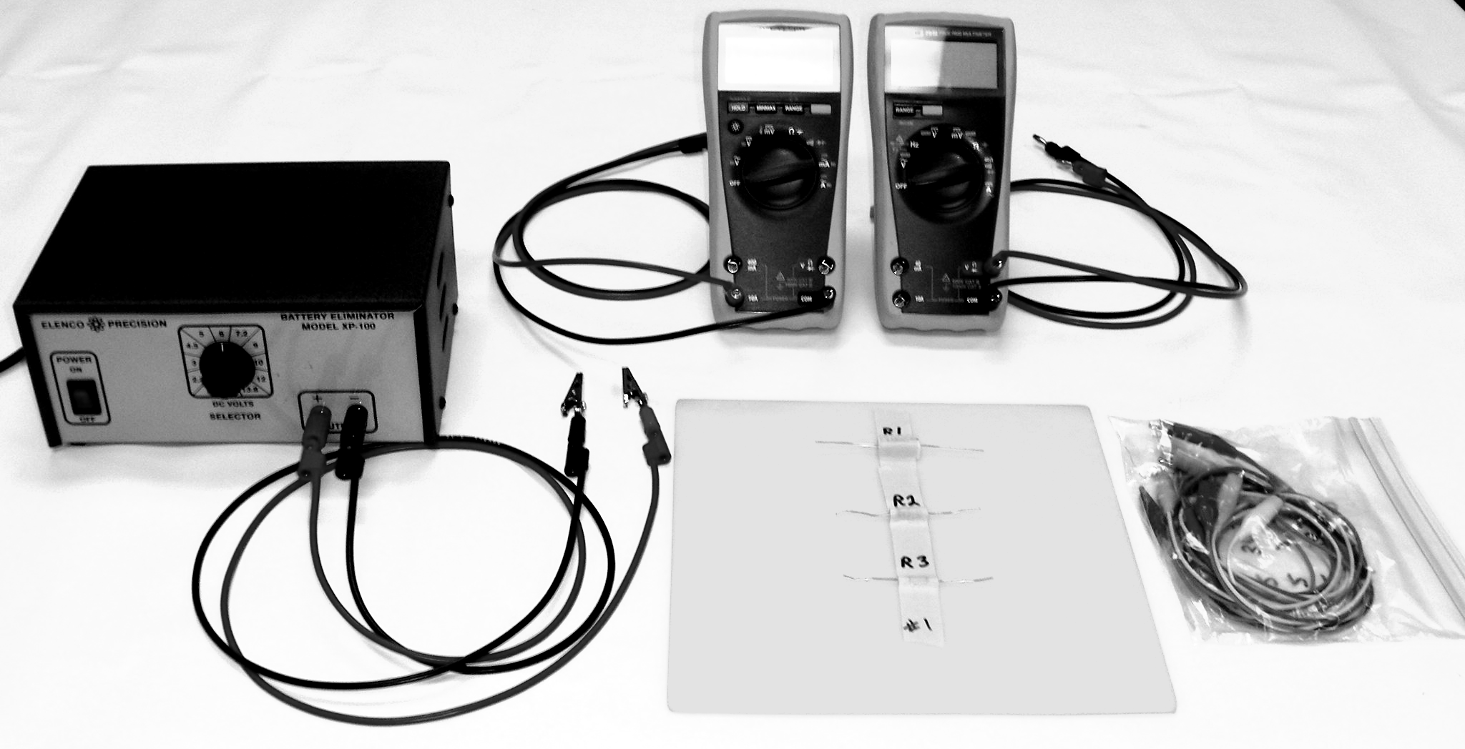

Objective
The objective of this experiment is the study of the behavior of series and parallel resistive circuits. The student will measure the equivalent resistance of resistors connected in series and parallel. Also, the student will measure currents through and potential differences across resistors connected in series and parallel. The measurements will be compared with theoretical predictions.

Theory

A. Series Circuit
A series circuit is one in which the elements (resistors and voltage source) are arranged to provide a single conducting path for current as in Figure 1.

In series circuits:
1. The current is the same at any point in the circuit since there is only a single path for
moving charges.

I_{T} = I₁ = I₂ = I₃ Formula 1 - series

where I_{T} is the current through the entire circuit and I₁, I₂, etc. represent the current
through each individual resistor.
2. From the Law of Conservation of Energy, the sum of the voltages across the resistors
should equal the voltage of the source.

V_{T} = V₁ + V₂ + V₃ + ... Formula 2 – series

where V_{T} is the voltage applied to the circuit, and V₁, V₂ etc. are the potential drops
(“voltage drops”) across the separate resistors

- The total resistance of the circuit should equal the sum of the separate resistances.

R_{T} = R₁ + R₂ + R₃ + ... Formula 3 – series

B. Parallel Circuit
A parallel circuit is one in which two or more elements (resistors and voltage source) are connected across two common points in the circuit providing separate conducting paths for current as in figure 2.

In Parallel Circuits:
1. The voltage is the same across each resistor, and is equal to the voltage of the source.

V_{T} = V₁ = V₂ = V₃ = … Formula 1 - parallel

where V_{T} is the voltage applied to the circuit, and V₁, V₂, etc. are the potential drops (“voltage drops”) across the separate resistors.

2. The current in a given path will vary inversely with the resistance (small current for
big resistance, and big current for small resistance). From the Law of Conservation
of Charge, the sum of the separate currents through each resistor will equal the total
current from the source.

I_{T} = I₁ + I₂ + I₃ + ... Formula 2 - parallel

where I_{T} is the current through the entire circuit and I₁, I₂, etc. represent the current
through each individual resistor.

3. The total resistance of a parallel circuit is less than the resistance in any one branch
of the circuit.
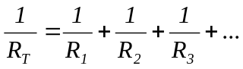 Formula 3 – parallel
where R_{T} is the total resistance in the circuit, and R₁, R₂ etc. are the resistances of each of the separate resistors.

Experimental Procedure
Procedure (1):
NOTE: in this procedure, the resistor should NOT be connected to the battery.
1. Using the ohmmeter, measure the resistance of each of the resistors and record the
values below.

R₁ = _________ Ω R₂ = _________ Ω R₃ = _________ Ω

2. Connect R₁, R₂ and R₃ in series and measure their equivalent resistance and record in
Table (1). Show sample calculations to the right of the table.
3. Connect R₁, R₂ and R₃ in parallel and measure their equivalent resistance and record
in Table (2). Show sample calculations to the right of the table.
Equivalent Resistance for
R₁, R₂ and R₃ in series
Ω
R _{equivalent Measured}
R _{equivalent Calculated}
% difference
Table (1): Series Connection Sample calculations

Equivalent Resistance for
R₁, R₂ and R₃ in parallel
Ω
R _{equivalent Measured}
R _{equivalent Calculated}
% difference
Table (2): Parallel Connection Sample calculations

Procedure (2): Series Connection
1. Connect R₁, R₂ and R₃ in series to the battery eliminator set at 6-volts as shown in Figure (1).
2. Using a voltmeter, measure the potential difference across each of the resistors and
the battery and record in Table (3). Again, do NOT forget the units.
3. Insert the ammeter at the appropriate points in the series circuit and measure the
current passing through each of these points and record in Table (3).
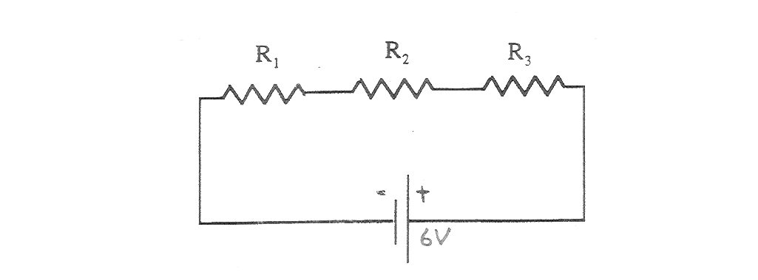
Figure 1
Procedure (3): Parallel Connection
1. Connect R₁, R₂ and R₃ in parallel to a 6-volt battery as shown in Figure(2).
2. Using a voltmeter, measure the potential difference across each of the resistors and
the battery and record in Table (4).
3. Insert the ammeter at the appropriate points in the parallel circuit and measure the current passing through each of the resistors and the current provided by the battery and record the values in Table(4).
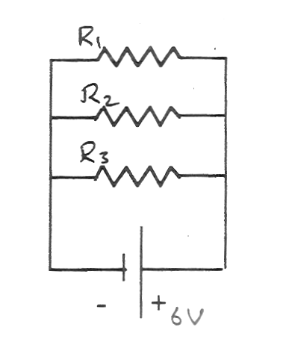
Figure 2

Data

Table (3): Series Connection
Potential Difference | Electric Current | Resistance
V_{R1 =} | I_{R1 =} | R₁ ₌ V_{R1} /I_{R1} =
V_{R2 =} | I_{R2 =} | R₂ ₌ V_{R2} /I_{R2} =
V_{R3 =} | I_{R3 =} | R₃ ₌ V_{R3} /I_{R3} =
V_{batt =} | I_{batt =} | R_{eq =} V_{batt} /I_{batt} =
V_{R1} + V_{R2} + V_{R3} =

Table (4): Parallel Connection
Potential Difference |  | Electric Current | Resistance
V_{R1 =} | I_{R1 =} |  | R₁ ₌ V_{R1} /I_{R1} =
V_{R2 =} | I_{R2 =} |  | R₂ ₌ V_{R2} /I_{R2} =
V_{R3 =} | I_{R3 =} |  | R₃ ₌ V_{R3} /I_{R3} =
V_{batt =} | I_{batt =} |  | R_{eq =} V_{batt} /I_{batt} =
 | I_{R1} + I_{R2} + I_{R3} =

Analysis
1. In the series circuit, compare the battery potential difference V_{batt} to the sum
V_{R1} + V_{R2} + V_{R3} by calculating the percent difference

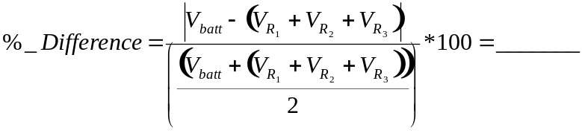

Are the two quantities within 5 % of each other? = __________

2. In the series circuit, compare the currents through the resistors. Are they within 5%
of each other? _____________

3. In the parallel circuit, compare the potential difference across each of the resistors
and the battery. Are they within 5% of each other? ___________

4. In the parallel circuit, compare I_{batt,} the total current provided by the battery, to the
sum of the currents through the three resistors I_{R1} + I_{R2} + I_{R3} by calculating the
percent difference.

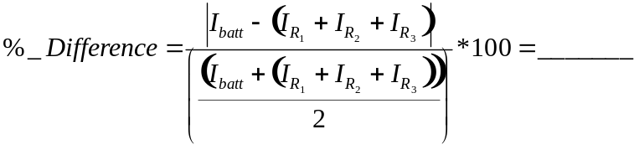

Are the two quantities within 5 % of each other? ___________
5. Using the data collected in procedures (2) and (3), apply Ohm's law to calculate the
values of the resistances and the equivalent in each of the series and parallel circuits
and enter your results in Tables(3) and (4) respectively.
Are the values for equivalent resistances in tables (3) and (4) within 5 % of the
respective measured equivalent resistances found in tables (1) and (2) ? ________

Hand In
Hand in this handout with the completed data tables and the answers to the questions. This time, you can answer the questions directly on the lab handout instead of on a separate sheet of paper.

