Charge

Equipment Needed

Friction Rod
Glass (-)
Hard Rubber (+)
PVC
Rod, Insulated w/ Metallic End
Swatch, Fur
Swatch, Silk
Lead, Alligator/Alligator
Flask Form Electroscope, Leaf Sarg.-Welch WL 1961 (2)

Note: The rods marked nylon or acrylic will also produce a negative charge. The glass may not work if humidity is very high.

Introduction
In this lab we will conduct experiments to convince ourselves that charge comes with two signs. We will make use of an electroscope in order to make qualitative measurements of charge under several conditions. In the first part of this lab, we will investigate the response of an electroscope, an instrument for measuring charge, to insulated rods with different types of charge on them. In some cases we will observe evidence of a repulsive force, and in some cases we will observe evidence of an attractive force. In the second part of the lab, we will explore a mechanism for charging the electroscope unique to conductors known as charging by induction. This method for charging the electroscope will produce oppositely charged conductors that we can use to further investigate the properties of charge.

A schematic of an electroscope is shown in Figure 1. A charged object is brought into contact with the knob at the top of the electroscope. This results in the leaves inside the electroscope being charged. Since the leaves have the same charge, they repel each other. The greater the charge applied to the electroscope, the greater the repulsion of the leaves. In principle, the electroscope could be used as a quantitative instrument for the measurement of charge. This would be an extremely difficult task, and we will simply use the electroscope as a qualitative instrument making use of the observation that the greater the deflection of the leaves, the greater the charge on the electroscope.

Figure 1 Schematic of the electroscope
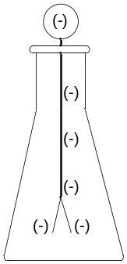

Procedure
- Charge
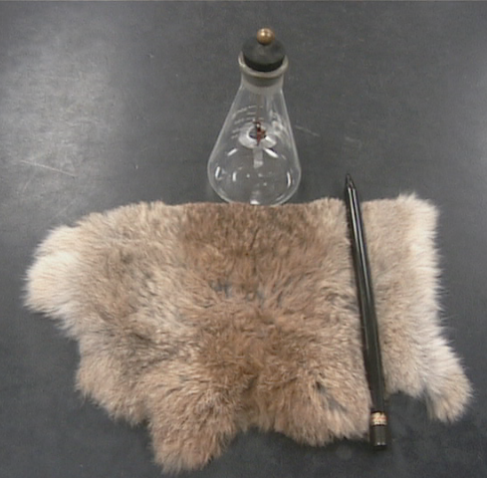
Figure 2
In the first part of this lab, we wish to demonstrate that charge occurs in two types. (See Figure 2.) Begin by rubbing your fingers on the ball on the top of the electroscope. This will remove any charge that may remain on the electroscope from previous use. Next, vigorously rub the piece of fur on the hard rubber rod. Your hand should feel some heat from the friction. This will cause a negative charge to accumulate on the rod. Bring the rod near the electroscope, but do not touch it.
  - How do the leaves of the electroscope respond?
  - How do the leaves respond when you take the rod away?
To understand these observations we need to know two things. First of all, the leaves are attached to the ball on the top of the electroscope through an aluminum rod. Thus there is a conductor from the ball to the leaves, which means that electric charge can move freely from the ball to the leaves. Second, when the rubber rod is brought near the ball, the negative charge on the rod repels the negative charge in the ball towards the leaves. Consequently the leaves both become negatively charged and repel each other.
  - Why then, do the leaves fall back down when you remove the rod?
Rub the rubber rod with the fur again to place a charge on it, and then rub the rubber rod on the ball. Repeat this process several times.
  - What happens to the leaves?
  - Do the leaves seem to deflect more each time you rub the rod on the ball?
  - Do the leaves come back together when the rod is taken away from the electroscope in this case?
  - Why does the electroscope behave differently when you touch the rod to it than when you only bring the rod near it?
Rub your fingers on the ball at the top of the electroscope.
  - What happens to the leaves and why?
At this point we have made two observations about the electroscope’s behavior. First, when a charged rod is brought near the electroscope the leaves deflect and then return when the rod is removed. Second, if the rod is rubbed on the ball of the electroscope the leaves deflect and remain deflected when the rod is removed, as in this case charge has been transferred from the rod to the electroscope.
Place a charge on the electroscope again using the same procedure you just employed. Once you have charge the electroscope, charge the rod again and bring it near the ball without touching it.
  - What happens to the leaves of the electroscope?
Rub the glass rod with the piece of silk and bring it near the ball without touching it.
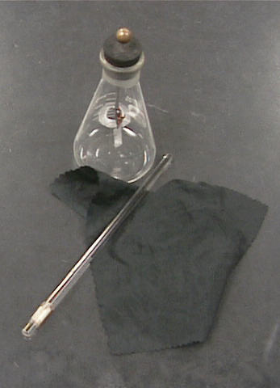
Figure 3
  - What happens to the leaves?
When the silk rubs the glass rod, negative charge is transferred from the glass rod to the silk, resulting in the glass rod having a net positive charge.
  - Explain how the glass rod being positively charged, could cause the electroscope leaves deflection to decrease when it is brought near the ball.
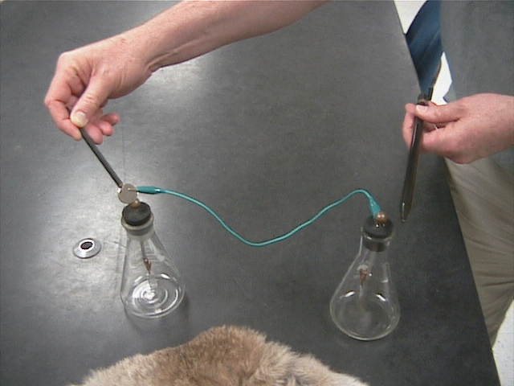
- Charging by induction
Clip one end of the alligator clip to one electroscope. Clip the other end of the alligator clip to the metallic end of the PVC rod. Connect the two electroscopes by pressing the metallic end of the PVC rod to the second electroscope. Charge the rubber rod and bring it near the knob on one of the electroscopes. Be sure to note which electroscope you brought the rod near. You should observe that the leaves in both electroscopes deflect. If not, double check that the alligator clips are making a good connection between the first electroscope and clip, the clip and metallic end, and the metallic end and the second electroscope.
While both electroscopes are showing a charge, remove the metallic end with the wire on it from the second electroscope. Avoid any contact or proximity with the second electroscope while doing the exercises. Note: You may have to recharge the electroscopes as you do the exercises.
  - Did the leaves on both of the electroscopes return to vertical after you removed the rod?
Bring a charged rubber rod near each of the electroscopes.
  - How do the leaves behave when the rod is brought near the same electroscope as previously?
  - If the rod is negatively charged, then what is the sign of the charge on the electroscope?
  - How do the leaves behave when the rod is brought near the other electroscope? Note that you may see two different behaviors in this case. The one we are interested is the first behavior shown. Observe carefully!
  - What do these two observations suggest about the signs of the charges on each of the electroscopes?
Handling one of the electroscopes by the glass part, gently bring the knobs near each other without touching them.
  - How do the leaves behave?
  - Explain how this confirms your answer to question e.
Even though the two electroscopes have opposite charges, within a given electroscope the net charge is always of the same sign so the leaves deflect.
- Conclusions from Parts 1 and 2.
  - Explain, giving specific evidence, how the series of observations you have made show that there are two types of charge.
  - Explain, giving specific evidence, how your observations demonstrate that like charges always repel.
  - Explain, giving specific evidence, how your observations demonstrate that opposite charges attract.
  - Explain why the two electroscopes in Part 2 obtained opposite charges. Charging a conductor in this manner without bringing the charged rod into contact with the conductor is called charging by induction.

