The Coulomb Balance
Sgt Welch-Cenco
Equipment Needed

Calipers, Digital Mitutoyo 500-474
Laser, HeNe ~670nm
AC Adapter, Laser HeNe
Power Supply, Pasco SF-9585A
Power Supply Cords, Pasco SF-9585A
Cloth, Backdrop, Black w/ clips
Jack, Table Silver
Ruler, 12-15in
Tape Measure, 5m Stanley 33-158
Mass Set, Fractional Ohaus 292-01
Meter stick
Ring stand, 135 cm w/ Meter Stick
Box, Air Shield Coulomb Balance
Coulomb Balance, Sgt.W. 2353A
Lead, Custom Banana/Banana (3)
Resistance Decade Box, TENMA 72-7270

Figure 1 – Physical Layout of Setup.

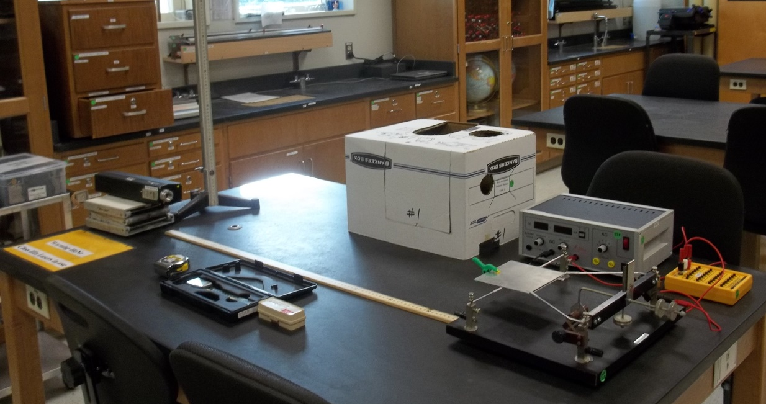

Introduction
In this experiment we will measure the force of electrostatic attraction between two oppositely charged plates. We will then use the measured force to determine the permittivity of free space, . Our apparatus is shown in Figure 1 with a schematic in Figure 2. It consists of two parallel plates a small distance apart, and aligned over each other. The lower plate is fixed and the upper plate rotates freely on knife edges. Counter weights attached to the bar supporting the upper plate allow us to hold the upper plate a small distance from the lower plate. Opposite charges are placed on the two plates by connecting them to opposite terminals of a high voltage power supply, and by establishing a potential difference between the plates. This will establish an attractive force between the two plates.

Figure 2 Schematic Layout of Setup
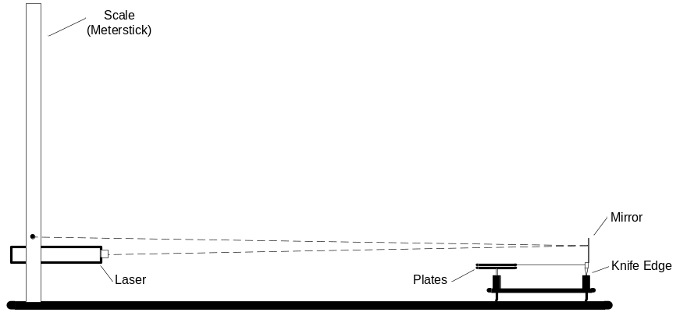

We can easily find an expression for the force between the two plates if we remember three things.
First, we can find the force on a charged object given the electric field by
.
Second the magnitude of the electric field of a uniformly charged infinite plate is
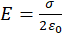, where
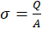 is the area charge density.
Third, the potential difference between the plates is related to the field by
, where
d is the spacing between the plates.
We calculate the force between the two plates by multiplying the electric field on the one plate by the charge on the second.
This gives
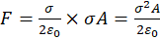.
The potential difference between the two plates is given by
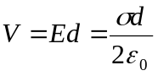.
We can solve this last expression for the charge density , yielding
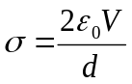.
If we substitute this expression for the charge density in the result for the force, we obtain
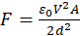 (Equation 1).
Clearly from this last expression we see that if we measure the force between the two plates, along with the area of the plates, the potential difference between them, and the spacing between the plates, then we will be able to find the value of the fundamental constant, 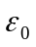.
Determining the potential difference between the plates and the area of the plates is very straightforward. The more difficult part of this experiment is to measure the spacing between the plates and the force on the plates. The apparatus that we will use here will make use of an optical lever to allow us to measure these two quantities. An optical lever, shown schematically in Figure 3, consists of a laser, a mirror, and a scale to detect the position of the laser beam. The mirror in this case is attached to the support of the upper plate in the Coulomb balance. When the balance is deflected through an angle θ, the mirror is also tilted by the same angle θ. Consequently, the beam will be deflected through an angle 2θ. We will provide a known force to the plates by applying a known weight and determine the deflection of the plates. Then when we apply a potential difference to the plates if we increase the potential until we obtain the same deflection, we have the same force on the plates. This is the manner in which we will determine the force between the plates.

Figure 3 Schematic of the optical lever
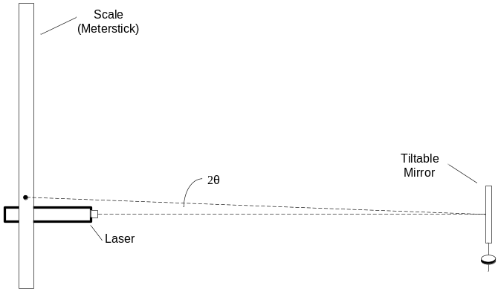
To determine distance between the plates, we will use the geometry shown in Figure 3. When the plates open a distance d, then the angle θ is given by 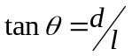, where l is the perpendicular distance from the center of the plates to the knife edge. Thus 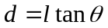. A point to note here is that the plates won’t actually be parallel. We will make the approximation that they are, and that the spacing between the plates equals the spacing between the center of the plates. As long as d is not too large (d/l<<1), this will be a good approximation. To determine the angle θ, we use 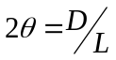. Putting these results together we obtain
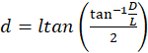 (Equation 2)
As long as θ<<l, we can simplify this expression as
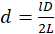. (Simplified Equation 2)

Procedure
- Set up
Begin by setting up the apparatus shown in Figure 1. The laser should be placed on a table jack so that the beam hits approximately the center of the mirror. Also you should point the laser horizontally (nominal) so that the reflected beam will return at an appropriate angle. The laser should be as close to the scale as practical.
- Adjust the counter weight on the back of the support bar so that the upper plate rests several millimeters (as close as you can) above the lower plate.
Note: This is extremely difficult to do. If the plates are not parallel, ask your instructor or lab technician for help with this adjustment. The plates are extremely fragile (and ridiculously expensive). Sometimes 2 mm is not attainable but you should attempt to get the plates as close together as possible without touching.
Figure 3 Geometry for the determination of the plate spacing d
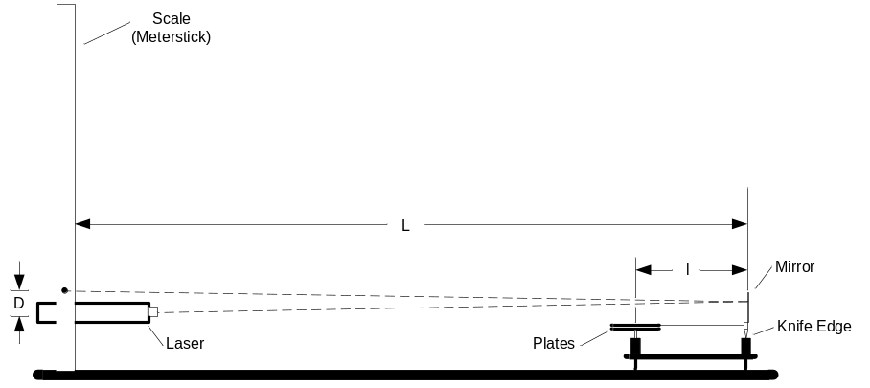

- Geometric Measurements—Measure
  - Measure the length and width of the top plate and place a mark on the geometric center on the back of the top plate. Measure the perpendicular distance from the center of the top plate to the mirror. This is the quantity, l.
  - Measure the perpendicular distance from the mirror to the scale (meter stick on the ringstand). This is the quantity, L. Record these values in your notebook.
  - D is the difference in readings of the scale for the contact and equilibrium position of the plates. Its determination will be explained later.
- Connect the circuit
Use banana plugs to connect the circuit shown in Figure 4. Before you connect the circuit, make sure that the power supply is unplugged, the power switch is in the off position, and the knob is all the way to the lowest setting (counterclockwise).
Figure 4 Circuit for connecting the plates to the high voltage power supply
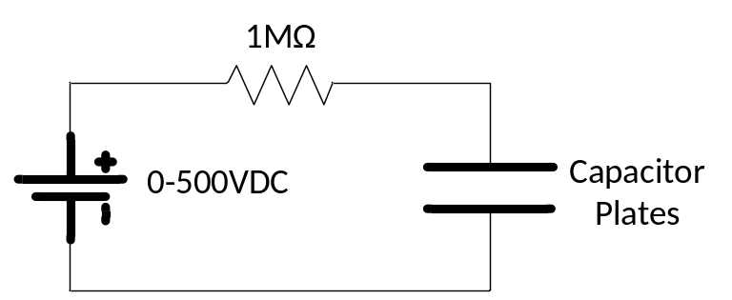

- Establish a reference point.
Place a small object such as a coin or the tweezers from the fractional weight set on the top plate so that the two plates close. Make a mark on the scale or record the position of the laser beam on the scale. The distance, D, will be measured from this reference point.
- Data Acquisition.
With the plates 2 mm apart (or as close as you can get them) note the point where the laser beam hits the scale (meter stick). Use the tweezers to place a 20 mg weight on the center mark you made on the top plate.
Note: All handling of the micro-weights must be done with the tweesers. If you handle them with your hand, it will compromise the nominal weight marked on the weight!
You should see the laser beam move toward the closed reference point (downward). Screw one of the counterbalances on the balance beam away from the mirror carefully until the laser beam returns to where it was before you placed the 20 mg weight on it. (Note: You will sometimes see oscillations during these processes. You should just wait until they settle out after each process.) Remove the 20 mg weight and return it to its container. You should now see the laser beam on the scale move in an upward direction. Wait until the oscillations damp out again. Be careful that the metal tab does not hang up on the magnet used to damp out the motion and that the arm is swinging freely. Turn on the power supply and slowly increase the DC potential until the deflection of the beam has returned to the reference point that denotes the 2 mm gap.
The force of attraction between the two plates is now the same as the weight of the 20 mg mass, .
Record the distance the laser beam is above the fully closed reference point. This is the quantity D. This quantity D should remain the same for smaller weights. Sometimes when using larger weights it may change. Also record the corresponding force that created this deflection, 20 mg in this case, and the potential in volts that gave the same deflection. This number you can read directly off the digital display on the power supply. When you have recorded the data, turn the power supply down and turn off the switch.

- Repeat the procedure in Step 5 four more times using masses of 30mg, 40 mg, 50 mg, 60 mg, 70 mg, and 80 mg respectively. (Your instructor will set theses values.)
Note: You may have trouble getting the 80 and 100 mg values. If the plates suck together you can use a larger D referred in Step 5.

Data Analysis
For each mass, use Equation 2 (simplified) to obtain the plate spacing, d. Then use Equation 1 to find the permittivity of free space, ε₀ vs. mass. Draw a horizontal line corresponding to your mean value. If your data seem to be randomly scattered around the line, then that is a good indication that your errors are most likely random errors. If there is some systematic trend in the data, then that may indicate a systematic error in your data.

Report Format (for optional use)
Your lab report should include the following:
- Short paragraph describing the objective of the lab.
- A one or two paragraph description of your experiment in your own words.
- A one-paragraph description in words of your data.
- Your table of data and the graph you’ve drawn. Make sure the graph is properly labeled, and includes a descriptive title.
- A one-paragraph description of your results. Be sure to explicitly show your calculations.
- Make a reasonable attempt to account for any discrepancies.
- A one-paragraph summary explaining very plainly the principal results of the lab.

Your report should be written with correct English spelling and grammar, and should be well organized, neat, and legible.
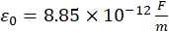 (Reference)
Where,
F is in farads
m is in meters

Laser Safety
Although these lasers are not particularly dangerous, we should take a few simple precautions to prevent the unlikely event of eye damage.
- Never look directly into the laser beam. Laser light has a high intensity and can also be easily focused. A direct shot of the laser beam on your eye will be focused by your cornea onto a small spot on your retina and can burn or possibly detach the retina.
- Never hold a reflecting object by hand in front of the laser beam. This prevents the possibility of accidentally shining the light into your eyes.
- Keep your head above the plane of the laser beam.
- Whenever the light strikes an object, there will be a reflection. At times the reflections can be almost as strong as the incident beam. Know where the reflections are and block them if necessary.
- The laser has a shutter in front of the beam. When not taking data, place the shutter in front of the laser beam.

