Density

And

Specific Gravity
Equipment Needed

Caliper, Digital General
Cylinder Set, Specific Gravity (w/o hook) Sgt. Welch WL1138
Density Bolt, Stainless 304SS
Graduated Cylinder, 50ml
Scale, Digital Sartorious BP-6100

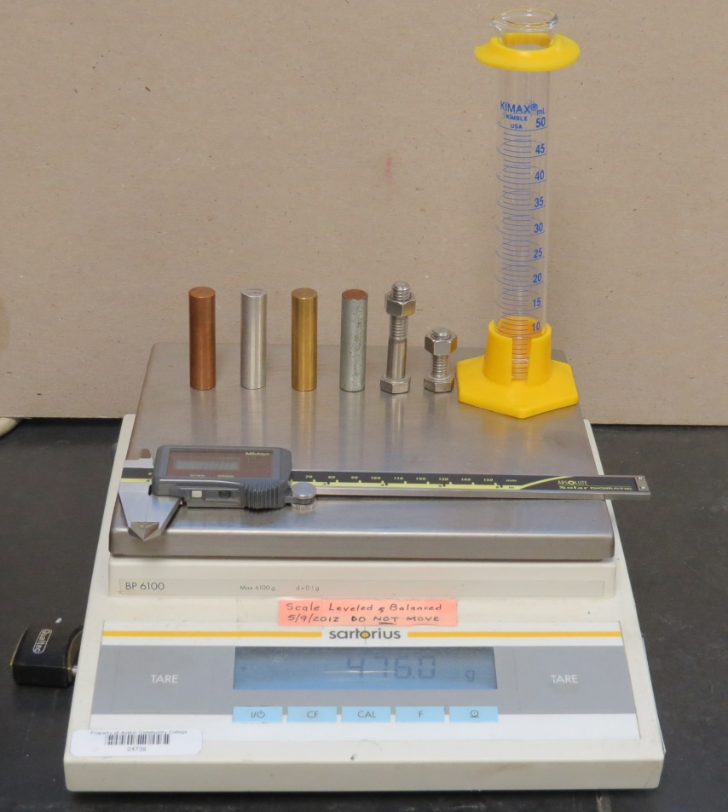
Introduction
Substances are identified by characteristic properties. One such property is mass DENSITY. Mass density is defined as mass per unit volume.
Denoted:
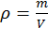
where
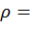 density of object in
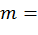 mass of object in grams
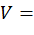 volume of object in centimeters³
The mass of a solid can be determined using a digital scale.
The volume of a regular object can be calculated from the measured dimensions.
The volume of an irregular object may be determined from the volume of water it displaces.
Sometimes, instead of giving the density of a substance, the specific gravity is given. The specific gravity of a substance is equal to its density divided by the density of water. It is a ratio and has no units. In the cgs system of units the density of water is 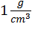 so the specific gravity is the same as the density without units.
Collect Data
Procedure 1: To determine the density and specific gravity of a regular solid.
- Using the digital scale, find the mass of a cylinder and record in Table 1.
- Using the caliper, find the diameter and length of the cylinder and record in Table 1.
- Repeat steps 1 and 2 for the other three cylinders.
Procedure 2: To determine the density and specific gravity of an irregular object.
- Determine the mass of the irregular object. Record it in Table 2.
- Fill a graduated cylinder about half full with water. Record the reading in the graduated cylinder to the nearest 0.1ml in Table 2 (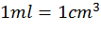).
- Place the irregular object into the water. Record the new reading of the graduated cylinder to 0.1ml. Record the data in Table 2.
- The difference in readings is the volume of the displaced water, which is the same as the volume of the object. Record this difference in Table 2.
- Repeat steps 1 through 4 for the other irregular object.
Calculations
Procedure 1 (Regular object)
- Determine the volume of each cylinder and record it in Table 1. The volume of a cylinder is denoted
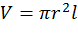
- Determine the density of each cylinder and record in Table 1.
- Determine the specific gravity of each cylinder and record in Table 1. In the cgs system of units, the 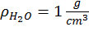
- Calculate the percent error for the specific gravity of each cylinder and record in Table 1. Notice: Two cylinders have a theoretical specific gravity and two do not.
Procedure 2 (Irregular object)
- Determine the density of the irregular objects.
- Determine the specific gravities of the objects and record in Table 2. Hint: The bolts and nuts are alloy 304SS.
- Calculate the percent error for the irregular objects and record in Table 2.

TABLE 1
Metal | Mass  (g) | Diameter  (cm) | Length  (cm) | Volume  (cm³) | Density | Specific  Gravity  (Theoretical) | Specific  Gravity  (Experimental) | Percent  Error
Cu
Al
Steel
Brass

TABLE 2
Object | Mass  (g) | 1st  Meas.  Before  (cm³) | 2nd  Meas.  After  (cm³) | Volume  (cm³) | Density | Specific  Gravity  (Theoretical) | Specific  Gravity  (Experimental) | Percent  Error
Calcite
Galena

Questions
- Discuss sources of error in the laboratory.

- Why do two of the cylinders not have a theoretical specific gravity? Explain.

- Which has the greater density, a glass of milk or a pitcher of milk? Explain.

