Snell’s Law

Equipment Needed

Dell Laptop Computer
AC Adapter, Dell Laptop
AC Adapter, Laser HeNe
Jack, Table Silver
Laser, HeNe ~670nm
Lens, Cylindrical D-Lens Pasco OS-8492
Optics Track, 120 cm Pasco OS-8508
Ray Table w/ Stand, Pasco OS-8536
Viewing Screen, w/ binder clips Pasco OS-8460

Typical Setup
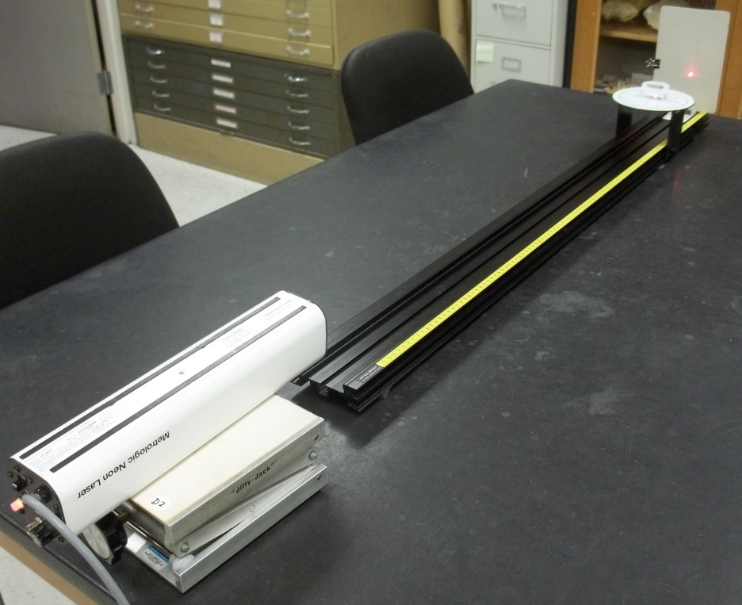

Introduction
In this lab we will investigate the behavior of light when it propagates from one medium into another. If the different media have different indices of refraction, then light incident at an angle other than normal to the interface will bend at the interface. This phenomenon is known as refraction and is quantitatively described by Snell’s Law. Figure 1 shows the relevant geometry. Let 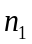 be the index of refraction of the incident medium and 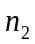 be the index of refraction in the refractive medium. Then Snell’s Law relates the angle at which the light is incident to the angle at which the light is refracted. As always, the convention in optics is to measure the angle from the normal. Snell’s Law is given by
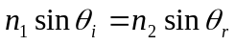.
Figure 1 Geometry for Snell’s Law
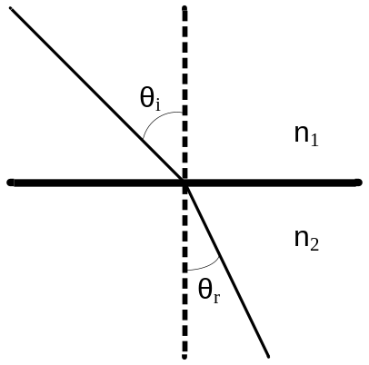
If the index of refraction is greater in the refracted medium than the incident medium, then the light will refract closer to the normal, as shown in Figure 1. If, on the other hand, the index of refraction is greater in the incident medium than in the refracted medium, then the light will bend away from the normal. In this lab we will use a diode laser as our light source that we will shine at a semicircular piece of plexiglass (acrylic.) We will measure the incident and refracted angles and verify Snell’s Law. We will also measure the index of refraction of the plexiglass.

Safety
Although these lasers are not particularly dangerous, we should take a few simple precautions to prevent the unlikely event of eye damage.
- Never look directly into the laser beam. Laser light has a high intensity and can also be easily focused. A direct shot of the laser beam on your eye will be focused by your cornea onto a small spot on your retina and can burn or possibly detach the retina.
- Never hold a reflecting object by hand in front of the laser beam. This prevents the possibility of accidentally shining the light into your eyes.
- Keep your head above the plane of the laser beam.
- Whenever the light strikes an object, there will be a reflection. At times the reflections can be almost as strong as the incident beam. Know where the reflections are and block them if necessary.
- The laser has a shutter in front of the beam. When not taking data, place the shutter in front of the laser beam.

Procedure Part 1
Place the rotating table on the optical bench with the flat side toward the laser as shown in Figure 2. The flat portion of the semicircular piece of the acrylic lens should be aligned so that its edge aligns with the diameter of the rotating table.
Figure 2
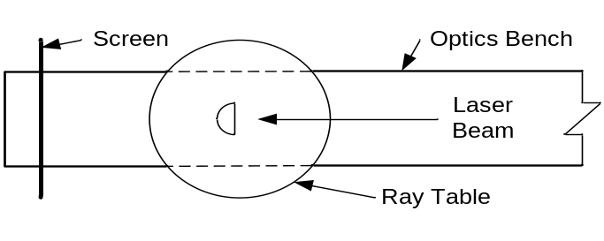
For five different angles, measure the incident and refracted angles. Be sure to measure the angle from the normal.

Procedure Part 2
Place the rotating table on the optical bench with the flat side toward the screen as shown in Figure 3. The flat portion of the semicircular piece of the acrylic lens should be aligned so that its edge aligns with the diameter of the rotating table.
Figure 3
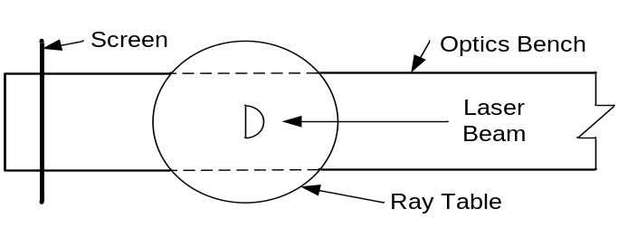
For five different angles, measure the incident and refracted angles. Be sure to measure the angle from the normal.

Data Analysis
In this experiment the incident medium is air that has an index of refraction 1.0. Thus we can write Snell’s Law for this example as
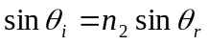,
where
= the index of refraction of the acrylic lens.
If we plot 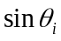 vs. 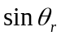, we should obtain a straight line with a slope of . Create two graphs using the data in Part 1 and Part 2 graph (using Excel™) vs. . Find the best-fit line that passes through your data. Excel™ will give the slope of the lines. This will be your measured value of the index of refraction of the acrylic lens.
Compare your measured values against 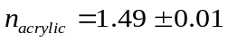.
- What is your percent error for each value?
- Was the value the same for both methods?
- Explain using Snell’s Law the relationship of vs. 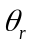 for the two different setups.
Procedure Part 3 The Critical Angle (optional)
In Part 2 we noticed that grew faster than . When reaches 90° there is no transmission of the beam through the surface and there is little reflection. This point is called the critical angle for that specific material (acrylic in this case.) Anything greater and the beam will be 100% reflected. Give the equation for the critical angle. (Hint: 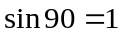) Find the critical angle for the acrylic D-lens experimentally. Include you data with your lab report.

