Latent Heat of Fusion

Equipment Needed

Beaker, 600ml —to cradle calorimeter
Cups, Foam (calorimeter)
Ice
Plastic cup (for water transfer)
Scale, Digital Sartorious BP-6100
Thermometer, Digital Extech 392050

Introduction
When a solid has reached its melting point, additional heating melts the solid without a temperature change. The temperature will remain constant at the melting point until ALL of the solid has melted. The amount of heat needed to melt a solid depends only on the mass of the solid and the latent heat of fusion of the solid (to fuse means to melt). We have:
Equation (1)
where
the amount of heat absorbed by the solid to melt it
the mass of the solid
the latent heat of fusion measured in Joules/g
The amount of heat necessary to warm or cool water depends on the mass or amount of water, the temperature change and the specific heat capacity of water. We have:
Equation (2)
where
Q is the amount of heat absorbed or shed by the water
m is the mass of the water and
c is the specific heat capacity of water measured in Joules/(g )
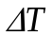 is the temperature change in degrees Celsius
For the specific heat capacity of water we will use: 4.186 J/(g )
Objective of experiment: To determine the latent heat of fusion of water/ice
In this experiment the heat of fusion of water/ice will be determined by adding ice to water in a calorimeter cup. We will measure the quantity of heat lost by the original amount of water to the ice as the ice melts and the heat lost by the original amount of water to warm the melted ice. We will assume that the ice used is at 0⁰ Celsius. The heat energy lost by the water does two things:
- It melts the ice.
- It warms the water formed by the melting ice from zero to the final temperature.
The final temperature of the water and melted ice will be the same. That is, the entire mixture will have reached thermal equilibrium.
We should have
heat lost by original water to ice =
heat gained by ice to melt it
+ heat needed to warm the water from the melted ice.
Equation (3)
where
heat lost by original water to ice
Equation 4
and
Equation (5)
and
heat needed to warm the water from the melted ice
but
so
heat needed to warm the water from the melted ice =
Equation (6)
Substituting equations (4), (5) and (6) into Equation (3) gives:
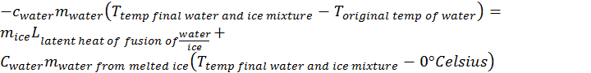
Equation (7)
We assume that all the ice will melt in this experiment. So, the mass of the water from melted ice is the same as the mass of the ice. So Equation (7) becomes:
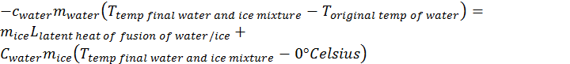
Equation (8)

Note that since temperature differences are provided by Equation (8), the temperatures can either be in Celsius or Kelvin. We will choose Celsius here. In Equation (8):
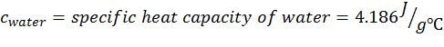
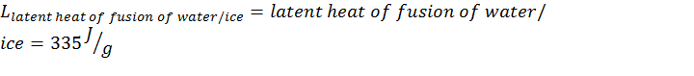

Procedure
- Determine and record the mass of the empty calorimeter cup (m _{cup})
- Fill the calorimeter cup about half full of tap water. (When using crushed ice from machine)
- Determine the mass of the calorimeter cup and water. Record in the Data Table.
- Calculate (see data table below) the mass of the that was added to cup (m_{water}). Record in the Data Table.
- Determine and record the initial temperature of the water before ice is added to the cup (T_{original temp of water}).
- Get ice from bowl in lab room.
- Add (approximately one tablespoon) of ice pieces of ice to the water in the calorimeter cup until the temperature of the ice and water mixture is between 5º and 10º C below room temperature. Keep the mixture well stirred and insulated from surroundings.
- When the ice is melted entirely (shouldn’t take more than 3-4 minutes) and water ice mixture reaches a constant equilibrium temperature, record the equilibrium temperature (Ttemp final water and ice mixture).
- Determine and record the combined mass of the calorimeter cup melted ice and water mixture.
- Calculate (see data table below) and record the mass of the ice, m_{ice}
Data
1. | Mass of empty calorimeter cup | __________ g
2. | Mass of calorimeter cup and water | __________ g
3. | Calculated mass of water | __________ g
4. | Initial temperature of water | __________
5. | Final temperature of water and melted ice | __________
6. | Mass of calorimeter cup and water after ice melts | __________ g
7. | Mass of ice added | __________ g
8. | Specific Heat capacity of water | 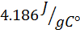
9. Use equation 8) (above and repeated below) to solve for the latent heat of fusion (The term 0 ⁰Celsius is omitted since it is zero.)
Equation (9)
the solution for using Equation (9) is:
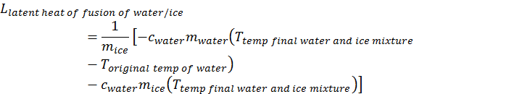
10. Substitute the values you have determined in the data table into the above Equation (9) as follows (note that A and C will be positive and B negative):
=__________ J
=__________ J
=__________ J
11. Heat of fusion of ice, ()
__________ Joules/g
12. Actual value for the heat of fusion of water/ice:
333.5. Joules/g
13. 
 

