Name______________________ Date_____________

PHYS 1401 General Physics I
Energy Conservation

Equipment

Air Track Kit w/ Photogate
Air Track
Air Supply

Lab Jack

Triple Beam Balance
LabPro Interface
Wooden block
Ruler

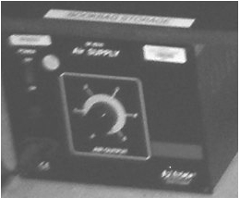
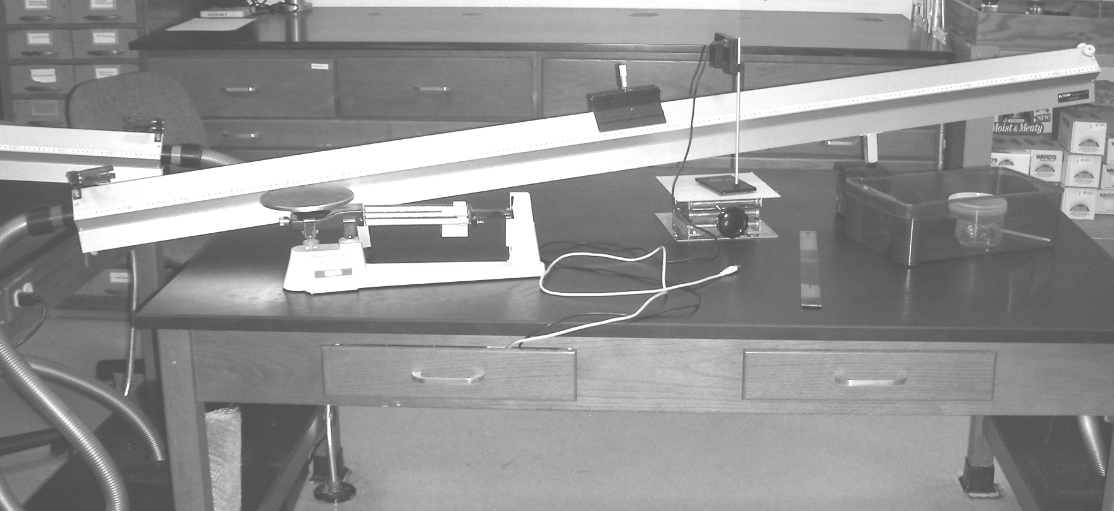
Terminology
Gravitational Potential Energy: PE_{G} = mgy
Kinetic Energy: 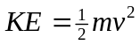
Mechanical Energy: E = KE + PE = ½ mv² + mgy

Overview
As an object slides down a frictionless surface its mechanical energy remains constant. However, its potential and kinetic energies change. You will make a plot of KE, PE, and E for a glider sliding down an air-track to test this idea.

Introduction
When the work done by all non-conservative forces acting on an object is zero, its mechanical energy remains constant. This is a fundamental tenet of science and has extremely broad application in all technical fields. The two types of energy that will be under consideration are the gravitational potential energy PE_{G} and the kinetic energy KE for the air-track glider. Since there are no other energies, i.e., from any springs, the sum of these two energies will be its mechanical energy E. Furthermore, since the normal force is perpendicular to the displacement it does no work and we will neglect any frictional forces acting on the glider then the non-conservative forces do no work and the mechanical energy for the glider will be conserved.
You will make measurements of PE and KE for five different locations on the air-track that the glider will pass over. These five positions should be located at approximately 0 cm, 30 cm, 60 cm, 90 cm, and 120 cm down the length of the track. 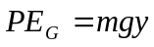 will be found by measuring the vertical coordinate position from the table top to the edge of the air track below the glider when it is at the appropriate position for each of the five locations. Multiplying the height by mg, where m is the mass of the glider and g is 9.80 m/s² gives us PE_{G}. However, we want to choose the zero of the coordinate system/potential energy to be at the fifth position or bottom location of the track and not the top of the table. To do this we will have to first measure the positions from the table’s surface and then subtract off the value that we get for the bottom y₅ position from all five of our recorded values. (See Figure 1.)
The velocity for calculating KE will be measured at four locations on the track. (It is at rest for the first location, 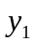, so the value KE at this position will be zero.) will be found by measuring the speed v at each point by using a flag mounted in the center of the glider as it passes through a photogate. The width of the flag will be determined by passing the glider through the photogate until it just trips the gate, you can tell this because the light on the photogate will then turn on. You should record the position of the leading edge of the glider at this location. You will then continue to push the glider through the photogate until the light just turns off. You should then record the position of the leading edge of the glider at this location. The optical width of the flag is the absolute value of the subtraction of the two values that you just recorded. You should enter this value into the computer under setup so that it will appropriately calculate the speed of the cart as it passes through the photogate. The photogate will be placed at the locations of 30 cm, 60 cm, 90 cm, and 120 cm to measure the corresponding velocities. (See Figure 1.)
Once this data is collected, you will plot the three quantities, PE, KE, and E=KE + PE versus the position of the glider on the track. This plot will allow you to test the idea of energy conservation as it applies to our simple glider, air-track system.

Accuracy
- All of your observations should be recorded to 3 significant figures. You should carry 3 significant figures in all of your calculations as well.

Procedure
- Set up the air-track with an inclination roughly similar to that shown in Figure 1. It works best if you place the jack under the single leg of the air track. The jack should be almost fully compressed.

0
30 cm
60 cm
90 cm

~120 cm
y₁ y₂ y₃ y₄ y₅

Figure 1. Air-track, glider, and photogate arrangement. Measure the y-values from the tabletop surface to the pin on the glider.
- Measure (3 sig. fig.) y₁ through y₅ as shown in Figure 1. Adjust them to the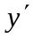’s and record in data table.
- Place the photogate at 30.0 cm from the release point. This is so you can find the velocity at y₂.
- With the flag at the center of the glider, measure the position that it both starts and stops the photogate. Subtract these two values to get the width of the flag and enter it into the computer.
- The flag should not strike anything as it passes through. All reference measurements should accordingly be measured at the center of the glider.
- Turn on the air track and let the glider accelerate from rest. Record the velocity through the gate. Repeat two more times.
- Repeat these velocity measurements with a similar procedure for y₃, y₄, and y₅.
- Measure the mass of your glider using the scale. That completes your data acquisition.

Data and Analysis

Mass of the glider m = __________________ (units and 3 sig. fig.)
Position when photogate turns on = ___________________
Position when photogate turns off = ______________________
Width of flag = |Position on – Position off| = ___________________

s  (cm) | v₁  (m/s) | v₂  (m/s) | v₃  (m/s) | v_{avg}  (m/s)
0.0 | 0.0 | 0.0 | 0.0 | 0.0
30.0
60.0
90.0
120.0

y  (m) | y' = y-y₅  (m) | s  (cm) | PE = mgy’ (J) | v_{avg}  (m/s) | KE =1/2 mv²  (J) | E = KE + PE  (J)
y₁= |  | 0.0 |  | 0.0 | 0.0
y₂= |  | 30.0
y₃= |  | 60.0
y₄= |  | 90.0
y₅= |  | 120.0 | 0.0

After filling out this entire table you are ready to make your graph. The vertical scale will be energy in joules and the horizontal scale should be position in centimeters e.g. 0, 30, 60, 90 cm, etc. (it need not be in SI units since it only marks a location). Draw best-fit lines for each quantity, PE, KE, and E for your graph.

Questions

E

energy
PE KE
(J)

displacement (cm)
Figure 2. Graph of PE, KE and E for the sliding glider.
- Probably the most sensitive measurement in this lab is that of the flag width, what would happen to the values of the velocities if you used a value of the width that was too large? How would this affect the kinetic energy values? What would this do to the value of the mechanical energy?
- In our lab we neglected friction; if friction was present what would it do to the values of the velocities? How would this affect the kinetic energy values? What would this do to the value of the mechanical energy?
- Is the best-fit line for the total energy E horizontal? Theoretically, should the best-fit line for E be horizontal? Explain why or why not.
- Within reasonable limits for experimental uncertainty were you able to show conservation of energy for the glider on the air track?

Report
- Introduction. You should try to answer the following questions: What are you going to do? How are you going to do it? This section will essentially be the standard Purpose and Procedure sections that you may have encountered in other lab courses. You should succinctly tell me in 2-3 paragraphs the answer to these two questions. Note: you are not required to reproduce in detail the lab procedure, but you should give the gist of what occurred in the lab. You need to especially note if there were any differences in your actual procedure from the stated procedure in the lab. You should explain why you made these changes.
- Data & Analysis. Present your data in a neat and organized manner. Use units where necessary. Clearly outline any calculations you made showing your numbers and units. Make neat and clean graphs following the correct graphing procedures. Label fully and show on the graph any analyses you are making from the graph.
- Results & Conclusions. Clearly answer any questions that were given with the lab. You should report all of the major calculated values obtained through out the lab. If you were supposed to have done a comparison then make sure that that calculation is included here. Make sure that you address all of the issues that were originally raised in the purpose of the lab.
- Error Analysis. You should also indicate several possible sources of error. Note that human error is not an acceptable answer for this section. This will indicate that you performed the experiment incorrectly and you will be docked points for this answer.

RVS - Energy Conservation Lab (See figure.2)
----------Graphing your data----------

- Open Graphical Analysis.

- Enter Displacement in cm for your X values.
- Enter Energy in Joules for your Y values.

- Click on DATA in the toolbar, then “New Data Set.” Then a second time (so we get a total of 2 new data sets).

- You can either retype your Displacements in the 2 new Displacement columns or just highlight your Displacement column (using the mouse button) then go to EDIT and COPY. Paste this in the Data Set 2 Displacement and then the Data Set 3 Displacement columns.

- Label Data Set 2 “PE” for your Potential Energy and enter your data.
- Label Data Set 3 “KE” for your Kinetic Energy and enter your data.

- Double click anywhere on the graph- and uncheck “Connect Lines.” Then click the “Axis Options” tab. Make sure Energy, Potential Energy, and Kinetic Energy boxes are “checked.” Click DONE.

- Go to ANAYLIZE in the toolbar and pick “Linear Fit.” Select all three choices (Energy, PE, & KE) with your mouse and mouse button. Hit done.

- Congratulations! You can grab and move your data boxes where they look nice

- before you print if you wish. Does the graph make sense?

