Name______________________ Date_______________

PHYS 1401 General Physics I

Newton’s Second Law

Equipment

Air Track
Air Track Kit
Smart Pulley
Computer w/Logger Pro
String
Mass & Hanger Set
Triple Beam Balance

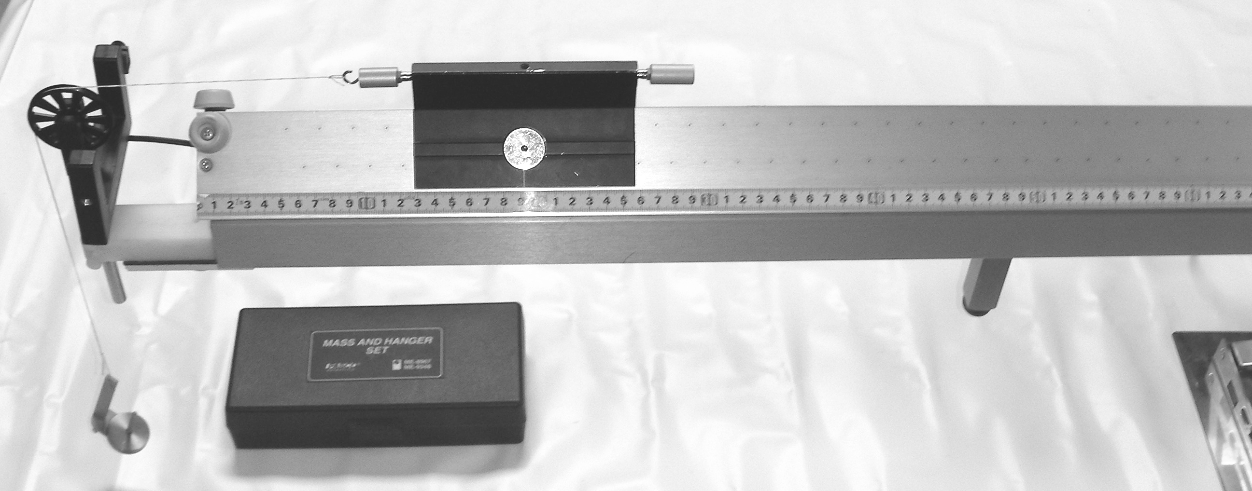

Figure 1

The purpose of this experiment is to investigate Newton's 2nd Law with an “air track/ hanging mass” system. Note: There are different ways to define a system, and for this lab, the system is defined as the cart, the pulley and the hanging masses. However, at this point in time we will neglect contributions to the system from the pulley. Thus, the total mass M_{total} of the system will be the mass of the cart, M_{c}, plus the hanging mass, M_{h}.

A small mass M_{h} will hang over a pulley at the end of the air track and will pull a larger mass M_{C} along the length of the air track. The computer will measure the changes in the angular rotation of the smart pulley and then solve for the acceleration of the system, a_{experimental}. From Newton's 2nd law,
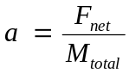

the acceleration a of the cart is:

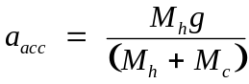

We will use this acceleration as the accepted value, a_{accepted.}

Procedure
- Plug the smart pulley into the Logger Pro port DIG/SONIC1. Place the pulley apparatus level with the air track opposite from the hose connection. Level the air track by placing the cart in the middle of the air track, then turn the air track on and adjust the leveling feet on the air track until the cart is motionless in the middle of the track. Attach the hook accessory to one end of the cart. Add the putty accessory on the other end to balance it. Attach a string (about 1.5 m long) between the cart and the hanging mass (M_{h}). Use 7g for M_{h} at first – note the mass of the hanger itself. Weigh the cart with accessories and record the mass as M_{C}. Any masses added to the cart must be divided equally on both sides of the cart in order to balance the cart. Make sure that the hanging mass accelerates the entire time the cart is traveling across the air track.

- On your computer, open the RVS Physics folder from the dock, then open the file James Newton's Second RVS.cmbl

- Hold the cart some distance from the pulley, so that the hanging mass is freely hanging. Click the green ‘Collect’ button, and then release the cart once you see that it is recording. After the mass hits the ground or prior to when the cart hits the pulley, catch the cart so it will not crash into the pulley. Click ‘Stop’. Practice this procedure. The timer must be running first. The cart can be released any time, but you must be ready to catch the cart.

- Examine the sampled acceleration data that was obtained from the run. Highlight the largest region of the data that looks fairly consistent, after having started the motion but before ending the motion. This is done by “clicking and dragging” across the relevant data points. Then click on the “stats” button or use the pull down menus to select the perform statistics option. Record the mean and the standard deviation. These will be your a_{exp} for each case and the standard deviation will be the uncertainty. Remember to apply the rules for uncertainties when you record your values.
Repeat with 10, 12, 15, 17 grams total mass for the hanging mass.

- Add 100 grams to the cart and use 12 g for M_{h} and run the experiment.
Add an additional 100 grams to the cart and repeat.

- Find a_{exp} with uncertainty and compare to:

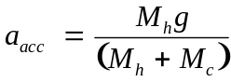

- Make a graph of a_{exp} versus M_{h}/(M_{h}+M_{c}) and obtain both the slope as well as the uncertainty in the slope. Remember to apply the rules for uncertainties. Compare your result with the accepted value for the acceleration due to gravity.
Changing Pulling Force
M_{h}  (kg) | M_{C}  (kg) | Graph as “y”  a_{exp}  ₍± _{Std. Deviation)}  (m/s²) | F  (M_{h}g)  (N) | M_{total}  (M_{h} + M_{C} )  (kg) | Graph as “x”  Mass  Ratio  (M_{h})  (M_{h} + M_{C} ) | a_{accepted}  (F/M_{total})  (m/s²) | %  error
.007 |  | ±
.010 |  | ±
.012 |  | ±
.015 |  | ±
.017 |  | ±
Changing Cart’s Mass (add 100g, then add 100 more)
.012 |  | ±
.012 |  | ±

Analysis
- How did you experimental values of the acceleration compare to the accepted values of the acceleration? What was the percent error as well as are the accepted values in the range of the experimental values with their uncertainties? You should address the question of how the experiment worked overall as well as the range of results in the experiment and you should definitely mention any outstanding experimental runs.

- Is there a systematic trend in your data with respect to the experiments in which you changed the pulling force?

- Is there a systematic trend in your data with respect to the data in which you changed the cart’s mass? Don’t forget to include the third line of the first table in your analysis here!

- How did your value for the acceleration due to gravity compare to the accepted value? What was the percent error as well as is the accepted value in the range of the experimental value with uncertainty?

- Did you verify Newton’s second law within experimental uncertainty? Support your answer.

Report
- Introduction. You should try to answer the following questions: What are you going to do? How are you going to do it? This section will essentially be the standard Purpose and Procedure sections that you may have encountered in other lab courses. You should succinctly tell me in 2-3 paragraphs the answer to these two questions. Note: you are not required to reproduce in detail the lab procedure, but you should give the gist of what occurred in the lab. You need to especially note if there were any differences in your actual procedure from the stated procedure in the lab. You should explain why you made these changes.

- Data & Analysis. Present your data in a neat and organized manner. Use units where necessary. Clearly outline any calculations you made showing your numbers and units. Make neat and clean graphs following the correct graphing procedures. Label fully and show on the graph any analyses you are making from the graph.

Make a graph of:
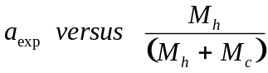

- Results & Conclusions. In a paragraph or two clearly answer any questions that were given with the lab. You should report all of the major calculated values obtained through out the lab. If you were supposed to have done a percent difference then you should also give that along with the value. Make sure that you address all of the issues that were originally raised in the purpose of the lab.

- Error Analysis. Indicate several possible sources of error. Note that human error is not an acceptable answer for this section. This will indicate that you performed the experiment incorrectly and you will be docked points for this answer.

