Name______________________ Date_____________

PHYS 1401 General Physics I
Torques

Equipment

Fulcrum and attachment
Triple Beam Balance
Meter Stick
Mass Set
3 String loops
Unknown Mass

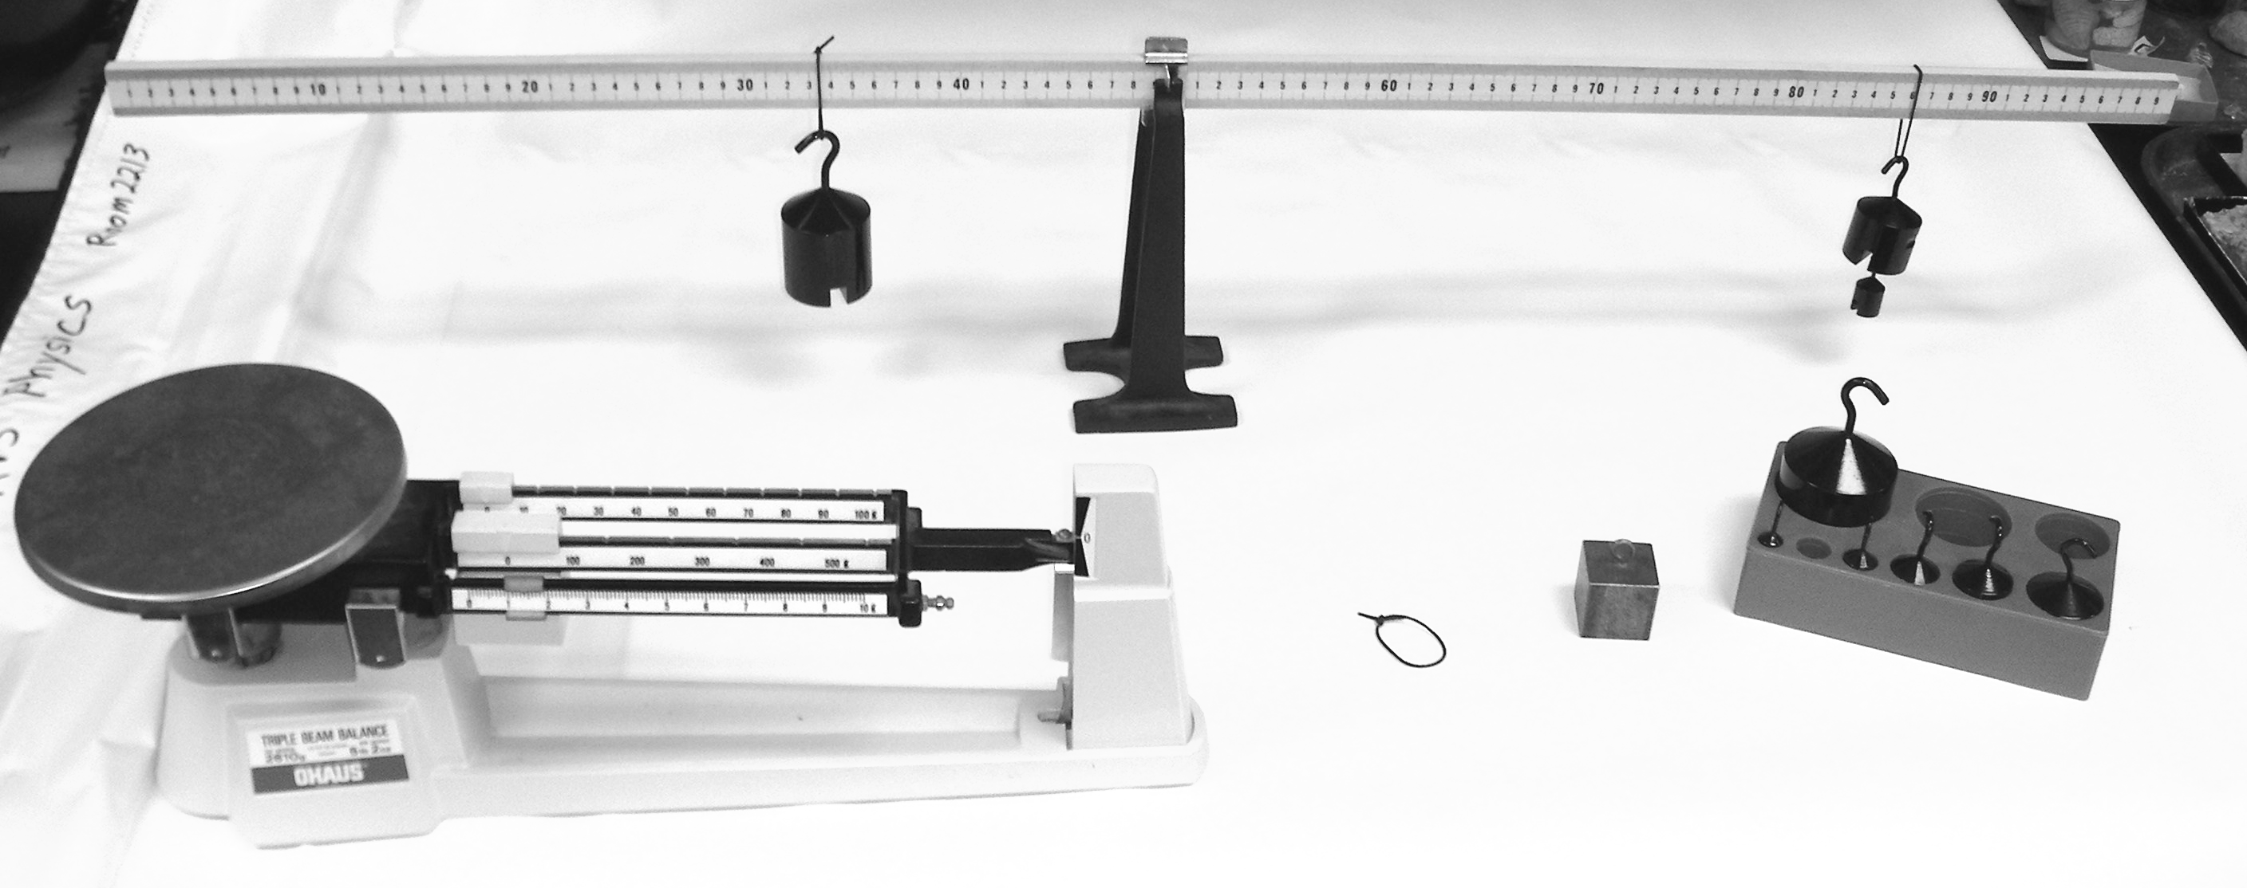

Theory
For a body to be in static equilibrium, two conditions have to be met:
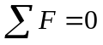 and 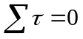
where
F is force
τ is torque. (The torque is the force times the lever arm, r)
The first condition, , is concerned with translational equilibrium and ensures that the object is not moving linearly or is moving at a uniform linear velocity.
The second condition, , is concerned with rotational equilibrium and ensures that the object is not rotating or rotating at a uniform angular velocity.

Procedure (For each setup, draw a scale diagram of the setup)
- Measure the mass of the meter stick without attachment and then place the meter stick on a support stand. Adjust the meter stick through the attachment until the stick is balanced on the stand. The balancing point is called the center of mass of the meter stick. Record this point.
- Case 1. With the meter stick on the support stand, suspend a gram mass 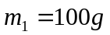 at the 15-cm mark on the meter stick. Then adjust the lever arm for a gram mass 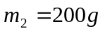 at the other end of the meter stick.
- Record the mass and position x as read on the meter stick and then record the lever arms. Compute the torques and find a percent difference between the clockwise (τ_{cw}) torques and counterclockwise (τ_{cc}) torques.
- Case 2. Place at the 20-cm mark and is at the 60-cm mark on the meter stick. Experimentally determine the position for 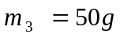 so that the system is in equilibrium. Follow a procedure similar to steps 2 and 3. Compute the percent difference of the clockwise and counterclockwise torques.
- Case 3. Place an unknown mass at the 10 cm mark of the meter stick. Suspend from the other side a counter mass 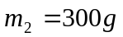 and adjust its position until the system is in static equilibrium. Using, , calculate the unknown mass m₁. Remove the unknown mass and determine its mass on the laboratory balance. This is the accepted mass. Calculate % error.
- Case 4. Suspend a mass at or near the zero end of the meter stick. Move the meter stick in the support clamp until the meter stick is in equilibrium. Record this new equilibrium position as x_{o}’. Using the total mass of the meter stick, calculate the clockwise and counterclockwise torques, and then calculate a percent difference. In this calculation, you will include the mass of the meter stick as if it were concentrated at its center of mass, x_{o} (around the 50 cm mark) calculating the lever arm to the new pivot point.

Data Table

Mass of meter stick, m_{meterstick} ______________________

Balancing point (center of mass) of meter stick, x₀ = ______________

* Attach a sheet to the laboratory report showing diagram and calculations for each use.
Values | Moment (lever) arms | Results *(see note above)

Case 1
m₁ = 100 g x₁ = 15 cm  m₂ = 200 g x₂ =_________ | r₁ = ___________  r₂ = ___________ | τ_{cc} = ___________  τ_{cw} = ___________  Perc.Diff. __________

Case 2
m₁ = 100 g x₁ = 20 cm  m₂ = 200 g x₂ = 60 cm  m₃ = 50 g x₃ = _______ | r₁ = ___________  r₂ = ___________  r₃ = ___________ | τ_{cc} = ___________  τ_{cw} = ___________  Perc.Diff. __________

Case 3
m₁ =? x₁ = 10 cm  m₂ = 300 g x₂ =_________ | r₁ = ___________  r₂ = ___________ | m₁ ____________  (measured on scale/ accepted)  m₁ ____________  (calculated, experimental)  Perc. error _________

Case 4
m₁ = 100 g x₁ = ________  m_{meterstick} = _______ x_{o} = _______  x_{o}’ = _______ | r₁ = ___________  r₂ = ___________ | τ_{cc} = ___________  τ_{cw} = ___________  Perc.Diff. __________



