Name______________________ Date_____________

PHYS 1401 General Physics I
Vector Equilibrium Lab

Equipment

Force Table
3 Force Table Pulleys
Mass and Hanger Set
Graph Paper
Protractor
Ruler

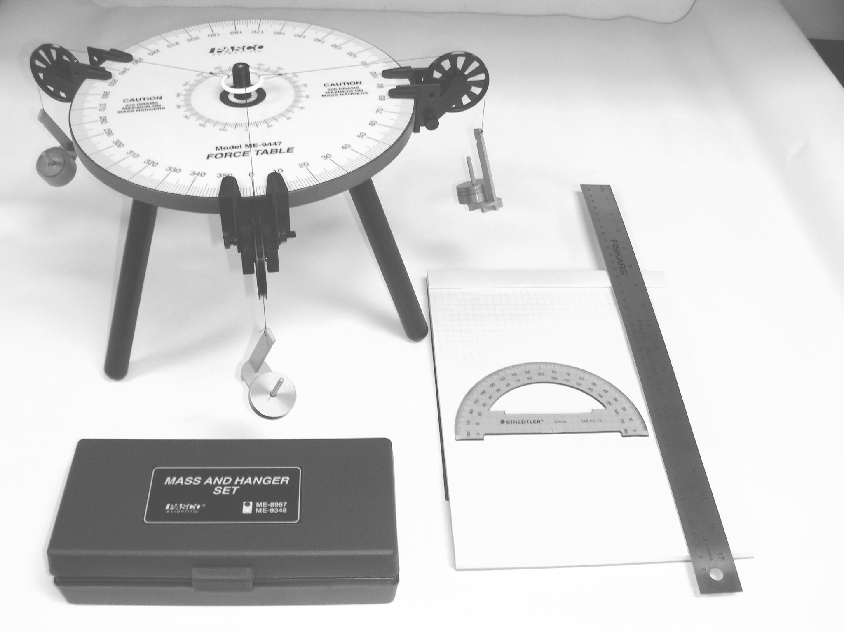

Objective
Two known vectors are added to find the resultant first by a graphical method using a protractor and a ruler and then by the algebraic method using components. The equilibrant is then found by taking the negative of the obtained resultant. The same effective vectors will be set up on the force table using gram masses and the value of the determined equilibrant will be experimentally determined and then compared to the theoretical value that was previously obtained.

Introduction
An object is said to be in equilibrium when the vector sum of all the forces acting on the object is zero:
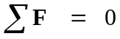
or in terms of components:
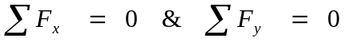
In this lab we will work with two vectors A and B. The value for vector A will be 155 units at 30º counter-clockwise from the +x-axis. The value for vector B will be 95 units at 110º counter-clockwise from the +x-axis. The resultant R = A + B, and the equilibrant E = -R = -(A+B), such that A + B + E = 0. All of your observations should be recorded to three significant digits and you should carry three significant digits in all of your subsequent calculations.

Procedure
- Using a piece of graph paper, graphically add using the tip-to-tail method
A = 155 units at 30º and B = 95 units at 110º.
Note: You should scale the lengths so that the majority of the graph paper is used in this sum, such as 10 unit = 1 cm as a scale factor. However, you should report your answers in terms of the original given units and not in terms of cm. Clearly write your scale factor on your graph. You should also note that the angles are measured in standard position as defined in a mathematics class, so that they are always measured counter-clockwise from the +x-axis.
Find the resultant, R = A + B, and with your ruler and protractor determine the magnitude and direction (angle in standard position) of the resultant that you obtained.

R = _____________________________

θ = _____________________________

- Now you will add the vectors algebraically by components. You need to show your work in order to obtain full credit for this portion of the lab.

A_{x} = ____________________________

B_{x} = ____________________________

R_{x} = A_{x} + B_{x} = ___________________________

A_{y} = ___________________________

B_{y} = ___________________________

R_{y} = A_{y} + B_{y} = ___________________________

Thus, the magnitude and the direction (angle) of the resultant are calculated as follows:

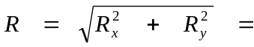_________________________

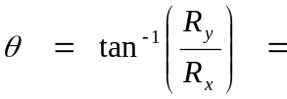____________________________

Do these values agree with the values obtained in part1?___________________

Which set of values do you think is more accurate? _______________________

Calculate the value of the scalar addition A + B = _________________________

How does this compare with the value that you obtained for R?_______________

Should it be comparable or not and why? ________________________________

- Now you will set up the force table with each unit of magnitude of our vectors now being represented by a gram of mass. Note: when you load the force table do not forget to account for the mass of the hanger itself in the tally for the magnitudes of the vectors. To place the force table in equilibrium you will need to also include the equilibrant, E. Since the equilibrant is equal to the negative of the resultant, as a trial value, you should use your results from part 1 to begin with such that:
E = R and θ_{E} = θ_{R} + 180º.

Now, you should experiment with the mass of the hanger and the angle to see if you can get the ring of the force table to be in the best possible state of equilibrium. This is obtained when you can gently nudge the ring and it will return back to being centered. Once you have found your best possible equilibrium values report them here:

E = _____________________________

θ_{E} = ____________________________

- Compare your values from parts 2 & 3.

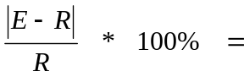___________________________

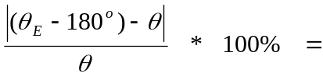_________________________

What are some possible sources of error in this lab?

