Name______________________ Date_____________

PHYS 1402 General Physics II
Equipotential and Electric Field Lines Lab

Equipment

Battery Eliminator DC Voltage Supply
DMM (Digital Multimeter)
Specialized Graph Paper
Conductive Paper
Cork Board
Metal Thumbtacks
Terminal Lead Wires
Alligator Clips

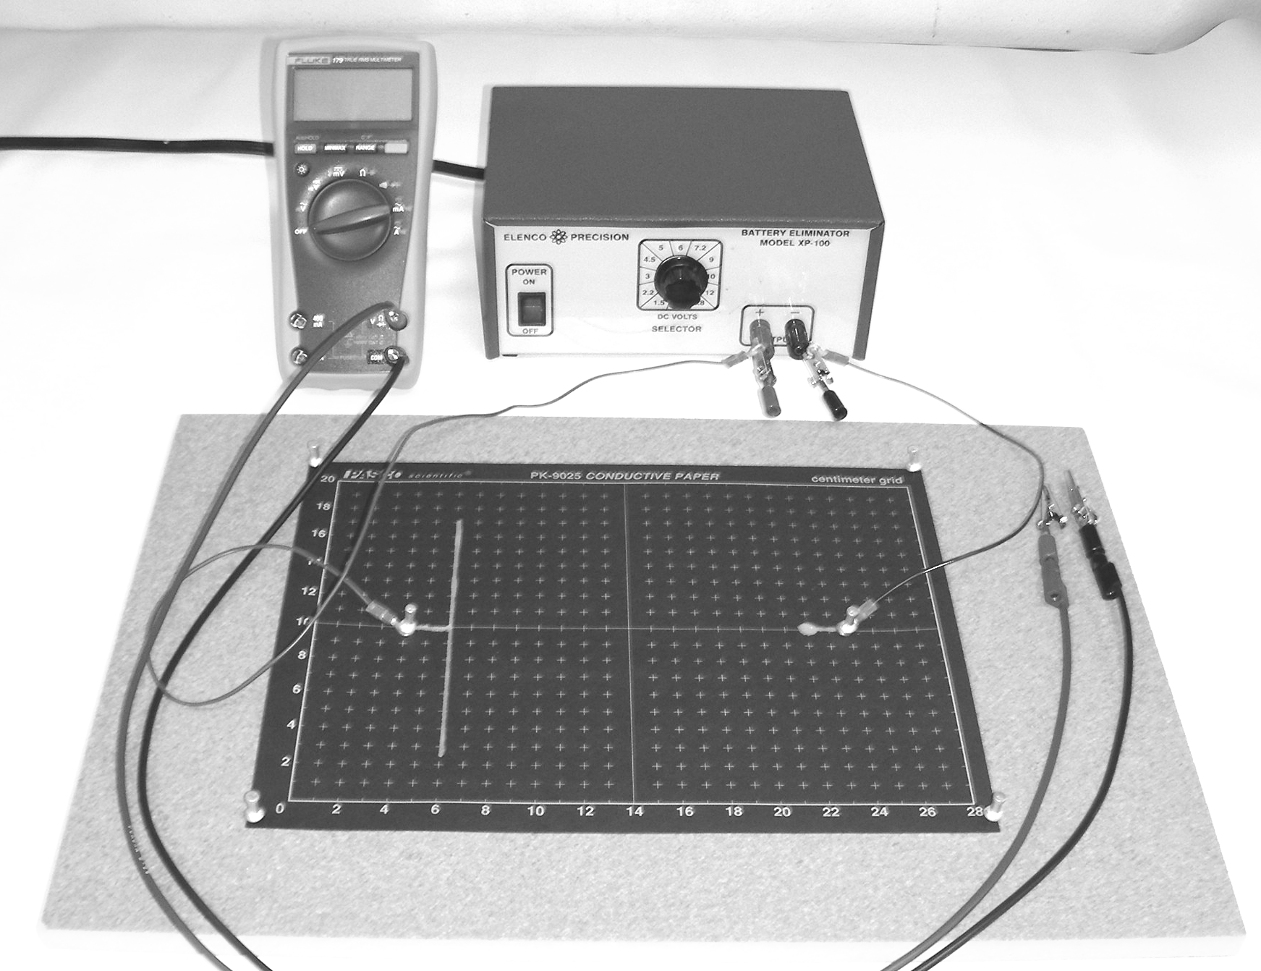

Objective
The objective of this lab is to map out the electric fields of three charge configurations. This is done by determining the equipotential lines of these charge configurations. The electric field lines are then inferred since they always cross the equipotential lines at a right angle.

Introduction
Field lines are used to help visualize a vector field, such as an electric field that surrounds a charge or a charged object. An electric field line is an imaginary line that is drawn such that the electric field vectors are always tangent to it at every point along the line; it is also directed in the same direction as the electric field itself. Thus, electric field lines will always start on a positive charge (or out at infinity) and end on a negative charge (or out at infinity). The number of electric field lines that are drawn is proportional to the amount of charge on the object, and the closer the field lines get the stronger the field is in that region. Note: electric field lines will never cross one another.

By definition all points on an equipotential contour line will have the same electric potential. This implies that no work is required to move a charge from one point to another on the same equipotential line and therefore the equipotential lines are perpendicular to the electric field lines at every point along the equipotential line. Conductive surfaces, such as the silvered areas on the conductive papers, also form an equipotential surface.
So you will first determine various equipotential locations and connect them with a smooth curve to form the equipitential line then you will draw in the electric field lines that go from the positive conductor to the negative conductor such that they cross the equipotential lines at right angles.

Procedure
- Assemble the electric field mapping apparatus as directed by the instructor or lab tech. Place the conductive paper on the board and connect the battery eliminator to the silver conductive areas on the paper. Set the battery eliminator to the 1.5 V setting. On your graph paper identify the appropriate conductive shapes and mark which one is connected to the (+) positive electrode and which one is connected to the (-) negative electrode.

- Place the reference probe, the one that is attached to the common input on the meter, on the negative conductor and mark this conductor as 0.0 V on your graph paper.

- Move the other probe down the line that connects the conductors until the meter reads 0.3 V and mark the position of the probe on the graph paper. Now find four other points to the right of the point and four other points that are to the left of this point that have the same 0.3 V reading on the meter and record their locations on the graph paper as well. These points are all at the same potential, so they all lie on the same equipotential line. Connect them with a smooth line (or curve as appropriate) and label this line with the 0.3 V reading that you had on the meter.

- Repeat this procedure for meter readings of 0.6 V, 0.9 V & 1.2 V.

- Place the probe on the positive conductor and write the value of the meter reading on the conductor on your graph paper.

- Your graph paper should have four (4) equipotential lines with nine (9) points each that are marked with an appropriate potential difference. As well as the two (2) conductive equipotential surfaces that will also have marked potential differences.

- Repeat this procedure for the other two configurations.

Analysis
- Make sure that you have drawn in the equipotential lines and marked them as indicated in the procedure above.

- For each charge configuration, you should draw seven (7) electric field lines distributed around the map. You must use a different color for the equipotential lines and the electric field lines. Each line must cross every equipotential line at a right angle and begin on the positive conductive surface and end on the negative conductive surface. Place an arrow on the field line in order to indicate the direction.

- For the parallel plate configuration, you will estimate the strength of the electric field near the center. The following formula will be used:

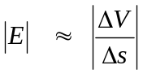

where ∆V is the potential difference across the appropriate ∆s displacement. Locate the two points where the equipotential line intersects the electric field line as the electric field line runs through the middle of the configuration nearest the center of the graph. Calculate ∆V by subtracting the measured values that you marked on these equipotential lines at the two intersection points and then divide this by the displacement, ∆s, between these two points as measured from the graph in order to get your estimate for the magnitude of the electric field in that region. Repeat this process again just to the left, right, above and below the center location that you just used. Present your data in the table and determine a percent difference between the last four values and the center value by using the provided formula.

 | V₁ | V₂ | ∆V | ∆s | E | % Difference
 | (V) | (V) | (V) | (m) | (V/m) | %
center |  |  |  |  |  | N/A
left
right
above
below
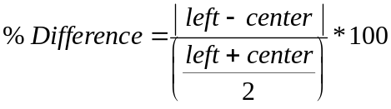
- Comment on the variation in the magnitude of E for the calculation that you did for the parallel plate configuration. Does the electric filed appear to be uniform in the central region of the plate? Finally comment on the accuracy of the three electric field maps that you drew. Do they look like the ones that you have seen in your textbook? Recall that an electric field line is a line along which a positive charge would move from a region of high electric potential to a region of low electric potential. Do the field maps seem to be in agreement with this idea?

Report
- Introduction. You should try to answer the following questions: What are you going to do? How are you going to do it? This section will essentially be the standard Purpose and Procedure sections that you may have encountered in other lab courses. You should succinctly tell me in 2-3 paragraphs the answer to these two questions. Note: you are not required to reproduce in detail the lab procedure, but you should give the gist of what occurred in the lab. You need to especially note if there were any differences in your actual procedure from the stated procedure in the lab. You should explain why you made these changes.
- Data & Analysis. Present your data in a neat and organized manner. Use units where necessary. Clearly outline any calculations you made showing your numbers and units. Make neat and clean graphs following the correct graphing procedures. Label fully and show on the graph any analyses you are making from the graph.
- Results & Conclusions. Clearly answer any questions that were given with the lab. You should report all of the major calculated values obtained through out the lab. If you were supposed to have done a comparison then make sure that that calculation is included here. Make sure that you address all of the issues that were originally raised in the purpose of the lab.
- Error Analysis. You should also indicate several possible sources of error. Note that human error is not an acceptable answer for this section. This will indicate that you performed the experiment incorrectly and you will be docked points for this answer.

