The Conservation

Of

Linear Momentum

Equipment Needed

Laptop computer with AC adapter & mouse N3-PR,M0-PR, or T0-L
Data logger with I/O cabling 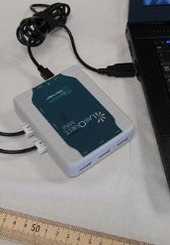 Y4-PR
Air Supply PP1-L 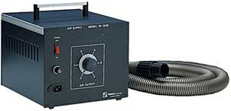
with hose @ corner of N5-PR
Air Track BB4-L 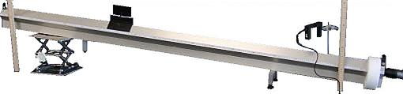
Air Track Kit PP2-L 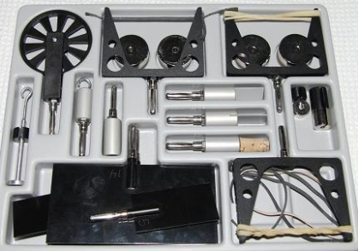
Glider (x2) PP2-L 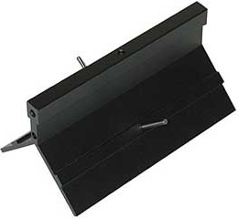
Ringstand, Miniature (x2) F5-L 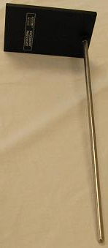
Scale, digital with ac adapter DD4-PR 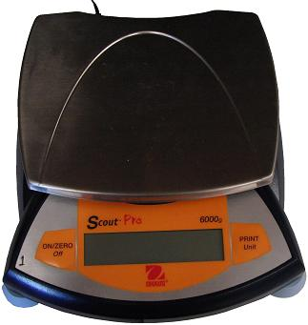
Photogate (x2) with I/O cabling 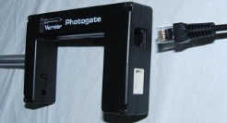 Y2-PR

Introduction
In this experiment you will test the validity of the Law of Conservation of Linear Momentum in one dimension with elastic and inelastic collisions.

Theory
If two objects collide and are subject to no net forces other than those of the collision itself, then it can be shown by the application of Newton's 2nd and 3rd Laws that the total linear momentum of the system of masses will not be altered by the collision. The linear momentum p₁ of an object of mass m₁ and velocity v₁ is given by 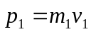 while the linear momentum p₂ of an object of mass m₂ and velocity v₂ is given by 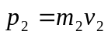. In a system consisting of two objects of momentum p₁ and p₂, the total linear momentum before collision is:
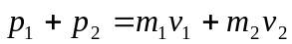
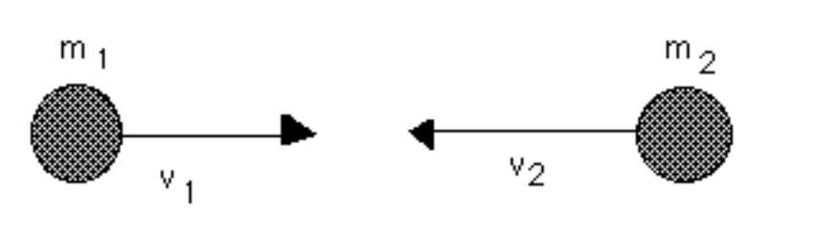

Figure 1
If the two masses collide, in general, their velocities will be altered to:
v₁' and v₂', respectively.
And the total momentum after collision is:
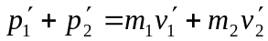
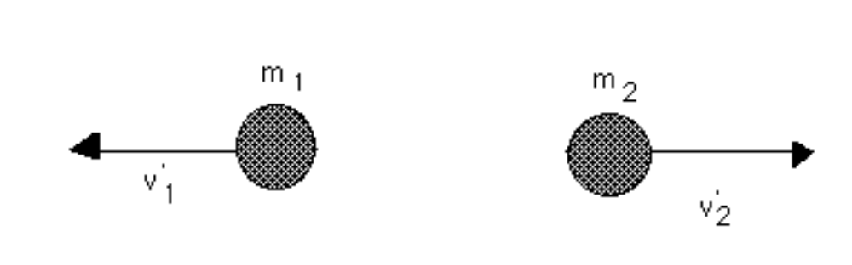

Figure 2
According to the conservation of linear momentum principle, the total linear momentum will not be altered by the collision, therefore
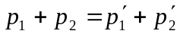 Equation 1
that is:
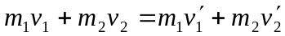 Equation 2
basic two gate Air track setup

- Setup apparatus components as shown in fig 3 – 7
  - Note: the blower is usually set on the floor so it is less likely to interfere with glider movement.
- Connect the white end of the photogate I/O cable to DIG1 & DIG2 of the ‘LabQuest Mini’ data logger and connect the telephone connector end to the photogate
- Connect the USB cable between the computer and the ‘LabQuest …’ datalogger
- Connect the AC power adapter to the computer
- Turn the computer on
- Click on the ‘student’ icon
- Open the Physics folder
- Double left click on the Logger Pro icon to open the data capture & display software
- Go to the pull down menu and select the following string of options:
  - File -> open -> ‘probes & sensor’ -> photogates -> ‘collision timer’ (or other, as directed)
- Make sure the ‘photogate distance 1’ is set to the flag width specified by your lab. If none is specified, then use the 0.10 m flag. To change the flag, click on the up or down arrowhead button from 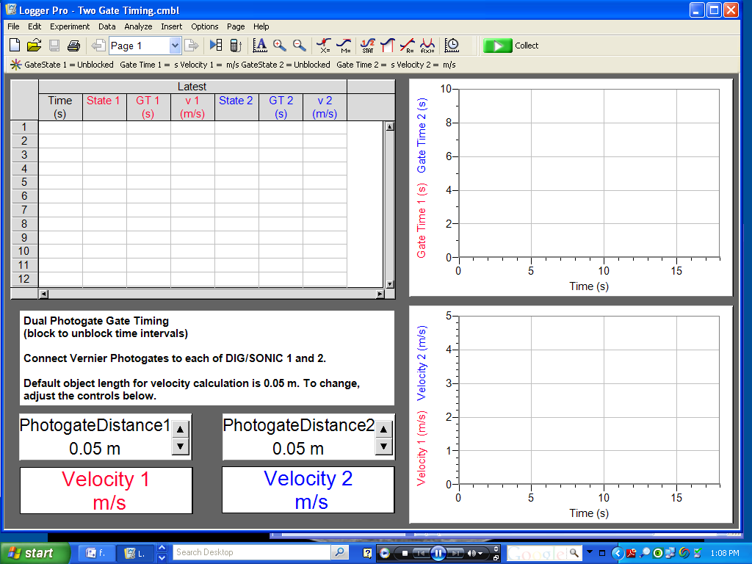 until they are set as needed. If the up or down arrows don’t take you to the needed flag width as may happen with, for example, a 25mm flag, then double click on the number 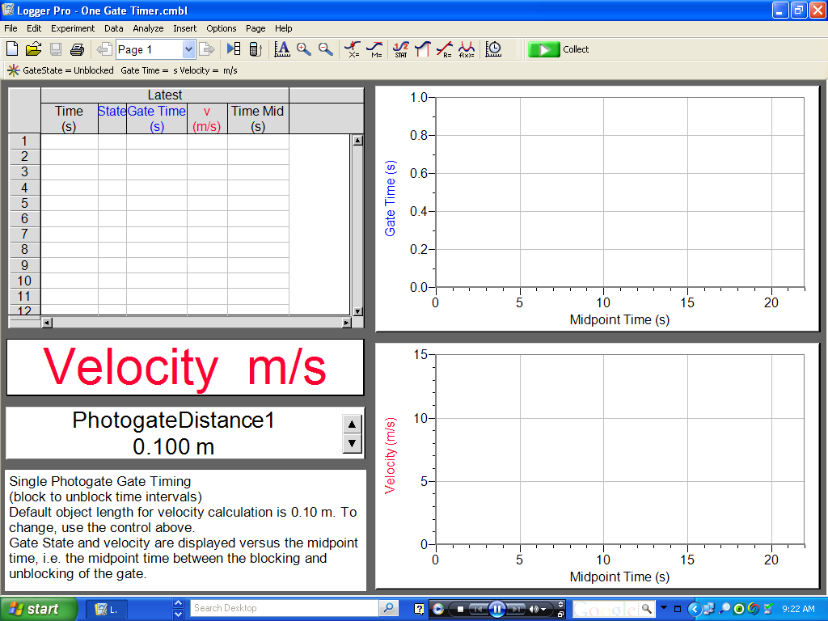 in the box. This leads to 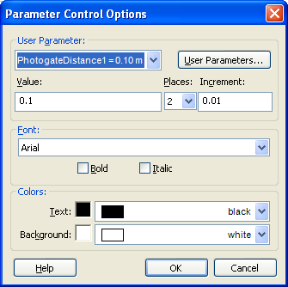 . Change the 2 in the 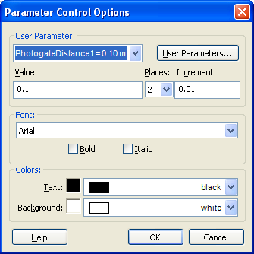 box to a three (or other, if using some other flag), then change the 0.1 in the 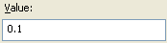 box to 0.025, then click , which leads to 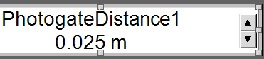. .
  - Note: the word ‘flag’ and the expression ‘photogate distance’ represent the same thing (an object that blocks the IR light beam of the photogate). If other objects are used as flags, adjust the ‘photogate distance’ as appropriate.
  - Note: the collect button at the top center of the screen should be colored green .
  - If the collect icon is gray 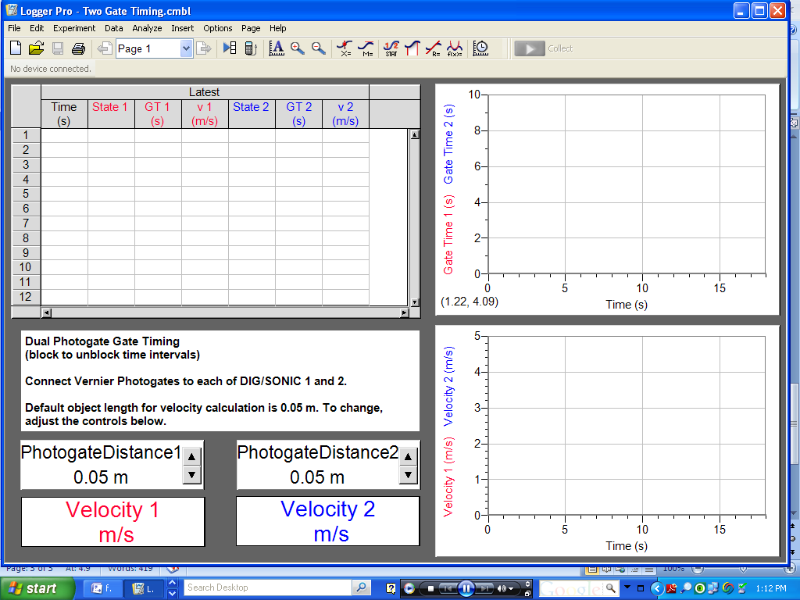 one of the connectors is probably not properly seated.
  - The first thing to do, if you have a gray button, is to carefully disconnect all connectors and then reconnect them.
  - If step ‘d’ doesn’t lead to a green button, then shut the computer down, then bring it back up and repeat step ‘d’.
  - If steps ‘d’ & ‘e’ don’t work ask for assistance.
- Check to confirm that the glider with its flag will pass thru the photogates and trigger the gates without hitting cables, the photogate, or other objects.
- For those lab activities that require the air track to be level, check for level
  - put the glider at the 100cm mid=point of the air track
  - turn the blower on
  - observer how the glider moves
Note: under ideal conditions, if the air track is level, the glider will not move. We do not live in an ideal world. When level, the glider may not move for brief periods of time; but, room & building ventilation, bumping the table while taking notes, Venturi effects, air track deformities, etc , will usually cause the glider to drift back & forth, to some degree, over some portion of the air track. If the glider accelerates to one end or the other, it is, most likely, not level.
  - Adjust both level adjustment screws. See fig 4.
- You are now ready to collect data.
  - Note: the computer may stop waiting for data after ~18 seconds. If this is a problem ask how to change this feature.
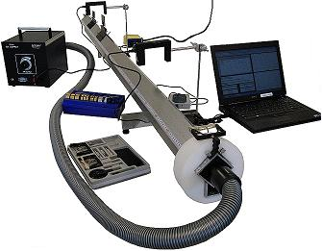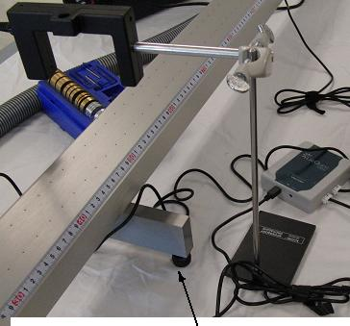
One of two level adjustment screws
Fig 3 basic setup Fig 4 closeup of basic photogate setup

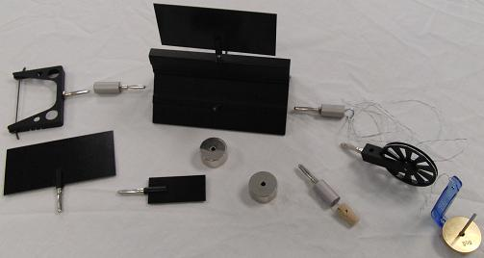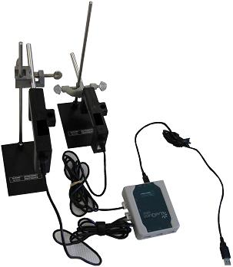
fig 5 glider plus attachable accessories ↘
to computer
Fig 6 basic cabling for two photogates

- Set the photogates with 40 to 50 cm of open space between them.
- Adjust the height of the photogates so the flags do not hit the photogate and so they will interrupt the beams when the gliders slide through the gates. (Test to ensure that photogate beam interruptions are timed and glider velocities are calculated.)
- Level the air track see fig 4.

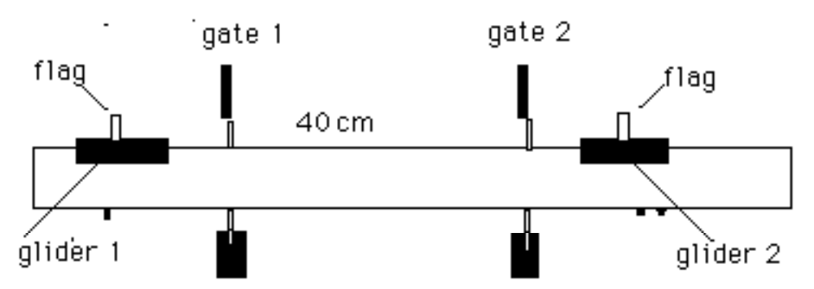
Figure 7 diagrammatic representation of the air track setup

Elastic Collision Procedure
The gliders with bumper & other attachments should resemble Figure 8A, 8B, or 8C.
Figure 8A
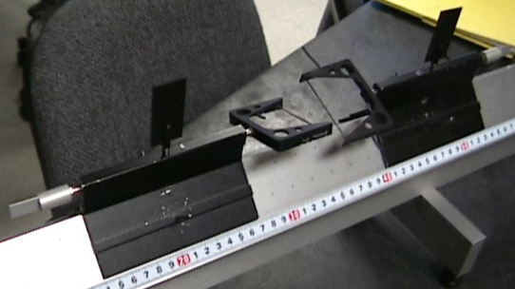

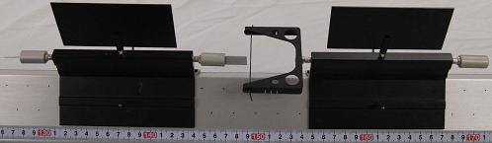
Fig 8B alternative configuration for elastic collision
Figure 8C
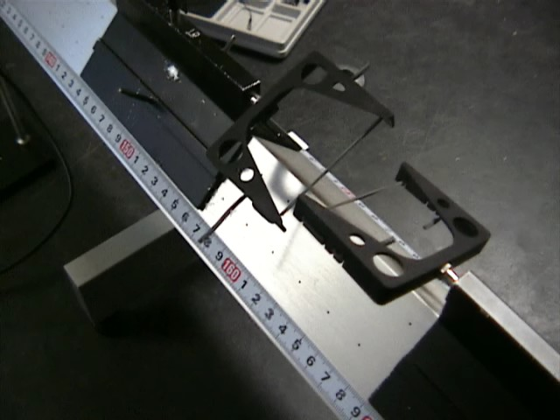

- Affix a bumper to glider 1 and glider 2 as shown in Figure 8C. Balance the gliders by attaching another fixture on the other end as shown in Figure 8A or 8B. Weigh both gliders (with the bumpers, flags, and counterbalance.)
- Enter the mass of each glider in Data Table 1. The masses of the gliders should be close to equal.
- Case 1: Place glider 2 between the two gates and carefully bring it to rest. Start the timer and launch glider 1 toward glider 2. Catch the glider that bounces off.
- Record your data.
- Repeat for the following 2 cases:
- Case 2: Add 0.1 kg to glider 1, keep glider 2 at rest.
- Case 3: Have both gliders moving towards each other with the no extra mass (as in Case 1.)
- The computer records all times and calculates the velocities. Calculate the momentum of each glider and enter the results in Table 1. Compare the total momentum prior to the collision to the total momentum after the collision. [Remember that momentum is a vector quantity! It has direction (+ or -) as well as magnitude]. Calculate % error between the total initial momentum and total final momentum.

Inelastic Collision Procedure
The gliders should resemble Figure 9A, 9B. or 9C.
Figure 9C is a close-up of the inelastic bumpers mounted between the gliders.

Figure 9A
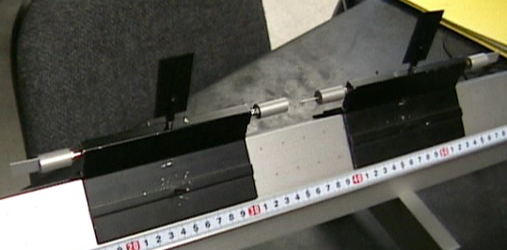

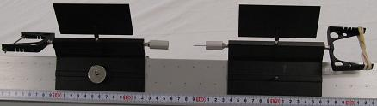
Fig 9B alternative configuration for inelastic collision

Figure 9C
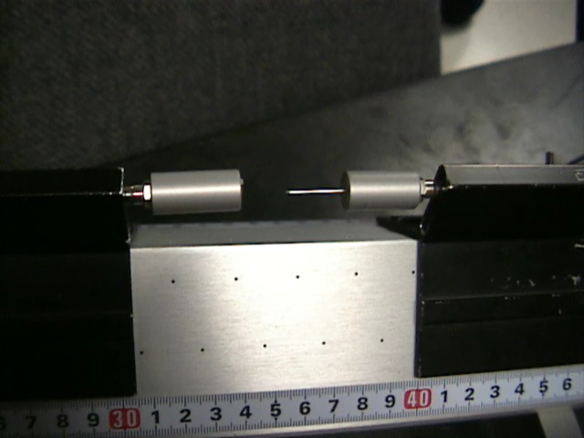

- Replace the bumpers with inelastic end pieces - a straight pin and clay cup.
- Repeat steps 3 through 7 of the elastic collision section.

Energy Calculations
- In the elastic collisions, the total kinetic energy is theoretically the same after the collisions as it is before the collisions. Compare your kinetic energies. Express the % difference (if any) between them. Record your results in Table 3. Remember, the expression for kinetic energy is:
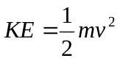
where m is the mass of the glider and v is the velocity of the glider.
- For the completely inelastic collisions where the objects stick together after the collision, show that some kinetic energy is be "lost" in the collision. Calculate how much was lost.
- Record your results in Table 4.

