Name________________________

Angular Acceleration

And

Moment of Inertia

Equipment Needed

Laptop computer with AC adapter & mouse N3-PR,M0-PR, or T0-L
Data logger with I/O cabling 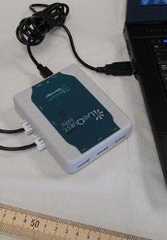 Y4-PR

Calipers, Digital stored in black case EE6-PR
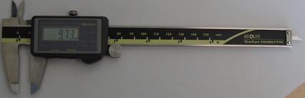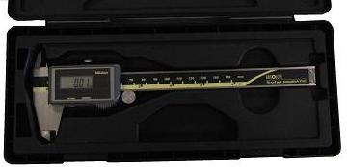

Clamp, 90º
Table clamp Large table clamp E2-L 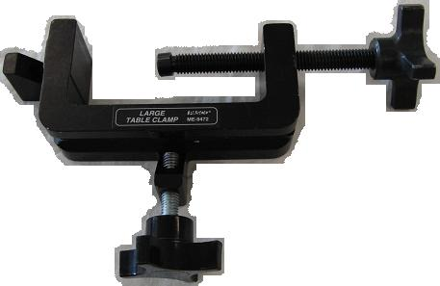

Mass Hanger, 50g H2-L 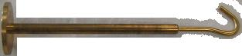
Mass Set, Gram, w/500g H2-L
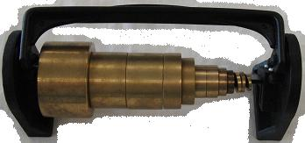
60cm rod @ L5-L
Rotational Motion Apparatus
@ SS1-L & SS2-L 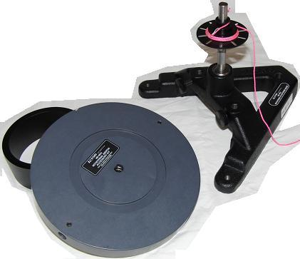
Scale, digital with ac adapter DD4-PR 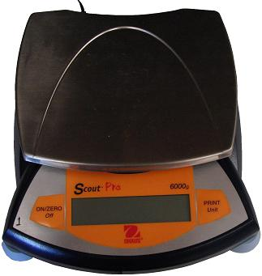

Photogate in smart pulley configuration
w/ photogate mount
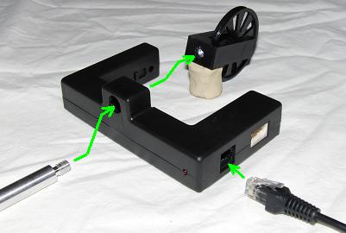

Rotational motion apparatus setup
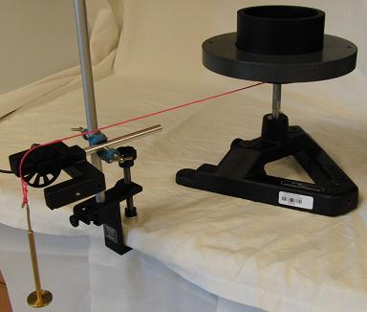
Fig 1 basic rotational motion setup

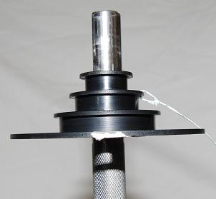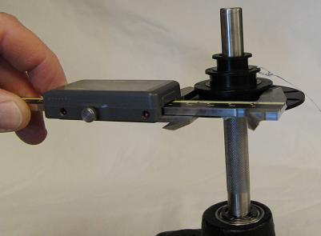
Fig 2 triple diameter pulley wheel Fig 3 measuring the pulley wheel diameters with a caliper.
Do not untie the string! In this figure, the diameter of the larger pulley wheel is being measured.

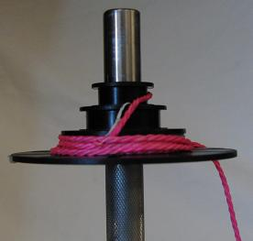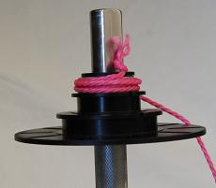
Fig 4A string wrapped around the bottom pulley Fig 4B string wrapped around the top pulley
Fig 4 string is already tied to the pulley wheel and does not need to be untied. Simply wrap the string around which ever pulley you need or choose to use.

Do not untie the string.

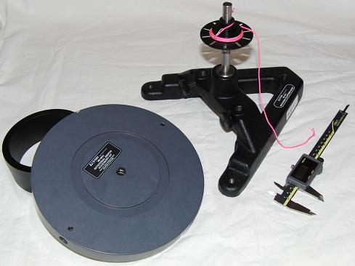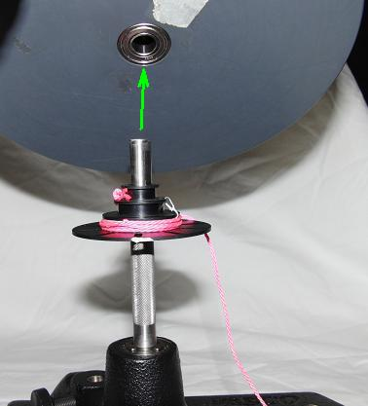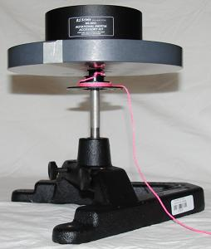
Fig 5A hoop + disc + axle Fig 5B attaching disc to axle Fig 5C rotational apparatus assembled
Fig 5 attaching the disc to the axle Note: the iron hoop is kept centered by setting
It in the groove on one side of the disc.

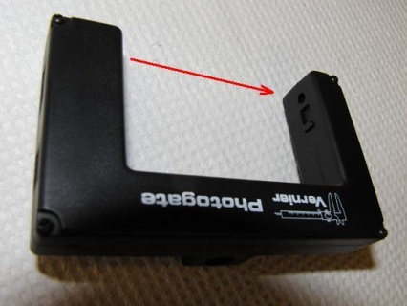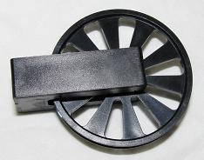
Fig 6A photogate with infrared Fig 6B ten spoke pulley Fig 6C photogate pulley assembly
light beam (below our range of visibility) wheel
Fig 6 linear motion sensor assembly
When the pulley executable file of Logger Pro is open and the 10 spoke pulley wheel has been added to the photogate, the software expects ten equally sized spokes with each spoke spanning 18° of arc on a pulley wheel groove of radius 24.0mm. If the wheel is turned ‘n’ full turns then the string has moved (~15.1 *n ) ± 0.8cm. ( = 2 π r )

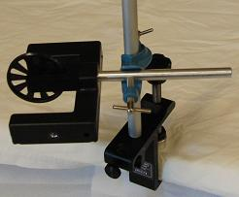
Fig 7 configuring the pulley for use with the rotational motion apparatus

Connect the photogate cable shown in fig 6C to the LabQuest Mini datalogger & connect the data logger via its USB cable to the laptop computer.

Open the Logger Pro software from the Physics desktop folder. Then,
File -> open -> ‘probes & sensors’ -> photogate -> pulley

Theory
In this experiment, we will investigate the concept of moment of Inertia. We will calculate the moment of inertia I of a disk by applying a torque τ to the disk causing it to have an angular acceleration α.
If a force F_{t} is applied tangentially to the step pulley of radius r, found on top of the disk, the disk will experience a torque:
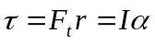 Equation 1
We will solve for the moment of inertia I by using Equation 1 and then compare it to the moment of inertia calculated from the following equation:
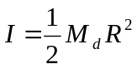
where
R is the radius of the disk
M_{d} is the mass of the disk.
Note: Do not confuse R with r.
We can also place a ring on top of the disk and find its moment of inertia using Equation 1. We will then experimentally find the moment of inertia of both ring and disk together and subtract the moment of inertia of the disk from the total moment of inertia of disk and ring together. Finally, we will compare this value to the following equation:
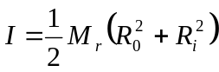
where
R_{o} and R_{i} are the inner and outer radii of the ring respectively
M_{r} is the mass of the ring.

Finding F_{t} , the Tangential Force
Figure 2
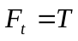
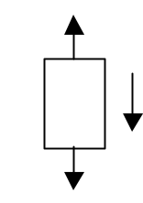
Weight = M_{h}g (M_{h} = hanging mass, g = 9.8 m/s²)

A string will be attached to the small step pulley on top of the disk while the other end of the string will go over a smart pulley and then be attached to a hanging mass, M_{h.}
The tangential force F_{t} on the disk is the tension T of the string. By studying Figure 2,
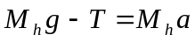
a is the acceleration of the hanging mass
Rearranging
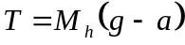
In this experiment, a is insignificant to g to two significant figures, so that the tension T is approximately equal to Mg.

PROCEDURE
- Set up the apparatus as shown in Figure 1. Level the disk. Note: It doesn’t require bubble accuracy. Attach a string to the small step pulley on top of the disk. Measure and record the radius r of the step pulley where the string will be wound up. Pass the other end of the string over the smart pulley to a hanging mass, M_{h}. Rotate the disk to wind the string on the pulley in one smooth layer. Plug the smart pulley into the adapter connected to DG1.
- Turn on the computer and click on the LoggerPro 3.3 icon and then go to the smart pulley file. Open→Experiments\Probes & Sensors\Photogates\Pulley.xmbl
- Three Graphs will open along with a data sheet.
- Click ‘Collect’ button at the top of the screen. Release the hanging mass and then click ‘Stop’ before the weight hits the floor or the string completely unwinds.
- On the menu, click Analyze→Autoscale→Autoscale from 0.
- On the Velocity vs. Time graph drag a box a good, smooth section of data.
- On the menu, click the linear fit button. Record the slope of the curve as the linear acceleration a. Calculate the angular acceleration α by using 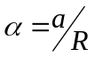. Calculate torque at the pulley radius from 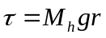.
- From 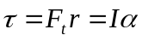 calculate I.
- Repeat for different masses and pulley radii or add a ring to the disk as assigned. Your instructor may want specific configurations.
- Compare to the calculated “static” moment of inertia:
.
- If you used the ring, find the moment of inertia of a ring, find the moment of inertia of both ring and disk together and then subtract the moment of inertia of the disk from the total moment of inertia. We would then compare this to the following equation:
where
R_{o} and R_{i} are the inner and outer radius of the ring respectively
M_{r} is the mass of the ring.

DATA
Disk: M_{d} = _________ R = __________ I_{disk} = (1/2)M_{d}R² = __________
Ring: M_{r} = _________ R_{o} = _________ R_{i} = ________
I_{ring} = (1/2) M_{r} (R₀²+R_{i}² ) = __________

For disk
Hanging  Mass M_{h}  (kg) | Hanging  Weight  M_{h}g  (N) | Radius r  of step pulley  (meters) | Torque τ  (N-m)  M_{h}gr | Linear Acc  a  (from graph)  (m/s²) | Ang acc α  (a/r)  (rad/s²) | I  τ /α  (kg-m²) | I  From above  (kg-m²) | %  difference

For ring
Hanging  Mass M_{h}  (kg) | Hanging  Weight  M_{h}g  (N) | Radius r  of step pulley  (meters) | Torque τ  (N-m) | Linear Acc  a  (from graph)  (m/s²) | Ang acc α  (a/r)  (rad/s²) | I_{total}  τ /α  (kg-m²) | I_{ring}  I_{total}-I_{disk}  (kg-m²) | I  From above  (kg-m²) | %  diff

