Density
And

Specific Gravity
Equipment Needed
Calipers, Digital stored in black case EE6-PR  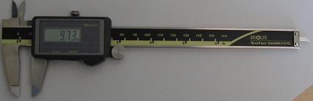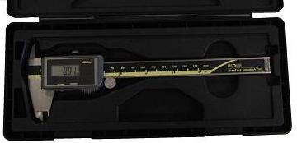 | Scale,digital with ac adapter DD4-PR 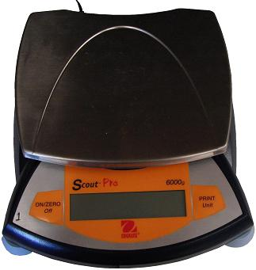
Density samples as Instructor specified F2-L & F1-L  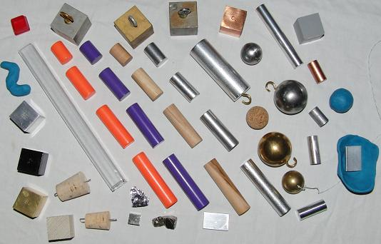 | Lab Jack G2-L 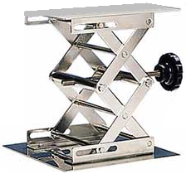 Ruler C3-L
graduated cylinder, 100ml CC5-L  triple beam balance QQ4-L 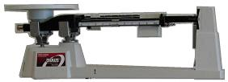  secondary water container, plastic BB5-L  overflow cup J1-L 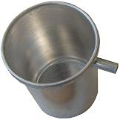 | paper towels Y4.5-L  String  PP4-L & back of DD6-PR  60cm ½” dia rod L5-L  Large table clamp E2-L 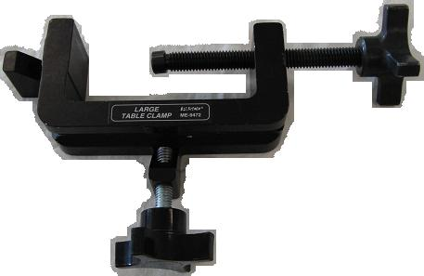

Lab setup
Various density setups & mass measurement options
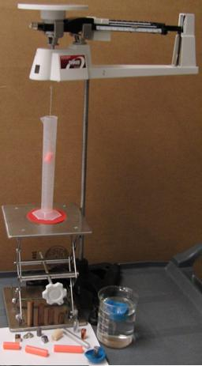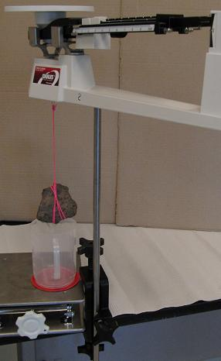
Fig 1 basic density setup using fig 2 setup with 500ml beaker &
a 100ml graduated cylinder a table clamp
& small material sample

Caution: The balance on top of the rod weighs ~10pounds. We’ve not seen or heard of it falling over; but, if it were to fall on your foot, it will be most unpleasant. So, take care not to knock it over or bump into it.

Refer to figs 3 thur 9 for setup and calibration details.
See figs 10 thru 15 for other setup options.
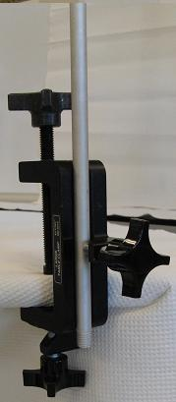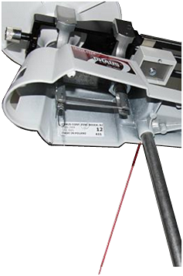
rod support slot
Fig 3 attach clamp to table Fig 4 set the balance on the support rod
(see fig 2 for full setup with the table clamp)
Zero the scale

Put each movable mass on each of the three beams to zero. Then adjust the fine zero adjust knurled knob at the left end of the beam until the zero reference line and the beam reference line come into alignment (see A in fig 6). If unable to align the two reference lines, then use the tare (or course zero) in combination with the fine adjustment.
Note: the principal purpose of the tare is to re-zero the scale after a sample container (such as a beaker or cylinder for holding fluids or powders or spheres) is set on the scale and then the balance is zero’d.

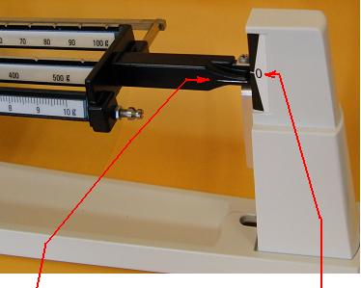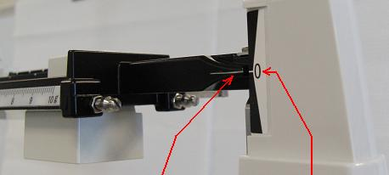
Fig 5A A B Fig 5B A B
A => position of balance beam line B => fixed zero reference line

Fig 6A 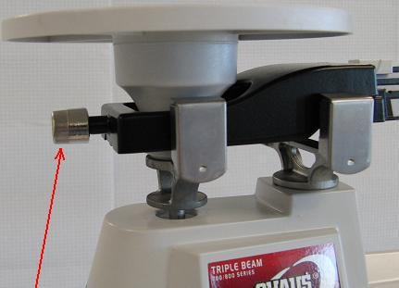 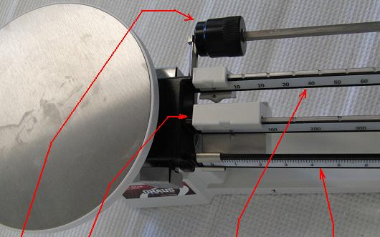
A Fig 6B B C D E
A => fine adjustment knob B => tare adjustment mass C => beam 1 of 3 D => beam 2 of 3 E => beam 3 of 3
or, course zero balance
Fig 8 fine zero adjust and course or Tare zero adjust

Weighing objects from the underside of the scale
Hang your sample mass from the underside of the balance. Note: the paper clip must be attached to the small pin indicated in fig 7B. Attachment elsewhere will lead to inaccurate measurements.

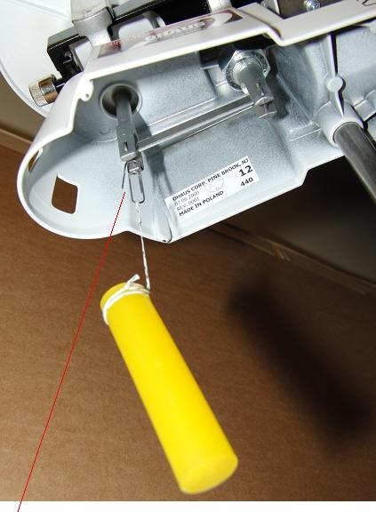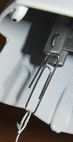
Fig 7A Paper clip attachment point for hanging Fig 7B closeup of paper clip
masses from the triple beam balance. attachment to the balance

See fig 8A->8H for how to attach the ‘object to be measured’ to the support string.

Fig 8 how to form a noose to hold objects
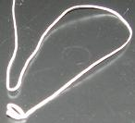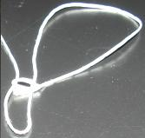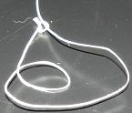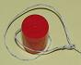
Fig 8A. put a fold (or bend) near fig 8B push the fold (bend) thru fig 8C add another turn to the fig 8D insert object to be held
the middle of the string the small loop at the end. slip knot loop in the double loop slip knot
This effectively forms a
slip knot

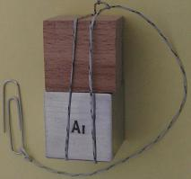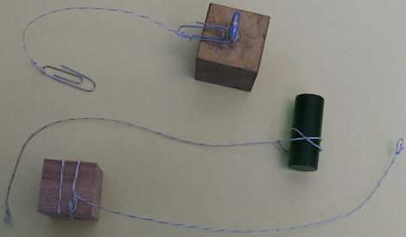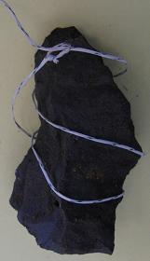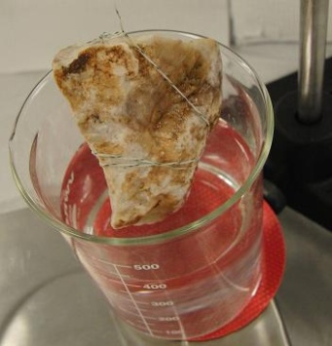
Fig 8E tighten the double loop fig 8F additional examples of mass attachment fig 8G triple loop fig 8H triple loop around
slip knot to string slip knot rock before immersion
around rock sample
in beaker of water

Submerging low density objects

To submerge low density objects, a higher density object must be used to pull the low density object below the supporting liquid’s surface. Fig 9 shows the setup for submerging a cork.

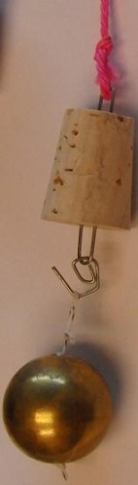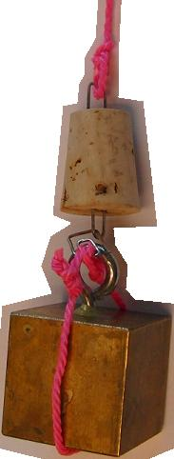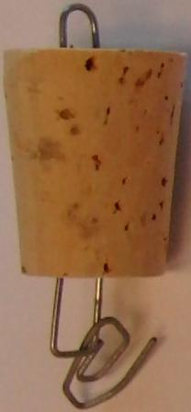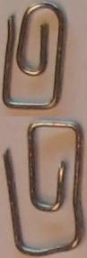
Fig 9A basic setup for submerging Fig 9B enlarged view Fig 9C miniature
low density objects low density cork paper clips

Adjust the lab jack as necessary to submerge the object being measured.

Note: do not allow the object being measured to rest on the bottom of the container. In addition, when using the 100ml graduated cylinder, the small spheres wedge into the cylinder at roughly the 20 – 25 ml mark. Submerge the sphere beneath the fluid’s surface but keep the sphere above any wedge point.
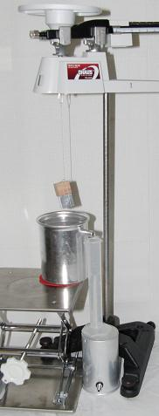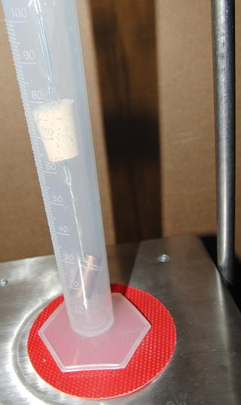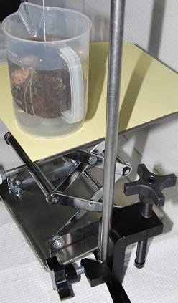
Fig 10 using an overflow can Fig 11 using a 100ml graduated cylinder Fig 12 irregular object also, see fig 2, 5G, & 5H

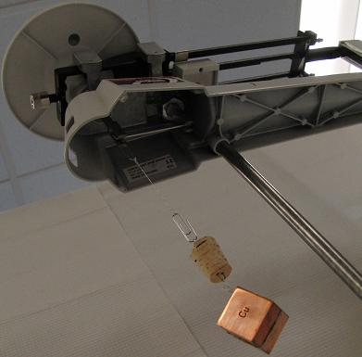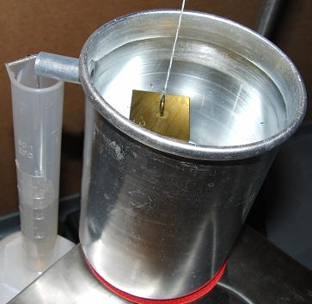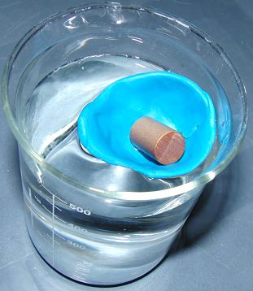
Fig 13 setup for determining the Fig 14 capture of overflow water Fig 15 clay boat with cargo
density of cork

Introduction
Substances are identified by characteristic properties. One such property is MASS DENSITY. Mass density is defined as mass per unit volume. The mass density of a regular solid may be determined quite easily.
- Use a digital scale measure the mass.
- Using an appropriate method, measure the dimensions of the solid.
- Calculate the volume of the regular object from the dimensions.
- The mass density can then be found by the formula:
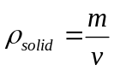
where
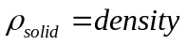 in 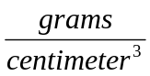
in 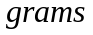
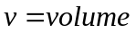 in 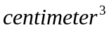
The volume of an irregular object may be determined by the volume of liquid it displaces. For this lab we will be using tap water. When we know the volume we can use the above calculation.
Specific Gravity is defined as the ratio of mass density of an object to the mass density of water given by the formula:
Specific Gravity 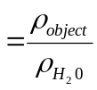
We will assume that the mass density of water is 1. (By definition: At 4°C pure water has a density (weight or mass) of about 1 g/cc, or 1 g/ml. Remember, the volume of water is temperature dependent.)

Objective A: To determine the density and specific gravity of a solid.

Procedure
- Using the ruler (or caliper), measure the height and diameter of the cylinders and calculate the volumes. Note: Some instructors choose different quantities or types of cylinders.
Record the measurements and volumes in Data Table A.
- Determine the mass of each cylinder and record the results in Data Table A.
- Calculate the density and specific gravity of each cylinder and record the values in Data Table A.
- Compare the experimentally determined specific gravity to the accepted value.
Objective B: To determine the density and specific gravity of an irregular object using the displacement method.

Procedure
- Determine the mass of the object. Record it in Table B.
- Fill a graduated cylinder about half full with water. Record the reading in the graduated cylinder to the nearest 0.1 ml in Table B (1 ml = 1 cm³).
- Lower the object with a string into the water. Record the new reading of the cylinder to 0.1 ml in Table B.
- The difference in readings is the volume of the displaced water, which is the same as the volume of the object. Record this difference in Table B.
- Determine the density and specific gravity of the object.
- Compare the experimentally determined specific gravity to the accepted value.
Objective C: (Optional)
To determine the density and specific gravity of a liquid. This method may be used to determine the mass density of the water if desired.

Procedure
- Determine the mass of the empty graduated cylinder and record in Table C.
- Add liquid to the graduated cylinder and determine the mass of the graduated cylinder plus liquid and record in Table C.
- Determine the mass of the liquid by subtracting the mass of the empty graduated cylinder from the mass of the graduated cylinder plus liquid. Record the data in Table C.
- Measure the volume of the liquid directly from the graduated cylinder.
- Determine the density and specific gravity of the liquid and record in Table C.
- Compare the experimentally determined specific gravity to the accepted value.

Table A
Metal | Mass  (g) | Height(H)  (cm) |  | Diameter(D)  (cm) | Volume  (cm³)  πHD²/4 | Density  (Exp.)  (g/cm³) | Specific  Gravity  (Exp.) | Specific  Gravity  (Acc.) | Percent  Error
1.

2.

3.

4.

TABLE B
Metal | Mass of  Metal  (g) | 1st Reading  Cylinder  (cm³) | 2nd Reading  Cylinder  (cm³) | Volume  (cm³) | Density  (Exp.)  (g/cm³) | Specific  Gravity  (Exp.) | Specific  Gravity  (Theor.) | Percent  Error

TABLE C
(Optional)

Liquid | Mass of  Graduated  Cylinder  (g) | Mass of  Liquid and  Graduated  Cylinder  (g) | Mass of  Liquid  (g) | Volume  (cm³) | Density  (Exp.)  (g/cm³) | Specific  Gravity  (Exp.) | Specific  Gravity  (Theor.) | Percent  Error

Question:
Which has the greatest density, a glass of milk or a pitcher of milk? Explain.

