Name: _____________________________

Specific Heat

Equipment Needed

Density cubes, large with hooks F2-L 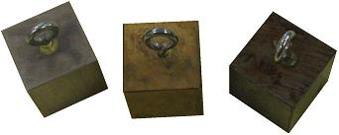
Clamp, Pendulum G3-L
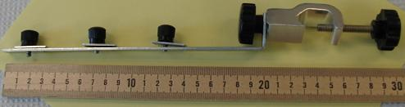

Styrofoam cups for calorimeter BB5-L 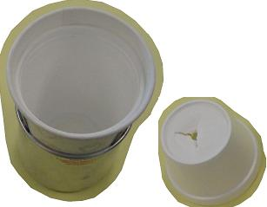
Extra cup for water storage BB5-L 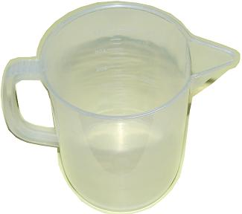

Cup, for boiling FF2-L 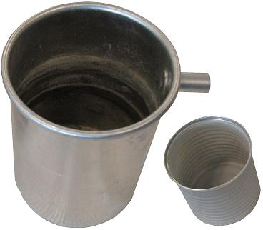
Hot plate FF2-L 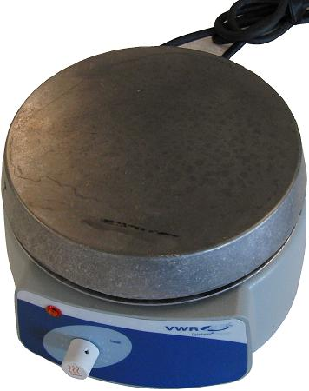
60cm ½” dia rod L5-L
Scale, Digital DD4-PR 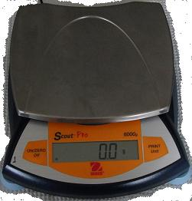
String with paper clip DD8-PR (in back)
Thermometer, Digital Y6-PR 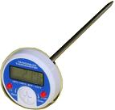
Paper towels Y4.5-L

Objective
The purpose of this lab is to determine the specific heats of several different metals.

Introduction
If you mix hot and cold water together, the temperature of the final mixture depends on how much hot water is added to how much cold water. If you throw a hot branding iron into a pail of cool water, you know that the temperature of the iron will go down. You also know that the temperature of the water will rise--but will its rise in temperature be more, less, or the same as the temperature drop of the iron? That is, will the temperature of the water rise as much as the temperature of the iron goes down? Or will the changes of temperature instead depend on the relative masses of the iron and the water?
In this experiment, you are going to investigate the quantity of heat per gram per degree (Celsius), known as the specific heat. Water has a specific heat of 1.00 cal/g°C--relatively large compared to most substances.
The heat (Q) lost by a specimen, say a piece of metal, submerged in water equals the heat (Q) gained by the water and by the container. In this experiment we will neglect the heat absorbed by the Styrofoam container, as it is negligible.

Qlost = Qgained

Heat, Q = Specific Heat of Substance x Mass of Substance x Change in Temperature.

Heat lost by metal block = Heat gained by water

CmMm(Tim - Tf) = CwMw(Tf - Tiw) Equation 1

Where Cm = specific heat of the metal
Mm = mass of metal
T_{im} = initial temperature of the metal
Tf = final temperature of metal and water
Cw = specific heat of water
Mw = mass of water
T_{iw} = initial temperature of water

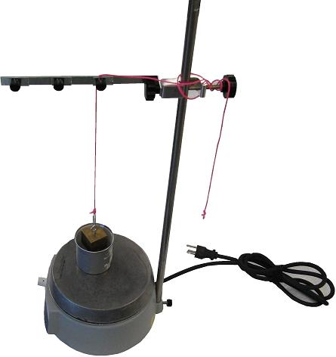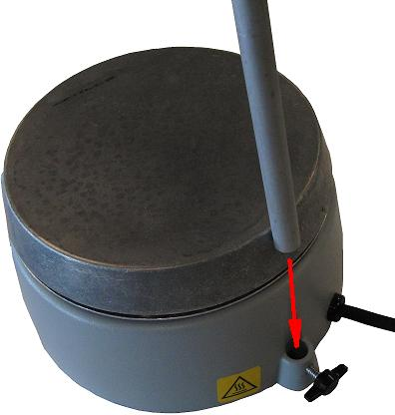
Fig 1A basic setup Fig 1B attachment point for mounting rod
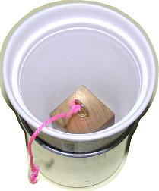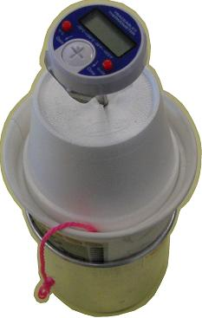
Fig 2A calorimeter cup (styrofoam cup) with lid Fig 2B sample in cup Fig 2C cup w/sample + lid
+ thermometer

Procedure Prevent electrical cords, string, Styrofoam cups, etc, from coming in

contact with the hot plate!
- Begin by boiling water in the provide metal cup. The cup should be filled with enough water to cover the sample.
- Find the mass of the metal (Mm) and record it in the table.
- Attach a piece of string to the metal and lower it into the beaker. Be sure the metal is completely. immersed in the water. Heat the metal in the water for at least 5 minutes. Our assumption will be that the metal’s temperature is the same as that of the boiling water. Measure and record the temperature of the boiling water. This is equal to the initial temperature of the metal (T_{im})
- Find and record the mass of the empty calorimeter cup. (Mc).
- Fill the calorimeter cup about one-half full of cold water (about 3° below room temperature) and find the mass of the cup and water (Mcw).
Subtract the mass of the cup to obtain the mass of the water in the cup (Mw).
- Find and record the initial temperature of the water (Tw).
- Holding the metal block by the string, quickly (but carefully) transfer the metal block into the calorimeter cup.
- Stir and record the temperature of the water when it reaches its highest point (Tf).
- Calculate the specific heat of the metal by using Equation 1.
- Compare the specific heat of the metal by its accepted value. Calculate the percent error.
- Repeat the above procedure for a different metal.

Data Table

Type of Metal | Mass of Metal  M_{m} (g) | Mass of cup + water  M_{cw (g)} | Mass of cup  M_{c (g)} | Mass of Water  M_{w} (g) | T_{im}  ºC | T_{iw}  ºC | T_{f}  ºC | Spec.Ht.  Experi.  (cal/gºC) | %  error

Specific Heats for Laboratory Samples at 20º C
Fe  0.119 | Cu  0.092 | Sn  0.054 | Zn  .0925 | Al  0.214 | Pb  0.0306 | Brass  .0917

