Acceleration Due
To
Gravity

(RRC3A): => Freefall

Section 1: Equipment Needed for freefall

Clamp, 90º (x2) E2-L 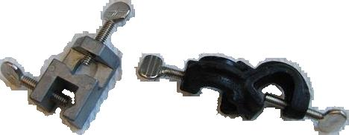
Table Clamp, large E2-L 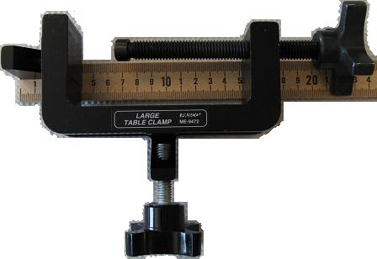
Scale, Digital DD4-PR 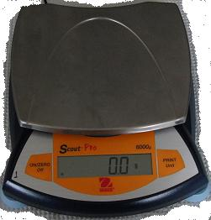
Meter stick H4.2-L (in window)
Ring Stand rod, 120 cm L4-L (on counter)
Pasco Freefall apparatus:
Free fall timer K3-L 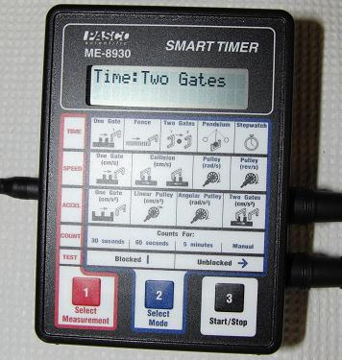
with AC adapter [9Vdc 1.7A tip+/sleeve-]

Freefall control box PP3-L 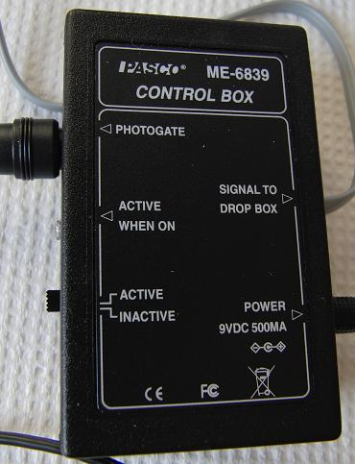
with AC adapter [9Vdc 500mA tip+/sleeve-]

Freefall drop box PP3-L 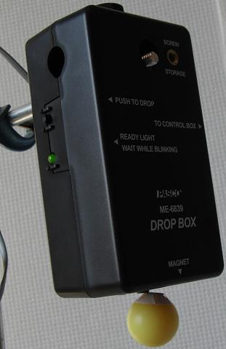
Time of flight stop switch PP3-L 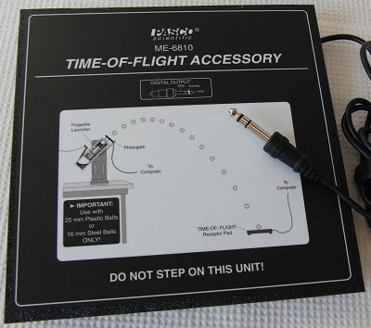
Interconnect wiring cables PP3-L 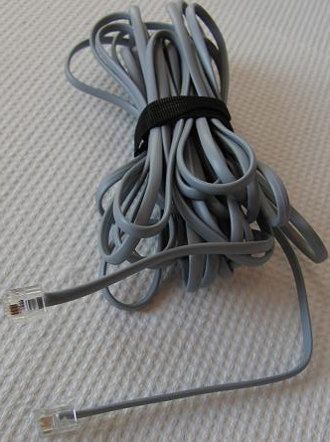
Freefall ball(s) with storage box PP3-L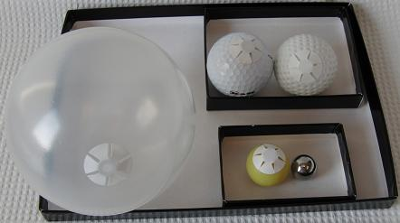
Freefall release switch E1-L 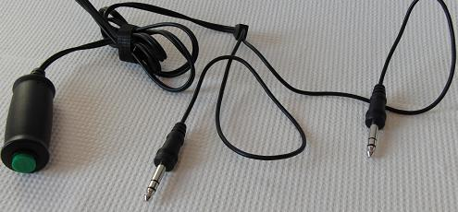
30cm short cross bar/rod to support the drop box E1-L
as shown below
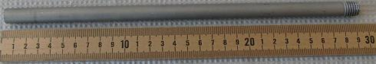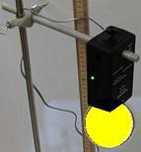
3 finger clamp E1-L 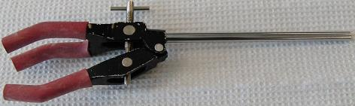

Purpose
To measure the acceleration due to gravity in the lab by direct measurement and by timing the period of a pendulum.

Introduction
The acceleration of a body in the earth's gravitational field, g, is inversely proportional to the square of the distance from the center of the earth. Therefore g gets smaller as one goes out into space. The value of g varies slightly on the earth's surface also. It is largest at the poles and smallest at the equator due to the rotation of the earth. It is also smaller at higher elevations. The local value of g is 9.793 m/s2. In this lab, we will use the text book value of 9.80 m/s2 as the accepted value when calculating the percent error in your results.

Method 1 – Free Fall

Theory
An object dropped near the Earth’s surface will fall with an acceleration of g, independent of its mass. This was the famous observation of Galileo. This is true specifically when air friction effects are negligible. Thus in a vacuum, a feather falls as quickly as a gold ring. The kinematic equation which describes the vertical position of an object at any time if it is dropped from rest is
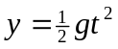. (1)
For this particular formulation, it is very convenient to think of y being measured in the downward direction. That is, as time goes by the object is at greater positive values of y as equation obviously implies.
In other situations it will be more convenient to “point” the y-axis upward. In this case a minus sign has to be stuck in front of the right side of equation (1) so that as time increases, the y-value decreases.
Remembering the general formulation for a straight line
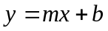, (2)
we can force equation (1) to fit this by letting
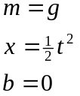. (3)
Your lab today is to experimentally determine the parameters m and b in equation set (3). You will accomplish this by measuring y and t for various heights of fall for a steel ball. After your data has been acquired you will plot y vs. x, where x takes on the value shown in equation (3). The slope of your best-fit line will be your value of g, and the intercept will be a further check on the validity of equation set (3).

Setup & Procedure
Wiring setup. Refer to fig 3 for the full setup.

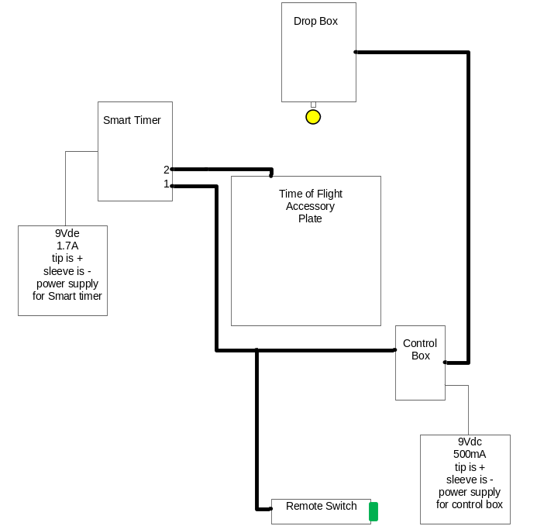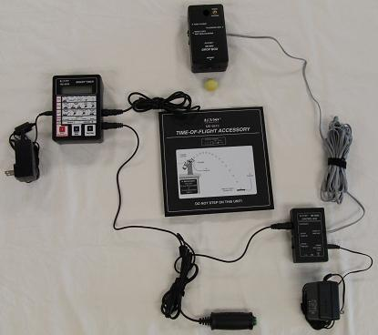
fig 1 wiring diagram for fig 2 & 3 fig 2 alternate view showing
physical wiring see fig 1

Assemble the freefall materials as shown in fig 2 &3.
Theory of operation: when the ‘remote (release) switch’ is pressed, it stops current flow in the ‘drop box’ which turns an electromagnet off and releases (drops) the ball. This also starts the timer which runs until the ball hits the ‘time of flight accessory’ plate which stops the timer and displays the time the ball was falling. Refer to functional procedure below.
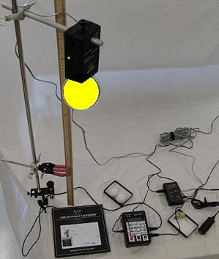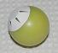
Fig 3 basic full setup Fig 4 showing iron washer
taped to freefall ball
This allows the ball to be held by
the drop box electro-magnet.
Procedure:
- On the timer, press the ‘select measurement’ red 1 mode select button once to select the ‘time’ mode
- Press the ‘select mode’ blue 2 select button 3 times to select the ‘two gates’ mode. This configures the timer as a start/stop timer.
- Check the ‘active/inactive’ switch on the side of the control box and make sure it is in the ‘active’ position
- Hang a ball underneath the ‘drop box’ as indicated in fig 2 & 3
  - Note: a steel washer is taped onto the non-steel balls (see the fig 4 example). A switch controlled electromagnet under the ‘drop box’ holds the steel washer that is held to the non-steel balls by the tape.
- Wait until the green ‘ready light’ on the drop box stops flashing, then continue.
- Press the ‘start/stop’ black 3 button on the smart timer (refer to the timer in the parts list). This sets the timer to expect a ‘start’ signal from the ‘remote (release) switch’.
- Press the green knob on the ‘remote (release) switch’. This both releases the ball and starts the timer.
- When the ball hits the ‘time of flight accessory’ plate (stop switch), it stops the timer and displays the freefall time.
Note: this is a piezoelectric contact detector that can be easily broken if excessive force is applied to it.
- Record freefall times vs drop height.

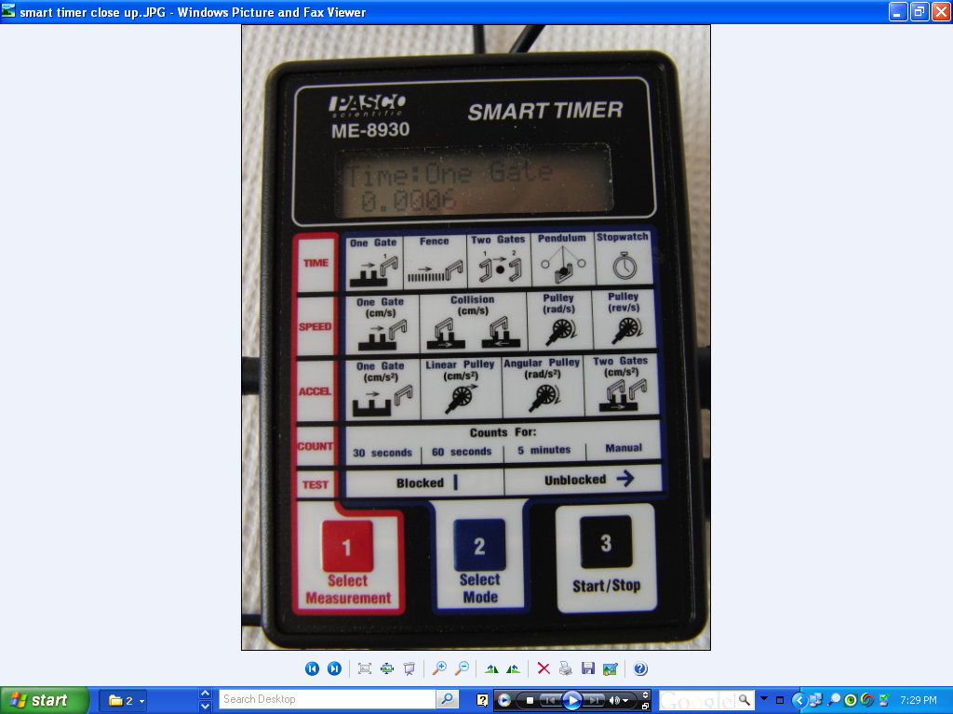
Fig 5 smart timer

Note: the AC power adapter for the Smart Timer Pasco ME-8930 has an output of 9Vdc & 1.7 A. The sleeve is negative & the tip has the + polarity.

the AC power adapter for the Control Box Pasco ME-6839 has an output of 9Vdc & 500 mA. The sleeve is negative & the tip has the + polarity.

Smart timer settings

press the button & set to then press the button & set to ‘one gate the display should display
press to ready the timer for a start signal when the green ‘ball-release’ switch is pressed. Hold a drop-ball against the drop-box’s solenoid magnet so it will be suspended from the drop-box 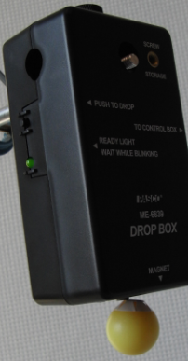 , press start then depress the green ‘ball-release’ switch and record the indicated time, in the smart timer’s sample picture.
- Adjust the distance d from the bottom of the ball to the top of the target pad.
- Attach the drop ball to the drop box.
- press on the smart timer to prepare it for measurement.
- Release the ball by depressing the green colored ball-release switch.
- Read the timer and repeat the above steps for additional measurements.
- Take 6 measurements with the small ball and the large ball from different heights.
You’ll be notified which drop balls to use.
Data Table: Free Fall
Trial | Height | Ball 1  Elapsed Time  Mass________ | Ball 1  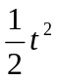 | Ball 2  Elapsed Time  Mass________ | Ball 2
1
2
3
4
5
6

Sample Calculation:

Questions
- Without air resistance, does the acceleration due to gravity vary with mass?
- How does air resistance affect the measured value of the acceleration due to gravity?
- What is your value for g? __________(three significant figures)
- What is the percent difference of your value from 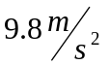? __________
(Note: in the Austin/Round Rock area, g = 9.793.

- Is your value of g reasonable? Explain why or why not.
- What is the value of the intercept on your graph? (three significant figures) __________
What is the meaning of the y-intercept on your graph?

