Friction
Equipment

AC Adapter, Dell Laptop
Cart, Constant Velocity I1-L 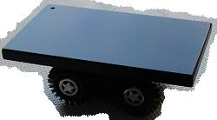
Dell Laptop Computer w/ Lab Pro
Dynamics Track, Pasco 120cm DD3-PR 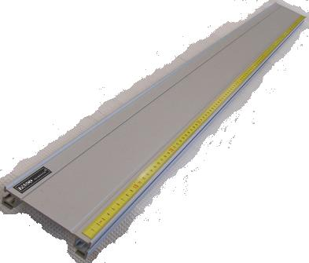
Friction Block, Wood w/ eye screw ME-9807 J3-L
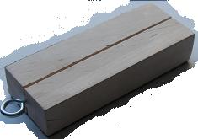
Wireless dongle EE2-PR 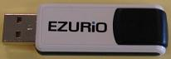
Lab Jack G2-L 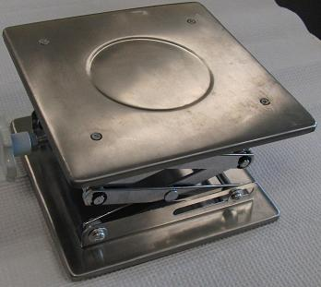
Mass Hanger, 50g. H2-L 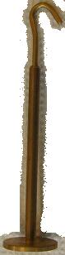
Mass Set, Gram . H2-L 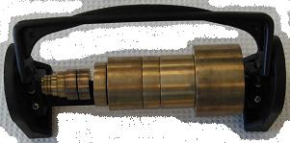
Protractor C3-L 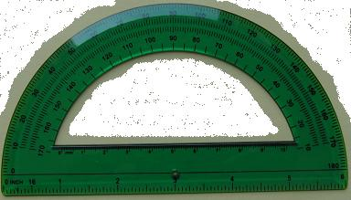
Pulley, Adjustable w/ Table Clamp F3-L 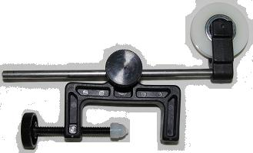
String DD6-PR (back side)
Wireless Dynamics Sensor System (WDSS) EE2-PR 

Right angle indicator QQ5-L 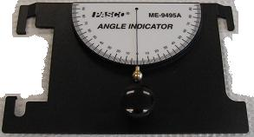

Introduction
In this lab, we will investigate the phenomenon of friction. Friction is the force that resists the motion of two objects sliding against each other. You probably already have some good intuition about friction. For example, we can imagine that it is harder to slide two rough objects past each other than two smooth ones.
Friction is not a fundamental force like gravity or electromagnetism, but is caused by the microscopic imperfections on the surfaces of objects. When objects slide past each other, tiny pits and bumps catch on each other making it harder for the objects to slide. We can reduce this catching by smoothing out the pits and bumps on surfaces.
As you can guess, the force of friction depends greatly on what the objects that are sliding against each other are made of. It also depends on how hard they are pressed together. Consider the figure below where mg is the force due to gravity on the object (also called its weight), F_{a} is the force applied, F_{f} is the force due to friction and F_{N} is the normal force.
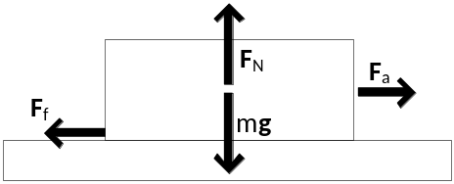
Fig 1
The applied force is to the right, so the opposing force due to friction is to the left. This opposing force is proportional to the normal force
.
Here µ is a unit-less scalar that is called the coefficient of friction (COF). In the above figure we can easily see that by Newton’s second law, the normal force must be equal to the objects weight, thus the force due to friction depends on the COF and how much the top object is pressing down on the bottom object. The COF is different for different materials and is usually between 0 and 1, but for some material (like rubber sliding on rubber) it can be greater than 1.
You may have noticed when sliding a heavy object across the floor that it is hard to start it moving, but once it is in motion it seems easier to push or pull. This is in fact the case. For objects that are not moving, µ=µ_{s}, the coefficient of static friction. For objects that are moving, µ=µ_{k}, the coefficient of kinetic friction. In general, µ_{s}≥µ_{k} as you will verify in this laboratory exercise.
Procedure
Begin by setting up the dynamics track with a pulley clamped on one end hanging over the lab table. See fig 2. Determine the mass of the wood block and place it with the two black strips side down on the track and connect the string to the hook. Add a 500g mass on top of the block. Drape the string over the pulley. Determine the amount of mass needed to just start the block sliding in each case and thus determine the COF of static friction for the block on the track surface. Record your data below.

 | two black strips w/500g | two black strips w/ 1000g | one black strip w/ 500g | one black strip w/ 1000g
mass req. to move block
COF (static)

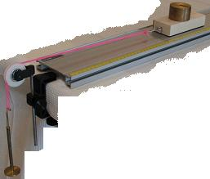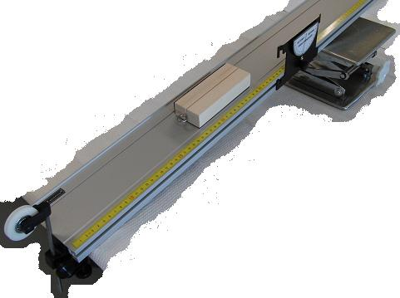
Fig 2 Fig 3 angled track using a lab jack & angle indicator
Q1) Does surface area appear to affect the value of the COF?

Now remove the pulley and put a lab jack under the dynamics track. See fig 3. With the wooden block placed on the high end of the track, begin raising one end of the track by slowly rotating the knob on the jack. Record the angle the track makes with the lab table where the wooden block just starts to slide down.

Q2) Draw the free body diagram of the block and track.

Q3) Using Newton’s second law, determine the relationship between the angle of the track and the COF.

Now we will analyze the friction between bodies in motion. Begin by attaching the WDSS to the wooden block with two rubber bands. Note: make sure that the rubber bands are fully within the notch of the friction block. If a rubber band is pinched between the block and the surface, the static COF will probably be too high for the battery driven tractor/cart to move the block. This will prevent you from determining the dynamic/kinetic COF.

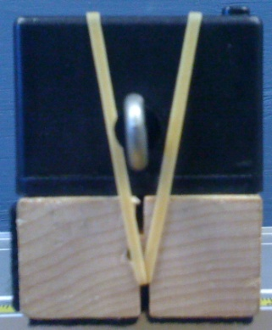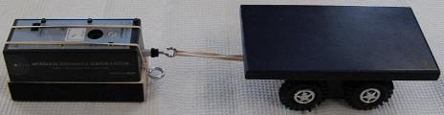
Fig 4 A Fig 4 B
Fig 4
Make sure that the Logger Pro program is running and set up to receive data from the WDSS and graph the force as a function of time. Do a few runs where you pull the wooden block by the attached rubber band by hand. Try to get the block to travel with a constant velocity and save the graph of your best run. This may take some practice.
Finally hook up the wooden block to a constant velocity cart with a rubber band. Begin taking data and switch on the cart. Be careful not to let it run off of the lab table; or, consider running it on the floor provided you don’t interfere with others. Repeat this procedure until you feel that you have a good graph.
Q4) Looking at your best graphs, explain what the different features of the graph tell you about the friction encountered by the wooden block. Be sure to identify where static friction is happening and where kinetic friction is happening.

Q5) Using the forces obtained from your graphs and the mass of the wooden block, WDSS, and the extra mass determine the COF for static and kinetic friction.

Q6) Which of the previous methods do you think best determined the COF for static and kinetic friction? Why?

