Centripetal Force
Equipment

Calipers, Digital stored in black case EE6-PR
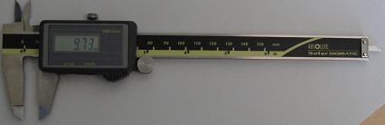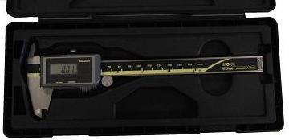
digital caliper in black case
Centripetal Motion apparatus RR2-L
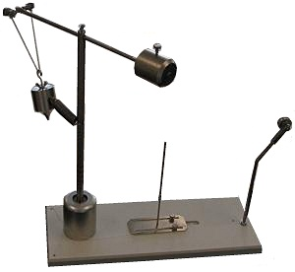
Mass Hanger, 50g H2-L 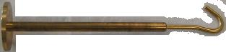
Mass Set, Gram, w/500g H2-L
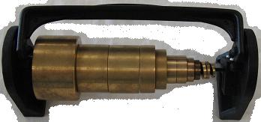
Ruler, 15in C3-L
Scale Digital DD4-PR 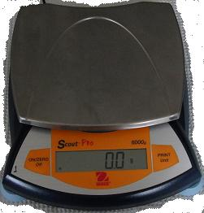
Stop Watch K3-L 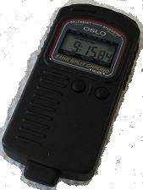
Large table clamp E2-L 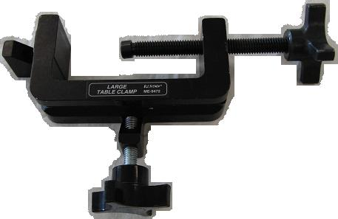
Photogate + cabling Y5-PR 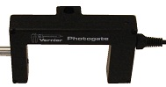
Universal clamp E2-L 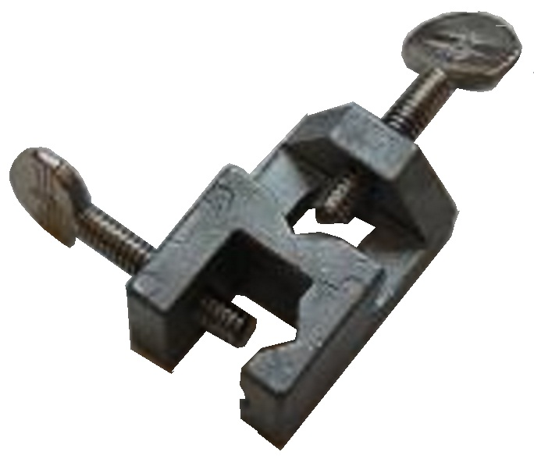
Small table clamp E3-L
60cm ½“ rod L5-L 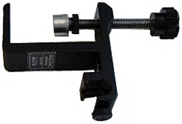
Data logger, with cabling 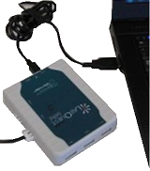 Y4-PR
Dell Laptop Computer with mouse &
AC Adapter, Dell Laptop N3-PR,M0-PR (on cart), or T0-L

Terminology
centripetal force: the force required to keep an object in uniform circular motion.
frequency: number of revolutions per second.
period: number of seconds to complete one revolution.
Overview
If you hang a mass on the end of a length of string and then start twirling the mass around, the mass will start swing farther and farther out. If you simply let the mass on the end of the string hang down and then take a spring scale and pull the mass out until you reach the radius of rotation, that force will be equal to the centripetal force on the plumb bob mass as it is being spun around.
We will compare a fairly direct measurement of force provided by a spring with the force calculated from the kinematically observed uniform circular motion. The quality of the comparison attests to the observed accuracy of the formula F_{c} = mv²/R.
Introduction
Newton’s 2nd Law of motion applied to uniform circular motion is written as
F_{c} = mv²/R, (1)
where F_{c} is the centripetal force, m is the mass of the object (plumb bob) in uniform circular motion with speed v and radius R.
When an object undergoes uniform circular motion, its speed can be computed by noting that its speed multiplied by the period of its motion is the circumference of the circle. As an equation this statement is written:
vT = 2πR (2)
or that,
v = 2πR/T.
Substituting equation (2) into equation (1) we obtain:
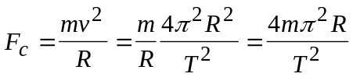. (3)
Equation (3) gives us the opportunity to calculate the force required for circular motion from two easily measured quantities, the radius R, and the period T. You will measure the radius with a ruler, and the period with a computer & a photogate. The photogate assembly is serving as a fancy automated stopwatch.
Accuracy
- All of your observations should be recorded to 3 significant figures. You should carry 3 significant figures in all of your calculations as well.

Figure 1A: Basic Setup 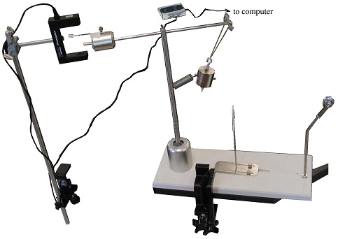

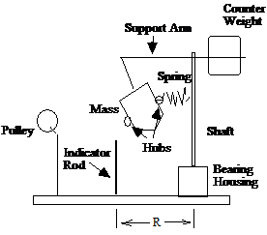

Fig 1B
Procedure
- As shown in fig 1, clamp the centripetal motion apparatus to the lab table with the large table clamp.
- Unbend half of a small paper clip, tape it to the ‘counter weight’, and add a small piece of masking tape around the end of the straightened paper clip: as shown in fig 2A.
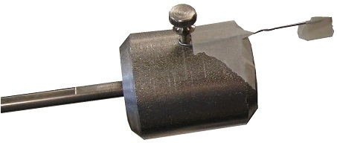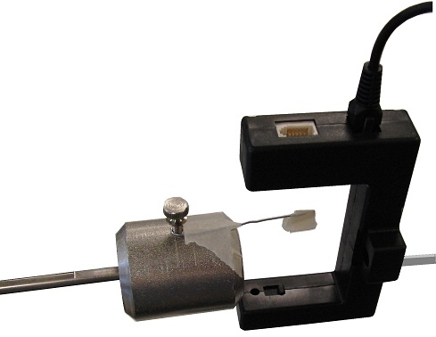
Fig 2A Fig 2B
The paper clip serves as a flag to trigger the photogate’s IR light beam.
A small piece of masking tape on the end of the paper clip may make it easier to see and align.
- Connect the photogate to the 60cm rod with the universal clamp as shown in fig 3.

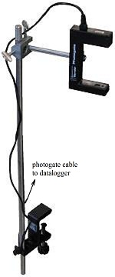
Fig 3
- Connect the cabling between the photogate, datalogger, & computer.
- Very slowly and carefully rotate the plumb bob and adjust the position of the photogate so it is safely triggered by the paperclip flag without any parts hitting any other parts (example: you don’t want any parts, like the plumb bob hitting the photogate or cabling, etc, while the system is rotating).
- Connect the cabling between the photogate, datalogger, & computer.
- Very slowly and carefully rotate the plumb bob and adjust the position of the photogate so it is safely triggered by the paperclip flag without any parts hitting any other parts (example: you don’t want any parts, like the plumb bob hitting the photogate or cabling, etc, while the system is rotating).
- Connect the cabling between the photogate, datalogger, & computer.
- Connect the cabling between the photogate, datalogger, & computer.

- Connect the cabling between the photogate, datalogger, & computer.
- Very slowly and carefully rotate the plumb bob and adjust the position of the photogate so it is safely triggered by the paperclip flag without any parts hitting any other parts (example: you don’t want any parts, like the plumb bob hitting the photogate or cabling, etc, while the system is rotating).
- Attach a string to the plumb bob mass with a paper clip. Attach a mass hangar to the other end of the string and drape the string over the pulley. Add mass to the mass hangar until the bottom of the mass hovers directly over the ‘indicator marker’ (see fig 1B & fig 4).
Fig 4 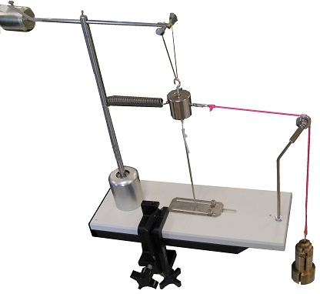
- If you attach a small piece of poster board high enough on the indicator post with a small piece of masking tape, and you then spin the plumb bob support arm enough to cause the tip of the plumb bob to be centered and pass over the tip of the indicator post and strike the poster board, the poster board will make a faint clicking sound and will jitter each time the plumb bob swings past the indicator post. See figure 6A & B. This will make it a bit easier to safely keep the plumb bob mass centered over the indicator post as you spin it.

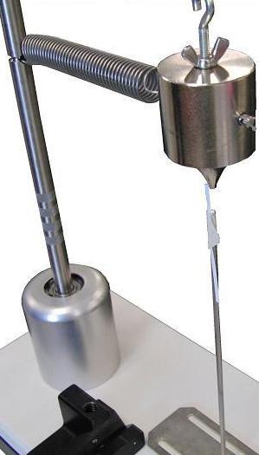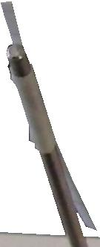
Fig 6A Fig 6B

- Turn the computer on and open the Logger Pro software.
- Go to file open → ‘probes & sensors’ → photogate → pendulum
- Weigh the plumb bob (note: in fig 1B, the plumb bob is labeled ‘the mass’.).
- Measure R: as shown in Figure 1B.
- Find, and record, the mass, m_{s} , of the plumb bob.
- Re-attach the mass (plumb bob).
- Disconnect the string from the plumb bob mass, start rotating the plumb bob and get it to swing centered over the indicator post. Then, start data collection by clicking on the collect button at the top middle of the Logger Pro software. Caution: you do not want to be hit by the swinging plumb bob or counter weight. One individual should spin the apparatus so the mass hovers directly over the radius marker when viewed from the side. Note: the pendulum software will display the time the plumb bob makes two revolutions; consequently, the time for one revolution will be half of the displayed period.

This completes the data acquisition portion of your experiment.

Data and Analysis Turn-in page:

Name ______________________
Mass of the bob M = __________________
Period T = __________________
Radius R = ___________________
Calculation of force 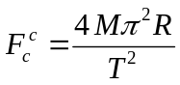= _________________
Suspended mass m_{s} m_{s} = ______________________
Measurement of spring displacement force 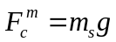= _____________________
Calculate the Percent Difference (error) 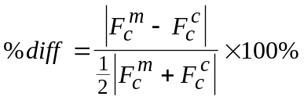 = ________________
Questions
- Which determination of the force, the calculation, or the measurement, do you consider to be more accurate? ____________________ Explain.
- Now consider the less accurate determination and describe the sources of error.

