Blackbody Radiation
h/e
& Planck

Equipment Needed

materials location UU1-PR thru UU4-PR

Photoelectric effect display amplifier 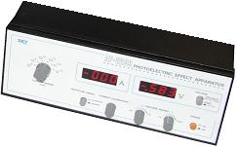
Mercury lamp, detector, & base assembly 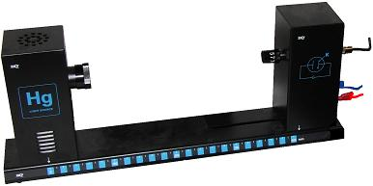
Mercury lamp & amplifier power supply 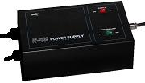
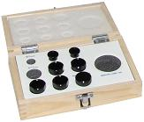
Filter & accessory component box cabling

Warning
The Mercury Light Source: Do no look directly at the bulb itself without the translucent or colored filters in place.

Introduction
In 1900, Max Planck developed a theory of the spectrum of light emitted by a ‘black body.’ In order to explain the spectra, Planck postulated that the oscillators comprising the body oscillated at discrete frequencies, and the energy of each oscillator was proportional to the frequency of vibration. In modern notation, Planck’s relationship is given by
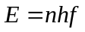
where
f is the frequency of the oscillation
n is some integer
h is a constant known as Planck’s constant
The h has a value
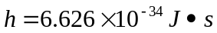
Albert Einstein adapted Planck’s idea in 1905 to explain a phenomenon known as the photoelectric effect.
The photoelectric effect was first discovered by Hertz in his experiments to investigate Maxwell’s theory of electromagnetic radiation. When ultraviolet light shined on a cathode, a cathode ray (stream of electrons) was emitted. This effect was investigated carefully by Millikan, and the following general observations were made.

- There was a certain cutoff wavelength of light. Wavelengths longer than this cutoff produced no current; wavelengths shorter than this wavelength did produce a current.
- The current was proportional to the intensity of the light.
- There was no observed delay between the light hitting the metal and the emission of electrons.

Although Maxwell’s theory could account for the fact that the current was proportional to the intensity of the light, it could not account for the other two observations.

Einstein explained the phenomenon by assuming that light occurred in discrete packets which had an energy given by 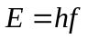. He coined the term photon as the name for these packets of energy. We assume that the electrons are bound to the metal by a binding energy given by 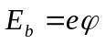. With this equation Einstein was able to correctly describe the photoelectric effect, and in so doing lay one of the cornerstones of the theory of quantum mechanics. Paradoxically, Einstein never accepted Quantum Mechanics as a correct theory.
Investigation of this property and the bonding energies of various materials has led to, what we now call, ‘solar cells’.
In this experiment, we will investigate Einstein’s equation and make a determination of the ratio of Planck’s constant to the charge of the electron.
Setup & calibration
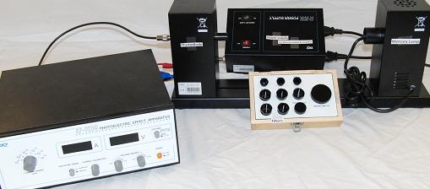
Fig 1 setup
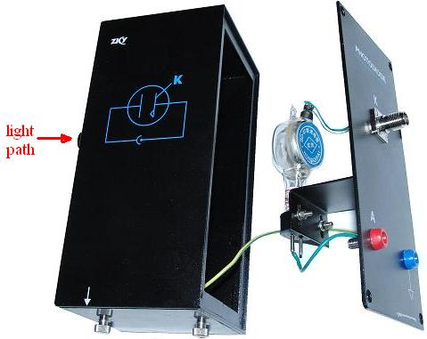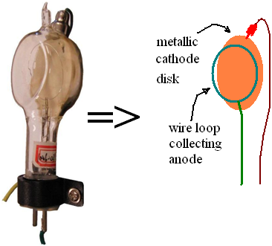
Fig 2A inside the sensor assembly Fig 2B Fig 2C 2 sensor elements:
the flat disk & wire loop.
sensor Light knocks
tube electrons from the
disk which are
collected by the loop.

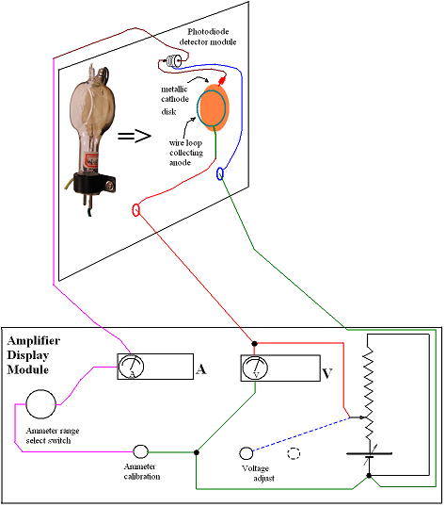
Fig 3A wiring representation

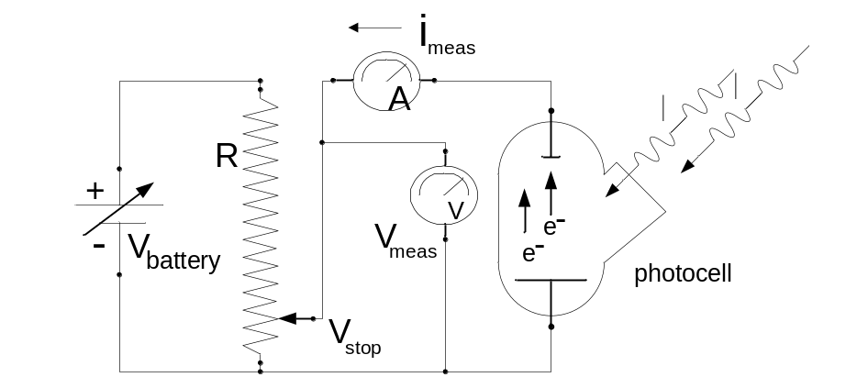
Fig 3B schematic representation

- Connect the Mercury lamp’s power cord to the Power Supply
- connect the 7 pin cable between the power supply and the AP-8209 Photoelectric Effect Apparatus control & readout (amplifier display) module.
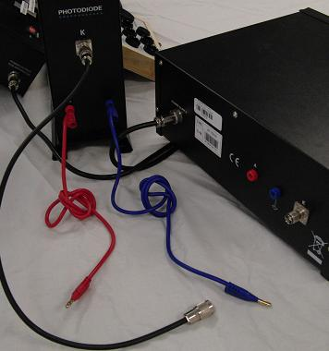
Fig 4
- The back of the AP-8209 (amplifier display) module should not have any other cables connected to it as indicated in fig 4.
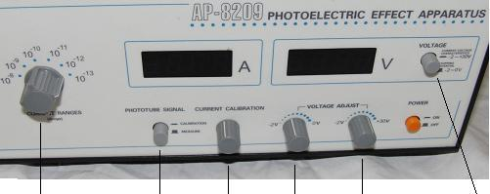
A B C D E F
ammeter range measure/calibrate current stopping iV iV or
switch calibrate Voltage V adjust stopping potential
Fig 5 control switch
- Turn on the power supply .
- From the Optical Filters box, remove the mercury lamp cap and slide it over the lamp’s output tube.
- depress the power switch on the power supply to turn on the Mercury Lamp.

Calibration procedure:
- Turn the current range switch (A in fig 5) to the 10⁻¹³ position.
- Set the phototube signal switch to the calibration position (make sure B is in the depressed or ‘in’ position)
- Set the ‘Voltage’ switch to the ‘stopping potential -2V to 0V’ (ie make sure F is out)
- Adjust the current calibration knob (knob C) until the current is zero Amps (0 A)
- Now, set the phototube signal switch to the “measure” position (ie make sure B is out)
- Connect the disconnected cables as shown in fig 6.
- Adjust the ‘Voltage adjust’ (-2V to 0V) knob (knob D in fig 3) to approx -0.1V.
  - (note: knob E has no effect when the ‘Voltage’ switch is in the ‘out’ (-2V to 0V) position).
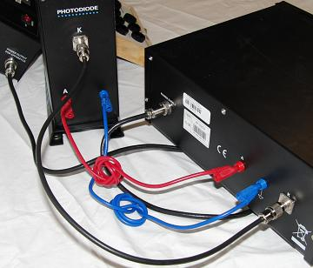
Fig 6
- Slide the photodiode as far from the lamp that the base will allow. Roughly to the 410mm position.
- Slide the φ2mm aperture into the photodiode inlet tube.
Basic Lab Procedure
- Slide one of the filters over the aperture of the photodiode inlet tube as shown in fig 7.
- Remove the Mercury lamp cover
  - Note: the Amperage readout should change to a non-zero value when the lamp cover is removed.
- Adjust the -2V to 0V voltage adjust knob (knob D in fig 3) until the Amperage readout just reads zero (that will be the equivalent of + zero not a -0).
- The Voltage readout will display the stopping Voltage for the filter you are using when the amperage just begins to read zero.
- Record the filter value and the stopping voltage.
- Refer back to your lab instructions; or, change filters and return to step 1 above.
- Note: take care to not touch the current calibration knob. Doing so will likely alter your calibration and have a detrimental effect on your data. If the calibration knob is adjusted, you will have to disconnect the photodiode cables and re-calibrate the “amplifier/display” module and then start over.
- When you’ve completed your readings, turn the mercury lamp off.

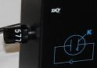
Fig 7 placement of the filter

When you shine light on the photocell, you obtained a current. The electrons emitted from the metal have a spread in kinetic energy, up to a maximum potential. You’ll measure the maximum of the kinetic energy by intentionally slowing down the electrons by applying a potential difference, called a retarding potential, which opposes the motion of the electrons. As you turn up the retarding potential, the current decreases until it goes to zero at a potential that stops the electrons of maximum kinetic energy. The potential at which the current goes to zero is called the stopping potential, denoted 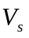. The maximum KE is given by 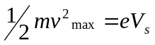.

- Record the stopping potential for the various filters in table 1.
The experiment then is to vary the frequency of the light by changing the filters allowing light into the cell. For each frequency, adjust the retarding potential until no current is observed, and record the stopping potential.

Table 1: Data Table
color | wavelength | frequency | stopping Voltage
red | 577nm
green | 546nm
blue | 436nm
violet | 405nm
UV | 365nm

Data Analysis
In this experiment, you are examining the Einstein’s equation 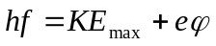. The maximum kinetic energy is obtained from the stopping potential, , using the relationship 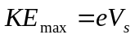. If you plug this expression for the maximum kinetic energy into the Einstein Equation, you obtain 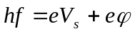. Solving for , you obtain 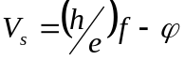. Thus, when you graph vs. f, you will obtain a straight line, with slope of 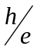 and y-intercept 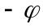. Calculate the frequencies for the wavelengths given in Table 1. Be careful about the units. Construct a graph of vs. f. Use a linear regression analysis to determine the best-fit slope and y-intercept. Don’t forget the units. From your slope and the textbook value of e, determine your value for Planck’s constant. Compute the percent difference between your value and the textbook value of Planck’s constant. Determine the work function for the metal in the cathode. Figure 8 shows a typical graphical layout.
Figure 8 Stopping Potential V_{s} vs. Frequency f
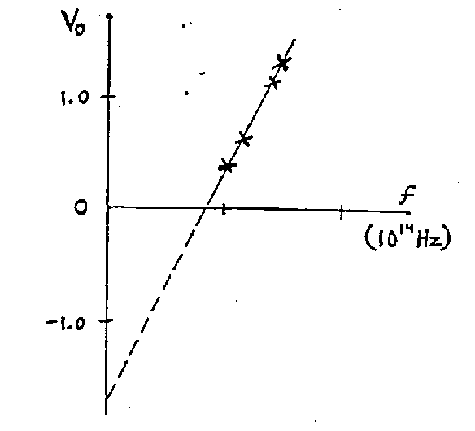

Report Format
Turn in your description of the apparatus, graph, and all calculations. Report the values you have obtained in an organized fashion.

