Topic W. Modeling, Part V: Additional Useful Modeling Formulas
Objectives:
- Be able to use and understand the parameters of normal, logistic, and sinusoidal models.
- Be able to use logarithmic models to make inverse models for exponential data.
- Be able to select appropriate models based on the nature of the process producing measurements.
Overview
Additional useful modeling formulas:
While there are a great many types of mathematical functions that could be used for modeling in addition to the types discussed previously (constant, linear, quadratic, exponential, and power-function), three more types are particularly useful in practical applications: normal, logistic, and sinusoidal.
Normal models produce the “bell-shaped curve” graph that usually is a good fit to the distribution of some characteristic around its average value for a population (e.g., the distribution of adult heights). Normal models are particularly relevant to measurement because the distribution of noise values usually follows such a model. The parameters we will use for normal curves are the population size, the average value, and the width of the peak.
Logistic models describe a smooth transition from one steady value to a different steady value (e.g., the temperature of water coming from the hot water faucet when the heater is far from the faucet). A process that shows exponential growth at some times must eventually level off – a logistic model can often be used to describe the entire process in such a case. The parameters of a logistic model are the starting and ending output values, the center (the input value at which the output is halfway between the two limits), and the rate of change at the center.
Sinusoidal models (based on the sine function discussed in the trigonometric topics) can be used to describe a great many processes that involve waves, vibrations, or rotation. This is the only model we will discuss that has a repeating pattern, and most repeating pattern in nature match some sinusoidal model. The parameters for a sinusoid are its wavelength (how often the pattern repeats), its baseline (the average output value over a full wavelength), its amplitude (how far output varies above and below the average), and its phase (the relative position of the peaks and valleys).
We will examine one additional type of model, even though it is used less often. Logarithmic models are the inverse of exponential models, and are thus appropriate in situations where equal-percentage changes of the input variable result in equal-amount changes of the output variable. The parameters used for a logarithmic model are closely related to those for the corresponding exponential model that would apply if x and y columns were exchanged: growth rate (or decay rate, if negative) and an x-intercept value (which would be the y-intercept value in an exponential model).
Illustrative graphs of the additional models discussed in this topic
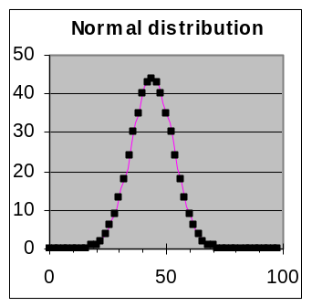 | 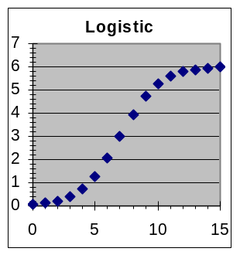 | 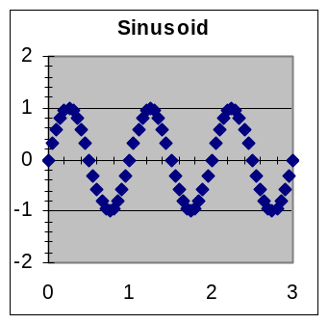 | 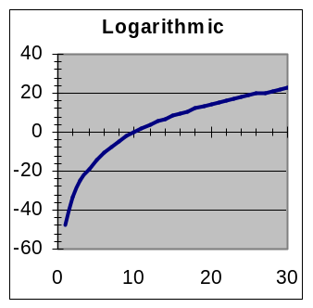
Section 1: Bell-shaped curves — Normal distribution models
It is often useful to model how some property is distributed among a collection of objects that are similar but not exactly alike. Such models are the mathematical answers to questions such as How tall are college students, to the nearest inch? or If you weigh soda cans to the nearest gram, how many have each weight? One good way to answer these questions is to fit a smooth model to data telling how many items have each value. Very often such a model will be close to the bell-shaped curve that mathematicians call a “normal” distribution because it usually results when many independent effects are combined.
A typical application of normal models is the distribution of demographic information
Normal-curve model for heights to the nearest inch  parameters: total =13,379, average = 5’10”, width = ±3”  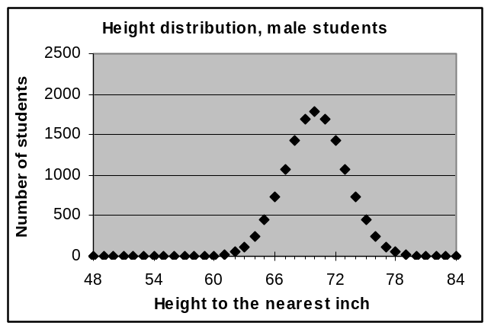  Formula used: =13379*NORMDIST(A3,70,3,FALSE) | Normal-curve model for heights to the nearest inch  parameters: total =16,708, average = 5’5”, width = ±3”  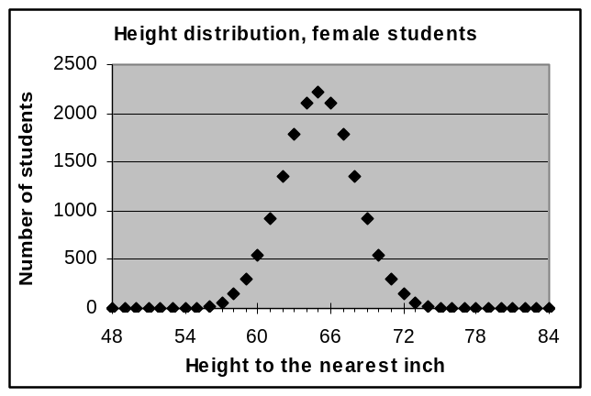  Formula used: =16708*NORMDIST(A3,65,3,FALSE)
Normal-distribution models are particularly interesting for measurements because noise usually results in repeated measurements of the same object having a normal distribution around the average value. The standard deviation of the noise corresponds to the width of the normal distribution.
Spreadsheets provide a predefined NORMDIST function that can be used in making normal-distribution models. The arguments supplied to the NORMDIST function are the average value for all items (this is the x value where the peak of the graph will be) and the width value that indicates how close a typical item is to the average. (NORMDIST also requires a logical constant as a third argument; this will always be FALSE for the way we are using the function.)
Math note: It is possible to compute the normal distribution with a standard mathematical formula, but it is more convenient to use the predefined NORMDIST function. Judge for yourself — the corresponding spreadsheet formula would be =0.3989*$G$3/$G$5*(0.6065^(((A3-$G$4)/$G$5)^2))
Example 1: Distribution of weights in a manufactured product  The exact weight of standard manufactured products often varies slightly due to small random changes in the machinery that makes them. Measurements of how the weights of a large test sample of individual items are distributed provides information about how dependable the declared weights are. The dataset to the right shows the percentage breakdown of measurements rounded to the nearest gram for a product whose intended weight is 915 grams (about 2 pounds).  [a] Fit a normal-curve model to this data and report the parameters found.  [b] Do you think that it is accurate for the manufacturers to put a statement on the package of this item that says “Weight 915 grams”? Why or why not?  [c] Can you think of way to describe this weight distribution using two numbers that is more informative that just stating the average?
  Weight Distribution
  Weight  (grams) | Percent  of total
  911 | 1
  912 | 3
  913 | 8
  914 | 17
  915 | 25
  916 | 23
  917 | 15
  918 | 6
  919 | 2
Solution approach:
[i] Make a normal-curve template from the General Model template in Models.xls, with appropriate parameters: G3 for Total (label in H3), G4 for Average (label in H4), and G5 for Width (label in H5).
[ii] Put this formula in C3: =$G$3*NORMDIST(A3,$G$4,$G$5,FALSE)
[iii] Place the weight-distribution data in the template, then as usual spread the formulas in columns C, D, and E down to match the data (to row 11).
[iv] Make a graph of the data and model so that you can see how well the model and data match.
[v] Set the Average and Width parameters in G4 and G5 to values that are approximately correct, such as 915 and 1 in this case. (A close match for the graphs is not needed – just get close enough that you can see the peak in both the model and the data. Rough parameter settings are a good idea in all fitting processes, but they are essential for normal-curve models because a Width value of zero gives a computation error in NORMDIST, and if Average is far away from the correct value all the modeled points will be zero, giving Solver nothing to work with.)
[vi] Use Solver to find the best-fit parameter values for this model.
Answers:
[a] The best-fit normal curve has parameters Total=99.8, Average=915.4 gm, and Width=1.58 gm.
[b] Since 915 grams is less than 0.1% away from the average and most values are within a fraction of a percent of it, 915 seems to be the best way to describe the weight using a single number. But since different people might use the weight information in different ways, it would be better to make it clear that the number is an average, so that they are warned that some items will be heavier and others lighter.
[c] The best description of a characteristic that has a normal distribution is to report both the average and the width of the distribution. In this case we might say: “These items weigh 915.4 ±1.6 grams.”
The worksheet for this example should be similar to this
 | A | B | C | D | E | F | G | H
1 | Weight | Percent | y model | Residual | Squared
2 | (grams) | of total | prediction | deviation | Deviation |  | Normal-curve parameters
3 | 911 | 1 | 0.542948 | 0.457052 | 0.208897 |  | 915.3682 | Average
4 | 912 | 3 | 2.575238 | 0.424762 | 0.180423 |  | 1.576364 | Width
5 | 913 | 8 | 8.167791 | -0.167791 | 0.028154 |  | 99.76079 | Total
6 | 914 | 17 | 17.32288 | -0.322883 | 0.104253
7 | 915 | 25 | 24.56767 | 0.432333 | 0.186911 |  | Model and data value counts
8 | 916 | 23 | 23.29893 | -0.298926 | 0.089356 |  | 3 | Number of parameters
9 | 917 | 15 | 14.77529 | 0.224708 | 0.050494 |  | 9 | Number of dev. averaged
10 | 918 | 6 | 6.265626 | -0.265626 | 0.070557
11 | 919 | 2 | 1.776729 | 0.223271 | 0.04985 |  | Goodness of fit of this model
12 | 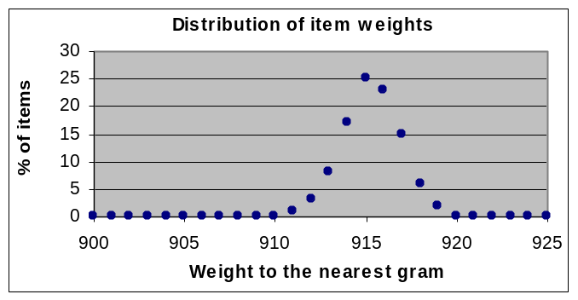 |  |  |  |  |  | 0.968896 | Sum of squared dev.
13 |  |  |  |  |  |  | 0.401849 | Standard deviation

Section 2: Gradual transition between two steady values – Logistic models
Basic logistic formula: 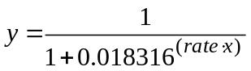
Even though the formula above looks somewhat strange, its graph is actually rather simple. The graph starts by being almost horizontal barely above zero at the far left, then smoothly transitions through a midpoint to again become almost horizontal barely below one on the far right. The basic logistic function has its largest rate of change at the midpoint, where its slope equals the rate parameter.
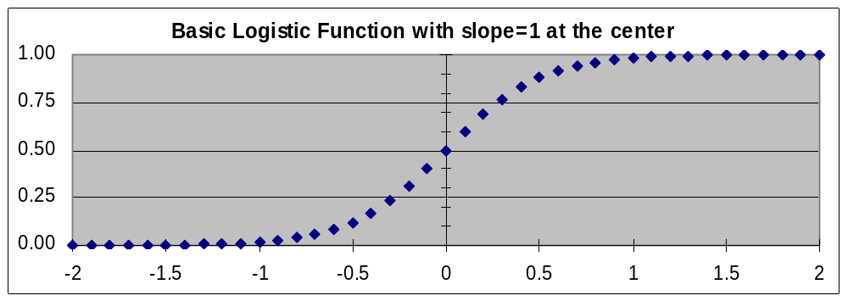
[Optional math fact: Where does the 0.018316 in the formula come from? Actually, any positive number except 1.0 could be used as the base of the exponent and you would still get a logistic graph – it would just have a different slope at the center. The value 0.018316 is used because it makes the slope at the center equal the rate parameter.]
In the basic logistic formula, the only parameter is the rate of change at the center. Here are some examples of the effect of different values for that slope. In all cases, the x-axis scale is from –2 to +2.
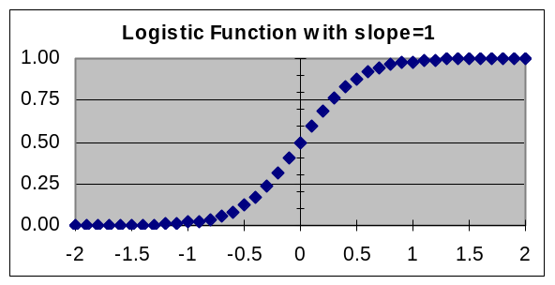 | 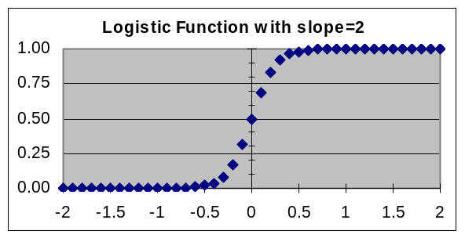
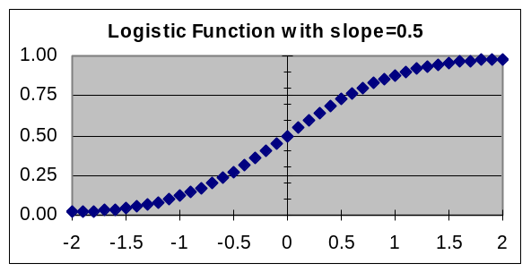 | 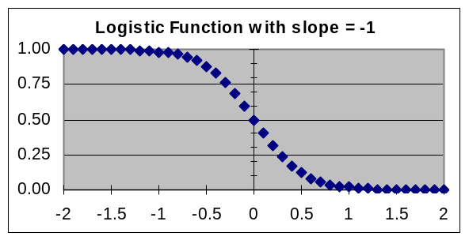

Spreadsheet formula for basic logistic: | =1/(1+0.018316^($G$3*A3)
Making the logistic formula more versatile, stage one – shifting right or left
While it is useful to be able to control the rate of transition by using the rate parameter, more adjustability is needed to make this formula a good match to typical transition situations whose graphs have shapes similar to the basic logistic. We can handle this by adding more parameters to control the size and position of the curve.
So in addition to the rate/slope parameter, we will add a center parameter that tells the x value where the midpoint occurs, enabling us to shift the curve to the right (with positive center values) or to the left (with negative center values). Since the logistic formula equals ½ when the exponent is equal to zero, the way to put the center parameter into the formula is to subtract center from the x value before multiplying by the rate. This leads to the following version of the logistic formula, in which both slope and left-right position can be controlled:
Simple logistic formula (with center adjustment): 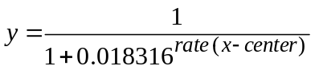
The advantage of having the center parameter is that we can use it for data where we can see that there is a logistic transition from zero to one, but we don’t know exactly when that transition occurred. By fitting a simple logistic model to the data, we can have the data tell us both when the transition occurred (the best-fit value for the center parameter) and what its maximum rate of change was (the best-fit value for the rate parameter).
Example 2: Wine fermentation time
As wine matures, a small amount of yeast grows and converts the sugar in the grapes to alcohol. At first growth is rapid because there is plenty of sugar and no alcohol; as more alcohol accumulates, the rate slows down as the increasing amount of alcohol and decreasing amount of sugar interferes with yeast metabolism, finally stopping when the maximum alcohol level for that type of wine is reached..
For the data shown below, [a] When was half the alcohol produced? [b] How fast was the percentage of alcohol compared to the saturation alcohol level increasing at that time?
Solution approach:  The data shows a transition from zero to one (since 100% = 1), so it can be modeled with the simple logistic model constructed from the General Model template. The appropriate spreadsheet formula to put in cell C3 is =1/(1+0.018316^($G$3*(A3-$G$4))) if we use cell G3 for the rate parameter and cell G4 for the center parameter.  Answers:  [a] Half the alcohol was produced by 8.68 days of fermentation (from the best-fit value of the center parameter).  [b] At the midpoint of fermentation, the alcohol level was growing at the rate of 16.5% of the saturation level per day (from the best-fit value of the rate parameter).
  Days of  fermentation | Saturation level %
  0 | 0%
  3 | 2%
  6 | 15%
  9 | 55%
  12 | 90%
  15 | 99%
  18 | 100%
  21 | 100%
The worksheet for this example should be similar to this:
 | A | B | C | D | E | F | G H
 | X | y data | y model | Residual | Squared |  | y = 1/(1+0.018316^($G$3*(x-$G$4)))
1 | Days | Saturation | prediction | deviation | deviation |  | Simple-logistic parameters:
2 | 0 | 0% | 0.003294 | -0.003294 | 1.09E-05 |  | 0.164513 | Rate
3 | 3 | 2% | 0.023243 | -0.003243 | 1.05E-05 |  | 8.680789 | Center
4 | 6 | 15% | 0.146279 | 0.003721 | 1.38E-05
5 | 9 | 55% | 0.552322 | -0.002322 | 5.39E-06 |  | Model and data value counts
6 | 12 | 90% | 0.898822 | 0.001178 | 1.39E-06 |  | 2 | Number of parameters
7 | 15 | 99% | 0.984607 | 0.005393 | 2.91E-05 |  | 8 | Number of deviations averaged
8 | 18 | 100% | 0.997834 | 0.002166 | 4.69E-06
9 | 21 | 100% | 0.999699 | 0.000301 | 9.09E-08 |  | Goodness of fit of this model
10 |  |  |  |  |  |  | 7.59E-05 | Sum of squared deviations
11 |  |  |  |  |  |  | 0.003556 | Standard deviation
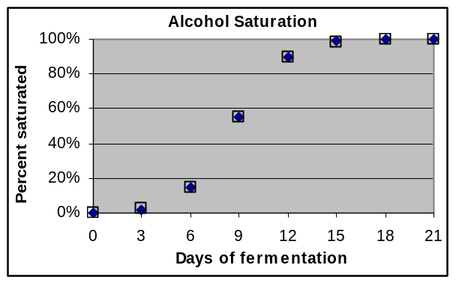
The data and model match well, but it would be difficult to give an accurate value for the midpoint or the rate of change at the center by visually reading the graph. This is where the numerical aspect of the model is particularly useful.
Didn’t we do something like this before? The technique used here of implementing a shift in x position by subtracting the amount of the shift from the x value used in the formula should be familiar. It is essentially the same approach that we used in an earlier topic when we subtracted the year 1992 from x in the model formula rather than subtracting it from the input values in the dataset. But the difference here is that the amount of the shift is a parameter, so we don’t have to know its value in advance — we can instead get the model-fitting process to tell us the exact amount of shift that the data implies.
Making the logistic formula more versatile, stage two – different step sizes, up/down shifts
Transitions that follow a logistic pattern need not involve only steps from zero to one. To complete our generalization of the logistic formula, we will add parameters that let us adjust the curve to take other step sizes, and to have other baselines.
Both new parameters are straightforward to implement mathematically. To make the amount of vertical change something different than 1, we will multiply the simple formula by a scale factor. We will call this the height parameter since the curve will now have y values ranging from zero to height.
Moving the baseline up or down is even simpler mathematically. We will add a floor parameter to the scaled formula. Positive values for floor will move the curve up; negative values for floor will move the curve down. (Note that we add floor at the very end. It is not multiplied by height.)
So the full logistic model we have constructed has four parameters, and lets the data (via the model-fitting process) determine what their values are:
- rate (cell G3) — The controls the slope of the graph at the midpoint, which reflects how fast (and in which direction) the transition occurs. The slope at the midpoint equals rate×height.
- center (cell G4) — The midpoint of a transition is not usually at an input value of zero, even though the midpoint of the graph will be when the exponent expression is equal to zero. The formula can be made to reflect this by subtracting a center parameter from the input variable x.
- height (cell G5) — The amount of change in output will not always be 1.0. Multiplying the basic logistic model by a height scaling parameter will make its values go from zero to height instead of from zero to one.
- floor (cell G6) — Not all transitions have zero as the lower limit for the output value. We can allow for this with a floor parameter that is always added to the basic logistic formula.
The resulting full logistic model formula is 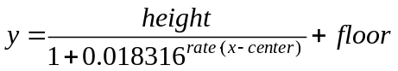
Corresponding spreadsheet formula: | =$G$5/(1+0.018316^($G$3*(A3-$G$4)))+$G$6

Example 3: Fit a full logistic model to the dataset to the right showing water temperature during the first 10 seconds after a hot-water faucet is opened, then answer these questions about the model:  [a] What real-world quantity corresponds to the floor parameter? What is its value for the best-fit model for this data?  [b] What real-world quantity corresponds to the center parameter? What is its value for the best-fit model for this data?  [c] How can you compute an estimate of the hot-water temperature from the best-fit parameters? What is its value in this case?  [d] How fast was the water warming up when the water temperature was halfway through the transition?
  Water Temperature
  Seconds | Degrees F
  1 | 68.8
  2 | 68.7
  3 | 70.9
  4 | 86.9
  5 | 115.5
  6 | 124.5
  7 | 125.4
  8 | 125.5
  9 | 125.7
  10 | 125.7
Solution approach:
[i] Use the General Model template to make a logistic worksheet, using the formula shown above.
[ii] Copy the data to the worksheet and make a graph of data and model.
[iii] Preset to approximate values to speed up Solver’s search: rate=1, floor=70, height=55, center=4
[iv] Use Solver to find the best-fit parameters.
Answers:
[a] The floor parameter corresponds to the temperature of the cooled-off water that has been standing in the hot-water pipes. In this case, that temperature was 68.5 °F.
[b] The center parameter corresponds to the time in seconds from when data-taking was started until the water temperature had risen halfway to the hot-water temperature. In this case, the midpoint was at 4.31 seconds.
[c] In this model, the hot-water temperature is the sum of the floor and height parameters, 125.6 °F.
[d] This is the product of the rate and height parameters, which is 31.9 °F/second in this case.
 | A | B | C | D | E | F | G | H
1 | X | y data | y model | Residual | Squared
2 | Secs | Deg F | prediction | deviation | deviation |  | Logistic parameters
3 | 1 | 68.5 | 68.56844 | -0.068438 | 0.004684 |  | 0.559017 | Rate
4 | 2 | 69.1 | 68.85719 | 0.242814 | 0.058959 |  | 4.310686 | Center
5 | 3 | 71.2 | 71.42354 | -0.223536 | 0.049968 |  | 57.05165 | Height
6 | 4 | 87.6 | 87.53105 | 0.068945 | 0.004753 |  | 68.53369 | Floor
7 | 5 | 115.5 | 115.5249 | -0.024861 | 0.000618
8 | 6 | 124.2 | 124.3091 | -0.109083 | 0.011899
9 | 7 | 125.5 | 125.4462 | 0.053849 | 0.0029
10 | 8 | 125.4 | 125.5704 | -0.170428 | 0.029046 |  | Model and data value counts
11 | 9 | 125.8 | 125.5837 | 0.216258 | 0.046767 |  | 4 | Number of parameters
12 | 10 | 125.6 | 125.5852 | 0.014834 | 0.00022 |  | 10 | Number of dev. averaged
13 | 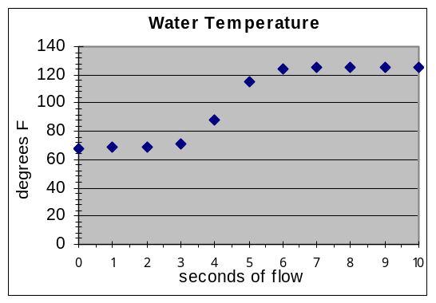
14 |  |  |  |  |  |  | Goodness of fit of this model
15 |  |  |  |  |  |  | 0.209814 | Sum of squared deviations
16 |  |  |  |  |  |  | 0.187 | Standard deviation

Section 3: Sinusoidal Models
Repeating behavior is very often encountered in the world, with examples such as ocean waves, heartbeats, vibrations of a spring, rotation of wheels, the phases of the moon, and the pattern of the seasons. Because none of the modeling functions we have discussed so far have repeating features, we need something more to be able to model repetitive phenomena.
For most repetitive situations, models based on the same sine function used in trigonometry will serve our needs. This may seem surprising — what do triangles and waves have to do with each other? One reason that mathematics is so powerful is that the same patterns show up in a great variety of different situations, which means that mathematical tools that were developed for one purpose often turn out to be useful in other contexts.
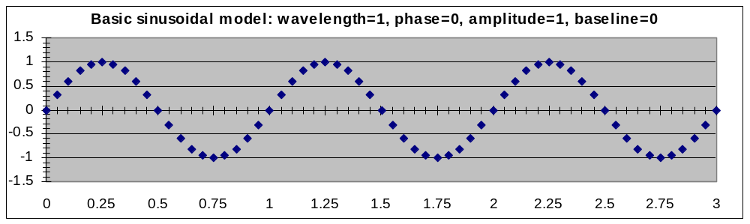
For modeling, we will want to be able to modify the shape of the standard sine function in several ways. First, we want to control how often the pattern repeats – the wavelength – so that we are not limited to the wavelength of the sine function (2π, or about 6.2832). Secondly, we need to be able to shift the pattern to the right or left so that the peaks and valleys of the model match the peaks and valleys of the data – this shift is called the phase of the model. Thirdly, we need to be able to match the amount of up-and-down variation in the model – the amplitude – to the amount of variation in the data. When the average value is not zero, we will also need to add a constant baseline to the model. The mathematical formula that serves these modeling needs will thus make use of four parameters:
If the wavelength, phase, amplitude, and baseline parameters are in G3, G4, G5, and G6, respectively, then the corresponding spreadsheet formula to be put into cell C3 of the model template is:
=$G$5*SIN(6.2832*(A3+$G$4)/$G$3)+$G$6
Summary of sinusoidal parameters
- Wavelength – How often does the pattern repeat? Wavelength is in the same units as the x data, and the ratio of x to the model wavelength is multiplied by 2π because that is the natural wavelength of the SIN function. When the x values are based on time, the wavelength is sometimes referred to as the period or as a cycle of the sinusoid.
- Phase (or phase shift) – Where in the pattern is the x = 0 point? The basic pattern (which has a phase shift of zero) can be shifted to the left or the right. Note that because the pattern repeats, a shift to the left of ¼ wavelength would result in the same pattern as a shift to the right of ¾ wavelength.
- Amplitude – This is simply a scale factor that determines how far the maximum and minimum y are from the average. While it is mathematically possible to use a negative amplitude (the pattern turns upside down), this is not done since the same effect can be obtained by a half-wavelength phase shift.
- Baseline – The average around which the pattern varies. This can be modeled by addition to the result of the SIN function after multiplying by the amplitude.
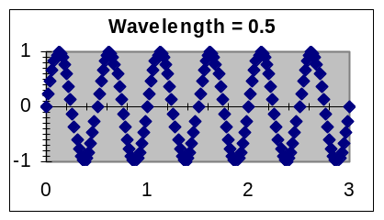 | 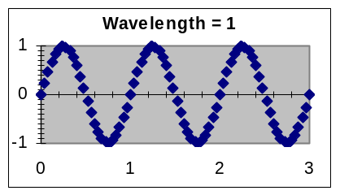 | 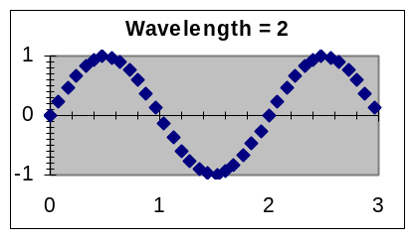
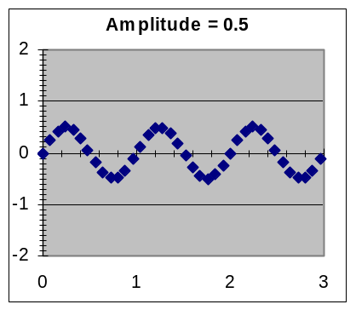 | 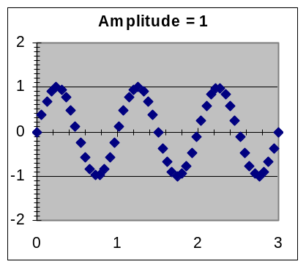 | 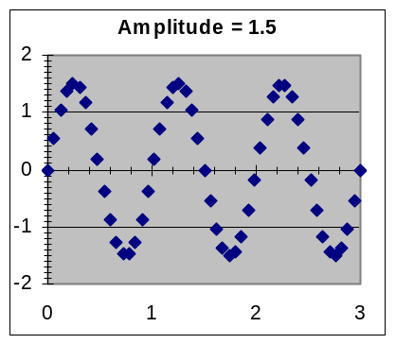
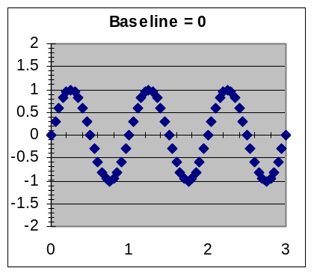 | 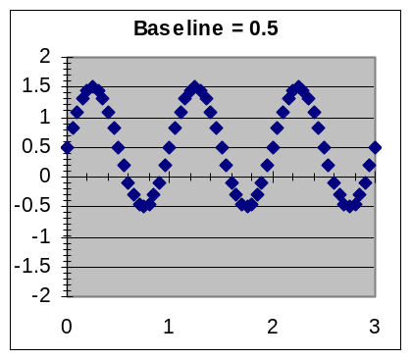 | 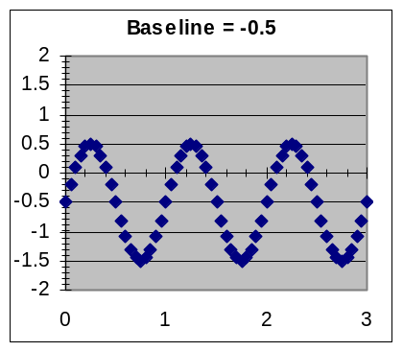
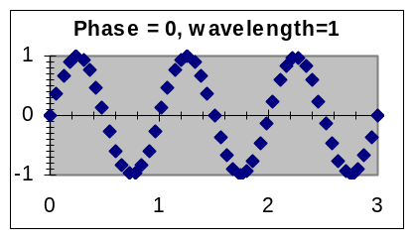 | 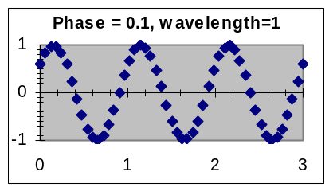 | 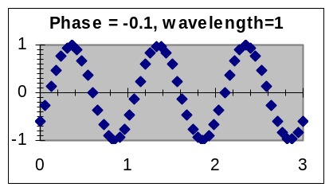

Example 4: Report and interpret the best-fit sinusoidal model for the dataset to the right, which records the amount that the average Fahrenheit temperature for a month is above or below the average temperature for the entire two-year period. The months are numbered starting with 1 for January 2003.  Solution approach:  [i] Copy the dataset to the Data Scratch Pad worksheet and display a scatter plot.  [ii] From the graph, make rough estimates of the amplitude and wavelength for the data, so that you will have values to use as initial parameter settings.  [iii] Use the model formula explained in this section to create a sinusoidal model worksheet from the General Model template in Models.xls, with parameters for wavelength, phase, and amplitude. Set the wavelength and amplitude parameters to the values you estimated in step [ii] above (leaving these parameters blank or zero will cause errors or confuse Solver).  [iv] Copy the dataset to the worksheet, then spread the formulas in columns C, D, and E down to match the data, as usual.  [v] Use Solver to find the best-fit parameters, and report your results.  Answer:  The best-fit sinusoidal model to this data has a wavelength of 11.9 months, a phase shift of 4.0 months, an amplitude of 23.3 degrees F, and a baseline average of 69.1 degrees F. The standard deviation for the fit is 2.8 degrees F.  Interpretation: The monthly temperature-difference averages at the location this data came from range by about 23 degrees above and below the yearly average of about 69 degrees. The pattern repeats about every 12 months, with the maximum-positive-slope point (i.e., spring) in April (month 4). Individual monthly averages can be expected to be within 2.8 degrees of this model about 2/3 of the time.
  Month | Temp
  1 | 47.8
  2 | 45.3
  3 | 54.0
  4 | 72.6
  5 | 83.4
  6 | 91.9
  7 | 92.9
  8 | 84.8
  9 | 79.5
  10 | 69.1
  11 | 60.1
  12 | 46.4
  13 | 50.8
  14 | 47.4
  15 | 62.8
  16 | 71.9
  17 | 83.1
  18 | 91.2
  19 | 93.4
  20 | 88.4
  21 | 75.5
  22 | 67.0
  23 | 59.6
  24 | 44.3
The final worksheet should look similar to this:
x | y data | y model | Residual | Squared |  | y = $G$5 * SIN((x-$G$4)*6.2832/$G$3)
Input | Output | prediction | deviation | deviation |  | Sinusoidal parameters
1 | 47.8 | 46.37 | 1.43 | 2.0577 |  | 11.85328 | Wavelength
2 | 45.3 | 49.43 | -4.13 | 17.0726 |  | 3.960422 | Phase shift
3 | 54 | 58.07 | -4.07 | 16.5328 |  | 23.28311 | Amplitude
4 | 72.6 | 69.89 | 2.71 | 7.3542
5 | 83.4 | 81.64 | 1.76 | 3.0990
6 | 91.9 | 90.08 | 1.82 | 3.3073 |  | Model and data value counts
7 | 92.9 | 92.89 | 0.01 | 0.0002 |  | 3 | Number of parameters
8 | 84.8 | 89.28 | -4.48 | 20.0901 |  | 24 | Number of dev. averaged
9 | 79.5 | 80.26 | -0.76 | 0.5799
10 | 69.1 | 68.31 | 0.79 | 0.6226 |  | Goodness of fit of this model
11 | 60.1 | 56.72 | 3.38 | 11.3938 |  | 169.8698 | Sum of squared deviations
12 | 46.4 | 48.70 | -2.30 | 5.2707 |  | 2.844124 | Standard deviation
13 | 50.8 | 46.44 | 4.36 | 19.0293 |  | 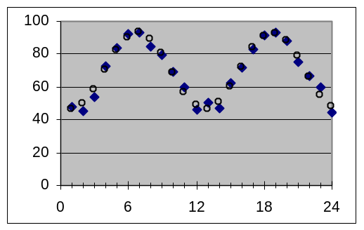
14 | 47.4 | 50.57 | -3.17 | 10.0663
15 | 62.8 | 59.96 | 2.84 | 8.0596
16 | 71.9 | 72.01 | -0.11 | 0.0132
17 | 83.1 | 83.41 | -0.31 | 0.0974
18 | 91.2 | 91.01 | 0.19 | 0.0357
19 | 93.4 | 92.72 | 0.68 | 0.4664
20 | 88.4 | 88.06 | 0.34 | 0.1155
21 | 75.5 | 78.32 | -2.82 | 7.9745
22 | 67 | 66.19 | 0.81 | 0.6531
23 | 59.6 | 55.01 | 4.59 | 21.0864
24 | 44.3 | 47.85 | -3.55 | 12.6379
Sinusoidal cycles and phases
Cycles: There is a close relationship between sinusoids and rotation. A spinning object repeats its sequence of positions every rotation, and the height of a point on a circle rotating at a constant speed varies over time according to a sinusoidal pattern. The wavelength of this sinusoid equals the rotation time of the circle, and the amplitude equals the radius of the circle. The phase is how long it has been since the point last passed the midpoint in an upward direction. The baseline is the height of the center of the circle.
Left-right shifts of the sinusoidal pattern: The standard sinusoid crosses the y axis where the curve has the steepest upward slope, where it is increasing past the average value. But the curve can be shifted right or left so that it crosses the y axis at some other point of the cycle. The distance from the nearest standard steepest-slope point to the actual crossing point is called the phase or the phase shift of the sinusoid. The phase shift is added to the x value before it is used inside the SIN function.
Two sinusoidal processes with the same wavelength can be in phase, in which case they will add together if they apply to the same measurement, or be out of phase, in which case there may be partial cancellation. Sometimes phase shifts are talked about in terms of angular degrees (e.g., “The electric and magnetic waves are 90 degrees out of phase”); this is based on taking a wavelength as being 360 degrees due to the analogy with rotation), so a phase shift of 90° means a phase shift of ¼ of the wavelength.
Section 4: Logarithmic models (the inverse model for exponential data)
The last basic models we will introduce in this course are logarithmic models. These are based on the LOG spreadsheet function discussed in an earlier topic. The main reason that logarithmic models are useful is that they are the inverse of exponential models – for a logarithmic model, equal-percentage changes in the input variable x result in equal-amount steps in the output variable y.
An example of a common use of a logarithmic model is in computing how old an archeological object is from how much radioactive Carbon-14 remains in it. The radioactivity of several objects of known age (such as tree rings) is measured, and then a model that predicts age from radioactivity level is fit to this data. Finally, measurements are made of the radioactivity of other similar objects (such as wooden tools) for which the age is unknown, and the model is used to estimate their age. (If you wanted to predict the level of radioactivity from the age you would use an exponential model, but here the roles of the variables are reversed.)
The two parameters of a logarithmic model are closely related to those for exponential models. The growth rate (or decay rate, if negative) parameter is the same as for exponential models, although in this case it is used as the second parameter (the logarithmic base) of the spreadsheet LOG function. Since the roles of x and y have been reversed, the initial-value (i.e., y-intercept) parameter from the exponential model become an x-intercept parameter in the logarithmic model. While there are several different ways that a logarithmic modeling formula could be written, the most convenient for our purposes will be 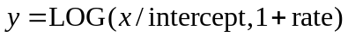 , which implies a formula in C3 of “=LOG(A3/$G$3,1+$G$4)”.
Example 5: For a particular measurement apparatus and technique, radiation readings of 1274, 1085, 865, 697, and 276 were observed for objects with known ages of about 1100, 2400, 4300, 6100, and 13800 years, respectively. Use this data to create a model that predicts the age of similar objects, and use that model to estimate the age of such an object whose radiation measurement is 515.
Solution:  [i] First, we must make an appropriate data table. Since we will be using the radiation readings to predict age, we will put the radiation readings into the column A and the respective age values to the right in column B.  [ii] Make a modeling spreadsheet, setting C3 to =LOG(A3/$G$3,1+$G$4) and spreading that model formula down to row 7 beside the data. Put the labels “x-intercept” and “rate” to the right of the parameter cells G3 and G4.  [iii] As usual, include deviations in column D and squared deviations in column E, and enter a sum-of-squared-deviations formula into a cell such as H8.  [iv] Adjust the parameters in G3 and G4 to initial values that make the model graph roughly match the data (example: G3 = 2000 & G4 = −0.0001)  [v] Use Solver to find the best-fit parameters: G3 = 1451 and G4 = −0.0001203; the implied model formula is age = LOG(radiation/1451, 1−0.0001203).  [vi] Enter the radiation level 515 into A8, giving an estimated age of 8,612 years.
  Radiation  reading | Age in  years
  1,274 | 1,100
  1,085 | 2,400
  865 | 4,300
  697 | 6,100
  276 | 13,800
NOTE: What is the real-world meaning of these model parameters? The growth/decay rate of −0.0001203 implies that 0.01203% of the Carbon-14 atoms decay each year. The “x-intercept” parameter shows what radiation-reading input would give an age output of zero; that is, what the radiation reading would be for a brand-new object.
Section 5: Recognition of appropriate models
Many other model formulas exist (including many possible combinations of models, as will be discussed in a later topic), but the set of basic models that have been discussed in this course cover the most important patterns that arise in application settings. This will be useful to you even if you do not do more model-fitting yourself, since it gives you ways to talk about patterns you encounter and to know what is being referred to in written material.
Example 6: For each of these graphs, which of the basic models discussed in this course best matches it: linear, quadratic, exponential, power-function, normal, logistic, sinusoidal, or logarithmic?
[a]  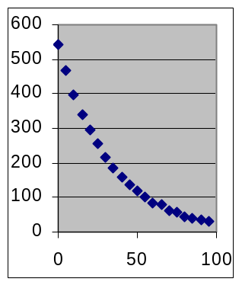 | [b]  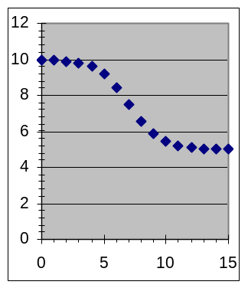 | [c]  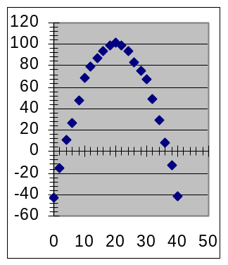 | [d]  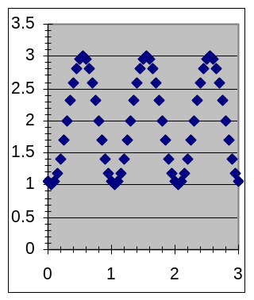
[e]  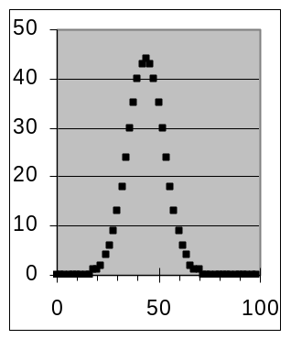 | [f]  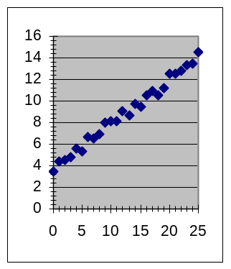 | [g]  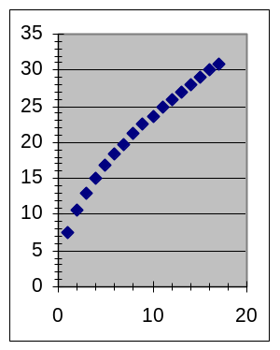 | [h]  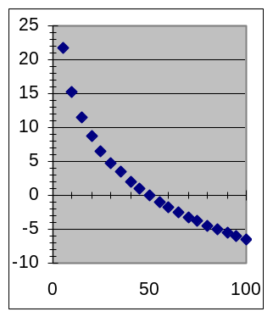
Try to identify the type of model in each case before looking at the answers on the next page.
Answers to Example 6:
[a] exponential. [b] logistic [c] quadratic [d] sinusoidal [e] normal [f] linear [g] power [h] logarithmic
EXERCISES:
Part I — Reproduce the results in Examples 1 – 6.
Part II — Work the assigned problems
[7] The water temperature at a faucet was measured (on the Fahrenheit temperature scale) each second after the hot-water tap is turned on. The results were: 72° at 1 second, 72° at 2 seconds, 75° at 3 seconds, 82° at 4 seconds, 95° at 5 seconds, 103° at 6 seconds, 105° at 7 seconds, and 105° at 8 seconds.
[a] What type of model is appropriate for this situation?
[b] At what time is the temperature changing most rapidly?
[c] About how fast is the temperature changing when it changes fastest?

[8] The weight of babies at birth to the nearest pound is tabulated from birth records, with these results: 1% weigh 2 pounds or less, 1% weigh 3 pounds, 2% weigh 4 pounds, 5% weigh 5 pounds, 19% weigh 6 pounds, 36% weigh 7 pounds, 26% weigh 8 pounds, 8% weigh 9 pounds, 1% weigh 10 pounds or more. If a normal-distribution model is fit to this data, what is the best-fit value for the width parameter?

[9] A bank balance earning a constant rate of compound interest has these values: $1550 after 5 years, $2002 after 10 years, $2585 after 15 years, $3339 after 20 years, and $4313 after 25 years. Find a model formula to compute how long it took for the balance to equal $2,938.

[10] Because the earth’s orbit around the sun is an ellipse, the distance between them varies according to the time of year. The table to the right shows the distance in miles at 50-day intervals (the first data point is the 50th day of the year, February 19th). Fit a sinusoidal model to this data, and then use the parameters of the model to compute the closest distance that occurs.
  Day | Distance
  50 | 91,907,193
  100 | 93,146,982
  150 | 94,243,003
  200 | 94,460,990
  250 | 93,660,185
  300 | 92,366,382
  350 | 91,477,551
Problems 11–20 have the same instructions, applied to different datasets. Copy and paste the datasets from the course web site copy of this topic into a spreadsheet, rather than retyping them.
For each of the datasets listed below (copy and paste it from the course website and)
[a] Display the dataset and determine which model type discussed in this course is most suitable.
[b] Write the best-fit formula that shows how to compute the y values from the x values.
[11] Dataset A | [12] Dataset B | [13] Dataset C | [14] Dataset D | [15] Dataset E
  x | y
  1 | 26.52
  2 | 26.41
  3 | 26.12
  4 | 25.43
  5 | 23.91
  6 | 21.05
  7 | 17.03
  8 | 13.16
  9 | 10.60
  10 | 9.29
  11 | 8.70
  12 | 8.46
  13 | 8.37
  14 | 8.33
  15 | 8.31
  16 | 8.30
  x | y
  0 | 172
  1 | 195
  2 | 216
  3 | 230
  4 | 244
  5 | 256
  6 | 261
  7 | 266
  8 | 264
  9 | 262
  10 | 255
  11 | 247
  x | y
  0 | 66.8
  2 | 65.3
  4 | 64.2
  6 | 63.6
  8 | 63.6
  10 | 64.2
  12 | 65.4
  14 | 66.9
  16 | 68.4
  18 | 69.7
  20 | 70.6
  22 | 70.9
  24 | 70.5
  26 | 69.6
  28 | 68.2
  30 | 66.7
  x | y
  1 | 239.7
  2 | 296.6
  3 | 386.6
  4 | 469.9
  5 | 597.6
  6 | 777.3
  7 | 952.2
  8 | 1180.0
  9 | 1424.4
  10 | 1682.6
  11 | 1980.3
  12 | 2309.7
  x | y
  1992 | 45,619
  1993 | 49,529
  1994 | 53,405
  1995 | 57,228
  1996 | 60,877
  1997 | 65,003
  1998 | 68,849
  1999 | 72,399
  2000 | 76,529
  2001 | 80,448
  2002 | 84,030
  2003 | 88,027
[16] Dataset F | [17] Dataset G | [18] Dataset H | [19] Dataset I | [20] Dataset J
  x | y
  1991 | 0.5%
  1992 | 1.1%
  1993 | 2.2%
  1994 | 4.5%
  1995 | 8.8%
  1996 | 16.5%
  1997 | 28.9%
  1998 | 45.5%
  1999 | 63.2%
  2000 | 77.9%
  2001 | 87.9%
  2002 | 93.7%
  2003 | 96.8%
  2004 | 98.4%
  2005 | 99.2%
  2006 | 99.6%
  x | y
  0 | 10.65
  1 | 8.46
  2 | 7.10
  3 | 5.60
  4 | 4.74
  5 | 3.90
  6 | 3.09
  7 | 2.62
  8 | 2.00
  9 | 1.55
  10 | 1.47
  11 | 0.98
  12 | 0.76
  13 | 0.97
  14 | 0.62
  15 | 0.49
  16 | 0.42
  17 | 0.29
  18 | 0.27
  19 | 0.21
  20 | 0.20
  x | y
  0 | 0.0%
  1 | 0.1%
  2 | 2.2%
  3 | 15.0%
  4 | 36.8%
  5 | 33.3%
  6 | 11.1%
  7 | 1.4%
  8 | 0.1%
  9 | 0.0%
  10 | 0.0%
  11 | 0.0%
  12 | 0.0%
  x | y
  0 | 0.00
  10 | 52.18
  20 | 73.57
  30 | 90.41
  40 | 104.30
  50 | 116.60
  60 | 127.82
  70 | 138.09
  80 | 147.46
  90 | 156.65
  100 | 164.93
  110 | 172.89
  120 | 180.86
  x | y
  0 | 0
  2 | 0
  4 | 2
  6 | 4
  8 | 9
  10 | 17
  12 | 32
  14 | 48
  16 | 61
  18 | 67
  20 | 69
  22 | 62
  24 | 48
  26 | 33
  28 | 19
  30 | 11
  32 | 5
  34 | 2
  36 | 1
  38 | 0
  40 | 0

