



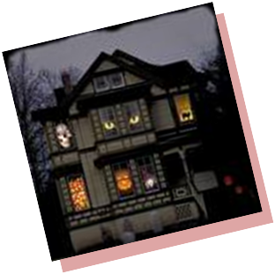


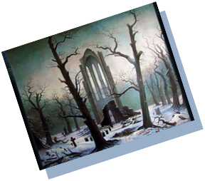
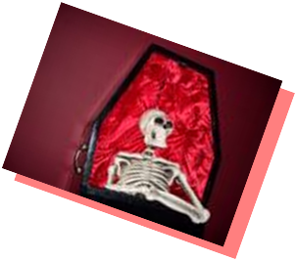

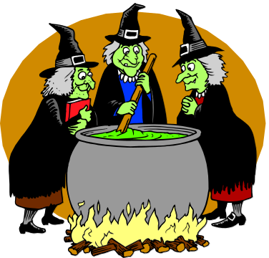

9:00 Haunted House opens
(Breakfast for Ghosts and Ghouls)
South Austin Campus Room 1130
12:45 It’s the Great Pumpkin, Charlie Brown!
(Master Plan Development)

9:30 Welcome to my
parlor…
(Welcome, Introductions,
and Overview of Meeting)
9:45 Things that go bump
in the night...
(Noel-Levitz Presentation)

10:15 Lost Souls
(Reasons for Withdrawal)

10:30 Coffin Break

10:45 Trick or Treat?
(Small Group Discussion Focused on Retention)

12:00 Feeding Frenzy
(Lunch)

1:45 Picking over the bones
(Retreat Evaluation)

Austin Community College
Institutional Planning Council
Planning Retreat
October 31, 2008

