New Faculty Reference Guide


AUSTIN COMMUNITY COLLEGE | DEVELOPMENTAL READING AND STUDY SKILLS FACULTY QUICK GUIDE

ACC Developmental Reading and Study Skills
Faculty Quick Guide

This is a quick guide for all DEVR/DSSK Faculty.
For detailed information please refer to the Full ACC Developmental Reading and Study Skills Information Booklet or the Austin Community College Website under the Faculty and Staff section at http://www.austincc.edu/facstaff/, or the ACC Developmental Reading Department website at http://www.austincc.edu/reading/, and/ or contact the Developmental Reading Department Chair.

All ACC Faculty and Staff utilize ACC Email, Lighthouse, and Online Services. To receive login information for the following services be sure to contact the ACC Helpdesk.

The Basics:

- Staffing: All courses will be assigned prior to the beginning of each semester. Once a faculty member accepts a course, they are responsible for meeting on their assigned days and times. If for any reason, a faculty member is unable to teach their assigned course for the semester, then they must contact the Department Chair prior to the beginning of the semester so a replacement instructor can be assigned.

- Mentors: All NEW Faculty will be assigned a mentor by the Department Chair. Mentors are an invaluable resource and are there to provide support for newly hired faculty. Mentors and Mentees must complete an evaluation at the end of the semester and submit this form back to the Department Chair.

- Textbooks: After an instructor accepts a course they may order textbooks one of the following ways:
- Estaffing through the Online Services Faculty Menu
** Please note- orders placed through staffing are not sent to the DEVR office.
OR
- Contact the DEVR office at NRG.

Note: The ACC Bookstore sets deadlines every semester for textbook orders. A member of the DEVR staff will notify faculty of the deadlines each semester. Textbooks may take up to 3 weeks after orders are process to arrive on the bookstore shelves. Late book orders may prevent students from purchasing the required textbooks the first week of class.

** The ACC Textbook manager will contact the DEVR staff member in charge of ordering textbooks with any questions regarding ALL Developmental Reading and Study Skills book orders. Be sure to notify this staff member of your book order to prevent delays or misorders for your course.

- What books to order?
Partner up with your assigned mentor for guidance on choosing a textbook. A Department approved textbook list is available at
http://eapps.austincc.edu/Textbooks/books.php?dept=DERE
Textbooks are housed at the DEVR offices at NRG and are available for review depending on inventory. To obtain an instructor’s copy, notify the DEVR offices at NRG in a timely manner.

NOTE: Publishers send a limited amount of textbooks. Instructors are expected to use their instructor’s copy for several semesters. New Faculty reviewing multiple textbooks will be instructed to return any textbook they are not using for the semester.

- ACC Resource Training: All New Faculty are encouraged to view the Non-Credit Online Tutorials available at http://www.austincc.edu/ITdocs/ . These tutorials are a resource in learning how to navigate and utilize ACC Faculty Online Services. Faculty will learn how to access class schedules, class rosters, textbooks ordering, and instructor-initiated withdrawals. Additional training sessions for Blackboard, Google Docs, Word, and other Faculty/Staff resources are available at http://www.austincc.edu/facstaff/ under Workshops and Events.

- Lighthouse: Update course materials on Lighthouse before each semester begins. Be sure to update all contact information as well as office hours. Instructions on Lighthouse are available on the ACC website under Faculty and Staff resources at http://www.austincc.edu/facstaff/.

- Class Roll: Each semester all faculty members are expected to call roll every class day during the first two weeks of the semester using an updated roster printed out via ACC’s Faculty Online Services. During the first week of class, if you have student that is not on your class roll, have them contact the DEVR office immediately. This is to ensure that no student is attending a class without being registered for it.

NOTE: Students may be dropped for nonpayment but may believe they are still enrolled in the course. Faculty must instruct students to see an advisor right away.

- Student Scores: Before the semester begins Faculty may check student Compass Reading/ Asset Reading Scores via ACC’s Faculty Online Services. Members of the DEVR staff will also check student scores and mail them out before the first day of class. It is the responsibility of the instructor to ensure each student is correctly placed in the appropriate reading course by the first day of class. Faculty must assess this by referring to the Developmental Reading Placement Chart, reviewing student’s course history, and evaluating student first day test scores. Newly hired staff should contact their mentor with any questions.

NOTE: Classes fill up fast! Delaying this assessment may result in the student being unable to move to another class due to a limited amount of seating in each course.

- Adds and Drops: Developmental Adds/Drops are extended past standard the ACC Add/Drop deadline but are still before the state mandated date. Check online or contact the DEVR offices for the exact deadline. During the first few days of the semester the DEVR offices will be moving and placing students in DEVR/DSSK courses at every campus. If classes are full, DEVR offices will be contacting instructors before overloading any class. Refer any student wanting to add your class to the DEVR offices.

- Tests: Every campus has an inventory of Department Tests. New Adjuncts must contact their assigned Mentor or a Full Time Faculty member to find out where the tests are stored.

NOTE: DEPARTMENT TESTS ARE USED BY ALL DEVR INSTRUCTORS. RETURN TESTS AT THE END OF CLASS!! DO NOT ALLOW STUDENTS TO WRITE IN TESTS!!

- Meetings/Department Resource Training sessions: Faculty will be notified by ACC Email of Department meetings and training sessions. All DEVR/DSSK Faculty are encouraged to attend meetings and training sessions when they are announced.

- Sick/Cancelling Class: If a faculty member knows ahead of time that she/he cannot teach a class, a substitute should be found. If a faculty member must cancel class due to illness, the class should be cancelled by calling the campus manager’s office so that a notice will be posted outside the classroom. If the situation is serious, Contact the Department Chair immediately.

NOTE: It is recommended that each faculty member make his/her policy clear about how long students should wait if the instructor is delayed.

- Questions: All NEW Faculty and Adjunct are encouraged to contact their assigned mentors for any questions. The Developmental Reading Department Chair, Full Time Faculty, and DEVR offices are also available for any support.
- Who to Ask?

FULL TIME FACULTY AND DEVR OFFICES
Dolores Segura | RVS | 223-6065 |  | Judy Hubble | RRC | 223-0069
Mary Leonard | NRG | 223-4711 |  | Glenda Shamburger | NRG | 223-4895
Julie Wauchope | HLC | 223-7434 |  | Dorothy Martinez | NRG | 223-4831
Ann Palmer | EVC | 223-5172 |  | DEVR OFFICE | NRG | 223-4710
Andrea Clark | CYP | 223-2018 |  | DEVR OFFICE | RVS | 223-6068
Elizabeth Frye | SAC | 223-9129 |  | DEVR OFFICE | RRG | 223-3070
Marilyn Burke | RVS | 223-6069
Cheryl Engle | HAY | 223-6557

Checklist of Faculty Responsibilities

BEFORE THE SEMESTER BEGINS
- Locate your classroom, mailroom, and duplication center for each campus you teach at.
- Fill-out a faculty information card for each campus where you teach and turn it in to the Mailroom to reserve a mailbox. Establish a routine for checking your mailbox every day you teach.
- Obtain an ACC Faculty ID at the Admissions and Records office at any campus.
- Purchase a Parking Permit for academic year at the Cashier’s office. Be prepared to show your Faculty ID.
- All ACC and Department communications are sent to your assigned ACC email. Establish routine for checking your ACC email at least twice a week.

BEFORE THE FIRST DAY OF CLASS
- Create class syllabi and review all college required elements on checklist. See the DEVR website under DEVR Faculty Resources and Syllabi for guidance.
- Update or upload syllabus and information on Lighthouse.
- Download class rosters from ACC Faculty Online Services.
- Know and be prepared to enforce course prerequisites.
- Review Academic Calendar for important dates: 1st class, 12th class day, withdrawal deadline, holidays, and last day of classes.
- Locate the bookstore on campus to verify the bookstore has your textbooks on the shelves for your students. Be sure to have your course information on hand including Course name, number, lecture number, and synonym number for the bookstore staff to look up your information. Contact the DEVR offices at NRG for any questions or concerns regarding textbook orders.

ACC Bookstores
Cypress : (512) 335-8363 | Rio Grande : (512) 474-2607
Eastview : (512) 927-1619 | Riverside : (512) 385-5727
Northridge : (512) 834-9366 | Round Rock : (512) 310-1761
Pinnacle : (512) 288-2303 | South Austin : (512) 445-7437

FIRST TWO WEEKS OF CLASSES
- After Drop-Add period, check rosters for accuracy. Advise any students attending but not on official roll to see Admissions and Records.
- Withdraw students who have never attended your class by cutoff date. Do not allow students to attend your class who are not on the class roll. Refer to DEVR offices for any support.
- Faculty members are expected to send a copy of their syllabus for each course taught to the Department Chair.

MID SEMESTER
- Perform Faculty Evaluations on stated calendar dates.
- Process on-line self evaluation form.
- Submit Portfolio to Department Chair.

END OF SEMESTER

- Submit grades on-line at ACC Faculty Online Access. A grade must be assigned for each student on the grade roll. You can access the grade rolls by clicking on Grading from the Faculty Online menu.
- Print out grades and make copies. Keep copies and supporting documentation for at least one year.
- For any “incomplete” (I) grade awarded at the end of the semester, complete and distribute a “Report of Incomplete Grade.”
- Return keys and any other materials that will not be used next semester.
- Completely fill out the data collection form with EXIT exam scores for each of your classes. Send data collection forms to Julie Wauchope at EVC at the end of each semester.
- End of Semester reports must be accurate and easily readable.
- The department may refer to End of Semester reports at any time.

ADDITIONAL NOTES:

DEPARTMENT TEXTBOOK LIST

Department: Developmental Reading

Approved Text Book List
PublisherAuthorISBN
TitleEdition | Developmental Reading
DEVR 0110 | Reading Skills Improvement
9781591944232 | Ten Steps Improving College Reading | 6th | Townsend | Langan
DEVR 0220 | College Reading Strategies
9780321364708 | Textcerpts Text Only | 2nd | Pearson | Wintner
9780321967077 | Texcerpts W/ Dictionary | 2nd | Pearson | Wintner
9780321873811 | Textcerpts W/ Dictionary /MicroLab | 2nd | Pearson | Wintner
9780321955852 | Textcerpts Pkg W/ MySkillsLab | 2nd | Pearson | Wintner
DEVR 0300 | Reading Fundamentals
9781259121593 | New Worlds W/ Connect | 5th | McGraw | Cortina
9781591944232 | Ten Steps Improving College Reading | 6th | Townsend | Langan
9781591942436 | Ten Steps to Building College Reading | 5th | Townsend | Langan
9781591942238 | Groundwork for Better Vocabulary | 4th | Townsend | Johnson
9781591940869 | Groundwork College Reading-Phonics | 4th | Townsend | Broderick
9780321873484 | Solving Mystery of Reading w/MRL | 1st | Pearson | Davidson
9780553583229 | American Heritage Dictionary Paperback | Sep-13 | Houghton | American
9781591940005 | Great Stories Suspense & Adventure | 1st | Townsend | Johnson
9780440414803 | Holes | May-00 | Random | Sachar
DEVR 0310 | Reading Skills Improvement
9781259348051 | Opening Doors W/ Conn Pkg | 7th | McGraw | Cortina
9781285437194 | Becoming a Master Student | 15th | Cengage | Ellis
9780321873484 | Solving Mystery of Reading w/MRL | 1st | Pearson | Davidson
9780553583229 | American Heritage Dictionary Paperback | Sep-13 | Houghton | American
9781568361666 | Delany Sisters' Book | Sep-96 | Kodansha | Delany
9780679734772 | House on Mango St | Apr-91 | Vintage | Cisneros
9780374500016 | Night | Jan-06 | Farrar | Wiesel
9781594481925 | The Color of Water | Feb-06 | Riverhead | McBride
9780205669004 | My Reading Lab Access Card |  | Longman | Pearson
DEVR 0320 | College Reading Strategies
9781256967637 | College Anthology /Dicti/My Reading Lab | 6th | Pearson | Noack
9781269199339 | College Study Essentail Ingredients | 2nd | Pearson | Lipsky
9780321881663 | Bridging the Gap W/MyReadingLab/eText | 11th | Pearson | Smith
9780321872470 | Bridging the Gap W/MyReadingLab/eText | 11th | Pearson | Smith
9781413002416 | Making Connections | 3rd | Cengage | Allen
9781121544420 | Preparing for College Success |  | McGraw
9780131487666 | Programmed College Vocabulary | 7th | Prentice | Feinstein
9780321364708 | Textcerpts Text Only | 2nd | Pearson | Wintner
9780321967077 | Textcerpts w/ Dictionary | 2nd | Pearson | Wintner
9780321873811 | Textcerpts W/ Dictionary /MicroLab | 2nd | Pearson | Wintner
9781285430454 | Least You Should Know Vocab Building | 8th | Cengage | Friend
9780495967002 | Science and Strategies Bundle | 1st | Cengage | Zadinda
9781308114408 | Ideal Reader | 3rd | McGraw | Burke
9780553583229 | American Heritage Dictionary Paperback | Sep-13 | Houghton | American
9780684842677 | Angela's Ashes : a Memoir | May-99 | Simon | McCourt
9781568361666 | Delany Sisters' Book | Sep-96 | Kodansha | Delany
9780385495226 | The Hot Zone | Jun-99 | Anchor | Preston
9780679774020 | All Over But the Shoutin' | Sep-98 | Doubleday | Bragg
9780449227428 | The Third Twin | Jun-97 | Fawcett | Follett
DEVR 0330 | Intergrated Reading and Writing
9780134048734 | Textcerpts W/ Myskillslab | 3rd | Pearson | Wintner
DEVR 0340 | Fundamentals of Vocabulary
9780553583229 | American Heritage Dictionary Paperback | Sep-13 | Houghton | American
DEVR 0341 | Vocabulary I
9780205211944 | Interactive Vocabulary | 5th | Longman | Olsen
9780321876652 | Interactive Vocab W/MyReadingLab | 5th | Longman | Olsen
9780553583229 | American Heritage Dictionary Paperback | Sep-13 | Houghton | American
DEVR 0342 | Vocabulary II
9780205642281 | Gaining Word Power | 8th | Longman | Rubin
9780553583229 | American Heritage Dictionary Paperback | Sep-13 | Houghton | American
DEVR 0343 | Advanced College Vocabulary
9780816508990 | English Words from Latin & Greek | 2nd | U of Arizona | Ayers
9780553583229 | American Heritage Dictionary Paperback | Sep-13 | Houghton | American
9780816523184 | English Words Latin&Greek WkBk | 5th | U of Arizona | Dettmer
DEVR 0360 | Spelling Skills
9780395753897 | College Spelling Skills | 2nd | Cengage | Shepherd
9780131487666 | Programmed College Vocabulary | 7th | Prentice | Feinstein
9780553583229 | American Heritage Dictionary Paperback | Sep-13 | Houghton | American
 | Study Skills
DSSK 0210 | Basic Study Skills
9781269199339 | College Study Essentail Ingredients | 2nd | Pearson | Lipsky
9781285437194 | Becoming a Master Student | 15th | Cengage | Ellis
9780137007561 | Academic Transformation | 2nd | Prentice | Sellers
9780553583229 | American Heritage Dictionary Paperback | Sep-13 | Houghton | American
9780840053091 | Math Study Skills WkBk | 4th | Cengage | Nolting
DSSK 0220 | College Study Skills
9781133586845 | World of Words | 9th | Cengage | Richek
9780553583229 | American Heritage Dictionary Paperback | Sep-13 | Houghton | American
DSSK 0310 | Basic Study Skills
9780137007561 | Academic Transformation | 2nd | Prentice | Sellers
978111182533 | Becoming a Master Student | 14th | Cengage | Ellis
9781269199339 | College Study Essentail Ingredients | 2nd | Pearson | Lipsky
9781133586845 | World of Words | 9th | Cengage | Richek
9781305109599 | Practicing College Learning Strategies | 7th | Cengage | Hopper
9781413030518 | Get Connected:Study Skill | 1st | Cengage | Dillon
9780940287402 | Winning At Math | 5th | Academic | Nolting
9780840053091 | Math Study Skills Wrkb | 4th | Cengage | Nolting
DSSK 0320 | College Study Skills
9780137007561 | Academic Transformation | 2nd | Prentice | Sellers
9781133586845 | World of Words | 9th | Cengage | Richek

Developmental Reading Placement Chart

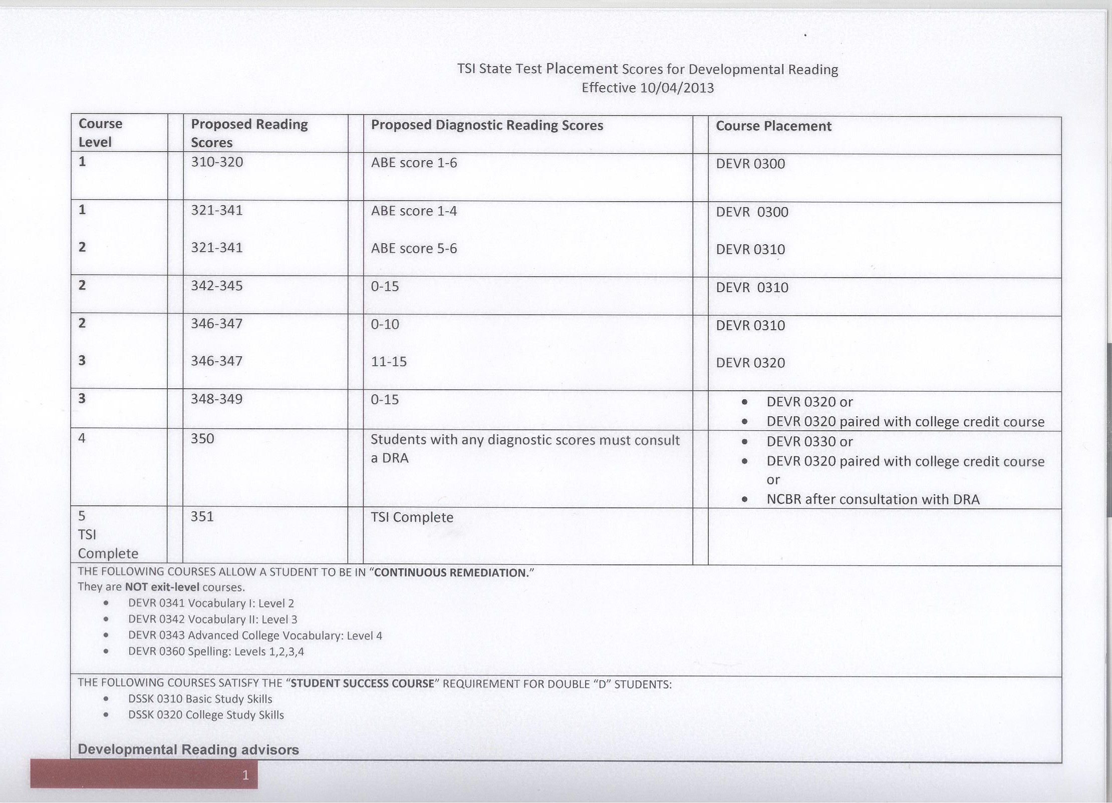

Developmental Reading Advisors
For Information contact

Andrea Clark
Cypress Creek Campus
223-2018

Julie Wauchope
Highland Campus
223-7434

Ann Palmer
Eastview
223-5172

Mary Leonard
Northridge & Elgin Campuses
223-4710

Cheryl Engle
Hays & Pinnacle Campuses
223-8016

Dorothy Martinez
Rio Grande Campus
223-3353

Judy Hubble
Round Rock Campus
223-2084

Marilyn Burke
Riverside Campus
223-6069

Dolores Segura
Riverside Campus
223-6065

Elizabeth Frye
South Austin Campus
223-6068

